Code_to_test1.R

tusk

2024-03-15

# To compile   
# The notebook icon 📄 appears just under the R script file name.   
# By hovering the mouse over it, you’ll see the shortcut Compile Report (Ctrl + Shift + K or (Cmd + Shift + K in Mac).   
# Click on the icon. Then, R will ask what Report output format you prefer. Choose MS Word. Finally, click Compile. That’s it. The Word file will launch when it is done.  
  
# Test   
rm(list = ls()) # Remove objects  
# setwd("P:/R_AST")  
getwd()

## [1] "F:/Git_public/Support/SRMS-Workshop/R-Compiling_a_report"

# Print R's built-in dataset  
cars

## speed dist  
## 1 4 2  
## 2 4 10  
## 3 7 4  
## 4 7 22  
## 5 8 16  
## 6 9 10  
## 7 10 18  
## 8 10 26  
## 9 10 34  
## 10 11 17  
## 11 11 28  
## 12 12 14  
## 13 12 20  
## 14 12 24  
## 15 12 28  
## 16 13 26  
## 17 13 34  
## 18 13 34  
## 19 13 46  
## 20 14 26  
## 21 14 36  
## 22 14 60  
## 23 14 80  
## 24 15 20  
## 25 15 26  
## 26 15 54  
## 27 16 32  
## 28 16 40  
## 29 17 32  
## 30 17 40  
## 31 17 50  
## 32 18 42  
## 33 18 56  
## 34 18 76  
## 35 18 84  
## 36 19 36  
## 37 19 46  
## 38 19 68  
## 39 20 32  
## 40 20 48  
## 41 20 52  
## 42 20 56  
## 43 20 64  
## 44 22 66  
## 45 23 54  
## 46 24 70  
## 47 24 92  
## 48 24 93  
## 49 24 120  
## 50 25 85

summary(cars)

## speed dist   
## Min. : 4.0 Min. : 2.00   
## 1st Qu.:12.0 1st Qu.: 26.00   
## Median :15.0 Median : 36.00   
## Mean :15.4 Mean : 42.98   
## 3rd Qu.:19.0 3rd Qu.: 56.00   
## Max. :25.0 Max. :120.00

p1_carspeed <- hist(cars$speed)

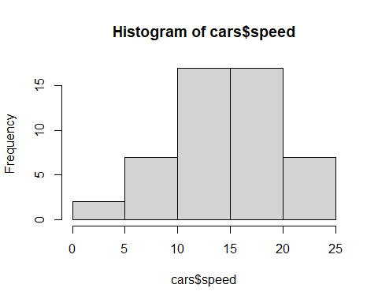

p1_carspeed

## $breaks  
## [1] 0 5 10 15 20 25  
##   
## $counts  
## [1] 2 7 17 17 7  
##   
## $density  
## [1] 0.008 0.028 0.068 0.068 0.028  
##   
## $mids  
## [1] 2.5 7.5 12.5 17.5 22.5  
##   
## $xname  
## [1] "cars$speed"  
##   
## $equidist  
## [1] TRUE  
##   
## attr(,"class")  
## [1] "histogram"