Rmarkdown prac

# 1 Embedding R code

We press **Ctrl (Cmd) + Alt + I**.

data(mtcars)  
head(mtcars)

## mpg cyl disp hp drat wt qsec vs am gear carb  
## Mazda RX4 21.0 6 160 110 3.90 2.620 16.46 0 1 4 4  
## Mazda RX4 Wag 21.0 6 160 110 3.90 2.875 17.02 0 1 4 4  
## Datsun 710 22.8 4 108 93 3.85 2.320 18.61 1 1 4 1  
## Hornet 4 Drive 21.4 6 258 110 3.08 3.215 19.44 1 0 3 1  
## Hornet Sportabout 18.7 8 360 175 3.15 3.440 17.02 0 0 3 2  
## Valiant 18.1 6 225 105 2.76 3.460 20.22 1 0 3 1

Does it amaze you? Well, using rmarkdown is much more complex than the above example! Your data analysis steps involve multiple stages and you’ll be selective in presenting results.

In practice, you’ll run the entire file first then load the objects before printing. This is an example only, and the output will not be printed.

Example:

source("P:/SRMS-Workshop/R-Source-Scripts/Code_to_test1.R") # Specify the full path for an R script

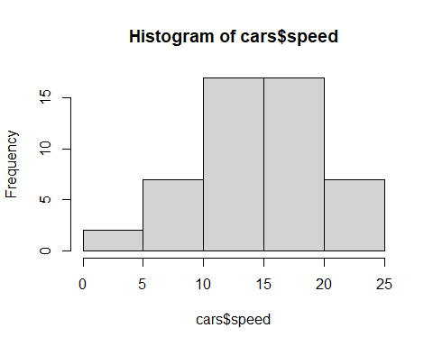

As an R script is run, we now have access to objects (Tables, and Figures) we need to present in a report. Let’s imagine that we are presenting a Figure on car speed.

# Figure  
p1_carspeed

## $breaks  
## [1] 0 5 10 15 20 25  
##   
## $counts  
## [1] 2 7 17 17 7  
##   
## $density  
## [1] 0.008 0.028 0.068 0.068 0.028  
##   
## $mids  
## [1] 2.5 7.5 12.5 17.5 22.5  
##   
## $xname  
## [1] "cars$speed"  
##   
## $equidist  
## [1] TRUE  
##   
## attr(,"class")  
## [1] "histogram"

# Desc stats (specify obj name)  
# descstats

# 2 Styles and formatting

Use a Word template. Go to Styles tab and choose Heading. Modify as appropriate. Specify at the top as reference_docx:yourtemplate.docx.

Also see BB for tutorial on Styles.

# 3 To create a Word document using the current Rmd file

Click on Knit (the icon looks similar to 🧶).

The icon resembles a needle and thread as Knit implies. It is placed with other menu icons at the top, just under the filename.

Alternatively, you can press Ctrl+Shift+K (or Cmd+Shift+ in Mac)

If you have an opened (code-exported) word document already, ensure to close it before you Knit. I hope it works!

Well-done! 👍