Midterm Project

Yijing Tao yt2785

2022-03-26

## Introduction

Finding out how to predict people’s average life expectancy in certain regions is very important now. The data in this study is collected from WHO, and will focus on immunization factors, mortality factors, economic factors, social factors and other health related factors as well.  
 In this study, there are in total 21 variables and one response. *(See the explanation of each variable in the appendix* ***table1****)*

Since the observations of this data set are based on different countries, it will be easier for a country to determine the predicting factor which is contributing to lower value of life expectancy. This will help in suggesting a country which area should be given importance in order to efficiently improve the life expectancy of its population.

## Visualization of the Data Set

After having the data set, I included all of the variables except “Country”, “Year” and “Alcohol” in the training and testing data set since the individual country name and repeated “Year” should not be an important factor which will affect the life expectancy, and the personal consumption of alcohol in this data set is too small and too similar to each other that I think it does not interested me in this project.  
 In this project, I used the function **featurePlot()** in caret to visualize the data. Since within the 18 predictors I am interested in, only “Status” is a binary pridictor, I excluded it when making the featurePlot.  
 When observing the 19 plots I have got, I found that generally we can consider that having higher “Thiness 1-19 years”, “Thiness 5-9 years” and “HIV/AIDS” might lead to a lower life expectancy, while having a higher “Income.composition.of.resources”, “School”, “Polio”, “Total.expenditure”, “Diphtheria”, “GDP” might lead to a higher life expectancy. *(See the plots of each variable in the appendix* ***picture1****)* Then I made a density plot to show the relationship between Status and Life expectency. From the plot, we can generally find that people living in developed regions seems to have longer life.  
 The trends listed above are all seemed reasonable in the common sense. But what make me feel strange is that from the plots we can generally find that having a higher “BMI” will lead to a higher life expectancy, while the value of “Hepatitis.B” and “Measles” seems have no relation to the life expectancy.

## Weakness and Training of Different Models

In this study, we can get a data frame which includes 1649 rows and 21 columns after omitting all of the NA values and the variable “Country”, “Year” and “Alcohol”. Then I randomly extracted 70% of the data to be training data and the 30% rest to be testing data.

To find out the relationship between different predictors and life expectancy, I decided first to find out the best fitted model. I built **KNN, linear regression, ridge, lasso, elastic net, PCR, PLS, GAM, MARS** in total 9 models. In all of the models, I conducted 10-fold cross validation method to get a better fitted model.

### KNN

The first model I used to fit is KNN model. The weakness of KNN is:  
1) High computational complexity; high spatial complexity.  
2) Low prediction accuracy for rare categories when the sample is not balanced  
3) Poor interpretability, cannot give rules like decision trees.  
 In KNN model, the tuning parameter is “k”, after training with the area (1,20), we can learn that the best tuning paremeter k is 12. Then I input the training data set and arrange y = life expectancy, x = 18 variables.  
 By calculating the test error using the test data set, we can find that the test error of the KNN model is extremely high (66.5529). Therefore, I think the KNN model is not flexible enough to capture the underlying truth.

### LM

Then I used linear regression model, whose weakness is being difficult to interpret the correlation coefficient if the features are highly correlated.  
 There is no any tuning parameters in the lm model, so I simply input the training data set and arrange y and x.  
 By calculating the test error using the test data set, we can find that the test error of the linear regression model is small (13.3670). Therefore, I think this model is flexible enough to capture the underlying truth.

### Ridge, Lasso and Elastic Net

The weakness of ridge, lasso and elastic net model is introducing a small amount of bias into the model, but greatly reduces the variance, and penalty might cause underfitting.  
 Both Ridge and lasso has 1 tuning parameter $λ$, and elastic net model has 2 tuning parameters $λ$ and $α$ **(0-1)**. Based on the rule, I tried different area of lambda and finally decided to set **-2 < $λ$ < 5** as the area of $λ$, and get the best tuning parameters $λ_{ridge}=0.597$**, $λ_{lasso}=0.135$, $λ_{elasticnet}=0.135$, $α_{elasticnet}=0.05$** .

The “x”’s used to train this model should be turned into a matrix.  
 By calculating the test error using the test data set, we can find that the test errors of these 3 models are small (TEridge =13.9203, TElasso = 13.9624, TEenet = 13.7627) . Therefore, I think these 3 models are flexible enough to capture the underlying truth.

### PCR and PLS

The weakness of PCR and PLS model is difficult in handling non-linear data and understanding the meaning of the result.

In the PCR and PLS model, the tuning parameter is the number of predictors included in the final model (with the smallest RMSE). In the PCR model, all of the 18 predictors are considered to be included, while in the PLS model, the model including only 17 predictors has the smallest RMSE.

The “x”’s used to train these 2 models should be turned into a matrix.  
 By calculating the test error using the test data set, we can find that the test errors of PCR and PLS model are small (both are 13.3670). Therefore, I think these models are flexible enough to capture the underlying truth.

### GAM

The weakness of GAM model is lack of parametric functional form makes it difficult to score the new data directly.

The tuning parameter of GAM model is whether the “select”. If it is “TRUE” then GAM can add an additional penalty variable to each semester so that it can be scored as zero. This means that the smoothing parameter estimate is part of the fit and can be completely removed from the terms in the model. If the corresponding smoothing parameter estimate is zero, then the additional penalty has no effect. In this project, the “select” is “FALSE”.

The “x”’s used to train this model should be turned into a matrix.  
 By calculating the test error using the test data set, we can find that the test error of GAM model is small (8.1645). Therefore, I think this model is flexible enough to capture the underlying truth.

### MARS

Although MARS has the weakness of requiring strict assumptions and the need to deal with outliers, MARS is not only highly adaptive compared to other methods, but also has a higher accuracy for model prediction. In the multidimensional case, due to the expansion of the sample space, how to divide the space becomes a crucial issue. MARS is a regression method with high generalization ability specifically for high-dimensional data. This regression method uses the tensor product of the spline function as the basis function, and the determination of the basis function (the number of tensor variables and the partition point of the variables) and the number of basis functions are done automatically by the data, without manual selection.  
In MARS model, after trying several times, I decided to take degree = 1-5, nprune = 10-29 to be the area of the tuning parameters. After training the model with caret package, it is reported that degree = 2 and nprune = 26 is the best tuning parameters that will lead to a model with the smallest RMSE.

The “x”’s used to train this model should be turned into a matrix.

By calculating the test error using the test data set, we can find that the test error of MARS model is small (6.1947). Therefore, I think this model is flexible enough to capture the underlying truth.

## Comparison

To find out the best fitting model, I compared their goodness of fit by comparing the RMSE using cross validation. The result of the comparison through cross validation is below. *(See the plots of cross validation comparison in the appendix* ***picture2****)*

From the comparison of cross validation, we can find that the **MARS model** is the best model to our data set since it has the smallest RMSE.

## Important Predictors

By making the *vip importance plot* of MARS model, we can find that changes in **“Income composition of resources”, “Adult Mortality Rates”, “HIV/AIDS”, “Thinness 5-9 years”, “Diphtheria”, “Infant death”, “Status(developing)”** and **“BMI”** will lead to an observable change in life expectancy. So these variables above play important roles in predicting the response, and the predictors come first will have a higher importance. (See the vip importance plot in the appendix **picture3**)  
 The other variables seems have no observable relationship with life expectancy in this study.

From the slope of *pdp::partial plots (See the pdp::partial plots in the appendix* ***picture4****)* and the *coefficient* *(See the coefficients in the appendix* ***table2****)*, we can find than among the 8 important predictors, a higher “Adult Mortality Rates”, “Infant death”, “HIV/AIDS”, and being a “developing” country will all lead to a lower life expectancy (the coefficient of “StatusDeveloping * h(Adult.Mortality-118)” is smaller than 0).  
 “Income composition of resources”(ICR), “BMI”, “Diphtheria” and “Thinness 5-9 years”(T5.9Y) don’t have a monotonous influence on life expectancy. When the predictor is smaller than 0.3 and larger than 0.8, the increase of “ICR” will lead to a lower life expectancy while when “ICR” is large than 0.3 and smaller than 0.8, the increase of it will lead to a higher life expectancy. When “BMI” is smaller than 45, the increase of “BMI” will lead to a higher life expectancy while when “BMI” is large than 45, the increase of it will lead to a lower life expectancy. When “Diphtheria” is smaller than 60, the increase of “Diphtheria” will not lead to any change in life expectancy while when “Diphtheria” is large than 60, the increase of it will lead to a higher life expectancy. When “T5.9Y” is smaller than 5, the increase of “T5.9Y” will lead to a lower life expectancy while when “T5.9Y” is large than 5, the increase of it will only lead to a slightly increase in life expectancy.

## Discussion

Compared to the interpretation I have made in the visualization, some of the variables I thought would be important to the result, such as “Polio” and “GDP”, was not included in the final model. However, in my own point of view, this might because the sample size is not large enough, or they are not as important as the 8 variables which are included in the final model, so I actually don’t think this means that they are completely not related to the life expectancy.

# Appendix

**The github link: https://github.com/YijingTao/p8106_midterm_project_yt2785.git**

|  |  |
| --- | --- |
| Variables | Explanation |
| Country |  |
| Year |  |
| Status | Developed or Developing status |
| Life Expectancy in age (Y) |  |
| Adult Mortality Rates | Adult Mortality of both sexes (probability of dying between 15 and 60 years per 1000 population) |
| Infant Death | Number of infant death per 1000 population |
| Alcohol | Alcohol, recorded per capita(15+) consumption (in liters of pure alcohol) |
| Percentage of expenditure | Expenditure on health as a percentage of Gross Domestic Product per capita(%) |
| Hepatitis B | Hepatitis B (HepB) immunization coverage among 1-year-olds(%) |
| Measles | Number of reported cases per 1000 population |
| BMI | Average Body Mass Index of entire population |
| Under-5 death | Number of under-five deaths per 1000 population |
| Polio | Polio(Pol3) immunization coverage among 1-year-olds(%) |
| Total expenditure | General government expenditure on health as a percentage of total government expenditure(%) |
| Diphtheria | Diphtheria tetanus toxoid and pertussis(DTP3) immunization coverage among 1-year-olds (%) |
| HIV/AIDS | Deaths per 1000 live births HIV/AIDS (0-4 years) |
| GDP |  |
| Population | Population of the country |
| Thinness 1-19 years | Prevalence of thinness among children and adolescents from age 10 to 19(%) |
| Thinness 5-9 years | Prevalence of thinness among children from age 5 to 9(%) |
| Income composition of resources | Human Development Index in terms of income composition of resources(index ranging from 0 to 1) |
| Schooling | Number of years of Schooling(years) |

Table1. Explanation of the variables

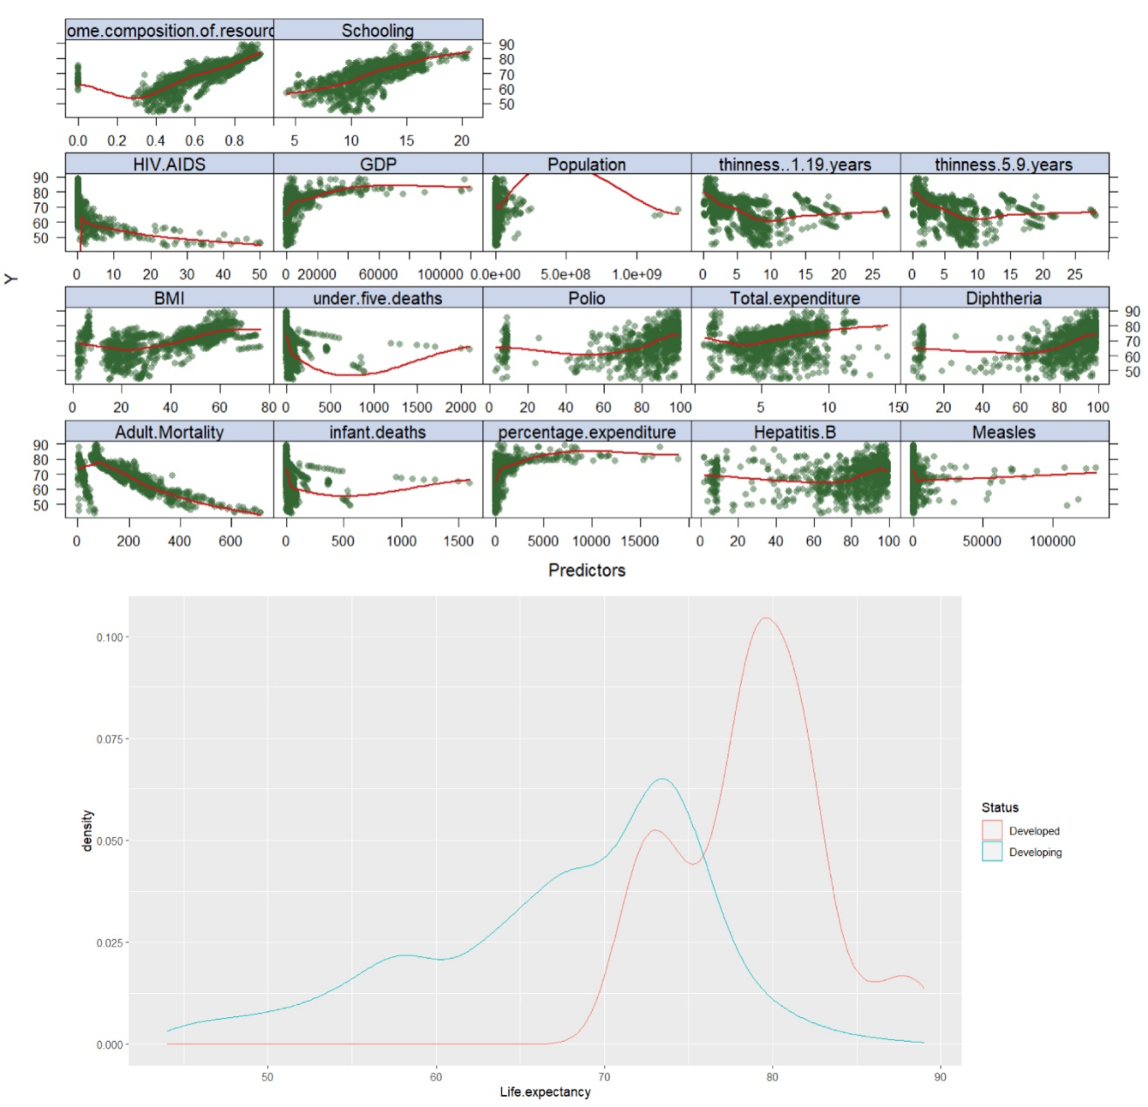

Picture1. Data Visualization

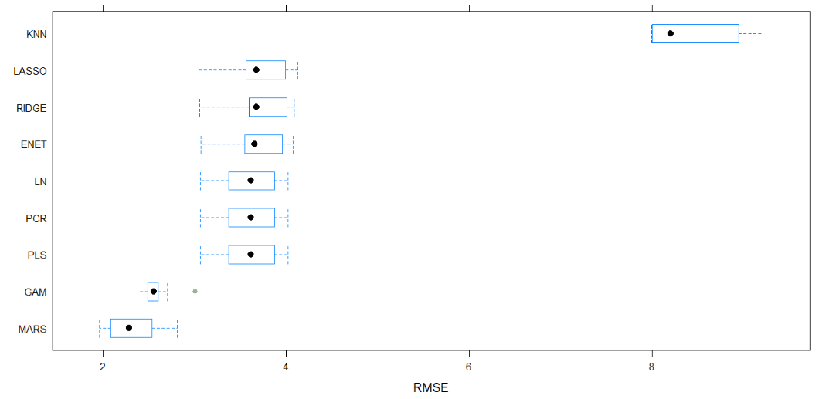

Picture2. CV Models Comparison

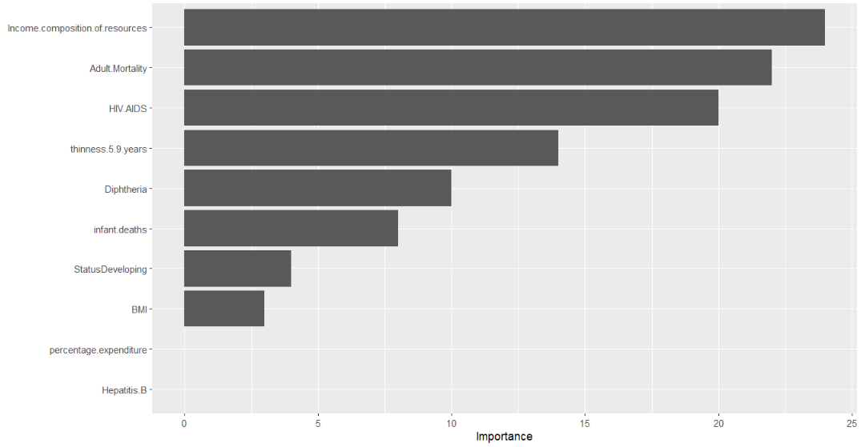

Picture3. MARS Model Vip Importance Plot

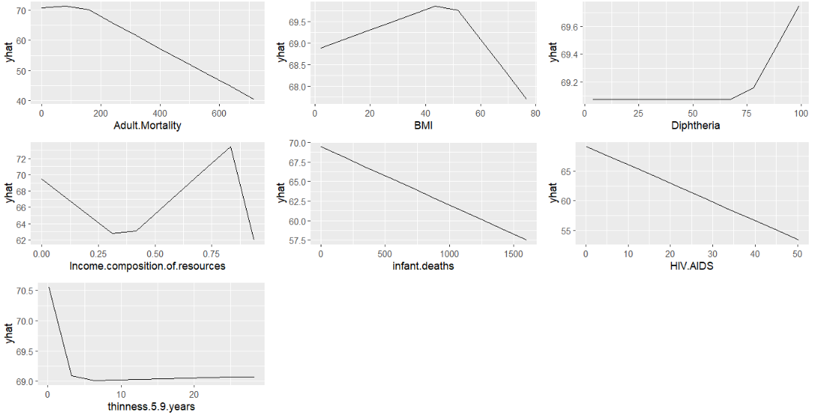

Picture4. MARS Model PDP::Partial Plots

|  |  |
| --- | --- |
|  | coefficients |
| (Intercept) | 61.786471 |
| h(Adult.Mortality-26) | 0.280941 |
| h(Adult.Mortality-66) | 0.466131 |
| h(Adult.Mortality-118) | -0.274095 |
| h(49.2-BMI) | -0.023207 |
| h(BMI-49.2) | -0.083352 |
| h(3.4-thinness.5.9.years) | 0.725277 |
| h(thinness.5.9.years-3.4) | -0.892401 |
| h(0.36-Income.composition.of.resources) | 187.009540 |
| StatusDeveloping * h(Adult.Mortality-118) | -0.031481 |
| h(99-Adult.Mortality) * HIV.AIDS | -0.007347 |
| h(Adult.Mortality-26) * h(HIV.AIDS-0.4) | -0.004372 |
| h(Adult.Mortality-26) * h(0.4-HIV.AIDS) | -0.012094 |
| h(Adult.Mortality-118) * h(HIV.AIDS-5.1) | 0.004744 |
| h(Adult.Mortality-118) * h(5.1-HIV.AIDS) | -0.009454 |
| h(Adult.Mortality-26) * h(0.836-Income.composition.of.resources) | -0.963716 |
| h(Adult.Mortality-69) * h(Income.composition.of.resources-0.36) | -1.494242 |
| h(119-Adult.Mortality) * h(Income.composition.of.resources-0.36) | 0.308195 |
| h(Adult.Mortality-119) * h(Income.composition.of.resources-0.36) | 0.557359 |
| h(215-Adult.Mortality) * h(0.36-Income.composition.of.resources) | -0.756175 |
| h(Adult.Mortality-215) * h(0.36-Income.composition.of.resources) | 1.038979 |
| h(infant.deaths-4) * h(3.4-thinness.5.9.years) | -0.008248 |
| h(Diphtheria-75) * h(thinness.5.9.years-3.4) | 0.011557 |
| h(3.4-HIV.AIDS) * h(thinness.5.9.years-3.4) | 0.257415 |
| h(HIV.AIDS-3.4) * h(thinness.5.9.years-3.4) | 0.036543 |

Table2. MARS Model Coefficients