|  |  |
| --- | --- |
| USER’S MANUAL  **Fluvial Egg Drift Simulator** | Draft prepared for: FluEgg Workshop: November 21, 22 2016 Urbana, IL |

Table of Contents

1. Background 1

2. Introduction 2

3. Installation 2

4. Software use 3

5. Graphical User Interface for the Fluvial Egg Drift Simulator (FluEgg) 4

6. Steps for FluEgg Applications 4

# Background

The Fluvial Egg Drift Simulator (FluEgg) was developed by Garcia et al. (2013) to simulate the transport dynamics of Asian carp eggs. The FluEgg model is written in the MATLAB® programming language (Mathworks, Natick, MA, USA). The work was funded by the U.S. Geological Survey (USGS) Illinois-Iowa Water Science Center with funds received from the U.S. Environmental Protection Agency Great Lakes Restoration Initiative.

After it’s publication in 2013, FluEgg’s capabilities have been enhanced to meet practical needs. This version of FluEgg now accepts unsteady hydrodynamic data as river input. This manual is updated to address this new feature. Model development is still ongoing as needs present.

# Introduction

The FluEgg model was developed to simulate how Asian carp eggs and larvae (specifically, silver, bighead, and grass carp) are transported and dispersed in a river. It is a three-dimensional, individual based, Lagrangian model that incorporates hydrodynamics and egg and larvae development. Inside the model, the river conditions are described with depth, discharge, velocity, turbulence, and water temperature; whereas the eggs are described with density and diameter and how those characteristics change over time as egg and larval develop.

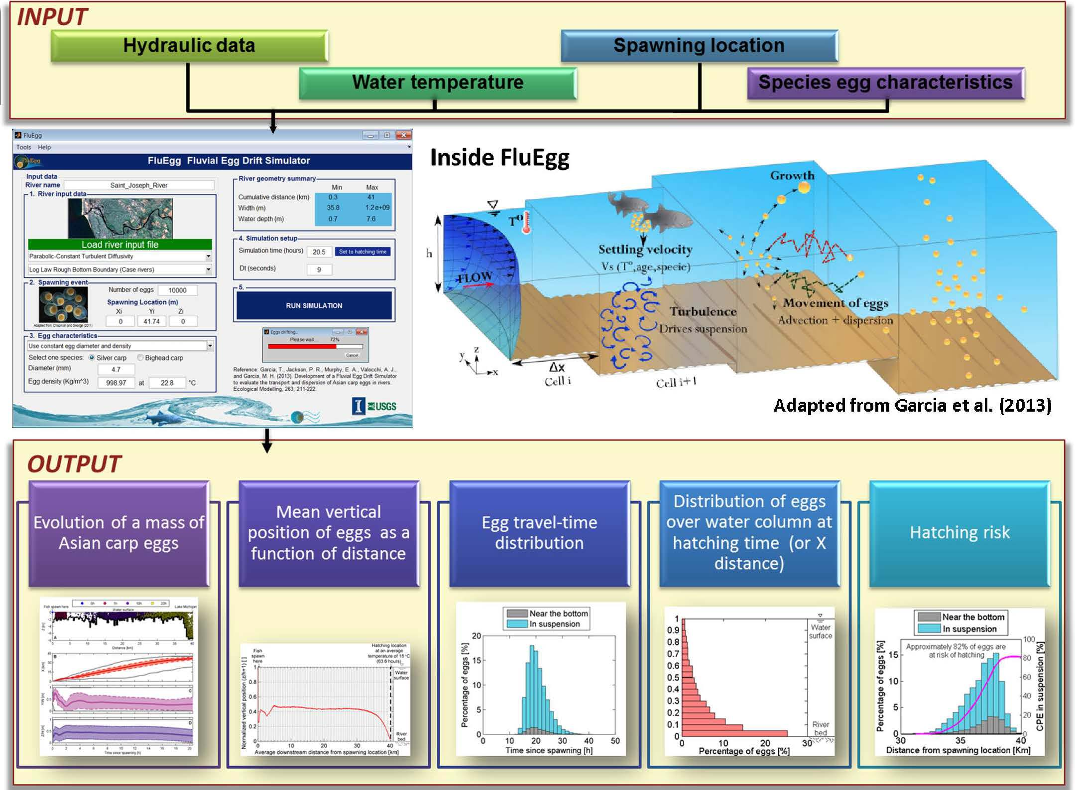

Figure xx.

# Installation

The executable file of FluEgg model can be downloaded from: <http://asiancarp.illinois.edu/FluEgg.html>. The model is compiled for a 64-bit processor. A 32-bit version is also available upon request. To run the FluEgg model it requires the 2013a MATLAB compiler runtime (MCR). This MCR needs installed on the computer if it does not have the MATLAB 2013a. The MCR is also available for download from the FluEgg download website. A readme file is included in the download materials to guide the user through installing the MCR. Note that some computers require administrator rights in order to install new software.

# Software use

Install the MCR by run the program (double click it), and place the FluEgg executable in the designated folder.

The completed version of User’s Manual will explain how to execute the FluEgg’s model and its functionalities. This draft version addresses the former portion only – instructions on how to input river data and run the FluEgg model, and how to analyze results.

Steps in Specifying Data Inputs

The FluEgg model is activated by double-clicking the executable file. The action launches a DOS console window, then a Graphical User Interface (GUI) window for FluEgg (termed as FluEgg home window hereafter). Do not close any of the two windows as both windows must remain open for the FluEgg to function.

# Steps for FluEgg Applications

Steps for applying FluEgg are:

1. Input river data,
2. Specify spawning event to be analyzed,
3. Specify egg characteristics,
4. Set up simulation scenarios,
5. Run simulation, and
6. Visualize the results. Note visualization of the results uses the postprocessing tools linked through the “Analyze results” push-button.

These application steps are illustrated with the following figures.

# Graphical User Interface for the Fluvial Egg Drift Simulator (FluEgg)

The FluEgg DOS window is shown as in fig. 1A and FluEgg home window is shown as in fig 1B. This home window consists of sequential boxes to guide users setting up a model, running the model, and analyzing results. Most operations in FluEgg modeling can be accomplished using these steps. Also there are three pulldown tabs at the top left side of the home window. These will be discussed after the GUI functions are explained.

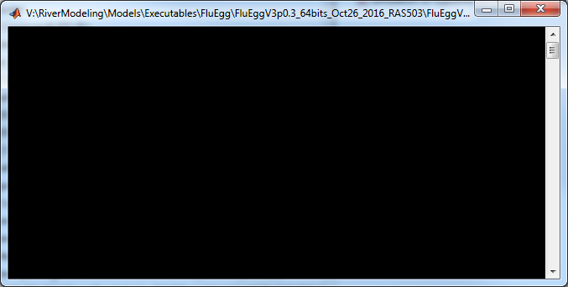

Figure 1A. An image of the FluEgg DOS window.

1. Specify a name in the “River name” box for the FluEgg run (red circle in fig 1B). The string in the box contains suggested fields for naming a FluEgg run. Adjust the fields to meet your needs. The purpose id for easy tracking scenarios simulated in the analysis. Note no empty space (“ “) or dot (“.”) is recognizable in the naming system.
2. The next step is to rad in the river input file. Click “Load river input file” bar (blue circle in fig 1B) to load the hydraulic data. There are two additional boxes below “Load river input file” bar, keep the default selections intact for now. A 2nd window appears after the “Load river input file” is activated, as illustrated by fig 1C. From this window we can input hydraulic data (river input file). A “river input file” can be either a user prepared file (csv, excel files are acceptable), or a HEC-RAS output file. The latter is used as the example here.

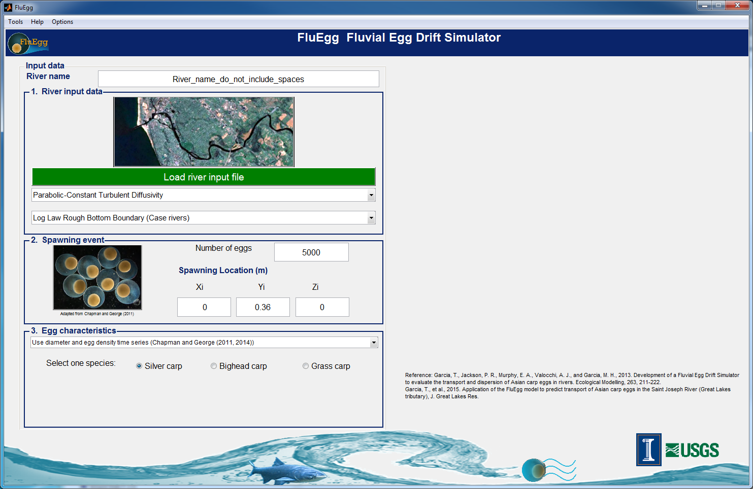

Figure 1B. FluEgg Fluvial Egg Drift Simulator home window.

1. In the “Input File Loading Window”, select the “Import HEC-RAS” tab if it is not highlighted (fig 1C, upper left). This indicates that we are using river input generated by the HEC-RAS. Click “Load HEC-RAS project file” bar (red circle as shown in fig 1C). A browser window pops up from which we can use to navigate to the HEC-RAS project folder. In the HEC-RAS folder, select the HEC-RAS project file (a .prj file). After selecting the .prj file, information about the HEC-RAS model is populated (several boxes on the upper-right-hand side). We will explain their usage later. Next specify the water temperature in the box highlighted by the green circle as shown in fig 1C; then click on the “import data” box (blue circle in fig 1C). This “import data” action may take a few minutes or longer, depending on the size of the river input file. We can observe the loading in progress as shown in fig. 1D.

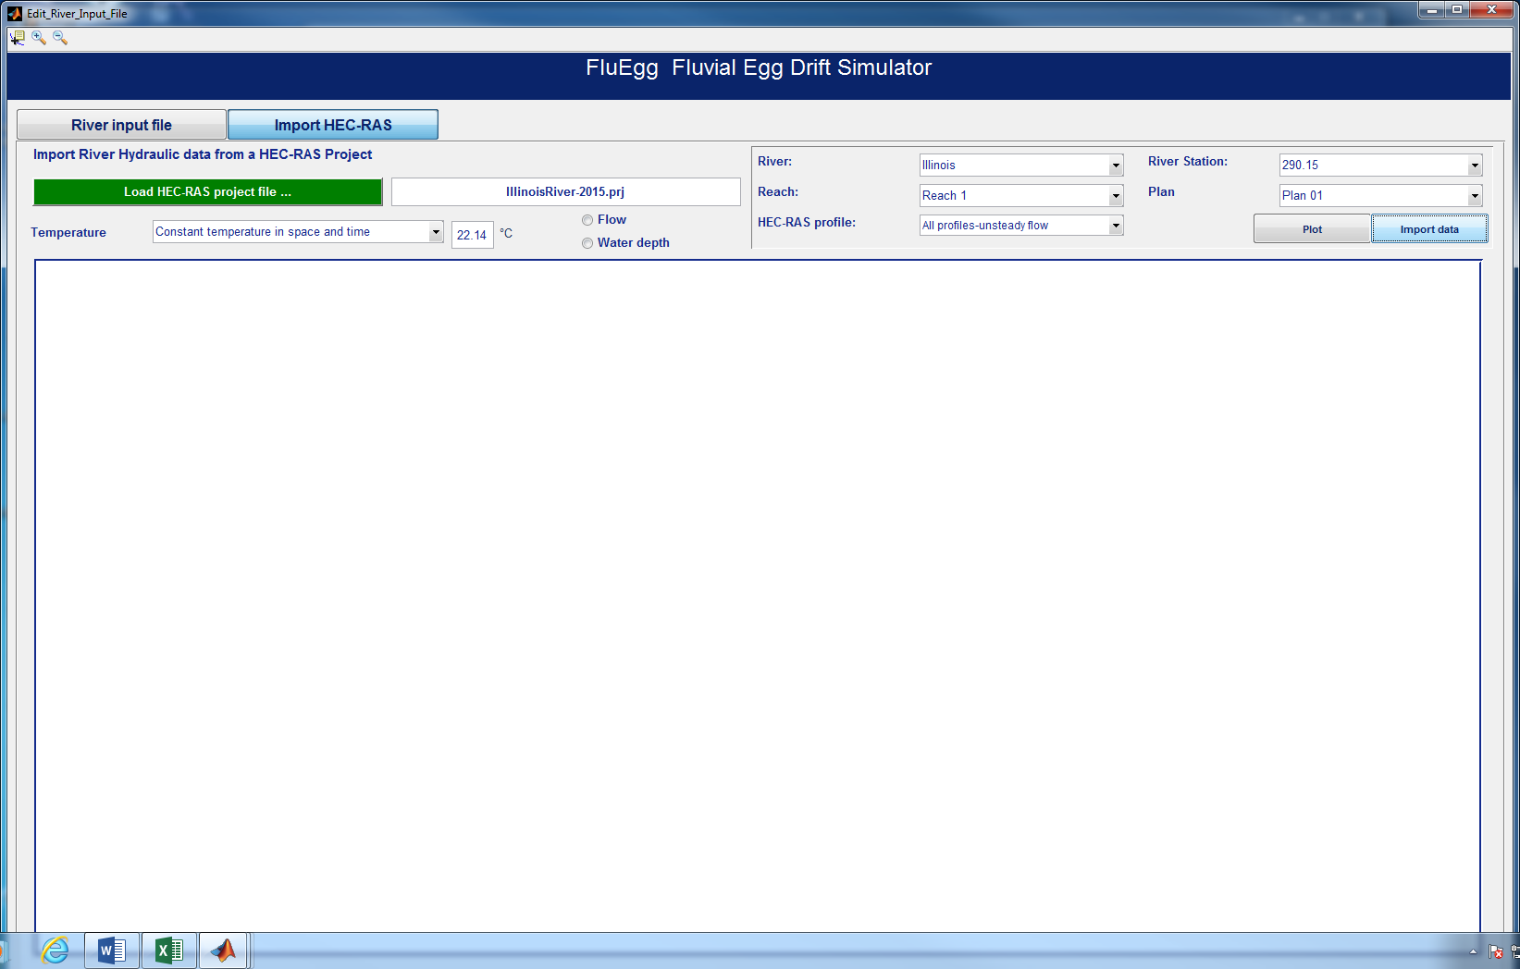

Figure 1C. River input file loading window.

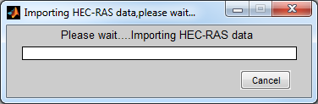

Figure 1D. HEC-RAS loading window.

1. After loading the river file, the next step in FluEgg modeling is to input fish egg data and relevant field information for the purpose of analyzing a spawning event. At present, several pieces of the input are estimated by the users. The excel file provided in the workshop folder contains this information. We will evaluate the feasibility to compute the information within FluEgg.
2. Specifying the spawning time. In the excel file, the time after fertilization has been estimated which we then used to estimate the spawning time. Specifying the spawning event is done through a “set up spawning event” tab in the “River Input File” window. This tab appears only after we have selected a “flow” or a “water depth” hydrograph (blue circle in fig 1E) for the analysis. In general, the hydrograph of either parameter gives adequate information about the hydrologic information (i.e., patterns and magnitudes of the storm) and works well; but in some cases one of the hydrograph plot may contain more informative relevant to the intended analysis. Here we take the opportunity to explain the usage of those “River Station”, “HEC-RAS profile”. The unsteady river input file contains flow and water depth data at each cross section and for every time step prepared. Users can view the “flow” or “water depth” hydrograph at any selected river cross section through “River Station” and selected time through specifying them in the “HEC-RAS profile” boxes (green circles in fig 1E). Users can use this design to view the flow or water depth at any cross section of interest. For the analysis, select the profile and river cross section closer to the projected location and time.

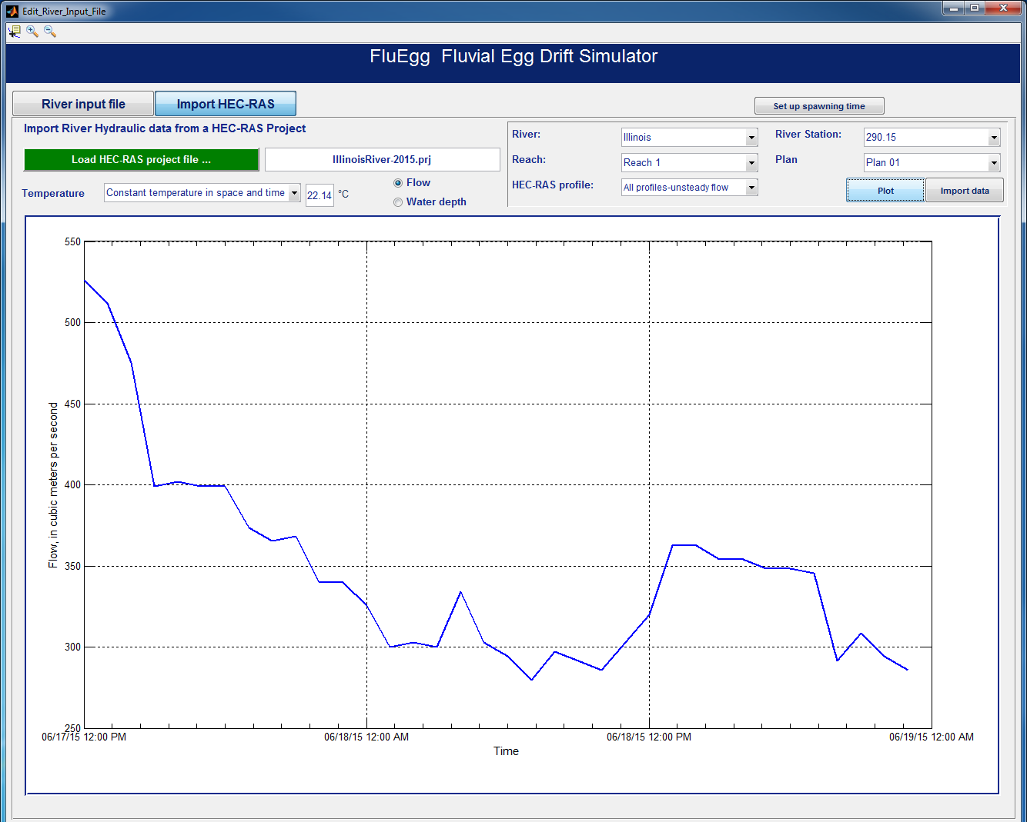

Figure 1E. Schematic showing information needed for setting up a spawning event.

1. Having the profile and cross section selected, click the “Set up spawning time” tab (red circle in fig 1E). A cursor will show and we can select the estimated spawning time on the hydrograph. The example shown in fig 1F illustrates that 10:14 AM, June 18, 2015, is selected. Once the spawning time is selected, click “continue” (red circle in fig 1F).

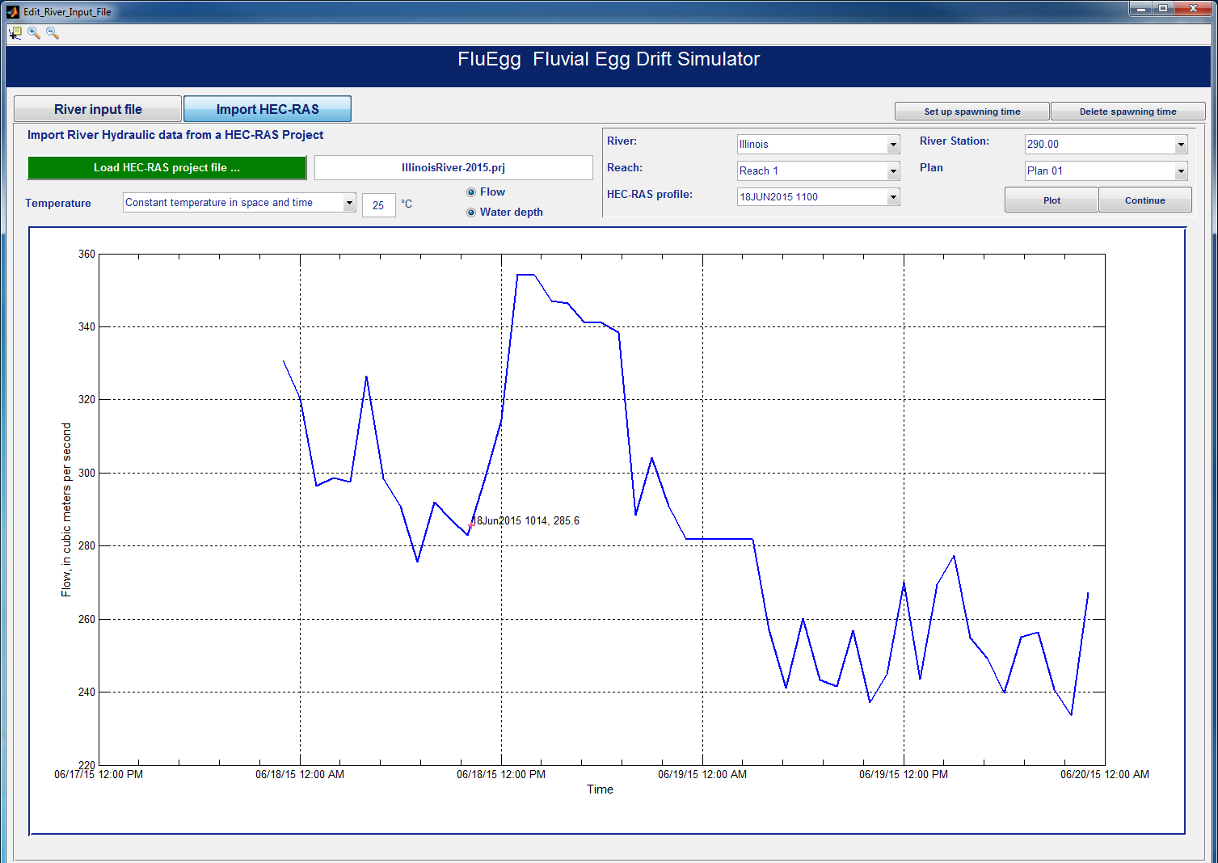

Figure 1F. Schematic showing how to specify spawning time in the selected hydrograph.

1. Return to the “FluEgg Fluvial Drift Simulator” window. Users can notice that boxes under the “River geometry summary” and Simulation setup” boxes are filled. Next we will specify input to boxed under the “Spawning event” and “Egg characteristics” windows.

The “Spawning Location (m)” window comprises inputs for specifying the number of eggs to be released and the coordinates of the spawning site. If the spawning location is known, users can test if the results will vary by the number of eggs released from the spawning site. However; if the spawning site is unknown, scenario analysis generally is used and different location tests are tested to assess the assumptions. The “Number of eggs” stipulates the number of eggs to be released from the spawning location, “50” is a reasonable number to start with; numbers as large as 10,000 has been tested but such number increased the computational time appreciably. For the coordinates, Xi is the longitudinal coordinate of the spawning site in the river system. The Xi is estimated from the egg sampling location plus a distance approximated by the travel distance of the egg after spawning (i.e., an estimated flow velocity * hours after fertilization). For analyses that aim for estimating the spawning site, use conservative estimates to initiate the test. However, users don’t have to specify the Yi (the lateral distance from the centerline of the river) and Zi (vertical depth from the bottom at the spawning site). The Yi and Zi will be updated by FluEgg based on the river input data.

“Egg characteristics” window specifies the species of carp analyzed.

Check the “Starting Date”, “Simulation time”, and “Ending Date” information in the “Simulation Setup” window. The starting time should reflect the spawning time we selected in Step E above, and the ending time reflects the length of the simulation requested. Users can alter the “Simulation time (hour)” however. For example, use the time after fertilization to shorten the run time, modify the starting time, etc.

Fig 1G shows that the name of the run file as ILR002run01, i.e., Illinois River model, geometry version 002, and FluEgg run 01; 50 eggs will be released from the estimated spawning site at river distance 11000 meter (m), which is approximately 5395 m upstream from the site where the egg was collected, and that FluEgg extracted Yi and Zi values were used. This analysis is for Silver carp.

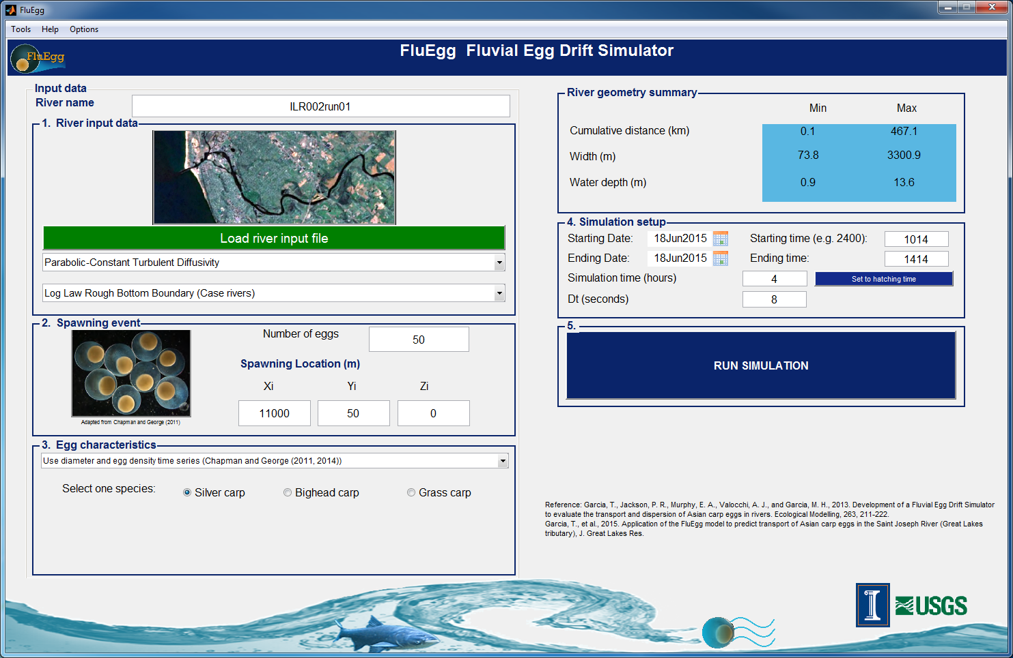

Figure 1G. Schematic showing FluEgg home window with completed input data.

1. After confirming all information is acceptable, click the “Run Simulation” bar. The “Analyze Results” and “New Simulation” bars appear after a successful run.

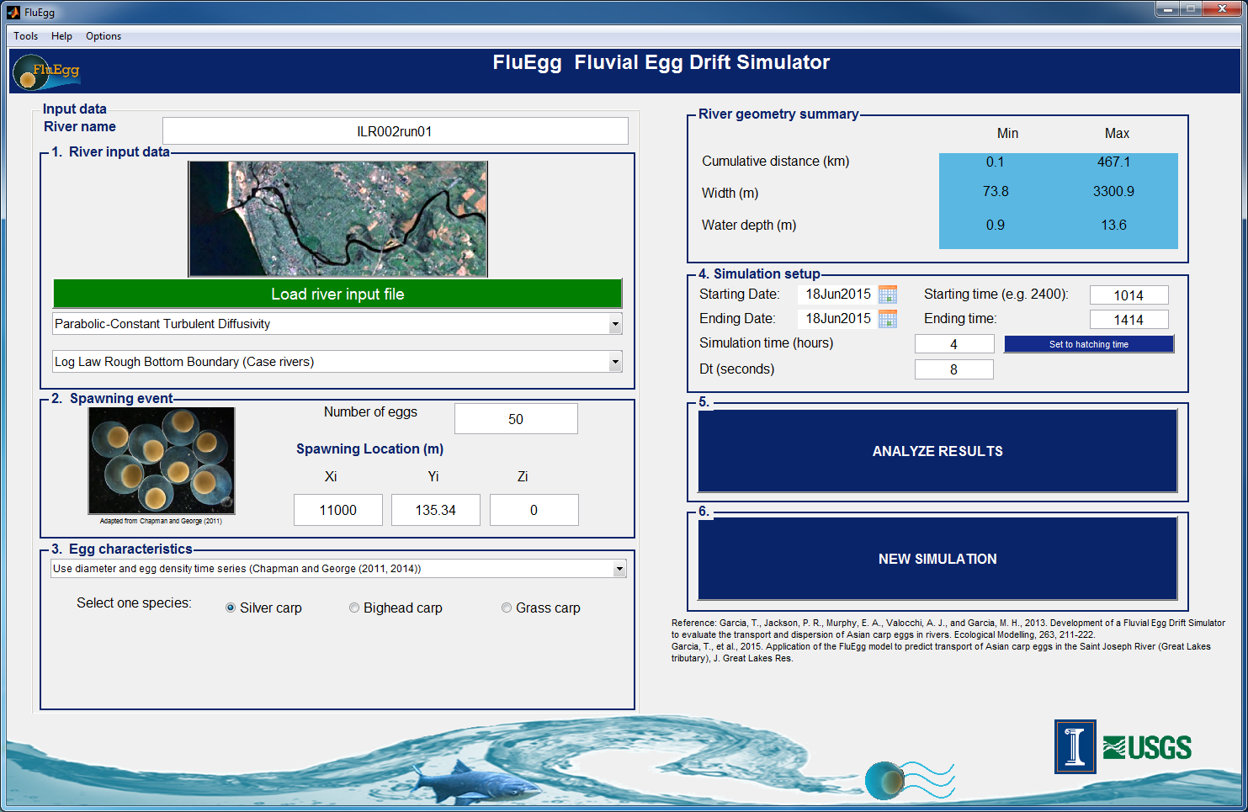

Figure 1H. Schematic showing the FluEgg home window with a successful simulation.

Analyzing Results

1. By clicking on the “Analyze Results” bar a “Result” window will appear (fig 2A). Next click on the “Browse” bar to navigate to the FluEgg output file (a file with a .mat extension). After selecting the FluEgg output file, specify the type of plots to examine. Fig 2A shows that we have selected plot Egg and their distribution in the longitudinal direction. Click the “Generate plot or video” bar.

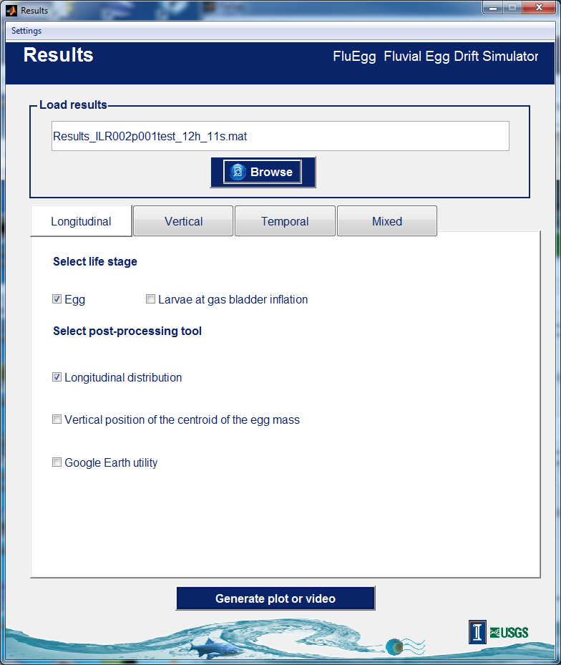

Figure 2A. An illustration of “Results” window.

1. The following window appears. Verify the information, uncheck the “Calculate eggs at risk of hatching” box (to be developed), and click “Continue”.

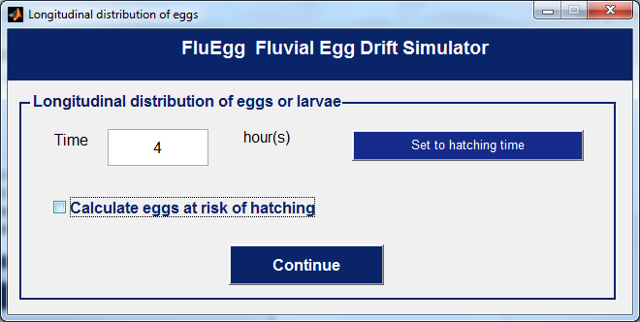

Figure 2B.

1. A plot showing the distribution of the 50 eggs at a downstream location 4 hours from the spawning time, as illustrated in fig. 2C, appears. River hydraulic data are used by FluEgg in the computation. The results include the mean distance downstream from the spawning site, leading and tailing edges of the plum.

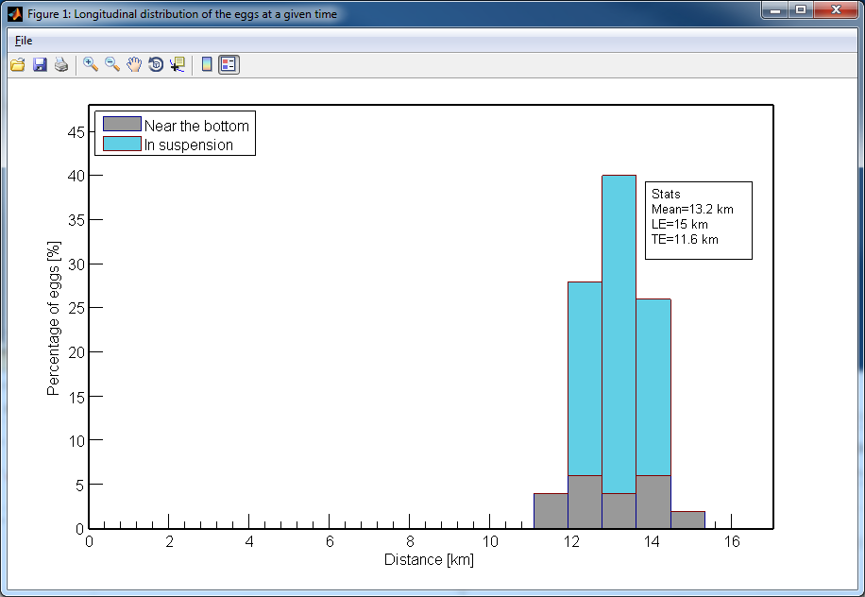

Figure 2C.

1. A new feature recently implemented into the FluEgg program is useful in back-casting the spawning site. See manuscript *** for the methodology. Users activate this option by selecting the “Mixed” box fig 2A. In plot options, select the “Calculate the percentage of eggs at a given location, depth, and time” (as fig. 2D). Click the “Generate plot or video” bar, and another window (for obtaining results) is showing in fig. 2E.

Explanation for using functions in fig. 2E. For the given spawning event, the FluEgg simulates the location of egg plume for the simulation time specified. The result we are seeking is if the egg plume convers the sampling location and at what chances. To get that information, we specify the distance from spawning location to sampling location, egg age as reported, and sampling depth and sampling time according to the field setup. After the information has been specified, click the “calculate the percentage of eggs”, this will the chance that eggs be caught by the net within the sampling time at the give sampling location.

1. Each spawning location run is a test of the chance that the plume will intersect with the sampling site and at what chances. Multiple estimates will be executed to generate a probabilistic distribution that we can assess the maximum likely hood of the

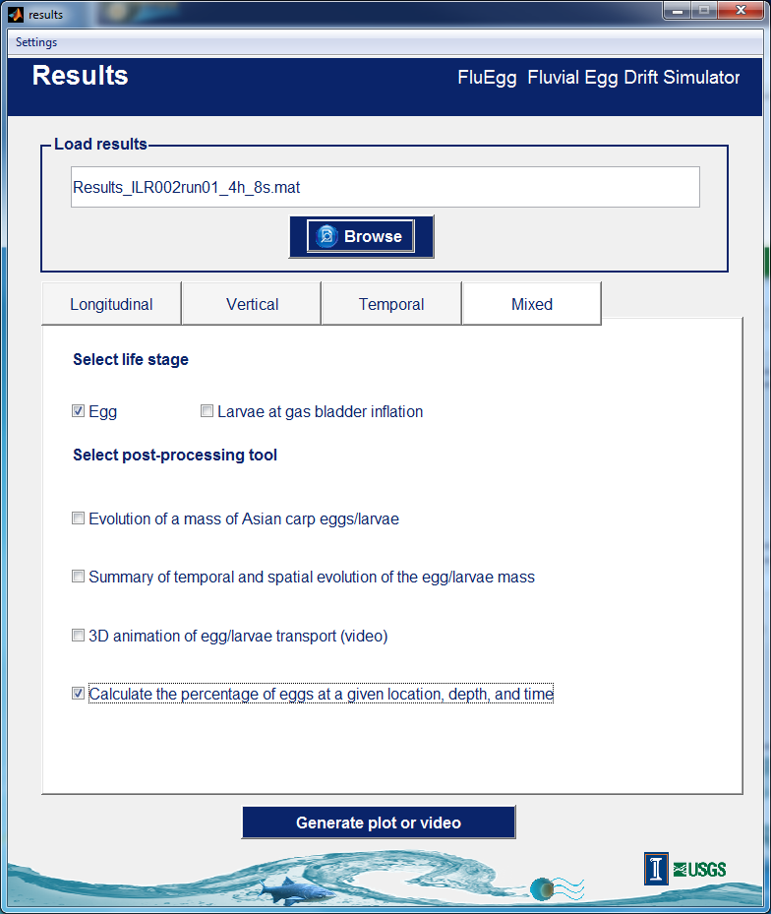

Figure 2D.

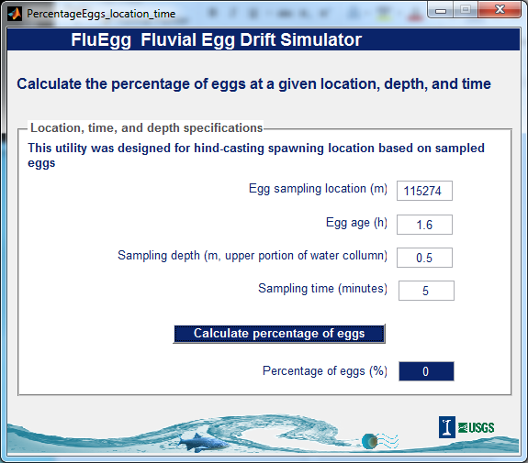

Figure 2F.

spawning location. This is done by varying the Xi value while keeping other parameters intact. For a run with the same river input data, click the “Load the River Input File” bar on the home window (fig 1H), then close the “River input file loading” window (fig. 1C).

Loading a New Case

It is likely in FluEgg analysis that we have to test for another Xi with the same river input and water temperature, or with the same river input with a different water temperature, or start with a new river input file. The how-to is explained as follows.

1. Re-run FluEgg to test a new Xi but with the same river input and water temperature:
2. Move back to the FluEgg home window (fig. 1H),
3. Modify the “Input data river Name” to reflect the case under study
4. Specify the new Xi in “Spawning Location (m),
5. Click “Load river input file” bar (fig 1H), and the “Input Loading” window will appear,
6. Close the “Input Loading” window—this refreshes the input data,
7. Proceed to the new simulation.
8. Run FluEgg with the same river input but a different water temperature:
9. Repeat A-1 to A-4 as above,
10. Modify the water temperature in the “Input Loading” window,
11. Close the “Input Loading” window—this refreshes and updates the input data (We can check if the temperature has been adjusted by pull down “Tools” tab in the FluEgg home window, then click “estimated hatching time”),
12. Proceed to the new simulation.
13. Start a new FluEgg run:

#### Google Earth utility

FluEgg provides a utility that generates results in a KML file for viewing in Google Earth.

##### Open the Google Earth post-processing tool.

Click the Google Earth utility feature under “Select post-processing tool”. Click the “Generate plot or video button at the bottom of the results window. The “google_earth” window will appear.

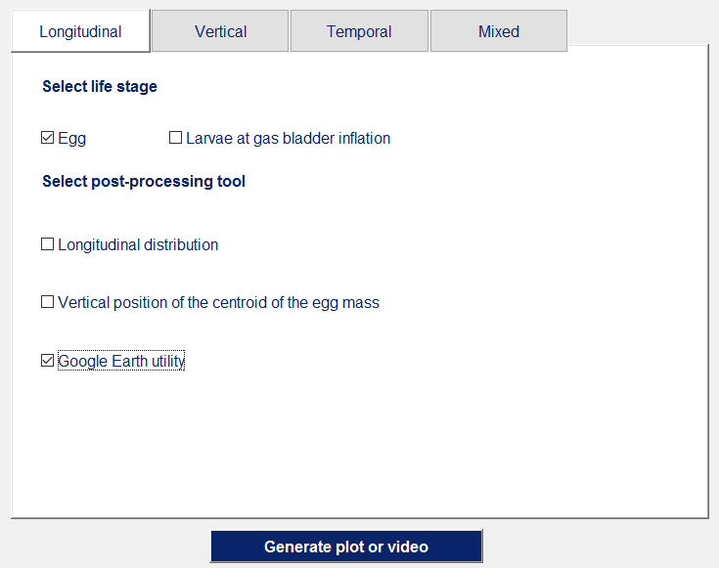

##### Load the centerline KML file.

Within the “google_earth” window, click the “Load river centerline (.kml) …” button. You will be prompted for a KML file to open.

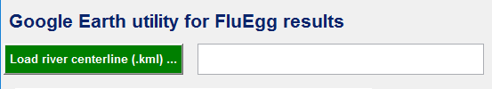

Navigate to the file named Illinois River FluEgg centerline.kml. Click the “Open” button within the dialog window.

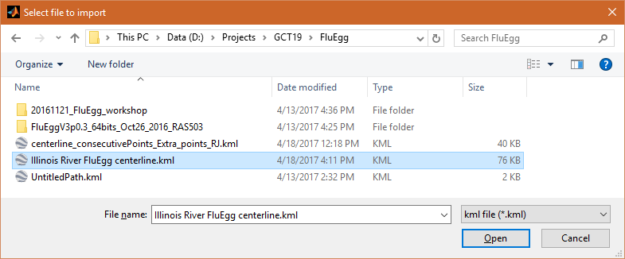

After you open the KML file that contains the Illinois River centerline, the name of the KML file will appear in the field to the right of the “Load river centerline (.kml) …” button.

The next figure shows the state of the google_earth dialog after the KML file has been loaded.

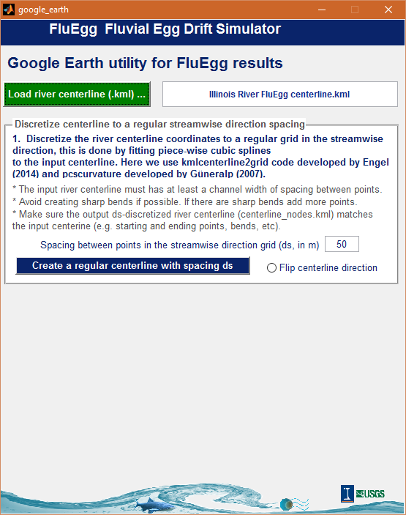

##### Create a regularly spaced centerline.

FluEgg creates a regularly-spaced gridded centerline that serves as the basis of simulation results display. Type 200 in the field requesting the spacing distance to indicate that you want a grid spacing of 200 meters.

Click the “Flip centerline direction option at the bottom right of the centerline creation box. See the figure below.

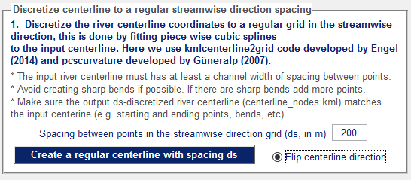

Click the “Create a regular centerline with spacing ds button. A dialog named Cubic spline interpolation of centerline will appear. Use the default values for the window size for smoothing and the polynomial degree. Click the “OK” button within the dialog window.

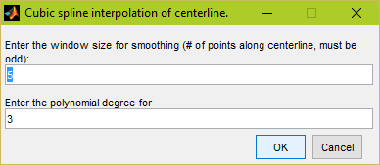

FluEgg will create the centerline. For the Illinois River model, this will take some time.

##### Export the results.

In the Export FluEgg results to Google Earth box, choose the export type. As shown below, the choices are “Egg location at hatching time” and “Longitudinal distribution of eggs at hatching time.”

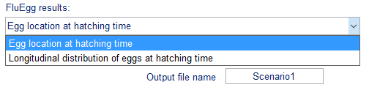

Type the length of the river centerline, which is 467,275 meters, in the field indicated.

Choose a name of the output file. If you’re only looking at one scenario, the default value of Scenario1 is fine.

The figure below shows the state of the google_earth dialog, with “Longitudinal distribution of eggs at hatching time” selected, just before generation of the creation of the results KML. You can double check your values before proceeding.

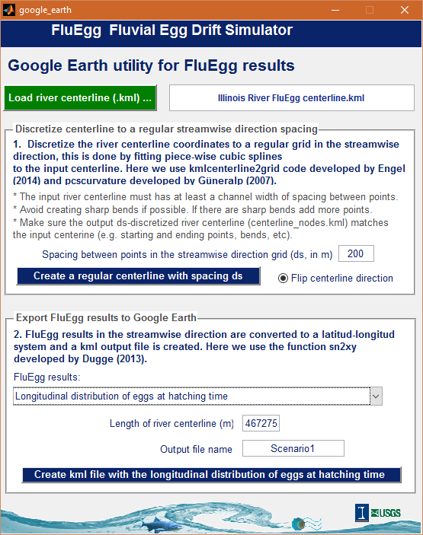

Click on the “Create kml file with the longitudinal distribution of eggs at hatching time” button.

If you selected “Longitudinal distribution of eggs at hatching time” for the results, a dialog will appear that prompts you for a bin size and scale factor. Enter 200 meters for bin size, and change the scale to 10,000. Depending on the distribution of eggs, these parameters can be adjusted for better viewing of the results in Google Earth.

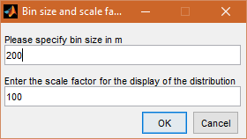

After the required steps to generate a KML file containing the results, a dialog window notifying you that a KML file has been created will appear.

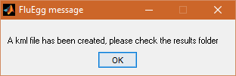

Click “OK” and check the results folder. The KML file containing the results will have the name of the scenario and “at hatching” or “distribution at hatching time,” depending on whether you selected “Egg location at hatching time” or “Longitudinal distribution of eggs at hatching time,” respectively.

In the example below, the KML file containing the longitudinal distribution results is selected.

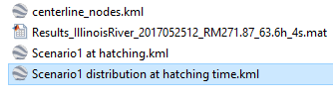

# View KML results in Google Earth

## Open Google Earth

Open Google Earth by either double clicking on the icon on your desktop (if it’s present) or accessing the Window Start menu.

## Open the KML file.

Open the file using the Open… option in the File drop-down menu.

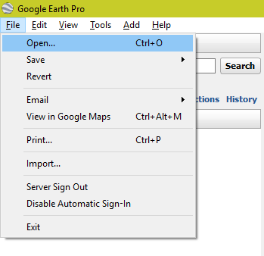

An open-file dialog window will appear prompting you for the location of a file to open. Navigate to the KML file and click the Open button within the dialog window.

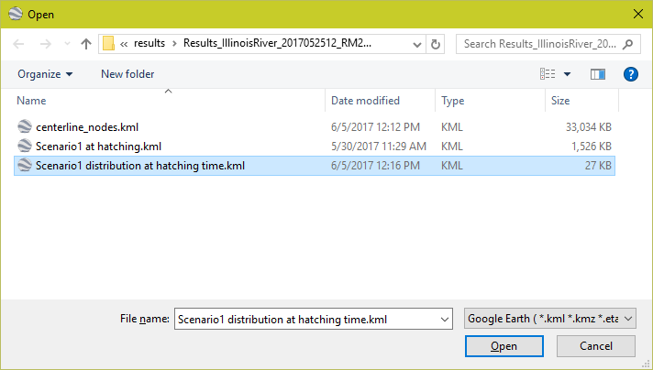

## View the results.

Google Earth will automatically center the perspective on the opened KML file.

The spawning location is indicated by the icon in the following image in both options.

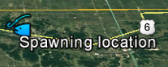

### Egg location at hatching time

The following figure shows an example of the KML file containing the egg location at hatching time results. By expanding the entry in the Places section of the sidebar, you can choose to display the position of eggs that are in suspension, the eggs that are near the bed, and the spawning location. The figure below shows the position of eggs near the bed.

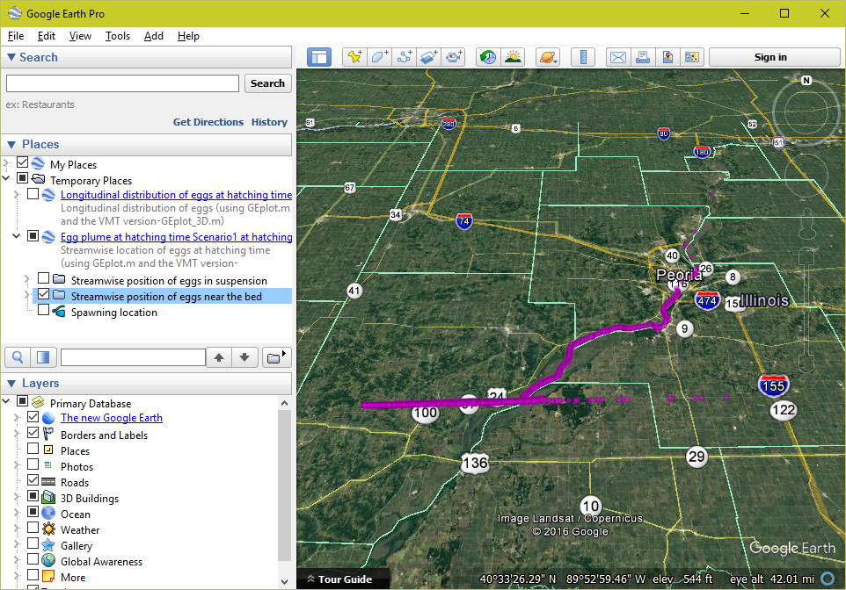

### Longitudinal distribution of eggs in suspension

The following figure shows an example of the KML file containing the longitudinal distribution of eggs at hatching time results. By expanding the entry in the Places section of the sidebar, you can choose to display the distribution of eggs that are in suspension, the distribution of eggs that are near the bottom, and the spawning location. The figure below shows the distribution of eggs near the bottom.