Lab7实验报告

57118112 王怡乐

1. **破解单表代换密码**

密文字母频率分布如下

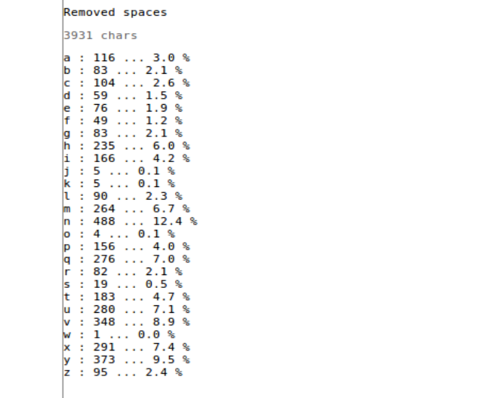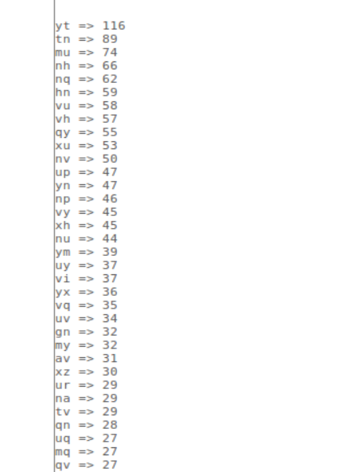 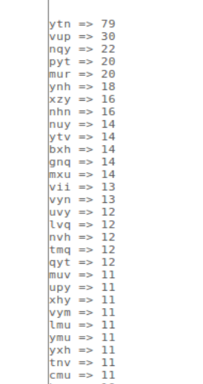

分析过程如下：

n->e，y->t，v->a，yt->th，ytn->the，vup->and

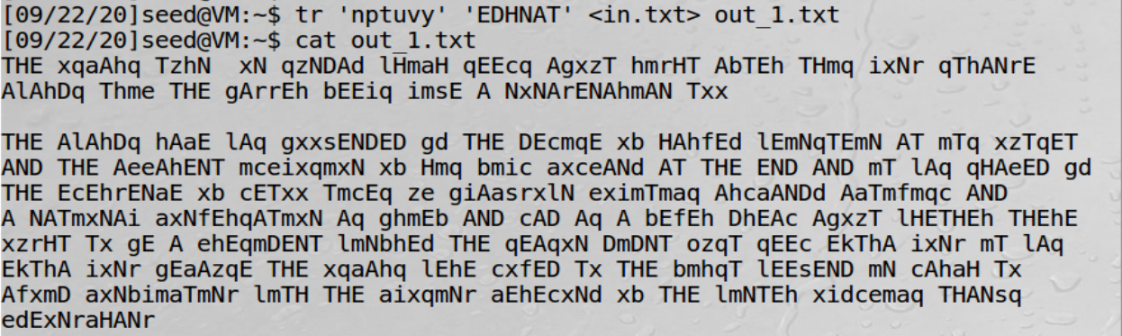

m->i，q->s

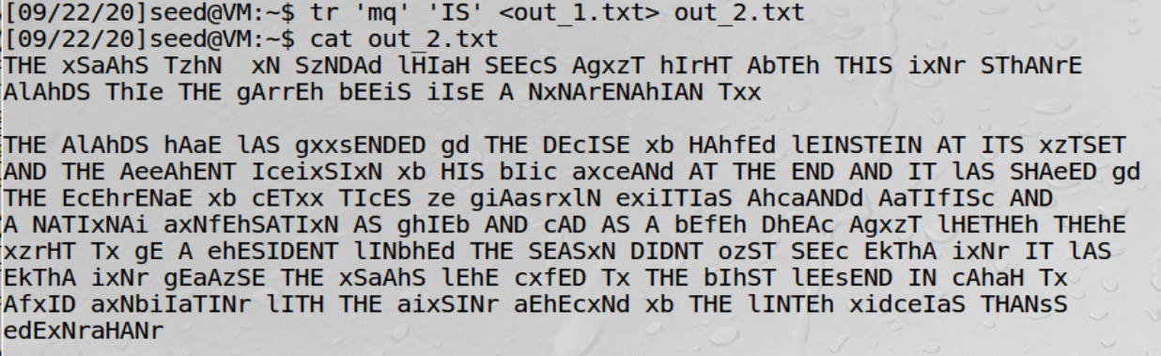

h->r，e->p，k->x，c->m，f->v，g->b，x->o

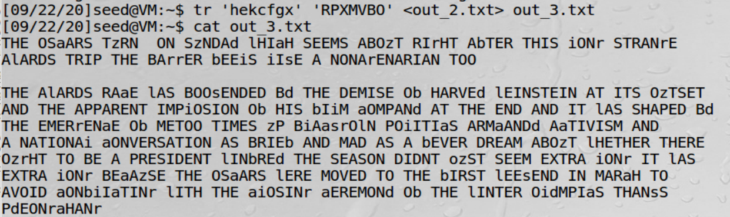

i->l，z->u，a->c

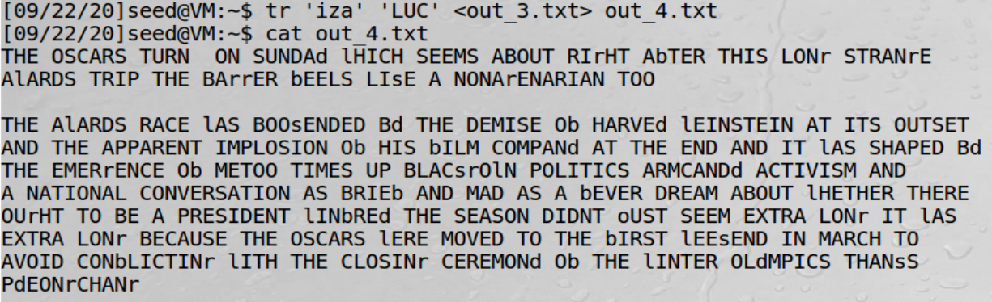

r->g，s->k，d->y，b->f，l->w，j->q

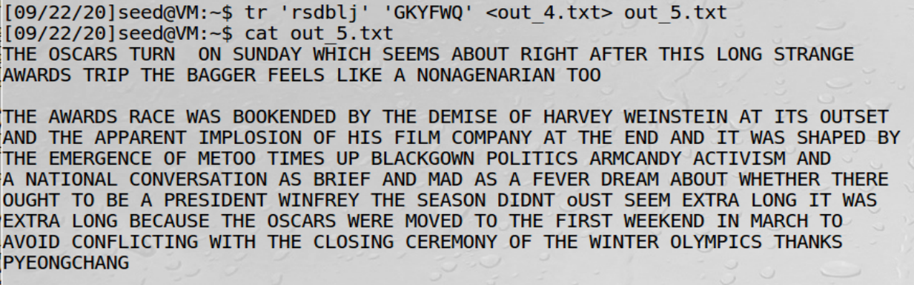

o->j，w->z



由此得到字母对应表

|  |  |  |  |  |  |  |  |  |  |
| --- | --- | --- | --- | --- | --- | --- | --- | --- | --- |
| a | b | c | d | e | f | g | h | i | j |
| c | f | m | y | p | v | b | r | l | q |

|  |  |  |  |  |  |  |  |  |  |
| --- | --- | --- | --- | --- | --- | --- | --- | --- | --- |
| k | l | m | n | o | p | q | r | s | t |
| x | w | i | e | j | d | s | g | k | h |

|  |  |  |  |  |  |
| --- | --- | --- | --- | --- | --- |
| u | v | w | x | y | z |
| n | a | z | o | t | u |

破译得到的密文如下：

THE OSCARS TURN ON SUNDAY WHICH SEEMS ABOUT RIGHT AFTER THIS LONG STRANGE

AWARDS TRIP THE BAGGER FEELS LIKE A NONAGENARIAN TOO

THE AWARDS RACE WAS BOOKENDED BY THE DEMISE OF HARVEY WEINSTEIN AT ITS OUTSET

AND THE APPARENT IMPLOSION OF HIS FILM COMPANY AT THE END AND IT WAS SHAPED BY

THE EMERGENCE OF METOO TIMES UP BLACKGOWN POLITICS ARMCANDY ACTIVISM AND

A NATIONAL CONVERSATION AS BRIEF AND MAD AS A FEVER DREAM ABOUT WHETHER THERE

OUGHT TO BE A PRESIDENT WINFREY THE SEASON DIDNT JUST SEEM EXTRA LONG IT WAS

EXTRA LONG BECAUSE THE OSCARS WERE MOVED TO THE FIRST WEEKEND IN MARCH TO

AVOID CONFLICTING WITH THE CLOSING CEREMONY OF THE WINTER OLYMPICS THANKS

PYEONGCHANG

ONE BIG QUESTION SURROUNDING THIS YEARS ACADEMY AWARDS IS HOW OR IF THE

CEREMONY WILL ADDRESS METOO ESPECIALLY AFTER THE GOLDEN GLOBES WHICH BECAME

A JUBILANT COMINGOUT PARTY FOR TIMES UP THE MOVEMENT SPEARHEADED BY

POWERFUL HOLLYWOOD WOMEN WHO HELPED RAISE MILLIONS OF DOLLARS TO FIGHT SEXUAL

HARASSMENT AROUND THE COUNTRY

SIGNALING THEIR SUPPORT GOLDEN GLOBES ATTENDEES SWATHED THEMSELVES IN BLACK

SPORTED LAPEL PINS AND SOUNDED OFF ABOUT SEXIST POWER IMBALANCES FROM THE RED

CARPET AND THE STAGE ON THE AIR E WAS CALLED OUT ABOUT PAY INEQUITY AFTER

ITS FORMER ANCHOR CATT SADLER QUIT ONCE SHE LEARNED THAT SHE WAS MAKING FAR

LESS THAN A MALE COHOST AND DURING THE CEREMONY NATALIE PORTMAN TOOK A BLUNT

AND SATISFYING DIG AT THE ALLMALE ROSTER OF NOMINATED DIRECTORS HOW COULD

THAT BE TOPPED

AS IT TURNS OUT AT LEAST IN TERMS OF THE OSCARS IT PROBABLY WONT BE

WOMEN INVOLVED IN TIMES UP SAID THAT ALTHOUGH THE GLOBES SIGNIFIED THE

INITIATIVES LAUNCH THEY NEVER INTENDED IT TO BE JUST AN AWARDS SEASON

CAMPAIGN OR ONE THAT BECAME ASSOCIATED ONLY WITH REDCARPET ACTIONS INSTEAD

A SPOKESWOMAN SAID THE GROUP IS WORKING BEHIND CLOSED DOORS AND HAS SINCE

AMASSED MILLION FOR ITS LEGAL DEFENSE FUND WHICH AFTER THE GLOBES WAS

FLOODED WITH THOUSANDS OF DONATIONS OF OR LESS FROM PEOPLE IN SOME

COUNTRIES

NO CALL TO WEAR BLACK GOWNS WENT OUT IN ADVANCE OF THE OSCARS THOUGH THE

MOVEMENT WILL ALMOST CERTAINLY BE REFERENCED BEFORE AND DURING THE CEREMONY

ESPECIALLY SINCE VOCAL METOO SUPPORTERS LIKE ASHLEY JUDD LAURA DERN AND

NICOLE KIDMAN ARE SCHEDULED PRESENTERS

ANOTHER FEATURE OF THIS SEASON NO ONE REALLY KNOWS WHO IS GOING TO WIN BEST

PICTURE ARGUABLY THIS HAPPENS A LOT OF THE TIME INARGUABLY THE NAILBITER

NARRATIVE ONLY SERVES THE AWARDS HYPE MACHINE BUT OFTEN THE PEOPLE FORECASTING

THE RACE SOCALLED OSCAROLOGISTS CAN MAKE ONLY EDUCATED GUESSES

THE WAY THE ACADEMY TABULATES THE BIG WINNER DOESNT HELP IN EVERY OTHER

CATEGORY THE NOMINEE WITH THE MOST VOTES WINS BUT IN THE BEST PICTURE

CATEGORY VOTERS ARE ASKED TO LIST THEIR TOP MOVIES IN PREFERENTIAL ORDER IF A

MOVIE GETS MORE THAN PERCENT OF THE FIRSTPLACE VOTES IT WINS WHEN NO

MOVIE MANAGES THAT THE ONE WITH THE FEWEST FIRSTPLACE VOTES IS ELIMINATED AND

ITS VOTES ARE REDISTRIBUTED TO THE MOVIES THAT GARNERED THE ELIMINATED BALLOTS

SECONDPLACE VOTES AND THIS CONTINUES UNTIL A WINNER EMERGES

IT IS ALL TERRIBLY CONFUSING BUT APPARENTLY THE CONSENSUS FAVORITE COMES OUT

AHEAD IN THE END THIS MEANS THAT ENDOFSEASON AWARDS CHATTER INVARIABLY

INVOLVES TORTURED SPECULATION ABOUT WHICH FILM WOULD MOST LIKELY BE VOTERS

SECOND OR THIRD FAVORITE AND THEN EQUALLY TORTURED CONCLUSIONS ABOUT WHICH

FILM MIGHT PREVAIL

IN IT WAS A TOSSUP BETWEEN BOYHOOD AND THE EVENTUAL WINNER BIRDMAN

IN WITH LOTS OF EXPERTS BETTING ON THE REVENANT OR THE BIG SHORT THE

PRIZE WENT TO SPOTLIGHT LAST YEAR NEARLY ALL THE FORECASTERS DECLARED LA

LA LAND THE PRESUMPTIVE WINNER AND FOR TWO AND A HALF MINUTES THEY WERE

CORRECT BEFORE AN ENVELOPE SNAFU WAS REVEALED AND THE RIGHTFUL WINNER

MOONLIGHT WAS CROWNED

THIS YEAR AWARDS WATCHERS ARE UNEQUALLY DIVIDED BETWEEN THREE BILLBOARDS

OUTSIDE EBBING MISSOURI THE FAVORITE AND THE SHAPE OF WATER WHICH IS

THE BAGGERS PREDICTION WITH A FEW FORECASTING A HAIL MARY WIN FOR GET OUT

BUT ALL OF THOSE FILMS HAVE HISTORICAL OSCARVOTING PATTERNS AGAINST THEM THE

SHAPE OF WATER HAS NOMINATIONS MORE THAN ANY OTHER FILM AND WAS ALSO

NAMED THE YEARS BEST BY THE PRODUCERS AND DIRECTORS GUILDS YET IT WAS NOT

NOMINATED FOR A SCREEN ACTORS GUILD AWARD FOR BEST ENSEMBLE AND NO FILM HAS

WON BEST PICTURE WITHOUT PREVIOUSLY LANDING AT LEAST THE ACTORS NOMINATION

SINCE BRAVEHEART IN THIS YEAR THE BEST ENSEMBLE SAG ENDED UP GOING TO

THREE BILLBOARDS WHICH IS SIGNIFICANT BECAUSE ACTORS MAKE UP THE ACADEMYS

LARGEST BRANCH THAT FILM WHILE DIVISIVE ALSO WON THE BEST DRAMA GOLDEN GLOBE

AND THE BAFTA BUT ITS FILMMAKER MARTIN MCDONAGH WAS NOT NOMINATED FOR BEST

DIRECTOR AND APART FROM ARGO MOVIES THAT LAND BEST PICTURE WITHOUT ALSO

EARNING BEST DIRECTOR NOMINATIONS ARE FEW AND FAR BETWEEN

**二、破解Vigenere密码**

采用如下程序分析密文

def findindexkey(subarr):

visiable_chars = [] # 可见字符

for x in range(32, 126):

visiable_chars.append(chr(x))

# print(vi)

test_keys = [] # 用于测试密钥

ans_keys = [] # 用于结果的返回

for x in range(0x00, 0xFF): # 枚举密钥里所有的值

test_keys.append(x)

ans_keys.append(x)

for i in test_keys: # 对于0x00~0xFF里的每一个数i和subarr里的每个值s异或

for s in subarr:

if chr(s ^ i) not in visiable_chars: # 用i解密s，如果解密后明文不是可见字符，说明i不是密钥

ans_keys.remove(i) # 去掉ans_keys里测试失败的密钥

break

# print(ans_keys)

return ans_keys

strmi = 'F96DE8C227A259C87EE1DA2AED57C93FE5DA36ED4EC87EF2C63AAE5B9A7EFFD673BE4ACF7BE8923C\

AB1ECE7AF2DA3DA44FCF7AE29235A24C963FF0DF3CA3599A70E5DA36BF1ECE77F8DC34BE129A6CF4D126BF\

5B9A7CFEDF3EB850D37CF0C63AA2509A76FF9227A55B9A6FE3D720A850D97AB1DD35ED5FCE6BF0D138A84C\

C931B1F121B44ECE70F6C032BD56C33FF9D320ED5CDF7AFF9226BE5BDE3FF7DD21ED56CF71F5C036A94D96\

3FF8D473A351CE3FE5DA3CB84DDB71F5C17FED51DC3FE8D732BF4D963FF3C727ED4AC87EF5DB27A451D47E\

FD9230BF47CA6BFEC12ABE4ADF72E29224A84CDF3FF5D720A459D47AF59232A35A9A7AE7D33FB85FCE7AF5\

923AA31EDB3FF7D33ABF52C33FF0D673A551D93FFCD33DA35BC831B1F43CBF1EDF67F0DF23A15B963FE5DA\

36ED68D378F4DC36BF5B9A7AFFD121B44ECE76FEDC73BE5DD27AFCD773BA5FC93FE5DA3CB859D26BB1C63C\

ED5CDF3FE2D730B84CDF3FF7DD21ED5ADF7CF0D636BE1EDB79E5D721ED57CE3FE6D320ED57D469F4DC27A8\

5A963FF3C727ED49DF3FFFDD24ED55D470E69E73AC50DE3FE5DA3ABE1EDF67F4C030A44DDF3FF5D73EA250\

C96BE3D327A84D963FE5DA32B91ED36BB1D132A31ED87AB1D021A255DF71B1C436BF479A7AF0C13AA14794'

arr = [] # 密文，每个元素为字符的ascii码

for x in range(0, len(strmi), 2):

arr.append(int(strmi[x:2 + x], 16))

for keylen in range(1, 14): # 枚举密钥的长度1~14

for index in range(0, keylen): # 对密钥里的第index个进行测试

subarr = arr[index::keylen] # 每隔keylen长度提取密文的内容，提取出来的内容都被密文的第index个加密

ans_keys = findindexkey(subarr) # 找出密钥中第index个的可能的值

print('keylen=', keylen, 'index=', index, 'keys=', ans_keys)

if ans_keys: # 如果密钥第index个有可能存在，尝试用密钥的index个去解密文

ch = []

for x in ans_keys:

ch.append(chr(x ^ subarr[0]))

print(ch)

# 运行到这里，观察输出可以发现，密钥长度为7时有解

print('###############')

import string

def findindexkey2(subarr): # 再造一个函数筛选密钥

test_chars = string.ascii_letters + string.digits + ',' + '.' + ' ' # 将检查的字符改为英文+数字+逗号+句号+空格

# print(test_chars)

test_keys = [] # 用于测试密钥

ans_keys = [] # 用于结果的返回

for x in range(0x00, 0xFF): # 枚举密钥里所有的值

test_keys.append(x)

ans_keys.append(x)

for i in test_keys: # 对于0x00~0xFF里的每一个数i和substr里的每个值s异或

for s in subarr:

if chr(s ^ i) not in test_chars: # 用i解密s，如果解密后不是英文、数字、逗号、句号、空格，说明i不是密钥

ans_keys.remove(i) # 去掉ans_keys里测试失败的密钥

break

# print(ans_keys)

return ans_keys

vigenerekeys = [] # 维基尼尔密码的密钥

for index in range(0, 7): # 已经知道密钥长度是7

subarr = arr[index::7]

vigenerekeys.append(findindexkey2(subarr))

print(vigenerekeys) # 输出的是[[186], [31], [145], [178], [83], [205], [62]].

print("#########")

ming = ''

for i in range(0, len(arr)):

ming = ming + chr(arr[i] ^ vigenerekeys[i % 7][0])

print(ming)

程序运行结果（部分）如下，则得到密钥和明文。

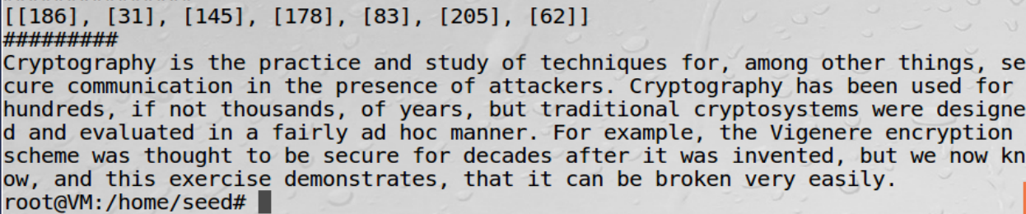

1. **破解一次一密密码**

使用如下程序分析密文

import binascii  
import argparse  
  
SPACE = ord(**' '**)  
  
  
def countalphas(char, position, ciphertexts):  
 count = 0  
 for ciphertext in ciphertexts:  
 if len(ciphertext) > position:  
 if chr(ciphertext[position] ^ char).isalpha(): count += 1  
 return count  
  
  
def main():  
 parser = argparse.ArgumentParser(description=**"Many-time Pad Cracker"**)  
 parser.add_argument(**"--filename"**, type=str,  
 help=**"Name of the file containing the ciphertexts (default: ciphertexts.txt)"**,  
 default=**"ciphertexts.txt"**)  
 args = parser.parse_args()  
 try:  
 with open(args.filename) as f:  
 ciphertexts = [binascii.unhexlify(line.rstrip()) for line in f]  
 *# Cyphertexts puliti (tolgo i vuoti), anche se non è necessario  
 # ciphertexts = [c for c in ciphertexts if c]* cleartexts = [bytearray(b'?' * len(c)) for c in ciphertexts]  
 except Exception as e:  
 print(**"Cannot crack {} --- {}"**.format(args.filename, e))  
 raise SystemExit(-1)  
  
 *# 'a'.isalpha() => true  
 # '!'.isalpha() => false  
 # ord('z') => 122* for col in range(max([len(x) for x in ciphertexts])):  
 for c1 in ciphertexts:  
 for c2 in ciphertexts:  
 if (len(c1) > col) and (len(c2) > col):  
 if chr(c1[col] ^ c2[col]).isalpha():  
 for k, c in enumerate(ciphertexts):  
 if len(c) > col:  
 if countalphas(c1[col], col, ciphertexts) >= countalphas(c2[col], col, ciphertexts):  
 cleartexts[k][col] = c1[col] ^ 0b100000 ^ c[col]  
 else:  
 cleartexts[k][col] = c2[col] ^ 0b100000 ^ c[col]  
  
 break  
  
 for line in cleartexts:  
 print(line)  
  
  
if __name__ == **"__main__"**:  
 main()

运行程序后，分析得到明文如下：

I am planning a secret mission.

He is the only person to trust.

The current plan is top secret.

When should we meet to do this?

I think they should follow him.

This is purer than that one is.

Not one cadet is better than I.

1. **实验体会**

本次实验是关于密码学的内容，主要讲了单表代换、简单的多表代换和一次一密的知识，这次实验是对上学期密码学课程的回顾，同时真正的实践也让我对这些知识有了更深的认识。实验过程中的代码编写是一个很大的挑战，查阅了很多源码资料。总之，这次实验是一个记忆很深的体验。