# Demo 1: Foundation Implementation Features

Code Repo: <https://github.com/YiliZh/quiz680>

## Table of Implemented Features

|  |  |  |  |
| --- | --- | --- | --- |
| Category | Feature | Implementation Details | Technologies Used |
| Authentication | Basic JWT | Simple token-based auth | JWT, bcrypt |
| PDF Processing | Basic upload | File upload & storage | FastAPI, PostgreSQL |
| Question Generation | Basic MCQs | Simple question templates | Python, SQLAlchemy |
| Frontend | Basic UI | Material-UI components | React, Material-UI |
| Database | Basic schema | User & content tables | PostgreSQL |
| API | Basic endpoints | CRUD operations | FastAPI |

## Detailed Feature Implementation

### 1. Project plan

### 2. Authentication & User Management

* Basic JWT authentication
* User registration and login
* Simple user profile management
* 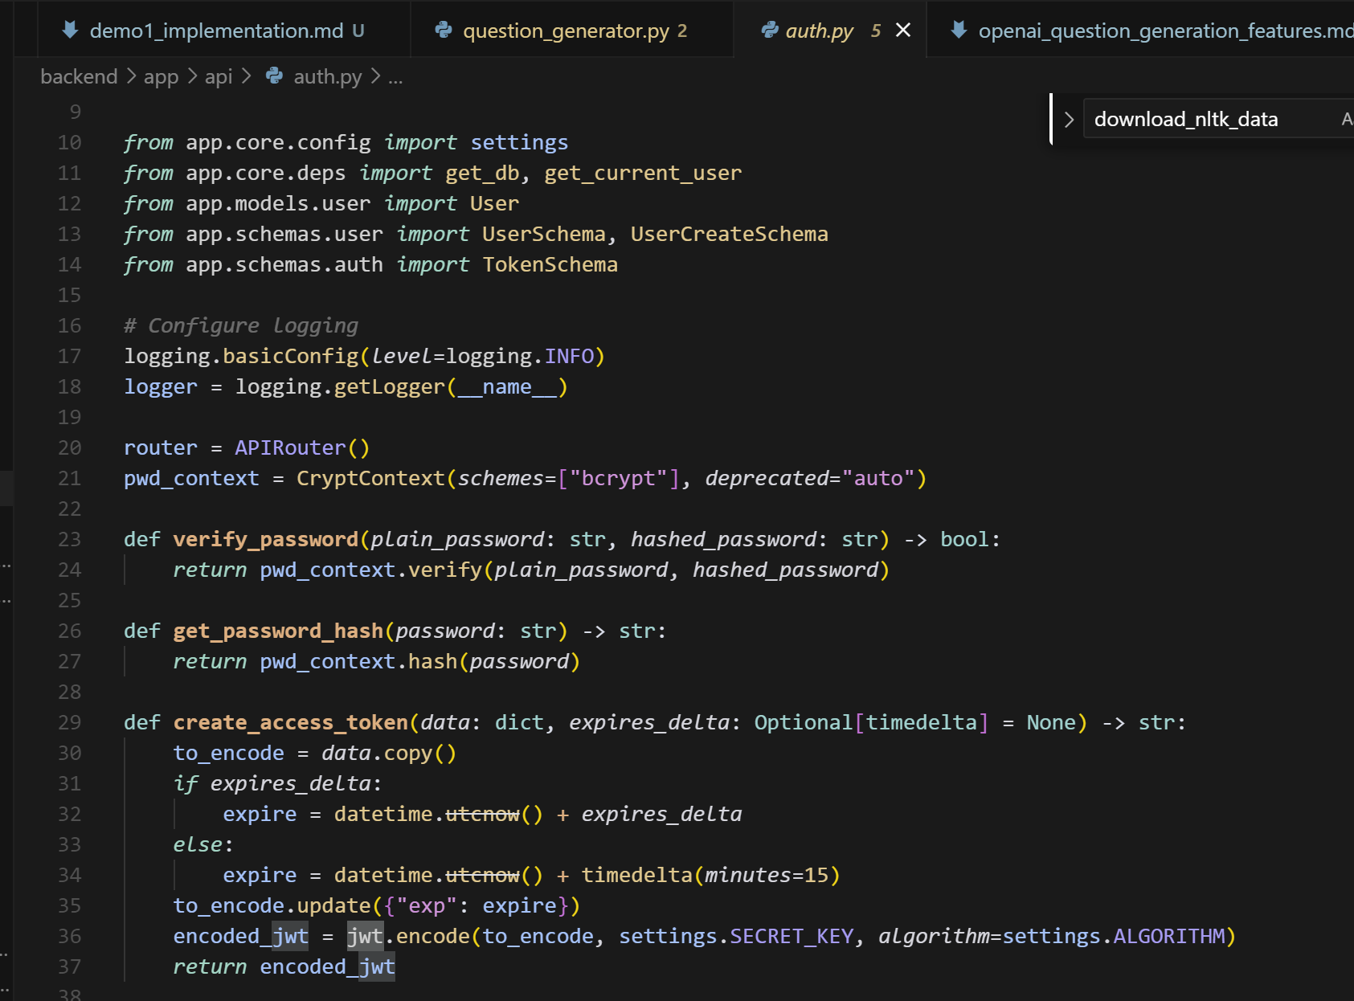

### 3. PDF Processing

* Basic PDF upload functionality
* Simple text extraction
* Basic file storage and management
* A screen shot of a computer

  AI-generated content may be incorrect.

### 4. Question Generation

* Basic multiple-choice questions
* Simple true/false questions
* Basic question templates

### 5. Frontend Implementation

* Basic React components
* Simple Material-UI integration
* Basic responsive design

### 6. Database Implementation

* Basic PostgreSQL setup
* Simple schema design
* Basic data relationships
* A screenshot of a computer

  AI-generated content may be incorrect.

### 6. API Implementation

* Basic FastAPI setup
* Simple database integration
* Basic CRUD operations

## Technical Specifications

### System Architecture

* Frontend: React 18.2.0
* Backend: FastAPI 0.104.0
* Database: PostgreSQL 15.0
* Authentication: JWT

### Development Tools

* Version Control: Git
* Package Management: npm, pip
* Development Environment: VS Code

## Screenshots:

## 

