DeKalb Chinese School

Midterm (Oct 20)

Name: Grade:

Section 1 : Listen and Find the corresponding icons first, and write the required Chinese word under the icon.

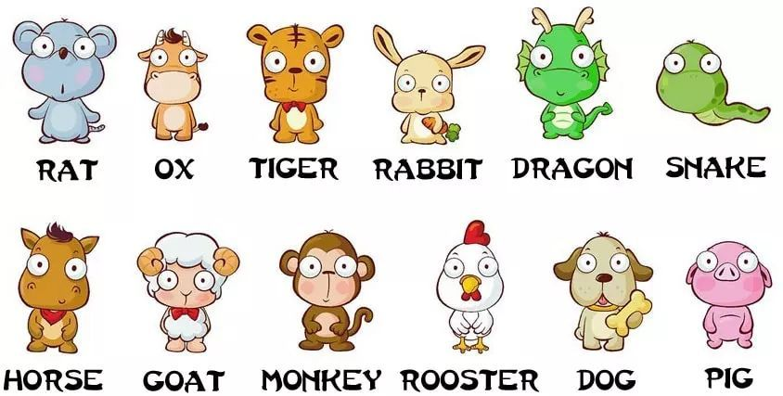    

    

Section 2 :

