Number

数字

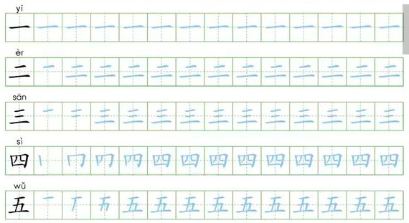

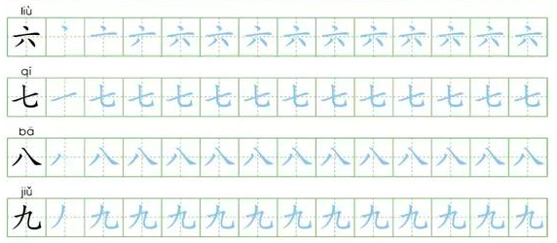

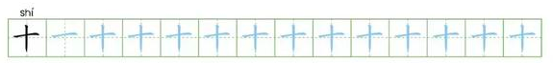

Woman女子 (daughter 女儿)

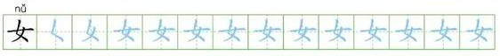

Horse

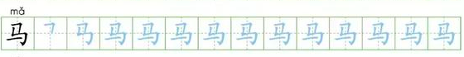

Mother

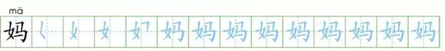

Older Sister

