**The Car Accidents in UK from 2005 to 2015**

**1 Introduction**

**1.1 Description of the Background**

Car accident, also called traffic collision or car crash, occurs when a vehicle collides with another vehicle, pedestrian, animal, road debris, or other stationary obstruction, such as a tree, pole or building. Car accident often result in injury, disability, death, and property damage as well as financial costs to both society and the individuals involved. Casualty figures from car accident attract less media attention than other, less frequent types of tragedy.

A number of factors contribute to the risk of collisions, including vehicle design, speed of operation, road design, road environment, driving skills. Method Collect the investigation data of the car accidents of UK, analyze the detail items such as the occurrence time, accident cause, rescue level and so on.

**1.2 Data Description**

To consider the problems, we can list the data as below: I found the data of UK car accidents from Website and upload to Github. I cleaned the data and set up our own data tables in most cases.

**1.3 Methodology**

As a database, I used GitHub repository in my study. My master data which has the main components 32 information.

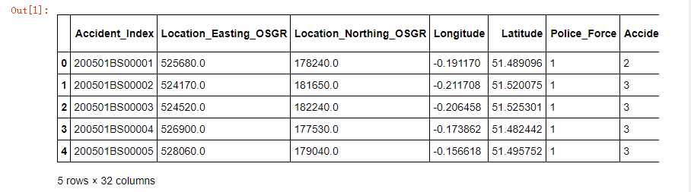

The number of rows by number of columns is

C:\Users\Yiling\AppData\Local\Temp\1602256596(1).png

Then I create a function to categorize accident severity:

|  |  |
| --- | --- |
| Accident severity = 1, | Fatal |
| Accident severity = 2 | Serious |
| Accident severity = 3 | Slight |

**Results and conclusion**

As the fig.1 showed that the lowest number of accidents was happening on December 25 (Christmas day). Also, we notice that the following days, in Christmas' holidays, have low averages. A large number of car accidents were found in the middle of every month (10th to 12th) and last two months. The 10th, 11th and 12th of each month are the worst days. A lower number of accidents is occurred in the first day of each month.

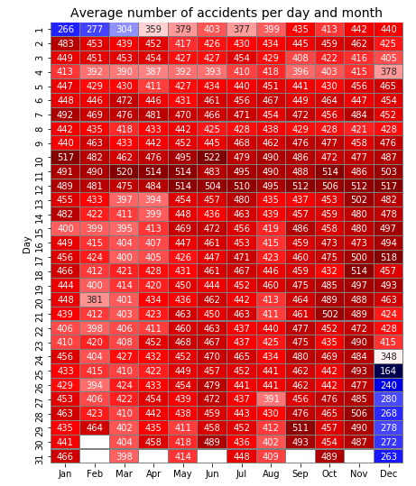

**Fig.1. Average number of accidents per day and month.**

As shown in fig. 2, we found that accidents mostly occur between 15:00 and 18:59.The hours between 20:00 and 6:59 have a lower average number of accidents.

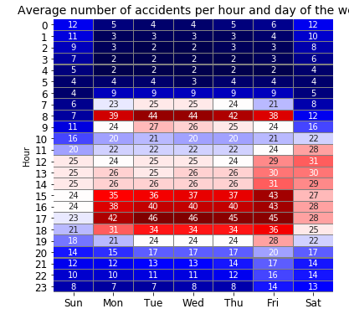

**Fig. 2. Average number of accidents per hour and day of the week.**

**Conclusion**

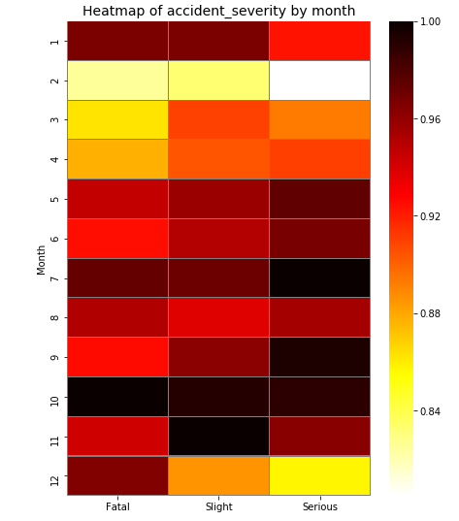

As shown in the fig. 3 that the three categories of accident are more likely to occur in October. They are less likely to occur in February.

Fig.3. Accident severity by month.

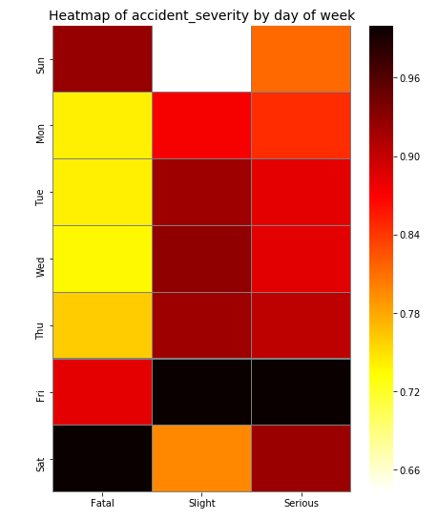

As shown in fig.4 that the fatal accidents are more likely to occur on Saturday and less likely to occur on Wednesday. Other accidents are more likely to occur on Friday and less likely to occur on Sunday.

Fig.4. Accident severity by day of week.

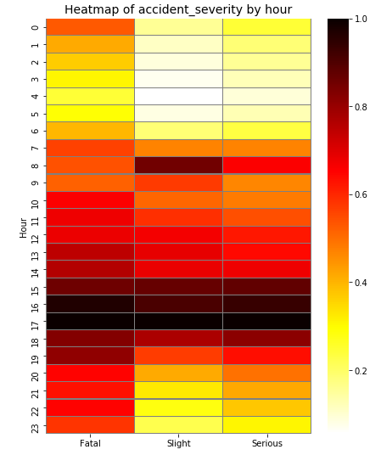

All accident categories are more likely to happen between 17:00 and 18:00. They are less likely to happen between 4:00 and 5:00 (Fig. 5).

Fig.5. Accident severity by day of hour.

We also found that the number of accidents is decreasing by year (Fig. 6) and the trend for accident categories are decreasing (Fig. 7).

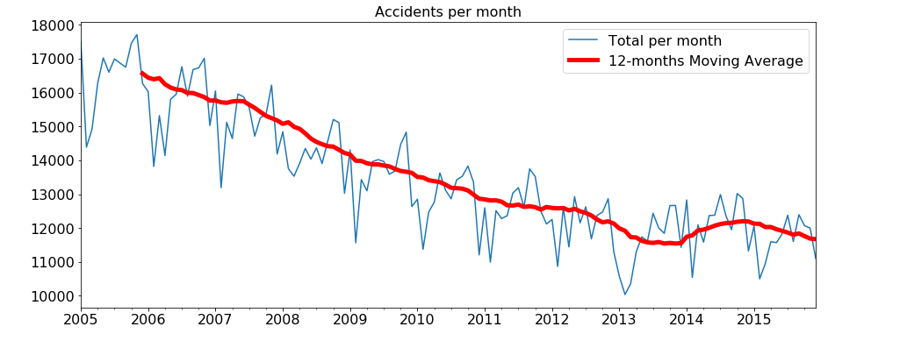

Fig.6. The trend of the number of accidents.

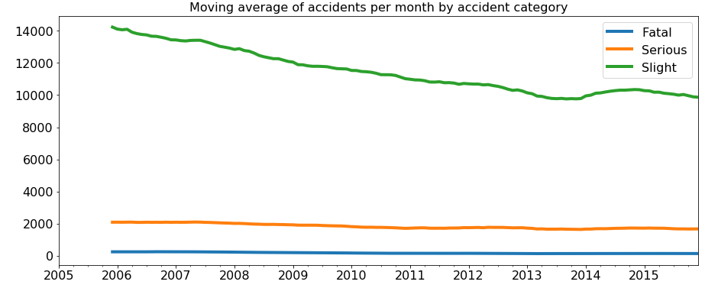

Fig.7. The trend of accident categories.