# Port Configuration

# Port 1 – 192.168.99.1/24
# Port 2 – 192.168.100.253/24
# Port 3 – 192.168.200.253/24

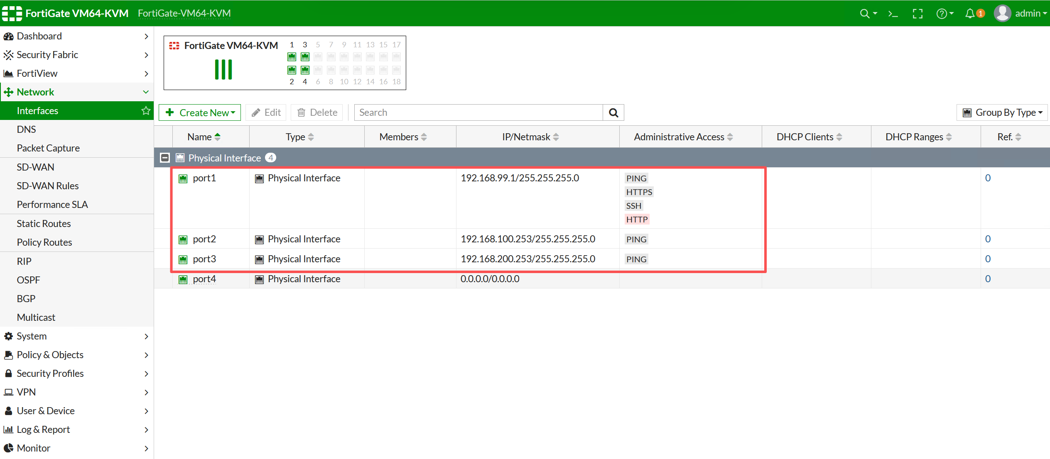

# Routing Configuration
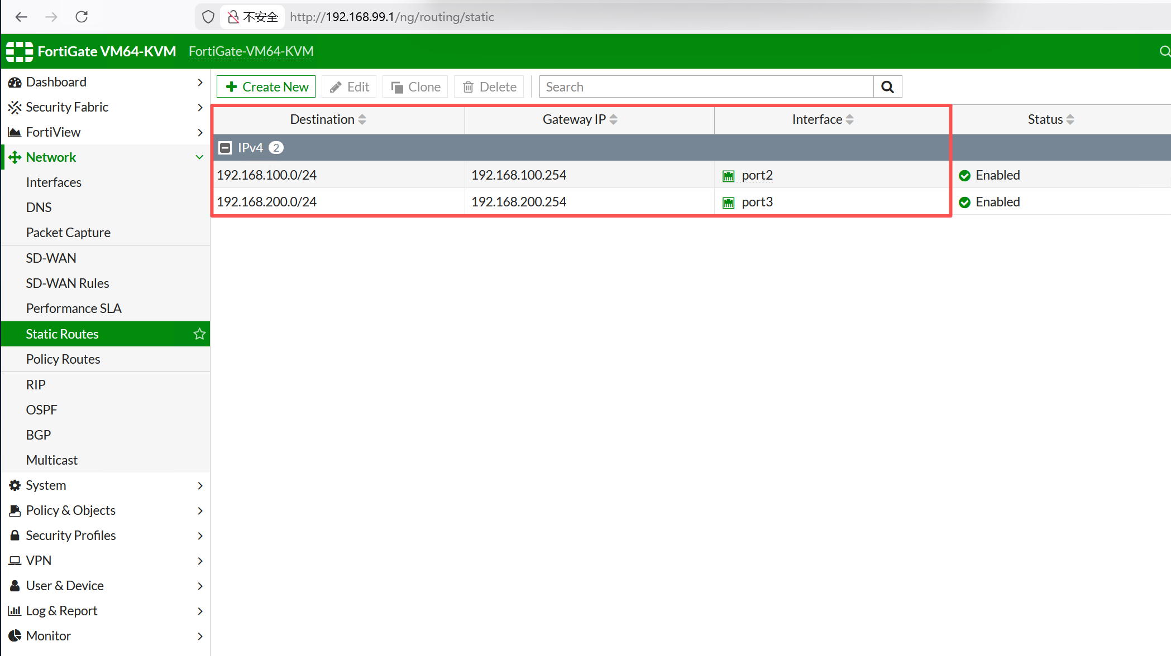

# Security Policy Configuration

# CLI Configuration
config system interface
edit port4
set mode static
set ip 10.100.210.3 255.255.255.0
set allowaccess ping https http ssh
next
end

config system interface
edit port1
unset ip
unset allowaccess
unset description
unset mode
next
end

