WIX1003/WXES1109 – COMPUTER SYSTEMS & ORGANIZATION

TUTORIAL 7

- By using a truth table, prove that the following diagram is a D type latch. Then, determine which of the input X and Y is EN (enable) and which is D.

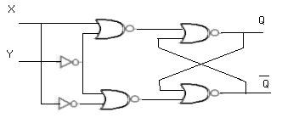

- Draw the output for the following D-type latch with control (C) input:

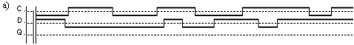

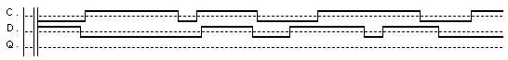
b)

- Draw the output for the following SR latch.
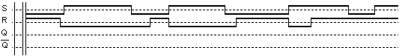
a)

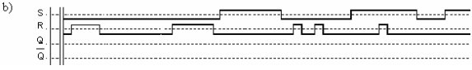

- Draw the output for the following negative edge triggered JK flip-flop.
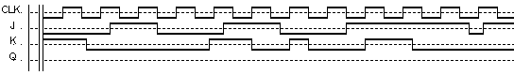
a)

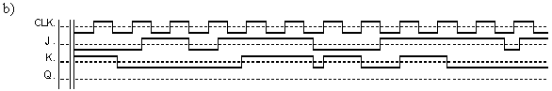

- Draw the output for the following negative edge triggered T flip-flop (assume starting value Q=1).
a)
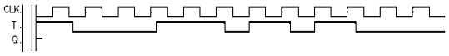

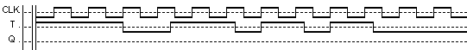
b)

- Build truth table for flip flop
- JK
- SR
- D
- T
Perform Karnaugh-map mapping to get the next state equation (i.e. Q (t+1)).

