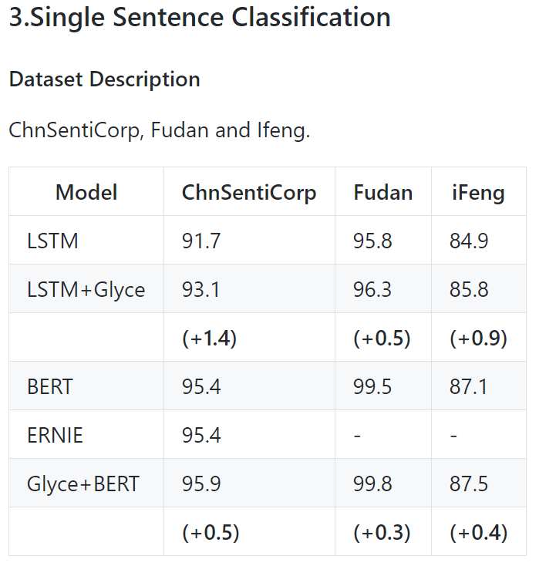

BASELINES

* LSTM
* BERT