  - 
  - Design Document
for ELORA — Initial Version

Author: Yimiao Hao
Programme: SETU — BSc Software Development (Year 4)
Supervisor: Omer Ali Date: 27/11/2025

Abstract
ELORA (Explainable Lifestyle & Obesity Risk Analytics) is a local-first system that turns routine self-reports into clear, actionable obesity-risk insight. Users record daily measures and habits; the UI visualises 7/30-day trends and computes a binary risk and score via a hybrid method: (P) from a trained classifier (NObeyesdad dataset) fused with a normalised rules score (R), We fuse the model probability P and a normalised rules score R as Risk = 0.7×P(model) + 0.3×R(rules). The results view provides a concise explanation (triggered rules/top features) and 2–3 non-medical recommendations; The UI can export a one- to two-page PDF report for personal record-keeping or optional sharing (e.g., with a coach/clinician). The report includes the risk score, brief rationale, 7/30-day trends and version info, and excludes direct identifiers. This specification defines scope, actors, functional requirements, data schema, and interfaces (CSV, optional FastAPI /predict). AUC/Macro-F1 for accuracy, time-on-task for usability, and inference/page latency for performance; these metrics define our thresholds.. Privacy is addressed through local storage, consent, export/delete, and stateless, non-persistent inference when the API is enabled; evidence is provided via screenshots, logs, and sample PDFs across four iterations.

Table of Contents
Abstract II
1.Introduction & Scope 1
1.1 Document Purpose and Scope 1
1.2 System Overview 1
2. System Architecture and Deployment 1
2.1System Architectural Overview 1
2.2Deployment Context 2
3. Technology Stack & Data Design 2
3.1Technology Stack Rationale 2
3.2 Logical Data Model 3
4. Interface Design and Principles 4
4.1 UI/UX Design Principles 4
5. Initial Test Plan & Quality Assurance 5
5.1 NFR Traceability and Test Approach 5
5.2 Test Strategy 5
6. Future Design Enhancements 5
6.1 Explainability Service Integration 5
6.2 Data Drift and Monitoring Module 6
6.3 LLM Personalization Component 6

1.Introduction & Scope

1.1 Document Purpose and Scope
This Initial Design Document serves to translate the conceptual functional requirements of the ELORA (Explainable Lifestyle & Obesity Risk Analytics) system into an implementable software architecture and component design.
(1)Purpose: To define the system's Three-Tier Architecture, rationalize the Technology Stack choices, detail the Data Model, and specify the Micro-architecture of the core components.
(2)Scope: This document covers the complete design for the Minimum Viable Product (MVP), focusing on the implementation of the core features (risk assessment, data storage, interactive trends) and adherence to critical Non-Functional Requirements (NFRs) concerning privacy and performance.

1.2 System Overview
ELORA is a Local-First application focused on user privacy, built to deliver explainable obesity risk analysis by fusing machine learning predictions with deterministic rules. The design must facilitate offline processing, rapid local inference, and easy distribution.

2. System Architecture and Deployment

2.1System Architectural Overview
ELORA is structured using a Three-Tier Architecture to ensure clean separation of concerns, high maintainability, and optimal performance for local operations. This design approach isolates the presentation logic from the data processing and machine learning kernel.
(1)Presentation Tier: Responsible for user interaction, form validation, and data visualization (Jinja2/HTML/CSS).
(2)Application Tier: Handles all application routing, business logic, risk computation, and PDF generation (FastAPI framework).
(3)Data Tier: Responsible for persistent storage of user records (SQLite).
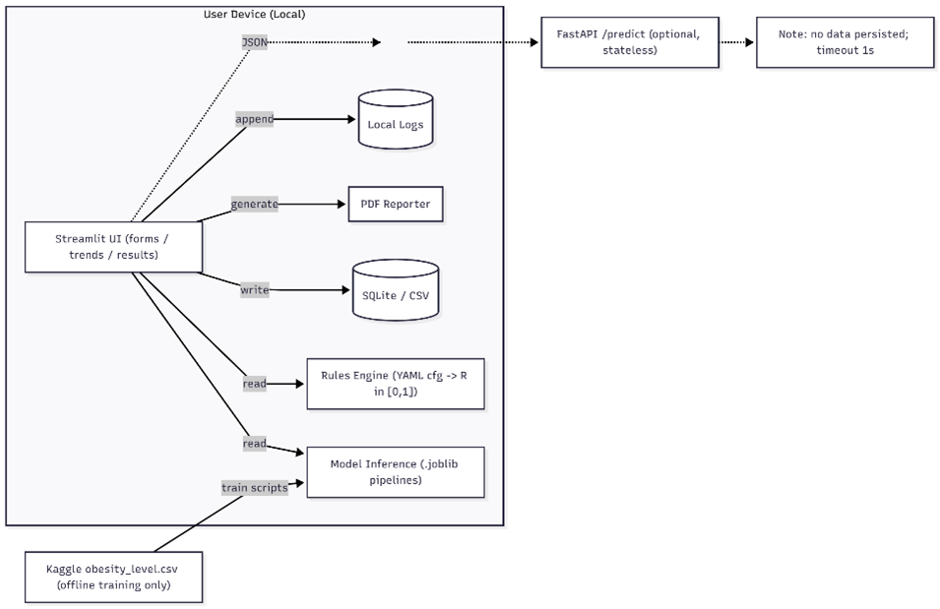
Figure 2.1: Local-First Three-Tier Architecture Diagram showing component interactions.

2.2Deployment Context
The system strictly follows the Local-First Principle (NFR-20). The entire application stack is designed to run locally on the end user's device.
(1)Inference Pipeline: The machine learning model (Random Forest) is compiled into a .joblib artifact and loaded directly by the application layer.
(2)Stateless API: The FastAPI framework provides a stateless /predict endpoint that processes inference requests without persisting data, ensuring quick response times and adherence to privacy requirements.

3. Technology Stack & Data Design

3.1Technology Stack Rationale
The following technologies were selected based on their performance, stability, and suitability for a local-first application:
Technology | Rationale and Core Benefit | Corresponding NFR
Python (Core Language) | Robust ecosystem for machine learning (Scikit-learn, joblib). | Robustness & Maintainability
FastAPI (Web Framework) | High-performance, low-latency framework chosen over heavier alternatives (Django) to meet the P50 < 200ms latency requirement. | Performance (NFR-01)
SQLite (Database) | Lightweight, file-based database that requires zero setup and aligns perfectly with the Local-First design constraint. | Privacy (NFR-20)
Joblib (ML Serialization) | Optimized for fast loading of Scikit-learn models (NumPy arrays), crucial for achieving inference times < 100ms. | Performance (NFR-02)
ECharts (Visualization) | Chosen for its ability to create interactive, dynamic dual-axis charts for trends, significantly enhancing usability over static plots. | Usability (NFR-12)
Table 3.1:Technology Stack Selection Matrix and Rationale.

3.2 Logical Data Model
The system utilizes a single primary table, Record, stored in the local SQLite database. This table captures user inputs and stores calculated risk metrics.
Field Name | Data Type | Purpose | Notes
id | Integer | Primary Key
date | Date | Record submission date | Key for trend analysis
weight_kg | Float | User reported weight | Primary model input
bmi | Float | Derived metric | Calculated as kg/m²
risk_score | Float | Hybrid Score | Result of 0.7P + 0.3R fusion
activity_level | String | Reported activity | Categorical input
created_at | DateTime | Timestamp of record | Audit trail
Table 3.2:Record Entity Data Dictionary.
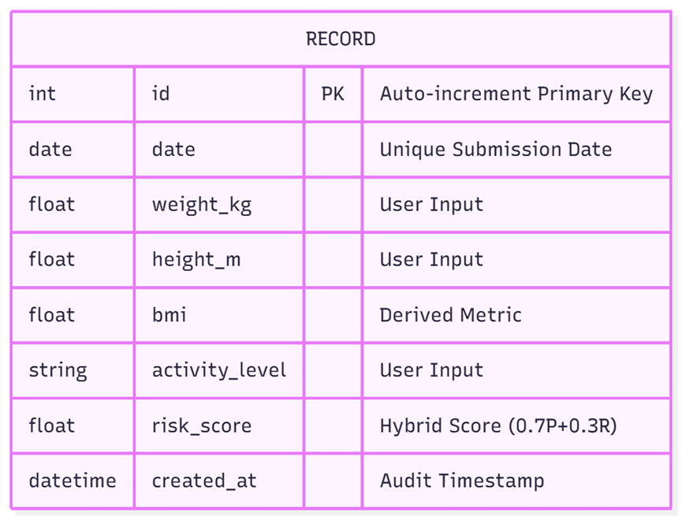
Figure 3.2: Entity Relationship Diagram (ERD) for the Local SQLite Database.

4. Interface Design and Principles

4.1 UI/UX Design Principles
The interface adheres to a minimalist, non-clinical aesthetic focused on user guidance and privacy reassurance.
(1)Clarity and Simplicity: The interface is designed to be usable by individuals with low technical proficiency (TSR ≥ 85%), adhering to the principle of "one screen, one primary action."
(2)Information Hierarchy: Risk assessment results are presented in layers: the Hybrid Score (prominent) is followed by supporting data (BMI, Model Confidence, Rationale).
(3)Privacy-Centric Design: Prominent disclaimers are placed on all assessment pages, and users are given immediate access to Export/Delete functions to maintain data control.
(4)Interactive Visualization: Utilizes ECharts to render dynamic trend lines, allowing users to zoom and hover over data points for immediate feedback, fulfilling the interactive visualization requirement.

5. Initial Test Plan & Quality Assurance

5.1 NFR Traceability and Test Approach
Metric (NFR) | Target | Test Approach
Accuracy (AUC / Macro-F1) | ≥ 0.85 | Offline Testing: Assess against the held-out test set using cross-validation.
Performance (Latency P50) | < 200ms | Performance Testing: Use a tool (e.g., Python Locust or ab) to measure inference response time on the /predict endpoint.
Usability (TSR) | ≥ 85% | Usability Testing: Observer logs Task Success Rate (TSR) for the core tasks.
Table 5.1:NFR Traceability Matrix and Test Approach.

5.2 Test Strategy
(1)Unit Testing: Focus on verifying data integrity (Pydantic validation, boundary checks) and the accuracy of the Hybrid Fusion algorithm and PDF generation logic.
(2)Integration Testing: Verify the end-to-end critical path: data submission must correctly trigger model inference and display the final score without logging errors.
(3)Reliability Testing: Implement logging for critical events (AUDIT_RECORD_CREATED, INFERENCE_ERROR) to track the system's stability (targeting error rate < 1%).

6. Future Design Enhancements

6.1 Explainability Service Integration
While the project mentions using SHAP, the current design document does not show how it integrates into the low-latency FastAPI service. Calculating SHAP values is computationally expensive and cannot be done synchronously on every prediction.
Design Enhancement | Rationale
Asynchronous SHAP Call | Design a separate, lower-priority thread within the Application Tier to calculate SHAP values only when the user navigates to the detailed Rationale View. This keeps the primary prediction path (P50 < 200ms) fast2.
Model Explainability Cache | Implement a local cache (e.g., using Redis, or a temporary SQLite table) to store the latest 10-20 SHAP plots. If the user views their assessment again, the explanation loads instantly.
Table 6.1:Design Strategy for Low-Latency SHAP Integration.

6.2 Data Drift and Monitoring Module
The model was trained on a specific dataset (NObeyesdad ) and assumes the distribution remains static. In reality, user input data will change over time, potentially leading to model degradation (concept drift).
Design Enhancement | Rationale
Input Distribution Monitor | Introduce a dedicated Monitoring module (a simple Python script run daily by the developer). This module will sample incoming user data (e.g., the distribution of weight_kg and age over the last 90 days).
Drift Alert Mechanism | Compare the current user data distribution to the original training data distribution. If the difference exceeds a statistical threshold (e.g., using the Kullback-Leibler divergence metric), the system flags an alert to the developer.
NFR Link | This directly addresses the Reliability challenge by anticipating model failure before accuracy drops severely.
Table 6.2:Data Drift Monitoring and Alerting Mechanism.

6.3 LLM Personalization Component
To enhance the UX and solve the "static recommendation" problem:
Design Enhancement | Rationale
Personalization Router | Introduce a new module: app/services/personalizer.py. This module sanitizes the key input features (Age, BMI, Activity Level, Hybrid Score) before transmitting them to the external LLM API (e.g., GPT).
Input Sanitization | This module strips any potentially identifiable information before sending the query: "Generate a 3-sentence empathetic tip for a [Hybrid Score: 65%] user with [Low Activity] and [BMI: 32.9]".
Privacy Assurance | The design ensures the LLM interaction is stateless and anonymous, preserving the core Local-First principle5.
Table 6.3:Data Drift Monitoring and Alerting Mechanism.

