  - 
  - Functional Specification
for ELORA — Final Version

Author: Yimiao Hao
Programme: SETU — BSc Software Development (Year 4)
Supervisor: Omer Ali Date: 27/11/2025

Abstract
ELORA (Explainable Lifestyle & Obesity Risk Analytics) is a local-first system that turns routine self-reports into clear, actionable obesity-risk insight. Users record daily measures and habits; the UI visualises 7/30-day trends and computes a binary risk and score via a hybrid method: (P) from a trained classifier (NObeyesdad dataset) fused with a normalised rules score (R), We fuse the model probability P and a normalised rules score R as Risk = 0.7×P(model) + 0.3×R(rules). The results view provides a concise explanation (triggered rules/top features) and 2–3 non-medical recommendations; The UI can export a one- to two-page PDF report for personal record-keeping or optional sharing (e.g., with a coach/clinician). The report includes the risk score, brief rationale, 7/30-day trends and version info, and excludes direct identifiers. This specification defines scope, actors, functional requirements, data schema, and interfaces (CSV, optional FastAPI /predict). AUC/Macro-F1 for accuracy, time-on-task for usability, and inference/page latency for performance; these metrics define our thresholds.. Privacy is addressed through local storage, consent, export/delete, and stateless, non-persistent inference when the API is enabled; evidence is provided via screenshots, logs, and sample PDFs across four iterations.

Table of Contents
Abstract II
1.Introduction & Scope 1
1.1Purpose 1
1.2Product definition & boundary 1
1.3 System Context 2
2.Actors & Context 3
2.1Actors & Roles 3
2.2Context 3
3.Functional Requirements 4
3.1Functionality Scope & Precedent 4
3.2Two “Exemplar” Functional Requirements 5
3.3The rest Functional Requirements 7
4.Data & Interfaces 8
4.1Data Fields (Inputs & Derived/Outputs) 8
4.2PDF 9
4.3API 10
4.4CSV Import/Export 10
5. Project Metrics & Non-Functional Requirements 10
5.1 Acceptance Metrics (KPIs) 10
5.2 System Constraints (NFRs) 11
6.Acceptance & Traceability 11
6.1Metrics & Measurement Methods 11

1.Introduction & Scope

1.1Purpose
This Functional Specification (FS) defines the functionality, interfaces, and data security constraints for the ELORA (Explainable Lifestyle and Obesity Risk Analytics) system within this term's Minimum Viable Product (MVP). It also establishes user-task oriented acceptance criteria, such as: AUC ≥ 0.85,MacroF1 ≥ 0.80 ,Page response < 200ms , Task success rate ≥ 85% , SUS ≥ 70 . This document serves as the unified basis for design, development, and review, guiding the implementation and acceptance of four iterations. It specifies the required evidence formats, including interface screenshots, runtime logs, PDF mock-ups, and API examples.

1.2Product definition & boundary
ELORA is an explainable obesity risk prototype system operating on a local-first principle. Centred around a complete closed-loop encompassing ‘reporting, trend analysis, prediction, explanation, recommendations, and PDF export’, it establishes the shortest pathway from data recording to actionable guidance. This MVP iteration focuses on actionable core capabilities: body composition data form submission, 7 or 30-day trend analysis, binary classification with risk score integration (Risk = 0.7×P(model) + 0.3×R(rules_normalised)), recommendation cards, and PDF report export. It also facilitates data import, export, and deletion to ensure usability and reproducibility. It must be explicitly stated that all system outputs are for lifestyle reference only and do not constitute medical diagnosis or treatment advice. To ensure scope control and delivery quality, advanced capabilities such as wearable device integration, multi-role permission control, and cloud multi-tenancy are excluded from this phase and will be addressed in subsequent iterations.
Figure 1.1：High-Level Functional Pipeline establishing the data-to-insight workflow.

1.3 System Context
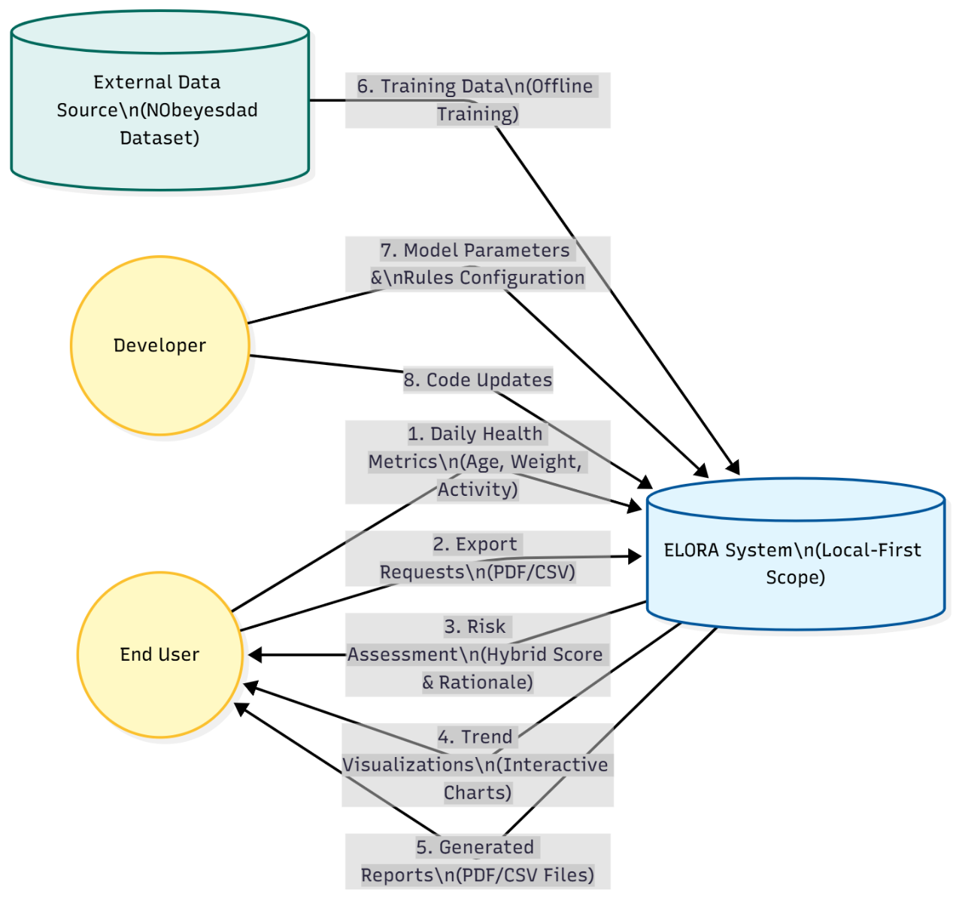
Figure 1.3：System Context Diagram of ELORA showing external entities and data boundaries.

The diagram illustrates the system boundary and its interactions with external entities.
End User: The primary actor who provides daily health inputs (FR-01) and receives actionable insights via the Risk Assessment (FR-20) and Trend Analysis modules.
Developer: Responsible for maintaining the underlying logic, including the rules.yaml configuration and model hyperparameters.
External Data Source: The Kaggle NObeyesdad dataset serves as the foundational input for the offline training pipeline (Random Forest Classifier), which is then serialized into the system.
Data Flow: All user data remains within the local boundary (Local-first), adhering to the privacy constraints defined in NFR-20.

2.Actors & Context

2.1Actors & Roles
Actor | Capabilities | Read/Write Scope | Key Pages/APIs
End User | Enter data, view trends, see risk and rationale, export results, get recommendations | R/W local records | Form, Trends, Assessment, PDF
Developer | Train or update models, configure rules, inspect logs | R/W models/config/logs | Scripts, Configuration
Supervisor/Marker | View demo, sample PDFs, and metrics | Read-only | Demo UI, Reports
Model API | Accept JSON and return predictions | No persistence (stateless) | predict
Table 2.1：System Actors and Access Capabilities.

2.2Context
The UI layer is responsible for reading pre-trained .joblib model files and rule configurations. We evaluated Python's built-in pickle format alongside other serialisation formats such as ONNX, ultimately selecting .joblib for three reasons: Firstly, it is optimised for model data, efficiently compressing large numpy arrays to produce smaller model files. This conserves local storage space and accelerates loading speeds, supporting sub-200ms page response requirements; Secondly, it offers seamless compatibility with scikit-learn, as .joblib is the officially recommended format for models trained using scikit-learn; additionally, it is a lightweight format suitable for loading tree-based models. Secondly, it offers seamless scikit-learn compatibility, as .joblib is the officially recommended format for models trained using scikit-learn, avoiding potential compatibility issues that may arise when using pickle or ONNX for loading tree-based models; Moreover, it possesses a lightweight nature for local use, requiring no additional runtime libraries (unlike ONNX, which is designed for cross-platform deployment), thereby maintaining a lightweight footprint on local systems and reducing installation complexity for end-users.
User data is primarily stored in a local SQLite database or CSV files, with support for direct PDF report export. The optional FastAPI service is solely for auxiliary inference computations and does not perform persistent data storage. The Kaggle platform is utilised exclusively during the offline model training phase and does not participate in user interaction workflows post-system deployment. The architecture diagram is as follows
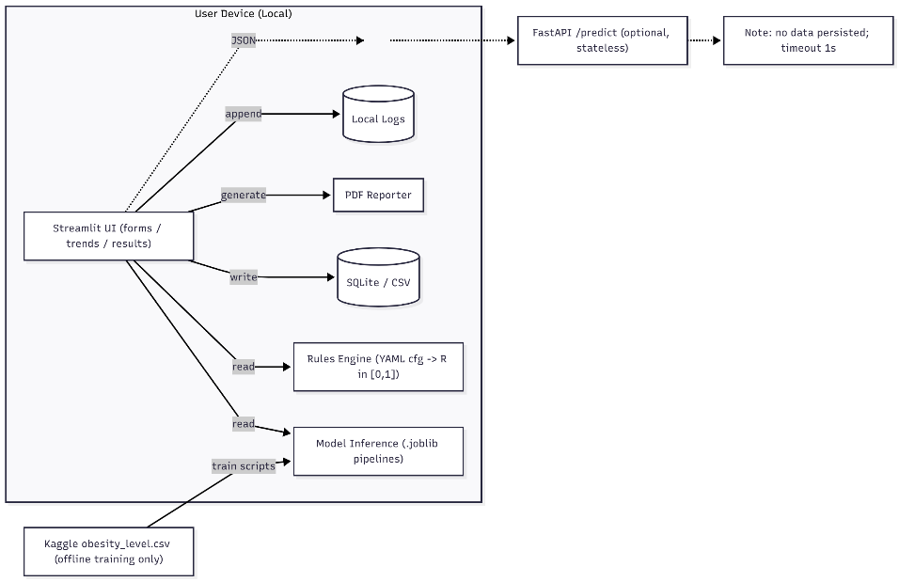
Figure 2.1：Local-First System Architecture and Data Flow.

3.Functional Requirements

3.1Functionality Scope & Precedent
Unlike basic BMI calculators found in existing app stores, ELORA integrates machine learning for personalized risk assessment. While standard tools only output a BMI number, ELORA fuses this with a trained classifier to provide explainable insights (Risk = 0.7P + 0.3R). The functionality is prioritised into Core (Essential for MVP) and Advanced (Desirable) features to ensure project deliverability.

3.1.1 Core Features (Must-Have / MVP)
These features constitute the primary deliverable path and must be completed to satisfy the project requirements:
(1)User Data Management: Supports daily entry of age, weight, and activity metrics with local persistence (SQLite/CSV).
(2)Hybrid Risk Assessment: Computes a fused risk score combining the Random Forest probability (P) and Rule-based logic (R).
(3)Trend Visualization: Generates interactive 7-day and 30-day charts for weight and BMI tracking.
Report Generation: Exports a privacy-preserving PDF report for user record-keeping.

3.1.2 Advanced Features (Nice-to-Have / Future Work)
These features extend the system capabilities but are not critical for the initial MVP:
(1)Cloud Integration: Optional stateless API calls to a remote inference service (FastAPI).
(2)Advanced Configuration: UI for switching between different .joblib model versions or editing rules.yaml thresholds.
(3)Cross-device Sync: Deferred functionality for synchronizing data across devices.

3.2Two “Exemplar” Functional Requirements

3.2.1Use Case 1: Record Daily Metrics (Ref: FR-01)
Field | Description
Use Case Name | Record Daily Health Metrics
Primary Actor | End User
Pre-conditions | 1. Application is running locally.  2. User is on the "Record Today" page.
Main Flow | 1. User inputs required biological data: Age, Gender, Height, Weight.  2. User selects lifestyle factors: Activity Level, Family History.  3. User clicks the "Save/Submit" button.  4. System validates that inputs match defined ranges (e.g., Age 14–99, Height 1.2–2.3m).  5. System saves the valid record to the local SQLite database.  6. System logs the event AUDIT_RECORD_CREATED to app.log.  7. System displays a success message and updates the daily preview.
Alternative Flow | Validation Failure:  1. If data is out of range (e.g., Weight < 0), system halts processing.  2. System highlights the invalid field in red and displays an error prompt.  3. User corrects the input and re-submits.
Post-conditions | A new record is persisted in the database; Trend charts are ready to update.
Acceptance Criteria | Time-on-Task (T1): < 60 seconds for data entry.  Success Rate: Task Success Rate (TSR) ≥ 85% in user testing.
Table 3.1：Use Case Specification – Record Daily Health Metrics.

3.2.2Use Case 2: Perform Hybrid Risk Assessment (Ref: FR-20)
Field | Description
Use Case Name | Compute Hybrid Risk Score
Primary Actor | End User
Pre-conditions | 1. User has submitted a valid daily record (via Record Today).  2. The trained model (model.joblib) and rules (rules.yaml) are successfully loaded.
Main Flow | 1. Trigger: User navigates to the "Assessment" page.  2. Data Retrieval: System retrieves the most recent health record from SQLite.  3. Pre-processing: System calculates BMI and standardises inputs (e.g., scaling Weight/Height).  4. Model Inference: System feeds features into the Random Forest Classifier to obtain the probability P(obese).  5. Rules Evaluation: System checks logic rules to generate a normalized rule score R.  6. Hybrid Fusion: System computes the final score using the formula:  Risk = 0.7 \times P(model) + 0.3 \times R(rules)  7. Display: System renders the "Assessment" page with the final score, a risk tier (e.g., "High"), and a progress bar.
Alternative Flow | Model Inference Failure:  1. If the model file is missing or corrupted, the system logs an INFERENCE_ERROR.  2. System falls back to Rules-Only Mode (Risk = R).  3. System displays a warning: "Risk calculated based on rules only (Model unavailable)."
Post-conditions | The calculated risk score and triggered factors are logged to risk_calc.log for auditing.
Metrics | Performance: End-to-end page response time (P50) < 200ms .  Accuracy: Model component maintains AUC≥0.85.
Table 3.2：Use Case Specification – Compute Hybrid Risk Score.

3.3The rest Functional Requirements
ID | Feature | Requirement Description
FR-10 | Trend Visualization | Plot interactive 7/30-day trends for weight, activity, and water with moving averages.
FR-11 | Trend Comparison | Calculate and display the mean difference between "Last 7 Days" and "Previous 7 Days".
FR-30 | Explainability | Display a "Triggered Rules" snippet on the results page to explain the risk score logic.
FR-31 | Recommendations | Generate 2–3 actionable, non-clinical lifestyle recommendations based on user input.
FR-40 | PDF Export | Generate a downloadable 1–2 page PDF report containing the summary and charts.
FR-50 | Data Portability | Support CSV import/export to allow users to backup or migrate their local data.
FR-60 | Audit Logging | Log system events (submission, prediction, export) to a local file for traceability.
Table 3.3：Summary of Supporting Functional Requirements.

4.Data & Interfaces

4.1Data Fields (Inputs & Derived/Outputs)
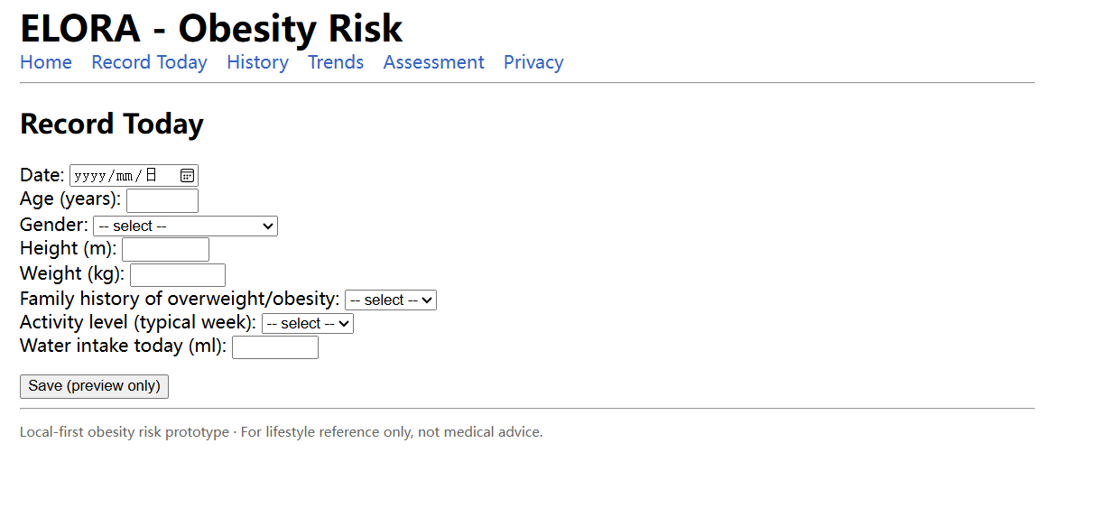
Figure 4.1: Data Entry Interface capturing core biometric inputs.
The system captures 7 core biometric inputs (Age, Gender, Height, Weight, etc.) and strictly validates types via Pydantic models.

4.2PDF

4.2.1Layout Structure (Top to Bottom)
(1)Header Section: Project name (ELORA), generation date, and disclaimer ("For lifestyle reference only; not medical advice").
(2)User Summary: Key user data including age, height, weight, BMI, activity level, and family history.
(3)Trend Area:7-day or 30-day weight trend (including units, legend, and moving average line); simple charts for activity/water intake can be added if applicable.
(4)Assessment Area: Obesity status (obese/non-obese), risk bucket, probability of obesity (prob_obese), and risk score.
(5)One-Sentence Rationale: Display at least 1 item from triggers[] (e.g., "BMI ≥ 28; +3kg weight gain in the past 30 days").
(6)Recommendation Cards: Action verb + quantifiable target (e.g., "3 sessions of 30-minute moderate-intensity aerobic exercise per week").
(7)Footer: Versions (model_version, rules_version), file name, and page number.

4.2.2Export Requirements
(1)Optional paper size: A4/Letter.
(2)Graphics format: Vector graphics (for clear scaling).
(3)Font requirement: Chinese font embedding to ensure correct display on different devices.
(4)Generation time: < 2 seconds.
(5)File naming convention: report_YYYYMMDD.pdf (e.g., report_20241017.pdf).

4.3API
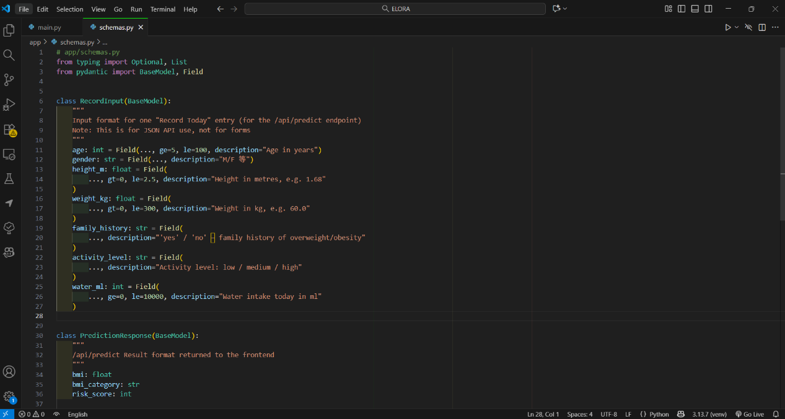
Figure 4.2: Pydantic Schema Definition for API Type Validation.
The stateless /predict endpoint accepts JSON payloads for inference without persisting user data.

4.4CSV Import/Export
The system supports full data portability via CSV import/export, ensuring users retain ownership of their records (Local-first).

5. Project Metrics & Non-Functional Requirements
This section defines the quantitative Key Performance Indicators (KPIs) and qualitative constraints used to validate the project's success, satisfying the requirement for valid and complete metrics.

5.1 Acceptance Metrics (KPIs)
The following quantitative thresholds define the acceptance criteria for the final MVP release:
Category | Metric | Threshold | Rationale
Accuracy | AUC (Binary) | ≥ 0.85 | Ensures the model provides reliable risk screening comparable to clinical baselines.
Accuracy | Macro-F1 | ≥ 0.80 | Ensures consistent classification across all 7 obesity tiers, avoiding minority class neglect.
Usability | Task Success Rate | ≥ 85% | Guarantees that non-technical users can complete core flows (e.g., Record Today) without error.
Usability | SUS Score | ≥ 70 | Indicates "Above Average" usability on the System Usability Scale.
Performance | Page Latency (P50) | < 200ms | Ensures the interface feels "instant" during daily data entry tasks.
Table 5.1: Key Performance Indicators (KPIs) and Acceptance Thresholds.

5.2 System Constraints (NFRs)
In addition to quantitative metrics, the system adheres to the following architectural constraints:
(1)Privacy (Local-First): User data must be stored exclusively in the local SQLite database. No data shall be uploaded to the cloud unless explicitly triggered by the user via the optional API.
(2)Reliability: The critical path (Data Entry , Risk Calculation, Result Display) must maintain an error rate of < 1%.
(3)Portability: The system must support CSV Import/Export to ensure users are not locked into the platform.

6.Acceptance & Traceability

6.1Metrics & Measurement Methods
(1)Accuracy: AUC (binary), Macro-F1 (7-class); cross-validation mean ± std + hold-out.
(2)Usability: TSR = successes / total; ToT = p50/p90 time on successful samples; SUS (10 items).
(3)Performance: Chrome Performance, API logs.

