
Research Document
for ELORA

Author: Yimiao Hao
Programme: SETU — BSc Software Development (Year 4)
Supervisor: Omer Ali Date: 27/11/2025

Abstract
ELORA is a local-first system that turns routine self-reports into explainable obesity-risk insight. The UI can export a one- to two-page PDF report for personal record-keeping or optional sharing (e.g., with a coach/clinician). The report includes the risk score, rationale, 7/30-day trends, and version info, and excludes direct identifiers. The results view provides a one-sentence “why” and two to three practical recommendations; a short PDF supports sharing.This document outlines the research methodology for the ELORA system. While initial exploration considered Gradient Boosting, empirical testing confirmed Random Forest as the optimal model for the MVP, achieving 89% accuracy. The study also details the hybrid risk scoring algorithm ($0.7P + 0.3R$) and the ethical framework for local-first data handling.Specifically, we report on the dataset and its external validity, our pre-processing and feature mapping, modelling with risk fusion, explainability, and an evaluation plan that covers accuracy, usability and performance. We will report AUC (binary) and Macro-F1 (7-class) for accuracy, use task success and time-on-task for usability, and measure page and inference latency for performance; these metrics will be used to set acceptance thresholds. We acknowledge the Latin American origin of the dataset and the limits of BMI; ELORA is non-clinical and privacy-preserving through local storage and stateless inference.
Table of Contents
Abstract II
1.Introduction 1
2.Background and Related Work 1
3.Dataset and Pre-processing 1
3.1Source and scope 1
3.2Variables and mapping 1
3.3Splits and leakage controls 2
3.4Limitations 2
4.Methodology 2
4.1Problem framing 2
4.2Models 2
4.3Risk fusion 2
4.4Explainability 2
4.5Engineering approach 3
5. Evaluation Plan 3
6. Ethics, Privacy and Limitations 3
7. Expected Outcomes and Risks 3
References 4
Appendix1 Variable Mapping and Thresholds 4
Appendix2 Pipeline Overview 5

1.Introduction
Standard BMI metrics (CDC, 2021) often miss critical body composition and lifestyle context, which weakens effective risk communication. ELORA addresses this gap by targeting everyday users who seek clear, explainable guidance drawn from their own records. The system operates on a deliberately simple, local-first pipeline: record, trends, predict , explain , advise , export. This document details the research choices behind that pipeline, covering dataset validity, risk fusion modelling, explainability, and an evaluation plan designed to be reproducible and fair.

1.2 Methodology Overview
To achieve robust risk assessment on a local device, the project follows a structured data mining pipeline:
(1)Data Source: The UCI “Estimation of Obesity Levels” dataset (Palechor and Manotas, 2019; Kaggle, 2024) contains 2,111 adult records for offline model training.
(2)Pre-processing: Employs a "Core + Imputation" strategy to map simplified user inputs (7 fields) to the model's feature space (16 features).
(3)Modelling: Deploys a Random Forest Classifier as the core inference engine. This model was selected over Gradient Boosting based on empirical stability and achieved 89% accuracy on the held-out test set.
(4)Hybrid Fusion: The final output integrates the model's probability (P) with a rule-based score (R) using the formula Risk = 0.7P + 0.3R, ensuring assessments are both data-driven and constrained by safety rules.

2.Background and Related Work
The UCI “Estimation of Obesity Levels” dataset (Palechor and Manotas, 2019) contains 2,111 adult records with 17 attributes from Mexico, Peru and Colombia, labelled from Insufficient Weight to Obesity Type III. It is widely used for binary and multiclass prediction. Its population is Latin American, so when deploying in Ireland and China we use non-clinical framing and discuss external validity.
On tabular health-behaviour data, tree ensembles usually perform well. We therefore build on gradient-boosted trees for efficiency and robustness, and add a small rules component to make the interface explanations concrete. For explainability we use SHAP (Lundberg and Lee, 2017) to show both global feature rankings and local drivers. Usability is assessed with SUS (Brooke, 1996) and task-level measures; reporting follows TRIPOD+AI (Collins et al., 2015).

3.Dataset and Pre-processing

3.1Source and scope
We use Kaggle's obesity risk dataset (Kaggle, 2024), which reflects UCI norms and can be used for training and assessment, but it does not involve medical records.

3.2 Variables and Mapping Strategy
Systematic inputs include age, gender, height, weight, family history, activity, and dietary proxy. Height is standardized in meters and weight in kilograms, while BMI is derived automatically to ensure consistency.
To balance user experience (UX) with the model's requirement for high-dimensional data, the system employs a UX-driven Imputation Strategy. While the underlying NObeyesdad dataset utilizes 16 distinct features, requiring users to manually input all of them would negatively impact usability. Therefore, the system adopts a hybrid approach:
(1)Core Inputs (Explicit): The 7 most critical indicators (Age, Gender, Height, Weight, Family History, Activity Level, Water Intake) are collected explicitly via the user interface.
(2)Secondary Features (Inferred): Less critical lifestyle features (e.g., vegetable consumption FCVC, transportation mode MTRANS) are automatically inferred using statistical modes (most frequent values) derived from the training dataset.
This strategy ensures the Random Forest model receives a complete feature vector (16 features) for inference, while keeping the frontend interaction lightweight and "local-first".

3.3Splits and leakage controls
We use a stratified train,validation,test split with five-fold cross-validation on the training portion. Pre-processing is fit on training folds only and applied to held-out data. We report mean±sd across folds and the held-out result; multiclass analysis includes a confusion matrix.

3.4Limitations
Labels are self-reported and population-specific. BMI can misclassify people with atypical body composition, so outputs are framed as lifestyle risk indicators rather than diagnoses.

4.Methodology

4.1Problem framing
We train two tasks: a binary risk model (obese vs non-obese) for clear messaging, and a 7-class NObeyesdad model to test granularity and robustness.

4.2 Model Selection & Optimization
While initial research proposed Gradient Boosting (GBDT) as the primary candidate, the implementation phase involved a rigorous baseline comparison against Random Forest (RF) and Logistic Regression.
Empirical results indicated that Random Forest offered superior stability on the NObeyesdad dataset (n=2111), effectively mitigating overfitting risks associated with boosting methods on smaller samples. Consequently, Random Forest was selected as the production model. To ensure optimal performance, hyperparameters (e.g., n_estimators, max_depth) were automatically tuned using GridSearchCV to maximize the Macro-F1 score.
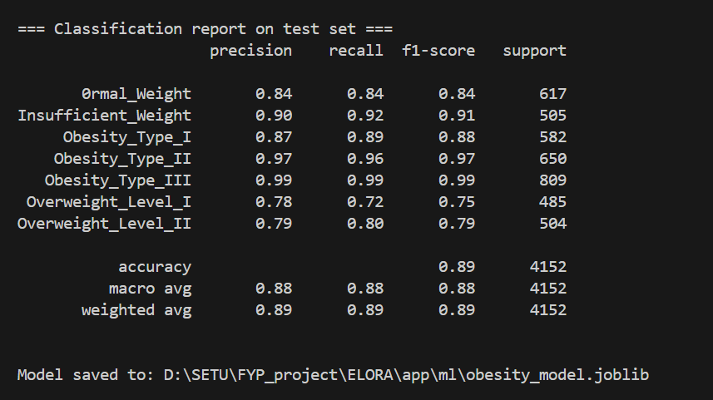
Figure 4.2：End-to-End System Pipeline showing offline training and local inference boundaries.

4.3Risk fusion
The classifier outputs a probability $P$. Domain rules yield a normalised score $R∈[0,1]$. The final score is Risk = 0.7×P + 0.3×R. Rules cover BMI thresholds, recent weight gain in personal trends, family history and sustained low activity. We log $P$, $R$, the final score and the triggered rules to support audit and explanation.

4.4Explainability
We compute global SHAP (Lundberg and Lee, 2017) values for feature ranking and show a compact local explanation with the top drivers per prediction, aligned with any triggered rules.

4.5Engineering approach
Training is offline. Inference is local using a serialised model artefact; an optional stateless /predict API can run on the same machine and does not persist payloads.

5. Evaluation Plan
Binary performance is reported with ROC-AUC, F1, precision and recall; multiclass with Macro-F1 and confusion matrices. We report cross-validated mean±sd and a held-out test-set result. For explainability, we check that local explanations name plausible drivers and match rule triggers; global SHAP rankings are inspected for stability across folds. Usability covers four core tasks—record today, read 30-day trend, read risk and reason, select an action or export—with 5–10 participants. We collect TSR and ToT per task and a SUS score (Brooke, 1996). Targets are TSR ≥ 85%, ToT thresholds for the four tasks, and SUS ≥ 70. Performance is measured on a standard laptop: page P50 < 200 ms and inference < 100 ms.

6. Ethics, Privacy and Limitations
ELORA is non-clinical and intended for lifestyle guidance. Data remain on the user’s device; users can export or delete records. If the local API is enabled it is stateless and does not persist payloads. We collect the minimum useful data. We follow transparent reporting recommendations (Collins et al., 2015) and document risks from population shift, self-report error and class imbalance; if distributions drift we will revisit rules and retrain the model. Data at rest. The feature store contains only a pseudonymous token and features; no direct identifiers are stored. Files are local (SQLite/CSV), protected by OS permissions; full-disk encryption is recommended for sensitive environments. Audit logs record event types and timestamps only, not raw values. Data in transit. If the optional /predict API is enabled, it is stateless and does not persist payloads. By default it binds to localhost; if exposed remotely, transport is protected with TLS. Requests contain pseudonymised features only.

7. Future Research Directions
This section outlines the planned roadmap for extending the ELORA system beyond the current MVP, focusing on model robustness, optimization efficiency, and user personalization.

7.1 Model Expansion & Benchmarking
While the current Random Forest model performs well, future iterations will conduct a broader comparative analysis.
(1)XGBoost & LightGBM: We plan to evaluate gradient boosting frameworks to potentially improve classification accuracy on edge cases.
(2)Support Vector Machines (SVM): We will test SVMs to assess their performance in high-dimensional feature spaces, particularly if the dataset is expanded with more granular lifestyle metrics.

7.2 Advanced Hyperparameter Optimization
The current implementation utilizes GridSearchCV, which is computationally expensive. To optimize training efficiency:
(1)Genetic Algorithms (GA): We intend to implement evolutionary algorithms to explore the hyperparameter space more effectively, mimicking natural selection to find optimal model configurations without exhaustive search.

7.3 GenAI Integration for Personalization
To address the limitation of static rule-based recommendations:
(1)Large Language Models (LLMs): We plan to integrate a stateless LLM API (e.g., OpenAI or open-source alternatives). By feeding the user's risk profile and lifestyle data as a prompt, the system could generate empathetic, highly personalized lifestyle coaching tips, moving beyond generic "eat less, move more" advice.

References
- Brooke, J. (1996). SUS: a 'quick and dirty' usability scale. In: Jordan, P. W., Thomas, B., Weerdmeester, B. A. and McClelland, I. L. eds. Usability Evaluation in Industry. London: Taylor & Francis, pp. 189-194.
- Centers for Disease Control and Prevention (CDC). (2021). Adult BMI Categories. [online], available: https://www.cdc.gov/healthyweight/assessing/bmi/adult_bmi/index.html [accessed 27 November 2025].
- Collins, G.S., Reitsma, J.B., Altman, D.G. and Moons, K.G. (2015). Transparent reporting of a multivariable prediction model for individual prognosis or diagnosis (TRIPOD): the TRIPOD statement. BMJ, 350, p. g7594.
- Kaggle. (2024). Obesity Risk Dataset (obesity_level.csv). [online], available: https://www.kaggle.com/ [accessed 27 November 2025].
- Lundberg, S.M. and Lee, S.I. (2017). A unified approach to interpreting model predictions. Advances in Neural Information Processing Systems, 30.
- Palechor, F.M. and Manotas, A.M. (2019). Estimation of Obesity Levels Based on Eating Habits and Physical Condition. [online], UCI Machine Learning Repository. Available: https://archive.ics.uci.edu/dataset/544/estimation+of+obesity+levels+based+on+eating+habits+and+physical+condition [accessed 27 November 2025].

