Trading System Data Base
This project is a data base for trading system.
The data base can store data for information of user, account, order, Market data, and watch list. Containing all the SQL function, including DROP, CREATE, INSERT, SELECT, and Transaction, Trigger, Procedures.
Diagram:
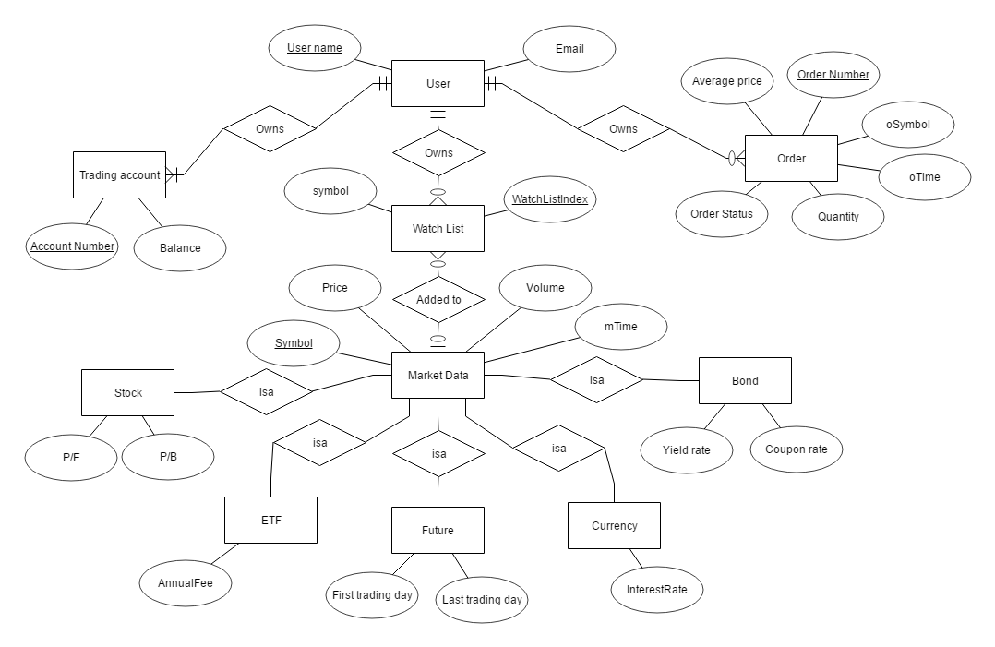
Database Schema:
