CSC423_Final_Project.R

W

Mon Jun 06 05:28:52 2016

UH=read.csv("e:/used.csv")  
save(UH,file ="e:/used_hondas.RData")  
load("e:/used_hondas.RData")  
head(UH)

## Price Year Mileage Location Color Age  
## 1 20746 2006 18394 St.Paul Grey 1  
## 2 19787 2007 8 St.Paul Black 0  
## 3 17987 2005 39998 St.Paul Grey 2  
## 4 17588 2004 35882 St.Paul Black 3  
## 5 16987 2004 25306 St.Paul Grey 3  
## 6 16987 2005 33399 St.Paul Black 2

#try to predict used hondas' price  
#Use Age of the car make sence rather than use the year of the car made.  
#Plot data  
plot(UH$Mileage,UH$Price)

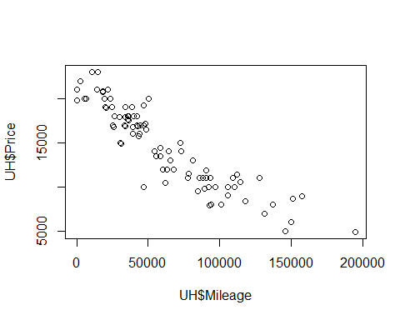

plot(UH$Location,UH$Price)

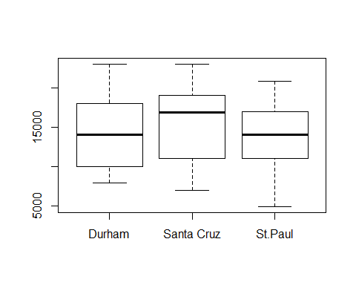

plot(UH$Color,UH$Price)

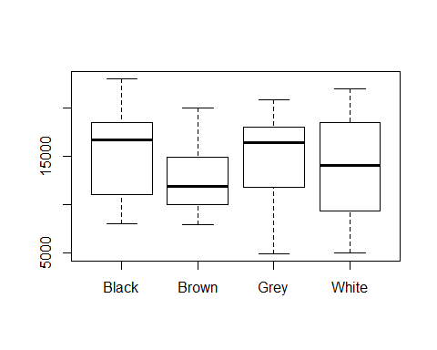

plot(UH$Age,UH$Price)  
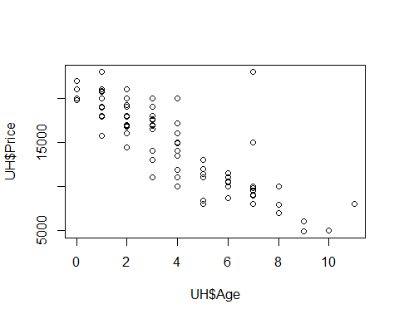

#correlation  
cor(UH$Price,UH$Mileage)

## [1] -0.9126773

cor(UH$Price,UH$Age)

## [1] -0.8230599

cor(UH$Mileage,UH$Age)

## [1] 0.7796946

#depending on the graphs, it looks more like a first order model.  
#Will test with first order moder, then add interactive terms.   
#Will also, test second order model and third order(just give it a try).  
  
  
paste0(UH$Color)

## [1] "Grey" "Black" "Grey" "Black" "Grey" "Black" "Grey" "Grey"   
## [9] "Black" "Brown" "Brown" "Grey" "Grey" "White" "Black" "Brown"  
## [17] "White" "Black" "Brown" "Black" "Black" "Brown" "Brown" "Grey"   
## [25] "Brown" "White" "Grey" "White" "Grey" "Grey" "Black" "Grey"   
## [33] "Brown" "Grey" "Grey" "White" "Brown" "Black" "Black" "Brown"  
## [41] "Brown" "White" "Brown" "Black" "Black" "Black" "Grey" "Brown"  
## [49] "Grey" "Black" "Black" "Black" "Black" "Black" "Black" "Black"  
## [57] "Brown" "White" "White" "Brown" "Brown" "Black" "Brown" "White"  
## [65] "Black" "Black" "Brown" "Black" "White" "Black" "Black" "White"  
## [73] "Black" "Grey" "Grey" "Black" "Black" "White" "Black" "Grey"   
## [81] "Brown" "Brown" "White" "White" "Black" "Black" "White" "Black"  
## [89] "Black" "Brown" "Grey" "Black"

#Take Color as dummy variable. "White" would be base level  
UH$C1 = ifelse(UH$Color == "Black" , 1, 0)  
UH$C2 = ifelse(UH$Color == "Brown" , 1, 0)  
UH$C3 = ifelse(UH$Color == "Grey" , 1, 0)  
  
paste0(UH$Location)

## [1] "St.Paul" "St.Paul" "St.Paul" "St.Paul" "St.Paul"   
## [6] "St.Paul" "St.Paul" "St.Paul" "St.Paul" "St.Paul"   
## [11] "St.Paul" "St.Paul" "St.Paul" "St.Paul" "St.Paul"   
## [16] "St.Paul" "St.Paul" "St.Paul" "St.Paul" "St.Paul"   
## [21] "St.Paul" "St.Paul" "St.Paul" "St.Paul" "St.Paul"   
## [26] "St.Paul" "St.Paul" "St.Paul" "St.Paul" "Durham"   
## [31] "Durham" "Durham" "Durham" "Durham" "Durham"   
## [36] "Durham" "Durham" "Durham" "Durham" "Durham"   
## [41] "Durham" "Durham" "Durham" "Durham" "Durham"   
## [46] "Durham" "Durham" "Durham" "Durham" "Durham"   
## [51] "Durham" "Durham" "Durham" "Durham" "Durham"   
## [56] "Durham" "Durham" "Durham" "Durham" "Durham"   
## [61] "Durham" "Durham" "Durham" "Santa Cruz" "Santa Cruz"  
## [66] "Santa Cruz" "Santa Cruz" "Santa Cruz" "Santa Cruz" "Santa Cruz"  
## [71] "Santa Cruz" "Santa Cruz" "Santa Cruz" "Santa Cruz" "Santa Cruz"  
## [76] "Santa Cruz" "Santa Cruz" "Santa Cruz" "Santa Cruz" "Santa Cruz"  
## [81] "Santa Cruz" "Santa Cruz" "Santa Cruz" "Santa Cruz" "Santa Cruz"  
## [86] "Santa Cruz" "Santa Cruz" "Santa Cruz" "Santa Cruz" "Santa Cruz"  
## [91] "Santa Cruz" "Santa Cruz"

#Take Location as dummy variable. "Santa Cruz" would be base level  
UH$L1 = ifelse(UH$Location == "St.Paul" , 1, 0)  
UH$L2 = ifelse(UH$Location == "Durham" , 1, 0)  
  
  
#Add possible interactive terms  
UH$M_A=UH$Mileage*UH$Age  
  
#Add possible Quadratic terms  
UH$M_SQ=UH$Mileage^2  
UH$A_SQ=UH$Age^2  
  
#Add Cube terms  
UH$M_CU=UH$Mileage^3  
UH$A_CU=UH$Age^3  
  
  
#First order model without interaction  
library(leaps)

## Warning: package 'leaps' was built under R version 3.2.5

yvar = c("Price")  
xvars = c("Mileage","Age","C1","C2","C3","L1","L2")  
model=leaps( x=UH[,xvars], y=UH[,yvar], names=xvars, nbest=2, method="adjr2")  
model$which

## Mileage Age C1 C2 C3 L1 L2  
## 1 TRUE FALSE FALSE FALSE FALSE FALSE FALSE  
## 1 FALSE TRUE FALSE FALSE FALSE FALSE FALSE  
## 2 TRUE TRUE FALSE FALSE FALSE FALSE FALSE  
## 2 TRUE FALSE FALSE TRUE FALSE FALSE FALSE  
## 3 TRUE TRUE FALSE TRUE FALSE FALSE FALSE  
## 3 TRUE TRUE TRUE FALSE FALSE FALSE FALSE  
## 4 TRUE TRUE FALSE TRUE FALSE TRUE FALSE  
## 4 TRUE TRUE TRUE TRUE FALSE FALSE FALSE  
## 5 TRUE TRUE TRUE TRUE FALSE TRUE FALSE  
## 5 TRUE TRUE FALSE TRUE FALSE TRUE TRUE  
## 6 TRUE TRUE TRUE TRUE TRUE TRUE FALSE  
## 6 TRUE TRUE TRUE TRUE FALSE TRUE TRUE  
## 7 TRUE TRUE TRUE TRUE TRUE TRUE TRUE

model$adjr2

## [1] 0.8311241 0.6738435 0.8616191 0.8528467 0.8722074 0.8661978 0.8758035  
## [8] 0.8721833 0.8750635 0.8747022 0.8739421 0.8739404 0.8728985

model=leaps( x=UH[,xvars], y=UH[,yvar], names=xvars, nbest=2, method="Cp")  
model$which

## Mileage Age C1 C2 C3 L1 L2  
## 1 TRUE FALSE FALSE FALSE FALSE FALSE FALSE  
## 1 FALSE TRUE FALSE FALSE FALSE FALSE FALSE  
## 2 TRUE TRUE FALSE FALSE FALSE FALSE FALSE  
## 2 TRUE FALSE FALSE TRUE FALSE FALSE FALSE  
## 3 TRUE TRUE FALSE TRUE FALSE FALSE FALSE  
## 3 TRUE TRUE TRUE FALSE FALSE FALSE FALSE  
## 4 TRUE TRUE FALSE TRUE FALSE TRUE FALSE  
## 4 TRUE TRUE TRUE TRUE FALSE FALSE FALSE  
## 5 TRUE TRUE TRUE TRUE FALSE TRUE FALSE  
## 5 TRUE TRUE FALSE TRUE FALSE TRUE TRUE  
## 6 TRUE TRUE TRUE TRUE TRUE TRUE FALSE  
## 6 TRUE TRUE TRUE TRUE FALSE TRUE TRUE  
## 7 TRUE TRUE TRUE TRUE TRUE TRUE TRUE

model$Cp

## [1] 31.580296 142.949984 10.898200 17.040820 4.478471 8.639323  
## [7] 3.011596 5.489553 4.535152 4.779554 6.302107 6.303225  
## [13] 8.000000

#First order model with interaction  
yvar = c("Price")  
xvars = c("Mileage","Age","C1","C2","C3","L1","L2","M_A")  
model=leaps( x=UH[,xvars], y=UH[,yvar], names=xvars, nbest=2, method="adjr2")  
model$which

## Mileage Age C1 C2 C3 L1 L2 M_A  
## 1 TRUE FALSE FALSE FALSE FALSE FALSE FALSE FALSE  
## 1 FALSE FALSE FALSE FALSE FALSE FALSE FALSE TRUE  
## 2 TRUE TRUE FALSE FALSE FALSE FALSE FALSE FALSE  
## 2 TRUE FALSE FALSE TRUE FALSE FALSE FALSE FALSE  
## 3 TRUE TRUE FALSE TRUE FALSE FALSE FALSE FALSE  
## 3 TRUE TRUE FALSE FALSE FALSE FALSE FALSE TRUE  
## 4 TRUE TRUE FALSE TRUE FALSE TRUE FALSE FALSE  
## 4 TRUE TRUE FALSE TRUE FALSE FALSE FALSE TRUE  
## 5 TRUE TRUE FALSE TRUE FALSE TRUE FALSE TRUE  
## 5 TRUE TRUE TRUE FALSE FALSE TRUE FALSE TRUE  
## 6 TRUE TRUE TRUE TRUE FALSE TRUE FALSE TRUE  
## 6 TRUE TRUE FALSE TRUE FALSE TRUE TRUE TRUE  
## 7 TRUE TRUE TRUE TRUE TRUE TRUE FALSE TRUE  
## 7 TRUE TRUE TRUE TRUE FALSE TRUE TRUE TRUE  
## 8 TRUE TRUE TRUE TRUE TRUE TRUE TRUE TRUE

model$adjr2

## [1] 0.8311241 0.7379639 0.8616191 0.8528467 0.8722074 0.8665477 0.8758035  
## [8] 0.8753839 0.8809727 0.8768376 0.8810313 0.8798692 0.8800075 0.8799120  
## [15] 0.8789667

model=leaps( x=UH[,xvars], y=UH[,yvar], names=xvars, nbest=2, method="Cp")  
model$which

## Mileage Age C1 C2 C3 L1 L2 M_A  
## 1 TRUE FALSE FALSE FALSE FALSE FALSE FALSE FALSE  
## 1 FALSE FALSE FALSE FALSE FALSE FALSE FALSE TRUE  
## 2 TRUE TRUE FALSE FALSE FALSE FALSE FALSE FALSE  
## 2 TRUE FALSE FALSE TRUE FALSE FALSE FALSE FALSE  
## 3 TRUE TRUE FALSE TRUE FALSE FALSE FALSE FALSE  
## 3 TRUE TRUE FALSE FALSE FALSE FALSE FALSE TRUE  
## 4 TRUE TRUE FALSE TRUE FALSE TRUE FALSE FALSE  
## 4 TRUE TRUE FALSE TRUE FALSE FALSE FALSE TRUE  
## 5 TRUE TRUE FALSE TRUE FALSE TRUE FALSE TRUE  
## 5 TRUE TRUE TRUE FALSE FALSE TRUE FALSE TRUE  
## 6 TRUE TRUE TRUE TRUE FALSE TRUE FALSE TRUE  
## 6 TRUE TRUE FALSE TRUE FALSE TRUE TRUE TRUE  
## 7 TRUE TRUE TRUE TRUE TRUE TRUE FALSE TRUE  
## 7 TRUE TRUE TRUE TRUE FALSE TRUE TRUE TRUE  
## 8 TRUE TRUE TRUE TRUE TRUE TRUE TRUE TRUE

model$Cp

## [1] 37.575590 106.849214 15.756301 22.206889 8.914440 13.029457  
## [7] 7.273749 7.575318 4.574638 7.512768 5.550041 6.366150  
## [13] 7.277661 7.343882 9.000000

#Second order model with interaction  
yvar = c("Price")  
xvars = c("Mileage","Age","C1","C2","C3","L1","L2","M_A","M_SQ","A_SQ")  
model=leaps( x=UH[,xvars], y=UH[,yvar], names=xvars, nbest=2, method="adjr2")  
model$which

## Mileage Age C1 C2 C3 L1 L2 M_A M_SQ A_SQ  
## 1 TRUE FALSE FALSE FALSE FALSE FALSE FALSE FALSE FALSE FALSE  
## 1 FALSE FALSE FALSE FALSE FALSE FALSE FALSE TRUE FALSE FALSE  
## 2 TRUE FALSE FALSE FALSE FALSE FALSE FALSE FALSE TRUE FALSE  
## 2 TRUE TRUE FALSE FALSE FALSE FALSE FALSE FALSE FALSE FALSE  
## 3 TRUE FALSE FALSE FALSE FALSE FALSE FALSE TRUE TRUE FALSE  
## 3 TRUE FALSE FALSE FALSE FALSE FALSE FALSE FALSE TRUE TRUE  
## 4 TRUE FALSE FALSE TRUE FALSE FALSE FALSE TRUE TRUE FALSE  
## 4 TRUE FALSE FALSE FALSE FALSE TRUE FALSE TRUE TRUE FALSE  
## 5 TRUE FALSE FALSE TRUE FALSE TRUE FALSE TRUE TRUE FALSE  
## 5 TRUE TRUE FALSE TRUE FALSE TRUE FALSE FALSE TRUE FALSE  
## 6 TRUE TRUE FALSE TRUE FALSE TRUE FALSE TRUE TRUE FALSE  
## 6 TRUE FALSE FALSE TRUE FALSE TRUE TRUE TRUE TRUE FALSE  
## 7 TRUE TRUE FALSE TRUE FALSE TRUE FALSE TRUE TRUE TRUE  
## 7 TRUE TRUE FALSE TRUE FALSE TRUE TRUE TRUE TRUE FALSE  
## 8 TRUE TRUE FALSE TRUE FALSE TRUE TRUE TRUE TRUE TRUE  
## 8 TRUE TRUE TRUE TRUE FALSE TRUE FALSE TRUE TRUE TRUE  
## 9 TRUE TRUE TRUE TRUE FALSE TRUE TRUE TRUE TRUE TRUE  
## 9 TRUE TRUE FALSE TRUE TRUE TRUE TRUE TRUE TRUE TRUE  
## 10 TRUE TRUE TRUE TRUE TRUE TRUE TRUE TRUE TRUE TRUE

model$adjr2

## [1] 0.8311241 0.7379639 0.8670944 0.8616191 0.8915234 0.8868805 0.8951834  
## [8] 0.8944591 0.8981579 0.8956571 0.8973291 0.8973144 0.8982066 0.8964719  
## [15] 0.8973214 0.8970304 0.8961196 0.8960818 0.8949378

model=leaps( x=UH[,xvars], y=UH[,yvar], names=xvars, nbest=2, method="Cp")  
model$which

## Mileage Age C1 C2 C3 L1 L2 M_A M_SQ A_SQ  
## 1 TRUE FALSE FALSE FALSE FALSE FALSE FALSE FALSE FALSE FALSE  
## 1 FALSE FALSE FALSE FALSE FALSE FALSE FALSE TRUE FALSE FALSE  
## 2 TRUE FALSE FALSE FALSE FALSE FALSE FALSE FALSE TRUE FALSE  
## 2 TRUE TRUE FALSE FALSE FALSE FALSE FALSE FALSE FALSE FALSE  
## 3 TRUE FALSE FALSE FALSE FALSE FALSE FALSE TRUE TRUE FALSE  
## 3 TRUE FALSE FALSE FALSE FALSE FALSE FALSE FALSE TRUE TRUE  
## 4 TRUE FALSE FALSE TRUE FALSE FALSE FALSE TRUE TRUE FALSE  
## 4 TRUE FALSE FALSE FALSE FALSE TRUE FALSE TRUE TRUE FALSE  
## 5 TRUE FALSE FALSE TRUE FALSE TRUE FALSE TRUE TRUE FALSE  
## 5 TRUE TRUE FALSE TRUE FALSE TRUE FALSE FALSE TRUE FALSE  
## 6 TRUE TRUE FALSE TRUE FALSE TRUE FALSE TRUE TRUE FALSE  
## 6 TRUE FALSE FALSE TRUE FALSE TRUE TRUE TRUE TRUE FALSE  
## 7 TRUE TRUE FALSE TRUE FALSE TRUE FALSE TRUE TRUE TRUE  
## 7 TRUE TRUE FALSE TRUE FALSE TRUE TRUE TRUE TRUE FALSE  
## 8 TRUE TRUE FALSE TRUE FALSE TRUE TRUE TRUE TRUE TRUE  
## 8 TRUE TRUE TRUE TRUE FALSE TRUE FALSE TRUE TRUE TRUE  
## 9 TRUE TRUE TRUE TRUE FALSE TRUE TRUE TRUE TRUE TRUE  
## 9 TRUE TRUE FALSE TRUE TRUE TRUE TRUE TRUE TRUE TRUE  
## 10 TRUE TRUE TRUE TRUE TRUE TRUE TRUE TRUE TRUE TRUE

model$Cp

## [1] 56.665035 136.469328 26.586595 31.224843 6.859860 10.748730  
## [7] 4.796624 5.396353 3.364079 5.411136 5.065310 5.077159  
## [13] 5.386517 6.773389 7.116892 7.346795 9.077568 9.107089  
## [19] 11.000000

#Third order model with interaction  
yvar = c("Price")  
xvars = c("Mileage","Age","C1","C2","C3","L1","L2","M_A","M_SQ","A_SQ","M_CU","A_CU")  
model=leaps( x=UH[,xvars], y=UH[,yvar], names=xvars, nbest=2, method="adjr2")  
model$which

## Mileage Age C1 C2 C3 L1 L2 M_A M_SQ A_SQ M_CU  
## 1 TRUE FALSE FALSE FALSE FALSE FALSE FALSE FALSE FALSE FALSE FALSE  
## 1 FALSE FALSE FALSE FALSE FALSE FALSE FALSE TRUE FALSE FALSE FALSE  
## 2 TRUE FALSE FALSE FALSE FALSE FALSE FALSE FALSE TRUE FALSE FALSE  
## 2 TRUE FALSE FALSE FALSE FALSE FALSE FALSE FALSE FALSE FALSE TRUE  
## 3 TRUE FALSE FALSE FALSE FALSE FALSE FALSE TRUE TRUE FALSE FALSE  
## 3 TRUE FALSE FALSE FALSE FALSE FALSE FALSE TRUE FALSE FALSE TRUE  
## 4 TRUE FALSE FALSE TRUE FALSE FALSE FALSE TRUE TRUE FALSE FALSE  
## 4 TRUE FALSE FALSE FALSE FALSE TRUE FALSE TRUE TRUE FALSE FALSE  
## 5 TRUE FALSE FALSE TRUE FALSE TRUE FALSE TRUE FALSE FALSE TRUE  
## 5 TRUE FALSE FALSE TRUE FALSE TRUE FALSE TRUE TRUE FALSE FALSE  
## 6 TRUE FALSE FALSE TRUE FALSE TRUE FALSE TRUE FALSE FALSE TRUE  
## 6 TRUE FALSE FALSE TRUE FALSE TRUE FALSE TRUE TRUE FALSE FALSE  
## 7 TRUE FALSE FALSE TRUE FALSE TRUE FALSE TRUE FALSE TRUE TRUE  
## 7 TRUE TRUE FALSE TRUE FALSE TRUE FALSE TRUE FALSE FALSE TRUE  
## 8 TRUE FALSE FALSE TRUE FALSE TRUE TRUE TRUE FALSE TRUE TRUE  
## 8 TRUE FALSE TRUE TRUE FALSE TRUE FALSE TRUE FALSE TRUE TRUE  
## 9 TRUE FALSE TRUE TRUE FALSE TRUE TRUE TRUE FALSE TRUE TRUE  
## 9 TRUE FALSE FALSE TRUE FALSE TRUE TRUE TRUE TRUE TRUE TRUE  
## 10 TRUE FALSE TRUE TRUE FALSE TRUE TRUE TRUE TRUE TRUE TRUE  
## 10 TRUE TRUE FALSE TRUE FALSE TRUE TRUE TRUE TRUE TRUE TRUE  
## 11 TRUE TRUE TRUE TRUE FALSE TRUE TRUE TRUE TRUE TRUE TRUE  
## 11 TRUE FALSE TRUE TRUE TRUE TRUE TRUE TRUE TRUE TRUE TRUE  
## 12 TRUE TRUE TRUE TRUE TRUE TRUE TRUE TRUE TRUE TRUE TRUE  
## A_CU  
## 1 FALSE  
## 1 FALSE  
## 2 FALSE  
## 2 FALSE  
## 3 FALSE  
## 3 FALSE  
## 4 FALSE  
## 4 FALSE  
## 5 FALSE  
## 5 FALSE  
## 6 TRUE  
## 6 TRUE  
## 7 TRUE  
## 7 TRUE  
## 8 TRUE  
## 8 TRUE  
## 9 TRUE  
## 9 TRUE  
## 10 TRUE  
## 10 TRUE  
## 11 TRUE  
## 11 TRUE  
## 12 TRUE

model$adjr2

## [1] 0.8311241 0.7379639 0.8670944 0.8666814 0.8915234 0.8894225 0.8951834  
## [8] 0.8944591 0.8985078 0.8981579 0.9009696 0.9003231 0.9019836 0.9016356  
## [15] 0.9012810 0.9011858 0.9004581 0.9003756 0.8994090 0.8993249 0.8983683  
## [22] 0.8981569 0.8970950

model=leaps( x=UH[,xvars], y=UH[,yvar], names=xvars, nbest=2, method="Cp")  
model$which

## Mileage Age C1 C2 C3 L1 L2 M_A M_SQ A_SQ M_CU  
## 1 TRUE FALSE FALSE FALSE FALSE FALSE FALSE FALSE FALSE FALSE FALSE  
## 1 FALSE FALSE FALSE FALSE FALSE FALSE FALSE TRUE FALSE FALSE FALSE  
## 2 TRUE FALSE FALSE FALSE FALSE FALSE FALSE FALSE TRUE FALSE FALSE  
## 2 TRUE FALSE FALSE FALSE FALSE FALSE FALSE FALSE FALSE FALSE TRUE  
## 3 TRUE FALSE FALSE FALSE FALSE FALSE FALSE TRUE TRUE FALSE FALSE  
## 3 TRUE FALSE FALSE FALSE FALSE FALSE FALSE TRUE FALSE FALSE TRUE  
## 4 TRUE FALSE FALSE TRUE FALSE FALSE FALSE TRUE TRUE FALSE FALSE  
## 4 TRUE FALSE FALSE FALSE FALSE TRUE FALSE TRUE TRUE FALSE FALSE  
## 5 TRUE FALSE FALSE TRUE FALSE TRUE FALSE TRUE FALSE FALSE TRUE  
## 5 TRUE FALSE FALSE TRUE FALSE TRUE FALSE TRUE TRUE FALSE FALSE  
## 6 TRUE FALSE FALSE TRUE FALSE TRUE FALSE TRUE FALSE FALSE TRUE  
## 6 TRUE FALSE FALSE TRUE FALSE TRUE FALSE TRUE TRUE FALSE FALSE  
## 7 TRUE FALSE FALSE TRUE FALSE TRUE FALSE TRUE FALSE TRUE TRUE  
## 7 TRUE TRUE FALSE TRUE FALSE TRUE FALSE TRUE FALSE FALSE TRUE  
## 8 TRUE FALSE FALSE TRUE FALSE TRUE TRUE TRUE FALSE TRUE TRUE  
## 8 TRUE FALSE TRUE TRUE FALSE TRUE FALSE TRUE FALSE TRUE TRUE  
## 9 TRUE FALSE TRUE TRUE FALSE TRUE TRUE TRUE FALSE TRUE TRUE  
## 9 TRUE FALSE FALSE TRUE FALSE TRUE TRUE TRUE TRUE TRUE TRUE  
## 10 TRUE FALSE TRUE TRUE FALSE TRUE TRUE TRUE TRUE TRUE TRUE  
## 10 TRUE TRUE FALSE TRUE FALSE TRUE TRUE TRUE TRUE TRUE TRUE  
## 11 TRUE TRUE TRUE TRUE FALSE TRUE TRUE TRUE TRUE TRUE TRUE  
## 11 TRUE FALSE TRUE TRUE TRUE TRUE TRUE TRUE TRUE TRUE TRUE  
## 12 TRUE TRUE TRUE TRUE TRUE TRUE TRUE TRUE TRUE TRUE TRUE  
## A_CU  
## 1 FALSE  
## 1 FALSE  
## 2 FALSE  
## 2 FALSE  
## 3 FALSE  
## 3 FALSE  
## 4 FALSE  
## 4 FALSE  
## 5 FALSE  
## 5 FALSE  
## 6 TRUE  
## 6 TRUE  
## 7 TRUE  
## 7 TRUE  
## 8 TRUE  
## 8 TRUE  
## 9 TRUE  
## 9 TRUE  
## 10 TRUE  
## 10 TRUE  
## 11 TRUE  
## 11 TRUE  
## 12 TRUE

model$Cp

## [1] 59.697716 141.174984 28.946801 29.304001 8.764598 10.561169  
## [7] 6.616182 7.228484 4.819289 5.111680 3.799594 4.333573  
## [13] 4.009502 4.293579 5.623717 5.700476 7.320077 7.385862  
## [19] 9.178601 9.244745 11.010118 11.174493 13.000000

#Consider both adjR^2 (should be high) and Cp (Cp=p and should be low),   
#pick 12 models from all models above for further analysis.  
model1=lm(Price~Mileage+Age+C2,data=UH)  
model2=lm(Price~Mileage+Age+C2+L1,data=UH)  
model3=lm(Price~Mileage+Age+C1+C2+C3+L1+L2,data=UH)  
  
in.model1=lm(Price~Mileage+Age+C2+L1+M_A,data=UH)  
in.model2=lm(Price~Mileage+Age+C2+L1+L2+M_A,data=UH)  
in.model3=lm(Price~Mileage+Age+C1+C2+C3+L1+L2+M_A,data=UH)  
  
sq.model1=lm(Price~Mileage+L1+M_A+M_SQ,data=UH)  
sq.model2=lm(Price~Mileage+C2+M_A+M_SQ,data=UH)  
sq.model3=lm(Price~Mileage+C2+L1+M_A+M_SQ,data=UH)  
sq.model4=lm(Price~Mileage+Age+C1+C2+C3+L1+L2+M_A+M_SQ+A_SQ,data=UH)  
  
cu.model1=lm(Price~Mileage+C2+L1+M_A+M_CU+A_CU,data=UH)  
cu.model2=lm(Price~Mileage+Age+C1+C2+C3+L1+L2+M_A+M_SQ+A_SQ+M_CU+A_CU,data=UH)  
  
  
#Check if betas are significant.  
summary(model1)

##   
## Call:  
## lm(formula = Price ~ Mileage + Age + C2, data = UH)  
##   
## Residuals:  
## Min 1Q Median 3Q Max   
## -3822.6 -952.1 -159.8 724.3 5506.0   
##   
## Coefficients:  
## Estimate Std. Error t value Pr(>|t|)   
## (Intercept) 2.149e+04 3.410e+02 63.019 < 2e-16 ***  
## Mileage -8.041e-02 6.765e-03 -11.886 < 2e-16 ***  
## Age -4.475e+02 1.176e+02 -3.806 0.000261 ***  
## C2 -1.232e+03 4.256e+02 -2.894 0.004797 **   
## ---  
## Signif. codes: 0 '***' 0.001 '**' 0.01 '*' 0.05 '.' 0.1 ' ' 1  
##   
## Residual standard error: 1650 on 88 degrees of freedom  
## Multiple R-squared: 0.8764, Adjusted R-squared: 0.8722   
## F-statistic: 208 on 3 and 88 DF, p-value: < 2.2e-16

summary(model2)

##   
## Call:  
## lm(formula = Price ~ Mileage + Age + C2 + L1, data = UH)  
##   
## Residuals:  
## Min 1Q Median 3Q Max   
## -4052.7 -1071.2 -199.7 880.3 5290.3   
##   
## Coefficients:  
## Estimate Std. Error t value Pr(>|t|)   
## (Intercept) 2.169e+04 3.528e+02 61.478 < 2e-16 ***  
## Mileage -8.034e-02 6.669e-03 -12.046 < 2e-16 ***  
## Age -4.457e+02 1.159e+02 -3.844 0.00023 ***  
## C2 -1.218e+03 4.196e+02 -2.902 0.00470 **   
## L1 -6.879e+02 3.652e+02 -1.884 0.06296 .   
## ---  
## Signif. codes: 0 '***' 0.001 '**' 0.01 '*' 0.05 '.' 0.1 ' ' 1  
##   
## Residual standard error: 1627 on 87 degrees of freedom  
## Multiple R-squared: 0.8813, Adjusted R-squared: 0.8758   
## F-statistic: 161.4 on 4 and 87 DF, p-value: < 2.2e-16

summary(model3)

##   
## Call:  
## lm(formula = Price ~ Mileage + Age + C1 + C2 + C3 + L1 + L2,   
## data = UH)  
##   
## Residuals:  
## Min 1Q Median 3Q Max   
## -3972.0 -989.6 -152.0 746.6 5033.5   
##   
## Coefficients:  
## Estimate Std. Error t value Pr(>|t|)   
## (Intercept) 2.146e+04 5.525e+02 38.848 < 2e-16 ***  
## Mileage -8.020e-02 6.860e-03 -11.692 < 2e-16 ***  
## Age -4.409e+02 1.190e+02 -3.704 0.000378 ***  
## C1 4.500e+02 5.097e+02 0.883 0.379810   
## C2 -8.708e+02 5.777e+02 -1.507 0.135481   
## C3 3.174e+02 5.764e+02 0.551 0.583329   
## L1 -8.053e+02 4.492e+02 -1.793 0.076607 .   
## L2 -2.346e+02 4.269e+02 -0.550 0.584023   
## ---  
## Signif. codes: 0 '***' 0.001 '**' 0.01 '*' 0.05 '.' 0.1 ' ' 1  
##   
## Residual standard error: 1646 on 84 degrees of freedom  
## Multiple R-squared: 0.8827, Adjusted R-squared: 0.8729   
## F-statistic: 90.28 on 7 and 84 DF, p-value: < 2.2e-16

summary(in.model1)

##   
## Call:  
## lm(formula = Price ~ Mileage + Age + C2 + L1 + M_A, data = UH)  
##   
## Residuals:  
## Min 1Q Median 3Q Max   
## -3845.2 -1001.9 -190.4 848.4 5927.8   
##   
## Coefficients:  
## Estimate Std. Error t value Pr(>|t|)   
## (Intercept) 2.254e+04 5.185e+02 43.468 < 2e-16 ***  
## Mileage -9.775e-02 1.030e-02 -9.489 4.96e-15 ***  
## Age -6.685e+02 1.526e+02 -4.382 3.31e-05 ***  
## C2 -1.104e+03 4.141e+02 -2.666 0.00916 **   
## L1 -8.172e+02 3.624e+02 -2.255 0.02667 *   
## M_A 3.513e-03 1.607e-03 2.186 0.03154 *   
## ---  
## Signif. codes: 0 '***' 0.001 '**' 0.01 '*' 0.05 '.' 0.1 ' ' 1  
##   
## Residual standard error: 1593 on 86 degrees of freedom  
## Multiple R-squared: 0.8875, Adjusted R-squared: 0.881   
## F-statistic: 135.7 on 5 and 86 DF, p-value: < 2.2e-16

summary(in.model2)

##   
## Call:  
## lm(formula = Price ~ Mileage + Age + C2 + L1 + L2 + M_A, data = UH)  
##   
## Residuals:  
## Min 1Q Median 3Q Max   
## -3772.8 -973.6 -137.2 777.9 5853.3   
##   
## Coefficients:  
## Estimate Std. Error t value Pr(>|t|)   
## (Intercept) 2.262e+04 5.524e+02 40.948 < 2e-16 ***  
## Mileage -9.741e-02 1.038e-02 -9.387 8.87e-15 ***  
## Age -6.703e+02 1.533e+02 -4.372 3.47e-05 ***  
## C2 -1.074e+03 4.211e+02 -2.551 0.0125 *   
## L1 -9.193e+02 4.268e+02 -2.154 0.0341 *   
## L2 -1.886e+02 4.115e+02 -0.458 0.6479   
## M_A 3.500e-03 1.615e-03 2.168 0.0330 *   
## ---  
## Signif. codes: 0 '***' 0.001 '**' 0.01 '*' 0.05 '.' 0.1 ' ' 1  
##   
## Residual standard error: 1600 on 85 degrees of freedom  
## Multiple R-squared: 0.8878, Adjusted R-squared: 0.8799   
## F-statistic: 112.1 on 6 and 85 DF, p-value: < 2.2e-16

summary(in.model3)

##   
## Call:  
## lm(formula = Price ~ Mileage + Age + C1 + C2 + C3 + L1 + L2 +   
## M_A, data = UH)  
##   
## Residuals:  
## Min 1Q Median 3Q Max   
## -3761.9 -909.0 -182.3 830.2 5632.8   
##   
## Coefficients:  
## Estimate Std. Error t value Pr(>|t|)   
## (Intercept) 2.228e+04 6.459e+02 34.486 < 2e-16 ***  
## Mileage -9.897e-02 1.060e-02 -9.334 1.40e-14 ***  
## Age -6.724e+02 1.542e+02 -4.361 3.69e-05 ***  
## C1 5.796e+02 5.006e+02 1.158 0.2502   
## C2 -6.886e+02 5.694e+02 -1.209 0.2299   
## C3 3.298e+02 5.625e+02 0.586 0.5592   
## L1 -9.164e+02 4.410e+02 -2.078 0.0408 *   
## L2 -2.195e+02 4.166e+02 -0.527 0.5996   
## M_A 3.735e-03 1.636e-03 2.283 0.0250 *   
## ---  
## Signif. codes: 0 '***' 0.001 '**' 0.01 '*' 0.05 '.' 0.1 ' ' 1  
##   
## Residual standard error: 1606 on 83 degrees of freedom  
## Multiple R-squared: 0.8896, Adjusted R-squared: 0.879   
## F-statistic: 83.61 on 8 and 83 DF, p-value: < 2.2e-16

summary(sq.model1)

##   
## Call:  
## lm(formula = Price ~ Mileage + L1 + M_A + M_SQ, data = UH)  
##   
## Residuals:  
## Min 1Q Median 3Q Max   
## -5234.1 -999.6 -37.1 894.5 4632.2   
##   
## Coefficients:  
## Estimate Std. Error t value Pr(>|t|)   
## (Intercept) 2.256e+04 4.501e+02 50.111 < 2e-16 ***  
## Mileage -1.519e-01 1.311e-02 -11.587 < 2e-16 ***  
## L1 -6.303e+02 3.395e+02 -1.857 0.0667 .   
## M_A -5.468e-03 1.246e-03 -4.387 3.21e-05 ***  
## M_SQ 5.956e-07 8.404e-08 7.087 3.40e-10 ***  
## ---  
## Signif. codes: 0 '***' 0.001 '**' 0.01 '*' 0.05 '.' 0.1 ' ' 1  
##   
## Residual standard error: 1500 on 87 degrees of freedom  
## Multiple R-squared: 0.8991, Adjusted R-squared: 0.8945   
## F-statistic: 193.8 on 4 and 87 DF, p-value: < 2.2e-16

summary(sq.model2)

##   
## Call:  
## lm(formula = Price ~ Mileage + C2 + M_A + M_SQ, data = UH)  
##   
## Residuals:  
## Min 1Q Median 3Q Max   
## -4496.5 -1017.4 110.0 953.2 4590.7   
##   
## Coefficients:  
## Estimate Std. Error t value Pr(>|t|)   
## (Intercept) 2.233e+04 4.317e+02 51.742 < 2e-16 ***  
## Mileage -1.450e-01 1.328e-02 -10.915 < 2e-16 ***  
## C2 -8.011e+02 3.970e+02 -2.018 0.04666 *   
## M_A -5.143e-03 1.269e-03 -4.053 0.00011 ***  
## M_SQ 5.364e-07 8.914e-08 6.017 4.1e-08 ***  
## ---  
## Signif. codes: 0 '***' 0.001 '**' 0.01 '*' 0.05 '.' 0.1 ' ' 1  
##   
## Residual standard error: 1494 on 87 degrees of freedom  
## Multiple R-squared: 0.8998, Adjusted R-squared: 0.8952   
## F-statistic: 195.3 on 4 and 87 DF, p-value: < 2.2e-16

summary(sq.model3)

##   
## Call:  
## lm(formula = Price ~ Mileage + C2 + L1 + M_A + M_SQ, data = UH)  
##   
## Residuals:  
## Min 1Q Median 3Q Max   
## -4719.6 -912.2 91.1 807.5 4399.6   
##   
## Coefficients:  
## Estimate Std. Error t value Pr(>|t|)   
## (Intercept) 2.256e+04 4.422e+02 51.025 < 2e-16 ***  
## Mileage -1.467e-01 1.312e-02 -11.178 < 2e-16 ***  
## C2 -7.981e+02 3.913e+02 -2.040 0.044464 *   
## L1 -6.275e+02 3.335e+02 -1.882 0.063249 .   
## M_A -4.862e-03 1.260e-03 -3.860 0.000219 ***  
## M_SQ 5.342e-07 8.788e-08 6.079 3.22e-08 ***  
## ---  
## Signif. codes: 0 '***' 0.001 '**' 0.01 '*' 0.05 '.' 0.1 ' ' 1  
##   
## Residual standard error: 1473 on 86 degrees of freedom  
## Multiple R-squared: 0.9038, Adjusted R-squared: 0.8982   
## F-statistic: 161.5 on 5 and 86 DF, p-value: < 2.2e-16

summary(sq.model4)

##   
## Call:  
## lm(formula = Price ~ Mileage + Age + C1 + C2 + C3 + L1 + L2 +   
## M_A + M_SQ + A_SQ, data = UH)  
##   
## Residuals:  
## Min 1Q Median 3Q Max   
## -4444.8 -846.1 18.1 916.4 4810.1   
##   
## Coefficients:  
## Estimate Std. Error t value Pr(>|t|)   
## (Intercept) 2.273e+04 6.161e+02 36.893 < 2e-16 ***  
## Mileage -1.290e-01 1.854e-02 -6.960 8.07e-10 ***  
## Age -3.956e+02 2.998e+02 -1.319 0.190811   
## C1 1.572e+02 4.803e+02 0.327 0.744327   
## C2 -6.825e+02 5.346e+02 -1.277 0.205399   
## C3 1.467e+02 5.268e+02 0.279 0.781331   
## L1 -7.754e+02 4.128e+02 -1.878 0.063941 .   
## L2 -2.138e+02 3.882e+02 -0.551 0.583374   
## M_A -7.353e-03 4.029e-03 -1.825 0.071663 .   
## M_SQ 5.259e-07 1.376e-07 3.823 0.000258 ***  
## A_SQ 5.334e+01 4.327e+01 1.233 0.221226   
## ---  
## Signif. codes: 0 '***' 0.001 '**' 0.01 '*' 0.05 '.' 0.1 ' ' 1  
##   
## Residual standard error: 1496 on 81 degrees of freedom  
## Multiple R-squared: 0.9065, Adjusted R-squared: 0.8949   
## F-statistic: 78.52 on 10 and 81 DF, p-value: < 2.2e-16

summary(cu.model1)

##   
## Call:  
## lm(formula = Price ~ Mileage + C2 + L1 + M_A + M_CU + A_CU, data = UH)  
##   
## Residuals:  
## Min 1Q Median 3Q Max   
## -4971.5 -996.8 14.1 872.8 4199.3   
##   
## Coefficients:  
## Estimate Std. Error t value Pr(>|t|)   
## (Intercept) 2.175e+04 4.142e+02 52.522 < 2e-16 ***  
## Mileage -9.165e-02 1.392e-02 -6.585 3.58e-09 ***  
## C2 -9.234e+02 3.839e+02 -2.405 0.01833 *   
## L1 -7.739e+02 3.302e+02 -2.344 0.02142 *   
## M_A -9.664e-03 3.092e-03 -3.125 0.00243 **   
## M_CU 2.308e-12 3.744e-13 6.164 2.29e-08 ***  
## A_CU 4.123e+00 2.327e+00 1.771 0.08008 .   
## ---  
## Signif. codes: 0 '***' 0.001 '**' 0.01 '*' 0.05 '.' 0.1 ' ' 1  
##   
## Residual standard error: 1453 on 85 degrees of freedom  
## Multiple R-squared: 0.9075, Adjusted R-squared: 0.901   
## F-statistic: 139 on 6 and 85 DF, p-value: < 2.2e-16

summary(cu.model2)

##   
## Call:  
## lm(formula = Price ~ Mileage + Age + C1 + C2 + C3 + L1 + L2 +   
## M_A + M_SQ + A_SQ + M_CU + A_CU, data = UH)  
##   
## Residuals:  
## Min 1Q Median 3Q Max   
## -4343.1 -965.1 -130.5 789.6 4547.7   
##   
## Coefficients:  
## Estimate Std. Error t value Pr(>|t|)   
## (Intercept) 2.201e+04 7.156e+02 30.763 < 2e-16 ***  
## Mileage -1.149e-01 4.108e-02 -2.798 0.00646 **   
## Age 2.828e+02 6.769e+02 0.418 0.67728   
## C1 2.136e+02 4.795e+02 0.446 0.65713   
## C2 -6.874e+02 5.414e+02 -1.270 0.20794   
## C3 5.420e+01 5.389e+02 0.101 0.92013   
## L1 -9.615e+02 4.199e+02 -2.290 0.02469 *   
## L2 -2.116e+02 3.865e+02 -0.548 0.58553   
## M_A -6.252e-03 4.250e-03 -1.471 0.14525   
## M_SQ 2.455e-07 4.519e-07 0.543 0.58851   
## A_SQ -1.218e+02 1.530e+02 -0.796 0.42852   
## M_CU 1.061e-12 1.619e-12 0.656 0.51400   
## A_CU 1.105e+01 8.439e+00 1.310 0.19414   
## ---  
## Signif. codes: 0 '***' 0.001 '**' 0.01 '*' 0.05 '.' 0.1 ' ' 1  
##   
## Residual standard error: 1481 on 79 degrees of freedom  
## Multiple R-squared: 0.9107, Adjusted R-squared: 0.8971   
## F-statistic: 67.11 on 12 and 79 DF, p-value: < 2.2e-16

#The betas in following 3 models, all < .05, keep them  
summary(model1)

##   
## Call:  
## lm(formula = Price ~ Mileage + Age + C2, data = UH)  
##   
## Residuals:  
## Min 1Q Median 3Q Max   
## -3822.6 -952.1 -159.8 724.3 5506.0   
##   
## Coefficients:  
## Estimate Std. Error t value Pr(>|t|)   
## (Intercept) 2.149e+04 3.410e+02 63.019 < 2e-16 ***  
## Mileage -8.041e-02 6.765e-03 -11.886 < 2e-16 ***  
## Age -4.475e+02 1.176e+02 -3.806 0.000261 ***  
## C2 -1.232e+03 4.256e+02 -2.894 0.004797 **   
## ---  
## Signif. codes: 0 '***' 0.001 '**' 0.01 '*' 0.05 '.' 0.1 ' ' 1  
##   
## Residual standard error: 1650 on 88 degrees of freedom  
## Multiple R-squared: 0.8764, Adjusted R-squared: 0.8722   
## F-statistic: 208 on 3 and 88 DF, p-value: < 2.2e-16

summary(in.model1)

##   
## Call:  
## lm(formula = Price ~ Mileage + Age + C2 + L1 + M_A, data = UH)  
##   
## Residuals:  
## Min 1Q Median 3Q Max   
## -3845.2 -1001.9 -190.4 848.4 5927.8   
##   
## Coefficients:  
## Estimate Std. Error t value Pr(>|t|)   
## (Intercept) 2.254e+04 5.185e+02 43.468 < 2e-16 ***  
## Mileage -9.775e-02 1.030e-02 -9.489 4.96e-15 ***  
## Age -6.685e+02 1.526e+02 -4.382 3.31e-05 ***  
## C2 -1.104e+03 4.141e+02 -2.666 0.00916 **   
## L1 -8.172e+02 3.624e+02 -2.255 0.02667 *   
## M_A 3.513e-03 1.607e-03 2.186 0.03154 *   
## ---  
## Signif. codes: 0 '***' 0.001 '**' 0.01 '*' 0.05 '.' 0.1 ' ' 1  
##   
## Residual standard error: 1593 on 86 degrees of freedom  
## Multiple R-squared: 0.8875, Adjusted R-squared: 0.881   
## F-statistic: 135.7 on 5 and 86 DF, p-value: < 2.2e-16

summary(sq.model2)

##   
## Call:  
## lm(formula = Price ~ Mileage + C2 + M_A + M_SQ, data = UH)  
##   
## Residuals:  
## Min 1Q Median 3Q Max   
## -4496.5 -1017.4 110.0 953.2 4590.7   
##   
## Coefficients:  
## Estimate Std. Error t value Pr(>|t|)   
## (Intercept) 2.233e+04 4.317e+02 51.742 < 2e-16 ***  
## Mileage -1.450e-01 1.328e-02 -10.915 < 2e-16 ***  
## C2 -8.011e+02 3.970e+02 -2.018 0.04666 *   
## M_A -5.143e-03 1.269e-03 -4.053 0.00011 ***  
## M_SQ 5.364e-07 8.914e-08 6.017 4.1e-08 ***  
## ---  
## Signif. codes: 0 '***' 0.001 '**' 0.01 '*' 0.05 '.' 0.1 ' ' 1  
##   
## Residual standard error: 1494 on 87 degrees of freedom  
## Multiple R-squared: 0.8998, Adjusted R-squared: 0.8952   
## F-statistic: 195.3 on 4 and 87 DF, p-value: < 2.2e-16

#Check multicollinearity  
library(car)

## Warning: package 'car' was built under R version 3.2.5

vif(model1)

## Mileage Age C2   
## 2.645901 2.745880 1.077875

vif(in.model1)

## Mileage Age C2 L1 M_A   
## 6.587398 4.962061 1.095482 1.028312 11.741803

vif(sq.model2)

## Mileage C2 M_A M_SQ   
## 12.437452 1.143465 8.316363 15.266095

#because of the interactive term M_A, M_A and Mileage has a high VIF. It is reasonable.   
  
#Use Training and testing partition of data to test models.  
train.percent = .70  
test.percent = .30  
sample = sample(1:nrow(UH), train.percent * nrow(UH)); head(sample)

## [1] 84 40 68 44 49 30

train = UH[sample,]; head(train)

## Price Year Mileage Location Color Age C1 C2 C3 L1 L2 M_A  
## 84 21910 2007 2637 Santa Cruz White 0 0 0 0 0 0 0  
## 40 19995 2006 23533 Durham Brown 1 0 1 0 0 1 23533  
## 68 19220 2005 46782 Santa Cruz Black 2 1 0 0 0 0 93564  
## 44 10988 2001 85740 Durham Black 6 1 0 0 0 1 514440  
## 49 9988 1999 96645 Durham Grey 8 0 0 1 0 1 773160  
## 30 14995 2003 30222 Durham Grey 4 0 0 1 0 1 120888  
## M_SQ A_SQ M_CU A_CU  
## 84 6953769 0 1.833709e+10 0  
## 40 553802089 1 1.303262e+13 1  
## 68 2188555524 4 1.023850e+14 8  
## 44 7351347600 36 6.303045e+14 216  
## 49 9340256025 64 9.026890e+14 512  
## 30 913369284 16 2.760385e+13 64

test = UH[-sample,]; head(test)

## Price Year Mileage Location Color Age C1 C2 C3 L1 L2 M_A M_SQ  
## 1 20746 2006 18394 St.Paul Grey 1 0 0 1 1 0 18394 338339236  
## 3 17987 2005 39998 St.Paul Grey 2 0 0 1 1 0 79996 1599840004  
## 4 17588 2004 35882 St.Paul Black 3 1 0 0 1 0 107646 1287517924  
## 8 13987 2003 64495 St.Paul Grey 4 0 0 1 1 0 257980 4159605025  
## 10 10987 2001 77665 St.Paul Brown 6 0 1 0 1 0 465990 6031852225  
## 15 9995 2003 92097 St.Paul Black 4 1 0 0 1 0 368388 8481857409  
## A_SQ M_CU A_CU  
## 1 1 6.223412e+12 1  
## 3 4 6.399040e+13 8  
## 4 9 4.619872e+13 27  
## 8 16 2.682737e+14 64  
## 10 36 4.684638e+14 216  
## 15 16 7.811536e+14 64

evaluate_model <- function(description, formula, plot=TRUE) {  
 train.fit = lm(formula, data=train)  
 train.summary = summary(train.fit)  
 Price_Hat = predict(train.fit, test) # fit test data using train model  
 cor.Price_hat.Price = cor(Price_Hat, test$Price)  
 if (plot==TRUE) {  
 plot(Price_Hat, test$Price, main=description, xlab="Predicted Price", ylab="Actual Price")  
 abline(0,1) # 45 degree angle, cosmetic  
 }  
 train.rmse = train.summary$sigma  
 predictors = dim(train.summary$coefficients)[1] # includes beta0  
 test.df = nrow(test) - predictors # degrees of freedom  
 test.rmse = sqrt(sum((test$Price - Price_Hat) ^ 2) / (test.df))  
 percent.error = (test.rmse - train.rmse) / train.rmse * 100  
 dat = data.frame(description, cor.Price_hat.Price, train.rmse, test.rmse, percent.error)  
 return(dat)  
}  
  
evaluate_model("model1", model1)

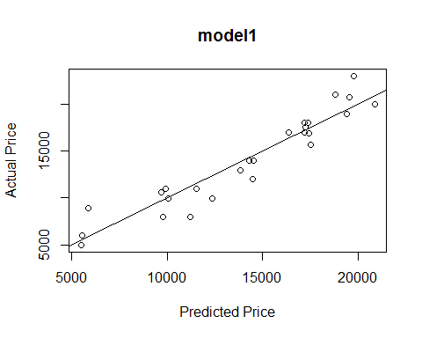

## description cor.Price_hat.Price train.rmse test.rmse percent.error  
## 1 model1 0.9455067 1677.173 1732.109 3.275541

evaluate_model("in.model1", in.model1)

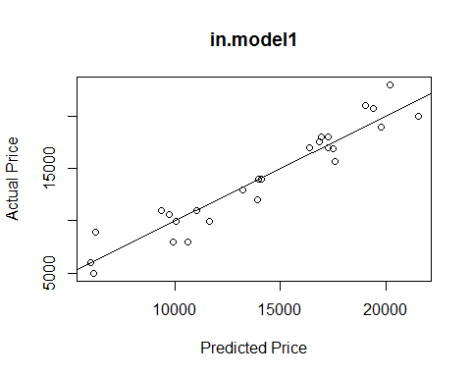

## description cor.Price_hat.Price train.rmse test.rmse percent.error  
## 1 in.model1 0.9556649 1675.764 1629.282 -2.773752

evaluate_model("sq.model2", sq.model2)

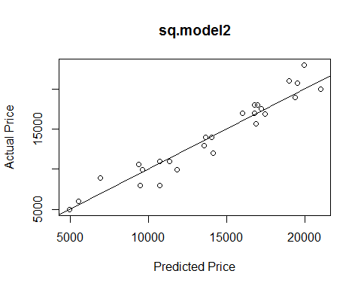

## description cor.Price_hat.Price train.rmse test.rmse percent.error  
## 1 sq.model2 0.9603641 1565.116 1519.912 -2.888264

#Pick up in.model1: Price~Mileage+Age+C2+L1+M_A as the best model because of low percent.error.  
  
  
#heteroscedasticity  
library(MASS)  
plot(in.model1)

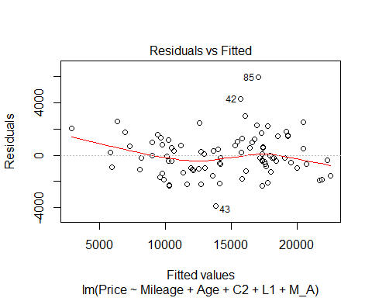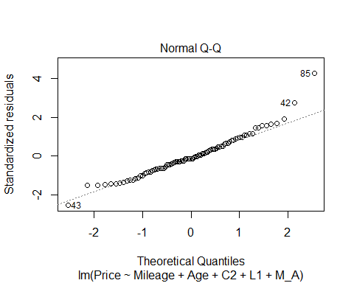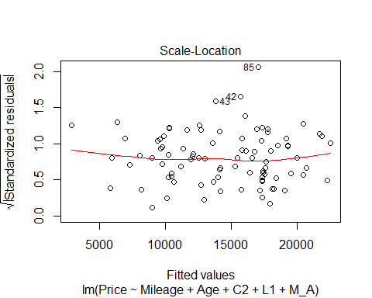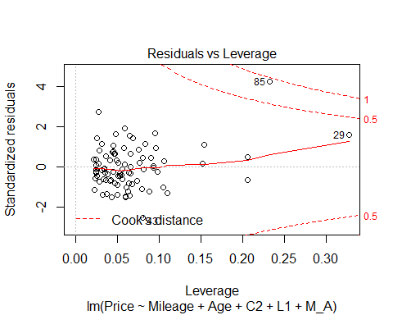

standardized.residuals = rstandard(in.model1)  
  
standardized.residuals[85-1]

## 84   
## -0.2436802

standardized.residuals[43-1]

## 42   
## 2.74549

standardized.residuals[42-1]

## 41   
## 1.448006

standardized.residuals[29-1]

## 28   
## -0.6502143

#None of the point's Cook's distance > 1  
#None of the point locates out of 3s.  
#So, could be treated as no outlier, no infuencial points.  
  
  
#Plot model  
require(effects)

## Loading required package: effects

## Warning: package 'effects' was built under R version 3.2.5

##   
## Attaching package: 'effects'

## The following object is masked from 'package:car':  
##   
## Prestige

mean = mean(UH$Age)  
sd = sd(UH$Age)  
fit=lm(Price~Mileage+Age+C2+L1+Mileage:Age,data=UH)  
plot(effect("Mileage:Age", fit,, list(Age=c(mean-sd, mean, mean+sd))), multiline=TRUE)

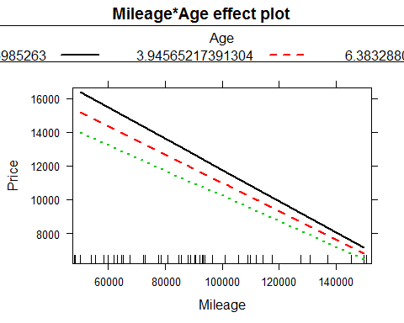

summary(fit)

##   
## Call:  
## lm(formula = Price ~ Mileage + Age + C2 + L1 + Mileage:Age, data = UH)  
##   
## Residuals:  
## Min 1Q Median 3Q Max   
## -3845.2 -1001.9 -190.4 848.4 5927.8   
##   
## Coefficients:  
## Estimate Std. Error t value Pr(>|t|)   
## (Intercept) 2.254e+04 5.185e+02 43.468 < 2e-16 ***  
## Mileage -9.775e-02 1.030e-02 -9.489 4.96e-15 ***  
## Age -6.685e+02 1.526e+02 -4.382 3.31e-05 ***  
## C2 -1.104e+03 4.141e+02 -2.666 0.00916 **   
## L1 -8.172e+02 3.624e+02 -2.255 0.02667 *   
## Mileage:Age 3.513e-03 1.607e-03 2.186 0.03154 *   
## ---  
## Signif. codes: 0 '***' 0.001 '**' 0.01 '*' 0.05 '.' 0.1 ' ' 1  
##   
## Residual standard error: 1593 on 86 degrees of freedom  
## Multiple R-squared: 0.8875, Adjusted R-squared: 0.881   
## F-statistic: 135.7 on 5 and 86 DF, p-value: < 2.2e-16

#The final model for predicting used Honda is:  
#Price=22540-0.09775*Mileage-668.5*Age-1104*C2-817.2*L1+0.003513*Mileage*Age  
  
  
#Predict Price:  
#i. Mileage=20000, Age=1, Color= Brown, location= Durham,   
#Mileage=20000, Age=1, C2=1,L1=0  
predict1=predict(fit, data.frame(Mileage=20000, Age=1, C2=1,L1=0))  
print(predict1)

## 1   
## 18878.83

#Mileage=50000, Age=7, Color= Black, location= Santa Cruz  
#Mileage=50000, Age=7, C2=0, L1=0  
predict2=predict(fit, data.frame(Mileage=50000, Age=7, C2=0,L1=0))  
print(predict2)

## 1   
## 14198.31

#Mileage=80000, Age=2, Color= White, location= St. Paul  
#Mileage=80000, Age=2, C2=0,L1=1  
predict3=predict(fit, data.frame(Mileage=80000, Age=2, C2=0,L1=1))  
print(predict3)

## 1   
## 13123.73