HW3writeup

Yiming Ge

1560672

Problem4

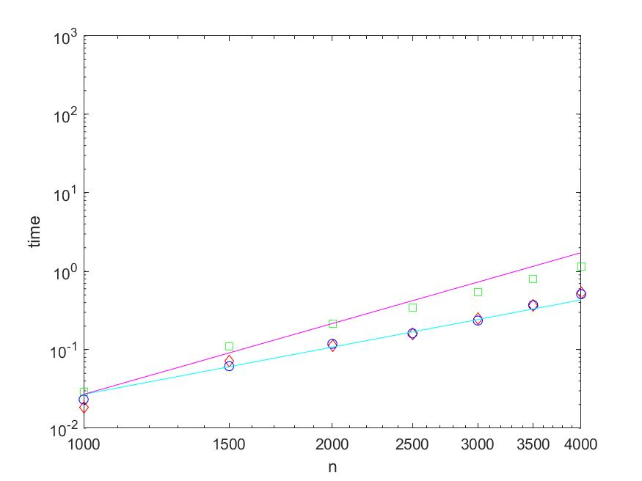

Comment:

Speed:

It seems like backslash should quicker than LU and inverse.

Backslash > LU > inverse

Inverse method is close to the line of O(n^3)

Backslash and LU method are close to the line of O(n^2)

Problem5

Backslash LU decomposition Inverse

1000times 0.0892s 0.0199s 0.1954s

10000times 0.8821s 0.1923s 2.0384s