HW5

Yiming Ge

2/18/2019

## R Markdown

This is an R Markdown document. Markdown is a simple formatting syntax for authoring HTML, PDF, and MS Word documents. For more details on using R Markdown see <http://rmarkdown.rstudio.com>.

When you click the **Knit** button a document will be generated that includes both content as well as the output of any embedded R code chunks within the document. You can embed an R code chunk like this:

library("wooldridge")  
  
## 1  
data1 <- lawsch85  
l1 <- lm(log(data1$salary) ~ data1$LSAT + data1$GPA + log(data1$libvol) + log(data1$cost) + data1$rank)  
summary(l1)

##   
## Call:  
## lm(formula = log(data1$salary) ~ data1$LSAT + data1$GPA + log(data1$libvol) +   
## log(data1$cost) + data1$rank)  
##   
## Residuals:  
## Min 1Q Median 3Q Max   
## -0.301356 -0.084982 -0.004359 0.077935 0.288614   
##   
## Coefficients:  
## Estimate Std. Error t value Pr(>|t|)   
## (Intercept) 8.3432262 0.5325192 15.667 < 2e-16 ***  
## data1$LSAT 0.0046965 0.0040105 1.171 0.24372   
## data1$GPA 0.2475238 0.0900371 2.749 0.00683 **   
## log(data1$libvol) 0.0949932 0.0332544 2.857 0.00499 **   
## log(data1$cost) 0.0375539 0.0321061 1.170 0.24427   
## data1$rank -0.0033246 0.0003485 -9.541 < 2e-16 ***  
## ---  
## Signif. codes: 0 '***' 0.001 '**' 0.01 '*' 0.05 '.' 0.1 ' ' 1  
##   
## Residual standard error: 0.1124 on 130 degrees of freedom  
## (20 observations deleted due to missingness)  
## Multiple R-squared: 0.8417, Adjusted R-squared: 0.8356   
## F-statistic: 138.2 on 5 and 130 DF, p-value: < 2.2e-16

## t-value = -9.541 < -1.96, reject null hypothesis and is significant.  
## Averagely, salary will decrease about 3.3% if rank increases about 10.  
  
## 2  
library(car)

## Loading required package: carData

null = c("data1$LSAT" , "data1$GPA")  
linearHypothesis(l1, null)

## Linear hypothesis test  
##   
## Hypothesis:  
## data1$LSAT = 0  
## data1$GPA = 0  
##   
## Model 1: restricted model  
## Model 2: log(data1$salary) ~ data1$LSAT + data1$GPA + log(data1$libvol) +   
## log(data1$cost) + data1$rank  
##   
## Res.Df RSS Df Sum of Sq F Pr(>F)   
## 1 132 1.8942   
## 2 130 1.6427 2 0.25151 9.9517 9.518e-05 ***  
## ---  
## Signif. codes: 0 '***' 0.001 '**' 0.01 '*' 0.05 '.' 0.1 ' ' 1

## Individually, LAST fails to reject null and GPA rejects null. Jointly,  
## LAST and GPA reject null hypothesis because F-statistics = 9.9517 > 3.07.   
  
## 3  
l2 <- lm(log(data1$salary) ~ data1$LSAT + data1$GPA + log(data1$libvol) + log(data1$cost) + data1$rank + data1$clsize + data1$faculty)  
null1 = c("data1$clsize" , "data1$faculty")  
linearHypothesis(l2, null1)

## Linear hypothesis test  
##   
## Hypothesis:  
## data1$clsize = 0  
## data1$faculty = 0  
##   
## Model 1: restricted model  
## Model 2: log(data1$salary) ~ data1$LSAT + data1$GPA + log(data1$libvol) +   
## log(data1$cost) + data1$rank + data1$clsize + data1$faculty  
##   
## Res.Df RSS Df Sum of Sq F Pr(>F)  
## 1 125 1.5974   
## 2 123 1.5732 2 0.024259 0.9484 0.3902

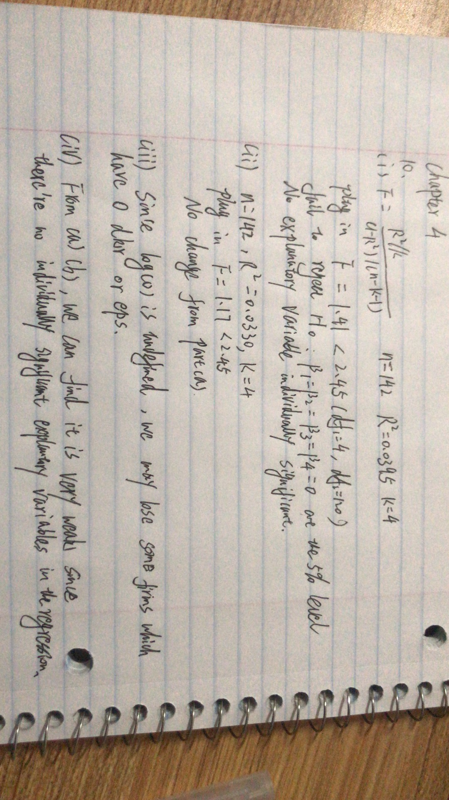## Since F - statistics = 0.95 < 3.07, it fails to reject null jointly.  
  
## 4  
## The location and the faculty quality may influence the rank of law school.