

SCHOOL OF COMPUTING

Diploma in Information Technology

ST0508 Software Application Project

Students’ Project Guide

CONTENTS Page No.

- Module Overview
  - Introduction 3
  - Module Aims
  - Module Plan
  - Assessment

2. Project Guides 4
  - Introduction
  - Weekly Progress
  - Role of Supervisor
  - Role and Responsibility of Group
  - Time-tabled Meetings 7
  - Project Management 9
  - Project Deliverables 10
    - Phase I and II Submission
    - Phase I and Phase II Written Report
    - Phase I and Phase II Presentation
    - FYP Showcase and Promotional Materials
    - Peer Assessment (Online)
  - Some Useful Tips for the Presentation 12
  - Project Resources 13
  - Tips For Managing Your Client 13
2.10 Managing Team Conflict 15
2.11 Software Development Approach 16

Appendix
Appendix A: Guidelines on structure of Phase 1 Report
Appendix B: Guidelines on structure of Phase 2 Report
Appendix C: Weekly Monitoring Report
Appendix D: Minutes of Meeting Template

1. Module Overview

  - Introduction
The Solutions Development Project module is a third-year core module for the SD Option of the Diploma in Information Technology Course.

  - Module Aims
Upon successful completion of this module, students should be able to show the following competencies:

- Develop front-end web client interfaces
- Develop software applications in various platforms and good coding practices.
- Participate and contribute to the review, analysis and verification of business and software requirements
- Apply software development methodologies
- Create and maintain software applications in accordance to technical detailed design
- Code from component specifications and test scripts
- Integrate software applications with Database Management Systems
- Prepare technical documentation on software applications development
- Develop test plan and run unit testing to determine functionality of software applications
- Participate and contribute to the review and verification of test requirements and test cases
- Perform post-build and deployment testing to facilitate software deployment releases

1.3 Module Plan
The schedule for this module is outlined below.

WEEK | PRACTICAL
1-2 | Requirements Analysis and Specification
3-5 | Functional Specification, System Design and Report Writing
6 | Presentation
6-12 | Coding and Testing
13-17 |  | Deployment, Gathering Data and Report-Writing
18 |  | Demonstration/Presentation

Throughout the whole duration of the project, documentations (including system documentation and user guide) should be carried out in concurrent with the other project tasks.

  - Assessment

It is important to understand how the project will be assessed. A good Software Application Project involves a combination of sound background research, a solid implementation and a thorough evaluation of the project's output in both absolute and relative terms. A good tip is to try to think of the project as an “investigation", rather than an effort to deliver a fully-functioning "product". Proper evaluation of the project is thus crucial to achieving better marks.

Invariably a good project must cover some new ground, e.g. by developing a complex application which does not already exist, or by enhancing some existing application or method to improve its functionality, performance etc.

At the end of Phase I, students will need to submit a group project report and present the project requirement analysis, requirement specification and preliminary system design. A demonstration of the application system by the group members and submission of system documentation, program listings and a user guide are required at the end of Phase II.

Evaluation will be based on both individual performance and group performance.
The assessment weightings are as follows:

CA | Assessment Component | Weightage
 | Phase I
CA1 | Technical Competency | 20%
CA2 | Presentation | 10%
 | Phase II
CA3 | Technical Competency | 30%
CA4 | Presentation | 40%
 | Total | 100%

The following list of major criteria is used in the assessment.

- Technical Competency and Teamwork
- Practical abilities and expecting quality (effort shown in development of software system using appropriate techniques, methods and tools, acceptable quality produced)
- Contribution to team’s work / Leadership Assessment (Does work, engage in team activities, leader empowers group members towards collaborative solutions)
- Having relevant knowledge, skills and abilities (apply concepts learnt, include taught and self-taught knowledge). There is an online quiz on project management in Phase 1 only.
- Report Writing (Content, Language, Organization and Format, Visuals)

- Presentation/Demonstration
- Delivery (verbal: volume, clarity, pace & pauses, pitch & tone, non-verbal: eye contact, gestures, facial expression, posture & body movement)
- Visuals (supporting materials, multi-media)
- Organisation (structure, sequence of information, transitions, time management)
- Content (scope, depth, relevance, application)
- Q&A (knowledge, clarity, answering techniques)

Technical Competency/Teamwork and Report will be evaluated by Project Supervisor. Presentation will be evaluated by Neutral Judges.

Technical Competency is mainly individual assessment and Presentation is group assessment. Peer evaluation result will be used for validating Contributing to Team’s Work and Leadership Assessment.

- Project Guides

2.1 Introduction
You will form groups of four to five members. Members of the project group will play the role of the project leader, assistant leader and project members. Make sure that everyone knows his role and responsibility and does it well throughout the project duration. The project is to be completed within the stipulated time frame. Therefore, proper project control and teamwork is very important in order for your group to deliver a successful software product, good project presentation and demonstration.
Read through the project outline carefully and clarify any doubts with your project supervisor. Work out a project specification (agreeable by the supervisor and external client) and a project plan.
You are expected to incorporate the different phases of the system development, from analysis through implementation. You are also required to present technical information effectively through a written technical report and presentation.

2.2 Weekly Progress
Once the group embarks on the project, a project plan is to be prepared. In the plan, the tasks allocated to each member and the estimated duration for completing the task must be clearly indicated. The leader will monitor the progress of the project based on the project plan.
Each group is expected to complete the weekly monitoring form. A sample of each form is given in the appendix C.
The project leader must do the following:
- Complete all the sections in the weekly monitoring report.
- To encourage self-directed learning & problem solving skills, students are strongly encouraged to brainstorm the solutions to the problems as a group prior to bringing up the issue to the supervisor.
2.3 Role of the Supervisor
A project supervisor will be assigned to each group to monitor the group’s progress and your participation. The supervisor will:

- Liaise with the project sponsor and the student group to finalise the project scope and the agreeable deliverables.
- Ensure that the allocation of workload among the group members is fair and agreed upon.
- Meet regularly (1.5 hour per week - as per allocated time in timetable with the group to provide consultation pertaining to the project).
- Ensure that the group adhere to deadline and work according to schedule.
- Advice the project group so that they are heading in the right direction and within the project scope.
- Assess the budget / resource requirement for in-house project if needed.
- Collect deliverables from group submission.
- Give feedback on group performance and individual team performance.

Note: Technical work should be the responsibility of students. Supervisors may give some suggestions but they are not expected to provide any technical solution.

2.4 Roles and Responsibilities of the Group
A project leader is either chosen by the members or assigned by the supervisor. All members should work closely as a group. The success of the project is highly dependent on how well you work with one another in the group.
The leader’s responsibilities are as follows:
- Plan and track progress of the group.
- Discuss problems encountered with the supervisor when necessary.
- Ensure all members attend scheduled meetings and provide explanations if members are unable to attend.
- Ensure the participation and fair contribution of all group members and where necessary, notify the supervisor if members do not co-operate.
- Act as the contact point for the supervisor.
- Update all project documentation.
- Help resolve problems between members, particularly if some members are not cooperative. Deal with members without prejudice.

Members' responsibilities are:
- Perform the tasks allocated according to the project plan.
- Participate in all activities organized for the group.
- Cooperate with each other in the group, and resolve any differences amicably.
- Carry out programming tasks – module coding, testing and integration of modules.

2.5 Time-tabled Meetings
The project group should hold regular meetings to report the progress of the project, to exchange ideas, to discuss various issues and problems and resolve differences. Not all meetings require the presence of the supervisor. However, the group should meet the supervisor as often as is needed or once a week. It is important that the group keeps a record of the discussion and meeting. Important issues should be highlighted to the supervisor.

Features of a well-organized team meeting

Items | Comments
Chairperson | The chairperson should prepare the agenda, ensure that suitable accommodation has been booked, and check that everyone is able to attend, or has had the opportunity to send in any contributions on paper or by e-mail.  In many teams the role of chairperson is rotated to give everyone the opportunity to experience the role, and to share the workload.
Agenda | Each meeting should have a clear agenda, with items such as:  - Last meeting's action points  - Progress report from each individual  - Project issues and concerns from each individual  - Reviews of deliverables  - Discussion of approaches to, and problems with, project tasks  - Review of the plan, and agreed actions for each individual for the coming week/fortnight  - Issues for discussion with your supervisor  In addition, you may dedicate further meetings to the production of key deliverables or to workshop-style activities, but these should not displace your regular progress meetings.
Minutes | The actions arising from each meeting along with all team decisions must be carefully documented in a set of minutes that is typed up quickly and distributed to all team members (often using e-mail). This will prevent time being wasted on repetition of discussions, ensure that all decisions are understood by all team members, and provide an audit trail for use in the case of future dispute.  Producing minutes should not be too arduous if a standard layout is reused for each meeting (most points can also be documented in a bulleted list). The role of meeting secretary should be rotated. However, most teams will identify an overall team secretary who should ensure that a copy of each set of minutes is deposited in the team's filing structure.
Accommodation | Try to find suitable accommodation that will allow you some privacy and preferably facilities such as a flipchart.  Avoid holding your meetings in a social setting, such as a café or food courts as you will find it hard to adopt a professional approach in such surroundings.
Decision process | Occasionally, you will come across issues where there is no obvious answer, or where you are unable to achieve consensus within the team. In order to handle these cases you will need to set up a decision-making process, such as voting. Whatever system you adopt, you should make sure that all team members are happy with it before you need to use it.
Refer to Minutes of Meeting template in Appendix D

Standard Agenda items for supervisor meetings
Items | Comments
Last meeting’s action points | There is little point in reading through the minutes action points or notes of your last meeting (unless a long time has elapsed and your supervisor needs reminding about the details of your project). In order to maximise the use of your time, you should simply review the action points that were agreed at your last meeting.
Progress since last meeting | It is not sufficient just to say that things are 'going OK’. You need to talk about the tasks that you have worked on and the deliverables that you have completed.  You also need to discuss the things that you had planned to do but have not done, and any consequent slippage against your plans. You should have thought about the consequences of this slippage in advance of your meeting, and be ready to discuss the actions you have taken or plan to take to get you back on track.
Issues and questions | This will include problems that have arisen since your last meeting. You may have solved them already, in which case you may wish to confirm that you have done so correctly. If you have not solved them, you should have thought the problem through, and be prepared to discuss your ideas for their solution. Do not expect your supervisor to solve your problems for you, as their job is merely to provide guidance.  It is also useful to review solved problems in order to demonstrate that you are managing your project effectively. You may also have a number of questions about how to approach activities and tasks within your project. The range of such questions is almost limitless. They could, for example, include questions about to booking resources, where to obtain information, how to access training materials, and how to apply modelling techniques.  If you have a long list of issues and questions, you prioritise them and make sure that you deal with important ones first. If you are running short of time, you may well be able to postpone some of the minor issues until your next meeting.
Review of deliverables | Includes any draft reports or development products that need to be reviewed with your supervisor. You should bring copies (for yourself and for your supervisor) of any relevant documents to the meeting.
Risks | You should discuss any worries you have about events or issues that may affect your project over the coming weeks. Your supervisor may be able to reassure you that your worries are unfounded, or suggest some preventative action to ensure that they do not materialise.
Plan for next period | You should review your latest plan, and discuss the activities you are planning to undertake during the period before your next meeting.  It is possible that your plan will need some revision following your earlier discussion of issues.
Agreed actions | You should close your meetings by reviewing all of the follow-up actions agreed with your supervisor during your meeting.

  - Project Management
Students are expected to be self-directed in learning concept of project management by accessing online resources. Assessment will be based on an online quiz in week 5. This assessment will be computed as part of CA1.
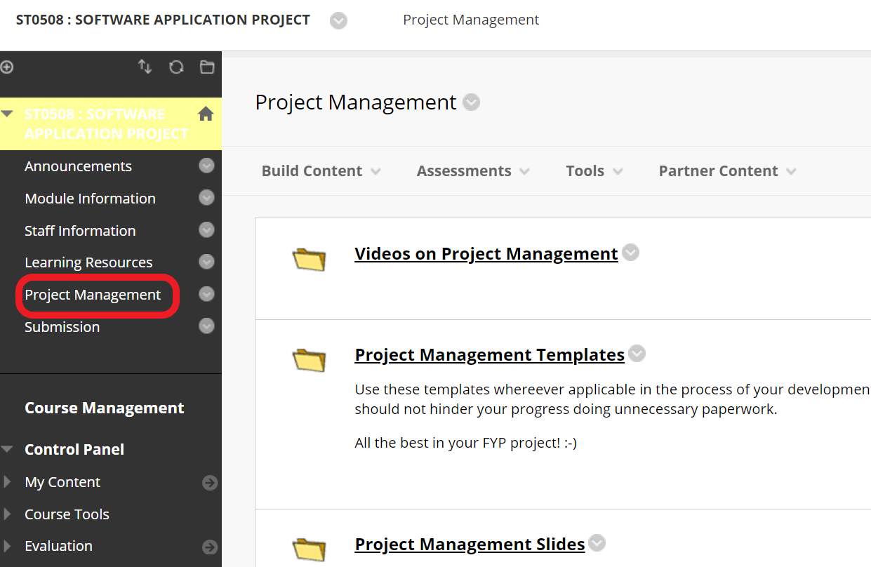
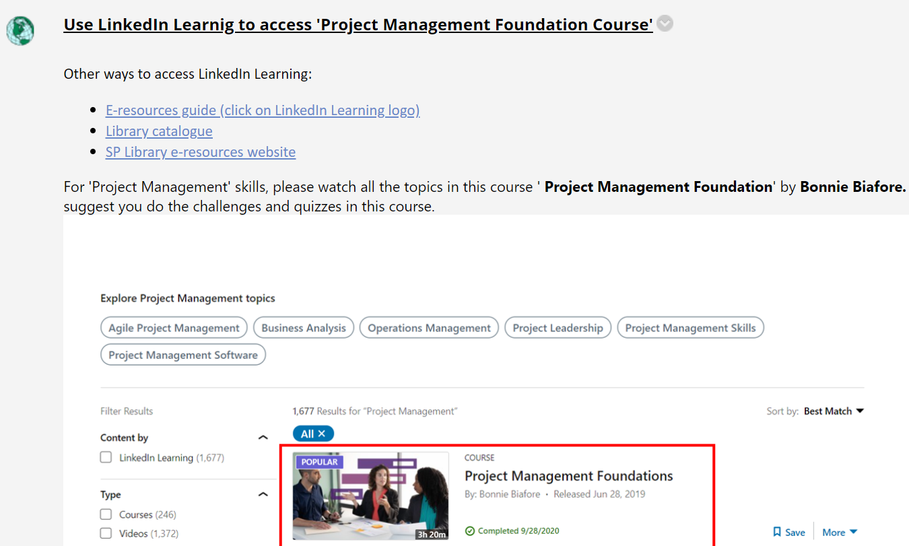
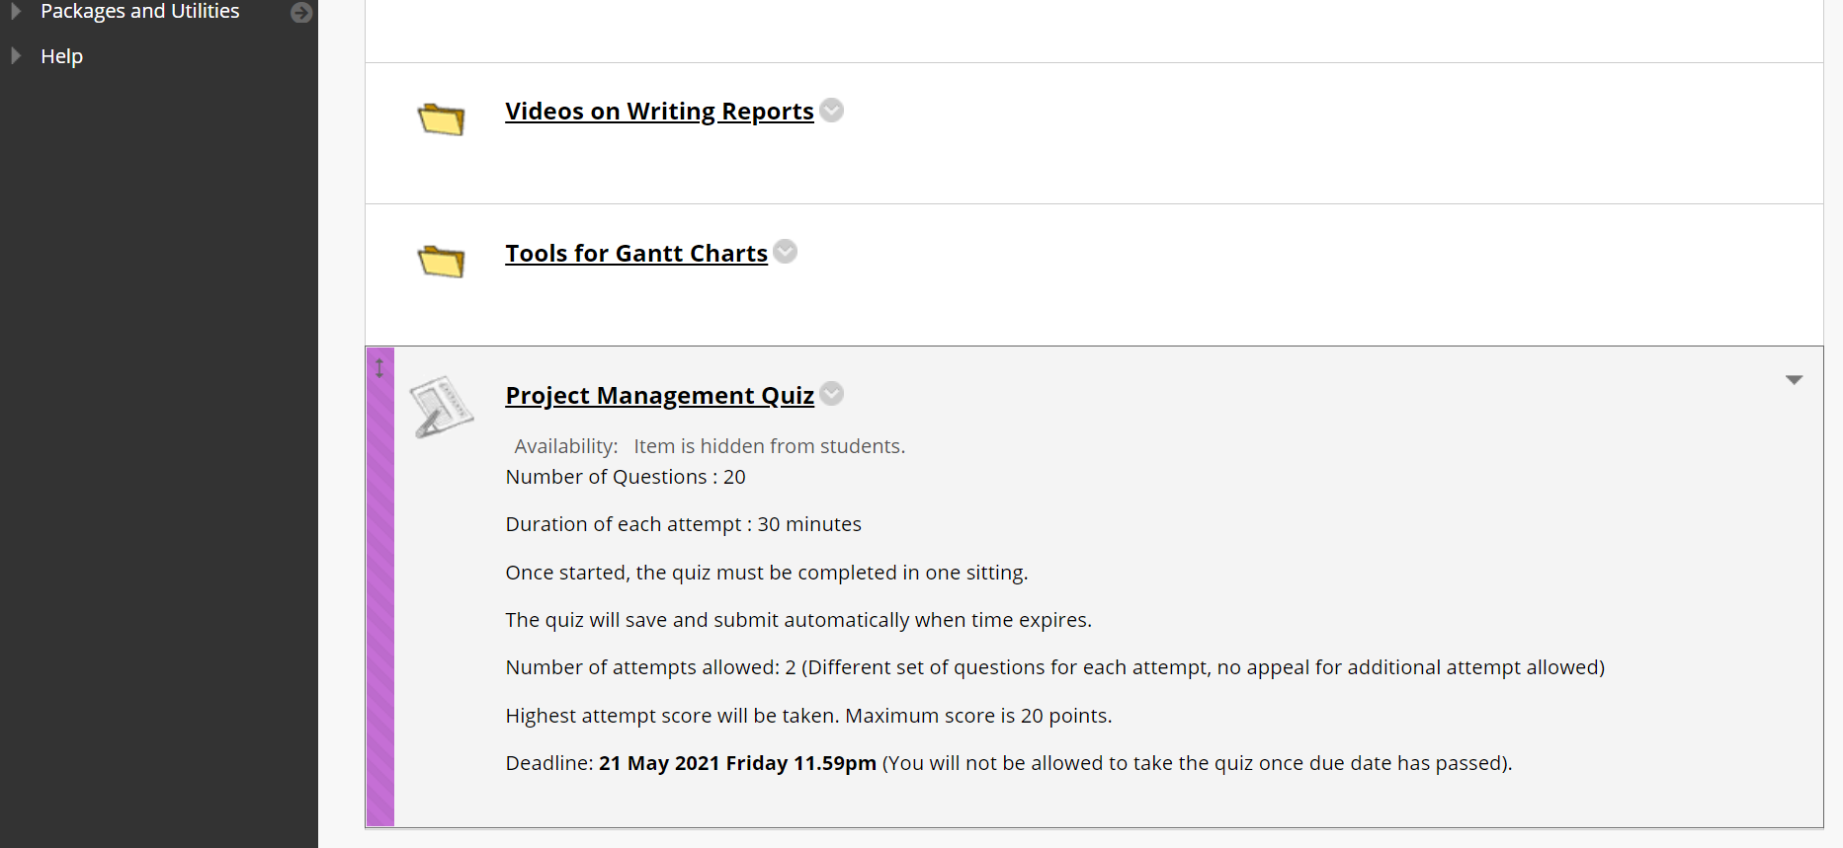

  - Project Deliverables
2.7.1 Phase I and Phase II Submission
The project will be divided into 2 major phases according to the module plan. Note the project deliverables stated in the next two paragraphs as they are used in the evaluation and awarding of marks.
Phase I: Requirement Analysis/Specification and Preliminary Design.
Phase II: Coding/Implementation, Testing, Deployment, Evaluation and Reflection.

You must complete the following for Phase I and II:
Phase | Deliverables | Deadline | Other Information
I | Online Quiz, Report and Slide Decks | Week 5 Fri 23.59pm | Submit via Blackboard
I | Presentation | Week 6 | Exact Time and Date TBC
I | Peer Evaluation | Week 8 Fri 23.59pm | Online format
II II | Peer Evaluation, Report and Slide Decks | Week 17 Fri 23.59pm | Submit via Blackboard
II II | Presentation | Week 18 | Exact Time and Date TBC
II II | Promotional Materials | Week 18 Fri 23.59pm | Refer to Blackboard Announcement

2.7.2 Phase I and Phase II Written Report
Each group is required to submit a written report to the supervisor. (Refer to Appendix A and Appendix B for contents of the report)

2.7.3 Phase I and Phase II Presentation
Not all members need to conduct presentation but all members must attempt to answer during Q&A.

In Phase 1 presentation, the group has to present the following:
- Background of client’s organization
- Objectives
- Project Analysis
- Requirement Specification
- Design Specification
- Wireframes and Prototype
- Schedule Plan and Major Milestones
- Conclusion

In Phase 2 presentation, the group has to present the following:
- Introduction
- Method and execution
- Demonstration
- Analysis of results
- Conclusion

Note: All reports and slide decks must be submitted via Blackboard, adhere to the deadline provided. Team conducting presentation must use the slides submitted.

2.7.4 FYP Showcase and Promotional Materials
Near end of semester, the school arranges a FYP Showcase event where all groups are expected present their projects in SP or online. The purpose is to encourage students to share their work with others.
To prepare for the event, every group will need to prepare some promotional material - A poster and video of the project. Details of specifications are available in Blackboard.
2.7.5 Peer Assessment (Online)
Peer learning is closely aligned with peer assessment, since during the process of assessing, reviewing and feeding back on each other’s work, students are also learning from and with each other – this is assessment for learning NOT assessment of learning.

Desirable conditions for fostering peer learning:
- Emphasizing value in cooperation and the roles involved.
- Establishing trust
- Discuss student expectations
- Agreeing on the process
- Encouraging reflection and reflective discussions
- Discussing and acknowledging previous negative (or positive) experiences with similar activities
- Providing and considering practical suggestions for how to change attitudes
- Students need to accept each other as true peers for peer learning and assessment to be effective.

Please refer to ‘TBL System Student Guide.pdf’ available in Blackboard for details.

2.8 Some Useful Tips for the Presentation

Presentation (and demonstration as well) is an important component of the assessment of project. As such, besides doing your best to develop your product, you should come well-prepared for the presentation. The following pointers may be useful.

As mentioned in 2.7.3, not all members need to conduct presentation but all members must attempt to answer during Q&A.

Rehearsal

You should run through the entire sequence of the presentation at least once before the actual presentation preferably at the same location where the presentation will be conducted. Ensure that you test your product on the actual machine that will be used at least some days before and the night before. If you need to use specific rooms or machines not assigned to your group, book them through your supervisor. Run through the various topics that you want to present. Check the equipment to make sure that they are in working condition.

Visual Aids

Try to make sure that your slides are not too detailed or too sparse. Rogerson (1989: 05) suggests 40 to 50 words per slide can be absorbed in one go, whereas Berndtsson et al. (2008: 95) suggest a maximum of seven lines of text with no more than seven words per line. Large paragraphs should be avoided.

Attire
Dress properly and formally to give project evaluators a good impression. This is important in any formal presentation. The group should discuss and agree on the dress code.

Delivery
Oral presentation can often suffer from over preparation. Sometimes presentations appear stilted; the talk doesn’t flow naturally, the speaker appears to be reading from a well-rehearsed script rather than talking to the audience. Try not to fall into this trap by learning your presentation word for word. The audience expect to be spoken to as people, not read to from a script. Remember that they are all individuals and expect to be spoken to as such rather than an amorphous group.

Questions & Answers
Project evaluators will ask questions during the presentation or demonstration to test your understanding and the extent of your involvement in the project. Try your best to answer. You should answer questions to the point during the presentation or demonstration.

2.9 Project Resources

2.9.1 Note on Laboratory/Room Time-tabling
Some projects required specific resources to be used in the development of the application. As such, the Time Tabling Committee will assign venues with the time slots to the project groups. These project groups are required to work on the assigned venues during the time-tabled slots.

2.9.2 Notebook computer
Each project group is allowed to sign out a notebook PC from the Comtech solely for the purpose of the project module. The group must obtain the approval from the supervisor if they want to install legitimate software required by the project on the notebook. The whole group will be collectively responsible for the notebook. All group members will have to bear the cost for repairing or replacing the notebook if it is damaged or stolen.

2.10 Tips For Managing Your Client

Items | Comments
Act early | Many of the benefits of working with a client are associated with investigating real-world requirements. As these should take place early in your project, you have an ideal opportunity to start work on the client-based aspects of your project as soon as possible. This will enable you to take advantage of the initial backing of your client and to demonstrate your commitment and professionalism.  If there is a significant delay to your starting work on your project, it will give the appearance of lack of interest, which will quickly be mirrored by your client.
Emphasize business benefits | In your communications with your client you should stress the business benefits of your project.
Make efficient use of time | Ensure that you plan in advance for all activities involving your client or their representatives. This may involve developing a highly structured approach to interviewing, analysing company documents thoroughly before following up with targeted questions, and making sure that every client site visit has a real and clear purpose.
Clarify and document well | You should document all contact with your client thoroughly, and make every effort to clarify issues on the spot, rather than relying on follow-up visits. Client time is a valuable commodity, and you should not waste it by revisiting issues that you should have resolved previously.
Agree formal User Requirement Document | Your User Requirement Document needs to be understood and agreed formally by your client. If they fail to appreciate the details of your project or, worse, cannot spare the time to assess it properly, you should be uneasy about their real levels of commitment.
Report Progress | The progress reports that you provide for your client should be brief (two or three paragraphs, possibly by e-mail) and above all should be regular. You should focus on what you have done since the last report, and what you plan to do before the next one. Do not leave it too long between reports, as this will give the impression of lack of commitment on your part.
Use your supervisor to manage issues | If you have a major issue that jeopardises the success of your project you should review it with your supervisor before raising it with your client. You should attempt to resolve lower-level issues with your supervisor wherever possible.
Diarise early | Try to book your client visits and your access to resources as early as you can.
Have fallback position | In any client-based project you must have a contingency plan that includes a fall-back position in the event that you do not receive the support you anticipated, No assessor is likely to accept the excuse that your project failed because your client was unavailable.
Establish business contacts | The main client sponsor of your project is likely to be a relatively senior figure within the business, This is important to ensure that your project has real backing, However, you should also try to establish lower-level contacts within the business, as you are will find it easier to get access to them.
Shield your client from academic deliverables | In all dealings with your client you should focus on the business deliverables/ even to the extent of producing a tailored 'client' version of your final report.

2.11 Managing Team Conflict

Items | Comments
Non-contribution of one or more individuals | If an individual is failing to work as a member of the team, the issue should be discussed openly in a meeting, and not in corridors or the crowded areas.  The aim should be to provide opportunity for the individual to contribute fully (for example by identifying more suitable tasks, identifying any personal issues that might be affecting the individual or ensuring that their role and responsibilities are understood fully), not to find ways of excluding them.  If, despite the best efforts of the team, you are unable to bring the individual back into the team, you should raise the issue with your project supervisor.
Lack of commitment to the goals of the team | In some teams there may be an absence of team spirit or clear goals for the team. Again, this should be discussed openly in team meetings, before raising it with your supervisor.
Internal disagreements | Occasionally disputes can arise within a team, either between two individuals who have fallen out for personal reasons, or because a specific project decision is being challenged.  If the issue is a disputed decision, then it should be clarified at the next team meeting, and resolved using the team's agreed decision-making process. If the issue is an interpersonal problem it may not be resolvable within the team and will need to be passed to your project supervisor as soon as possible.
Poor organization | Teams more often fall apart through a general lack of organisation than any other specific cause. The most frequent issues are pool planning, unclear roles and responsibilities, and lack of communication.  All of these points should be addressed at the beginning of the project, but if problems arise during the course of the project they should be raised at an early stage with your supervisor (you are unlikely to be operating effective team meetings in this case).

2.12 Software Development Approach

2.12.1 The classical waterfall model (conventional model)

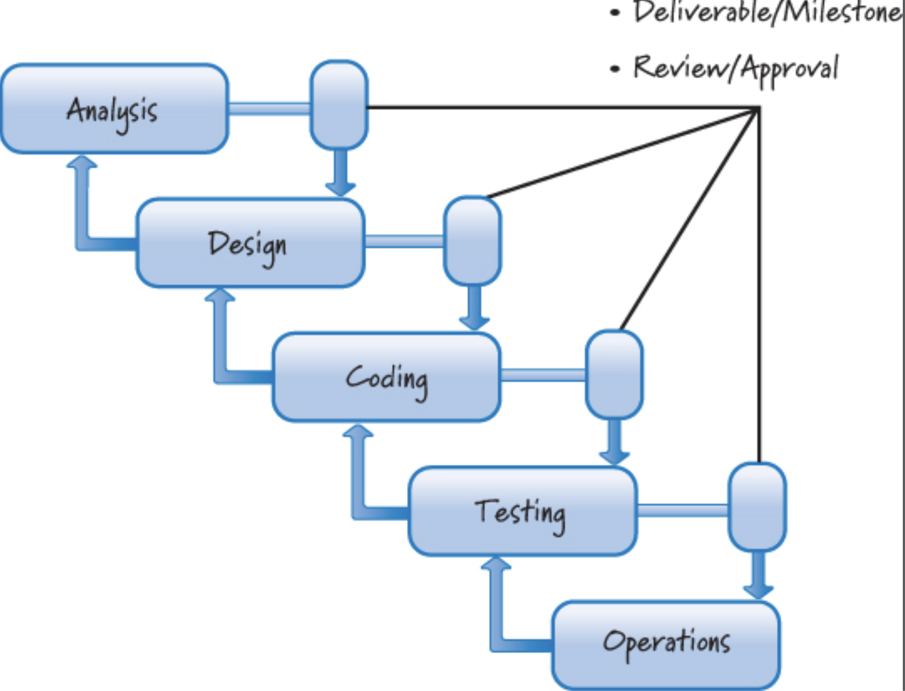

The classical waterfall model was developed in 1956 in an attempt to provide an engineering process to the development of software. This model is so named because it attempt to plan for and anticipate up front all of the features a user might want in the end product, and to determine how best to build those features. This model allowed some limited iteration between stages as shown above as ‘splashing back’ in the above figure.

One of the main problems with this conventional waterfall approach is that the user’s understanding of the problem is unclear and there are ambiguities in the subsequent requirements specification. The conventional approach to software development is only appropriate for projects that are:

- Understood clearly – so that the initial requirements are captured accurately and subsequent specifications and designs are very close matches with what is actually needed.
- Easily deployable – the users are comfortable using the system and they are confident to maintain the system when needed. Or the users, for any reasons, have not decided if they would like the system to be deployed and start using the system till the whole project is completed.

You should only use this approach for your project if you are confident that you fully understand the requirements of the system or they have already been provided to you in an unambiguous way by the client. In most cases, we cannot guarantee to fully understand the needs of our users – in which cases one of the following approaches is perhaps more suitable for you to follow.

2.12.2 The incremental model

Incremental development is based on the age-old principle of “Build some of it before you build all of it.” We avoid having one large, big-bang-style event at the end of development where all the pieces come together and the entire product is delivered. Instead, we break the product into smaller pieces so that we can build some of it, learn how each piece is to survive in the environment in which it must exist, adapt based on what we learn, and then build more of it.

This means that you need to get an overall software structure (kernel) in place as part of the first release of your system. The other parts of the system are then brought online and released to the user as the system is developed. Thus, each release to the user provides added functionality to the existing system. In a project lasting around six months you would not really expect to have more than three releases.

The figure below shows the incremental model – in this case there are three incremental releases for the system. Notice that the requirements for the system are gathered in the usual way at the start of this process.

you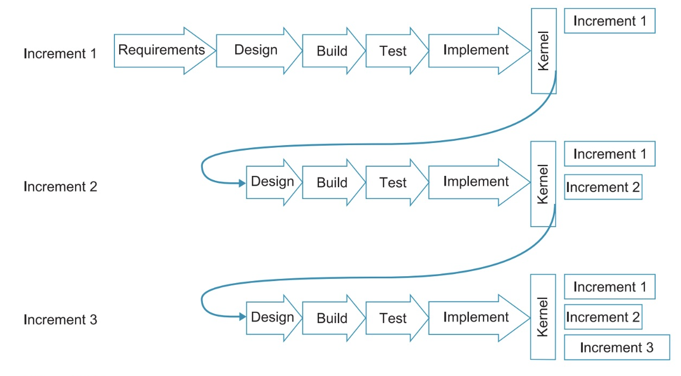
You then design and prepare the first release of the system. This includes a kernel for your program and the first component of functionality that will be useful to the client. The second phase of the process involves designing the second increment of the system and developing and implementing this within the existing system. This process continues until all the increments have been completed and the system is fully working.

The above figure highlights two other aspects of the incremental approach. The first point to note is that the design stages of the later increment are not as detailed as the design stage of the first increment release. This is because the first increment of the system must also include the design of the all-important system kernel (structure). Subsequent releases just need to focus on the individual increments and hence the design stage of these increments is reduced. The second important point to notice is that the increments are nto all the same size – some will add more functionality to the system than others, and some will be harder to produce than others. Consequently, the design, build, test and implement stages of each increment may not be the same size.

When planning to undertake an incremental development it is important to have an outline plan in place for the entire system at the start. You cannot just plan the easiest parts of the system, develop and release these to the user, and worry about the more complex aspects of the system later. It may be that later, as you tackle the harder parts of the development, you discover a fundamental flaw with your ideas that requires you to rework significant parts of your program. This would mean that earlier, easier work that you did on your project would be wasted. You must ensure that you have a good understanding of how the overall system will operate before beginning work on the intermediate releases.

An example of taking the incremental model approach – Two increments
Suppose you were developing a system for a user that logged and statistically analysed calls to a help desk. You might release this system to the user in two increments during the course of your project. The first release would provide the overall structure for the system and would allow user to log calls to the help desk. The second release would provide the added functionality of the statistical analysis of the logged calls (for example, identifying peak periods, common problems, regular callers, etc.). Thus, by providing the user with a partially working system early, it allows them to become familiar with the system’s operation before the added complexities of the analysis component are brought online. The first release would also enable them to start gathering data into the system earlier – data that would otherwise have been lost had they waited for a fully working system later on. This also means that you can check that the right information is being gathered by the system for subsequent analysis by the second release.

Advantages
- The user gets something early so that they can get an idea of the system’s capabilities and an idea of what you are able to produce in the longer term for them. Thus, the client/user can provide early feedback if something isn’t right or improvements can be made. This is particularly useful if the system requirements were not entirely clear at the project’s outset.
- Delivering something early gives you a sense of achievement and the client/user a clear understanding that progress is being made.
- It can help you plan and manage your project more effectively. By breaking the project down into a number of deliverables, you will be able to plan, reasonably accurately, how long each deliverable should take to develop. In addition, when you are controlling your project, any slippage in meeting a deliverable will provide an early warning that your project may be falling behind schedule and you will be able to do something about it.
- The user does not need to learn how to use the entire system in one go. They can be introduced to the system over a period of time, becoming confident with its functionality before later releases add to its complexity.

Disadvantages
- It might be difficult to break your program down into a series of subsystems that are worth delivering to the client/user as separate units. For example, you don’t want to end up providing a large number of small deliverables to the user that appear to provide little improvement over earlier releases. This waste your time and can lead the user to think that you are making little progress and wasting their time too.
- Although it is advantageous to meet your client/regularly, additional contact with them can encourage them to identify too many improvements. They may identify more changes than you have time to implement and the changes they request may take your project in a direction that is inconsistent with the requirements of your FYP module.

Configuration management
As you develop and release new versions of the system you must make sure that you keep track of these versions; what changes have been made, who has made these changes, who has received them, where they are saved/backed-up to, etc? If something goes wrong with a ‘release’ it is useful to be able to go back to the previous version to try to determine what has gone wrong. Make sure that you date stamp each version of the program that you produce. You might also consider updating the version number too (particularly for major changes). This will allow you to keep track of the latest version of your system and, as you make frequent back-ups, which back-up is the most up-to-date. Also, for team projects, keep a note of which team members are working on which parts of the system and consider these questions – will these parts integrate seamlessly? Do you need to define certain coding standards that everyone must adhere to? What are the likely effects of one part of the system on another when they are merged?

If configuration management is going to be an important part of your project, seek advice from technical domain expert who may be able to recommend a software tool to you to support this.

Appendix A: Guidelines on structure of Phase I Requirement Analysis and Specification Report

Section | Description
Cover Page | - School name, Diploma name, Module code and name, Group number,  - Name of project  - Supervisor’s name  - Admission numbers (in asc. order) and names
Content | A single page of contents will be sufficient, listing the top two or three levels of heading within your report.
Abstract/Summary | A brief summary of how you conducted your project, and what it delivered. Always less than one page in length and usually last section to be written.
Background | A few paragraph should be sufficient to cover the background to your project. Try to explain the overall aims of your project, its type and the work you have done to date. You should also describe your external client, if you have one.
Objectives | The list of objectives should be collectively describe what the final deliverables and achievements of your project will be.
Project Analysis | - Identification of Problem Areas  - Method used in gathering User Requirements  - Stakeholder Analysis  - Risk and Impact Assessment  - Resource Analysis
Requirement Specification | - Description of Major Functions (eg. Web Site, Mobile App, Admin Portal etc)  - Features and Functionality
Design Specification | - Project architecture  - Database design  - Use cases
Wireframe Interface | Sitemap  Wireframe (Initial Sketches and Improvised Design)  User Flow (where applicable)  Prototype (provide link)
Project Schedule | A complete picture of how and when the project is planned to be executed.
Major Milestones | Timings for your main deliverables and activities. You must ensure that they are aligned with your school’s project submission deadline.
Appendix B: Guidelines on structure of Phase II Final Report

Section | Description | Length in Pages
Cover Page | - School name, Diploma name, Module code and name, Group number,  - Name of project  - Supervisor’s name  - Admission numbers (in asc. order) and names | 1
Acknowledgement | This is usually an optional section giving you the opportunity to thank school, supervisor and client who have provided support to you during the project. | 1
Content | A single page of contents will be sufficient, listing the top two or three levels of heading within your report. | 1
Abstract/Summary | A brief summary of how you conducted your project, and what it delivered. Always less than one page in length and usually last section to be written. | 1
Introduction | The introduction provides a full description of the problem your project was designed to solve and of your objectives. | 1
Requirement review | The requirement review should summarize the current list of features and functions within your problem domain. Brief description of proposed solution. | 8
Method and execution | - Software Development Life Cycle  - Project Architecture  - Constraints  - Revisit Risk and Impact Assessment  - Implementation Schedule (Planned vs Actual)  - Frontend and Backend Coding Process  - Testing  - Deployment | 40
Analysis of results | - Results from User Acceptance Testing (UAT)  - Feedback from client  - Collection of data after deployment to determine efficiency or/and effectiveness of solution (where applicable)  The results of your project should be presented in summary form, with detailed tables of results included in the appendices. | 4
Critical Evaluation | The results and execution of your project should be critically evaluated.  - Things that went well  - Things that went badly  - Discussion of problems encountered and decisions made  - Summary of changes to original scope or plans  - Potential improvements  - Next steps and follow-up actions  - Key messages for future projects  - Reflection on alternative approaches | 4
Conclusion | The conclusion section will provide readers with a high-level summary of the key outcomes of your project and a discussion of your success in meeting the original objectives of your project. | 1
References | References should be provided for all materials that you have referred to in your report. | 1
Appendices | Full details of items referred to in your reports, such as program listings, Program API documentation, Scrum documentations, Weekly Monitoring Reports, Minutes of Meetings | -

Appendix C: Weekly Monitoring Report

Class: | Date: __/___/____(dd/mmm/yyyy)
Supervisor Name:

Project Title:

Project Leader Name: | Signature:

1. Student weekly performance summary
Adm. No. | Name | Progress¹ | Remarks
1.
2.
3.
4.
5.
¹ State whether: A=On Schedule B=Ahead Schedule for no. of days C=Behind Schedule for no. of days

2. Weekly Scrum.
Week No:__ Date: __/___/____(dd/mmm/yyyy)
Member Name 1
Project Progress | Description
Last week’s Progress
(What he has accomplished since last meeting?)
This week deliverables
(What he is going to do before the next meeting?)
Obstacles
(What obstacles are in the way?)
Member Name 2
Project Progress | Description
Last Week’s Progress
(What he has accomplished since last meeting?)

This week deliverables
(What he is going to do before the next meeting?)
Obstacles
(What obstacles are in the way?)

Member Name 3
Project Progress | Description
Last week’s Progress
(What he has accomplished since last meeting?)
This week deliverables
(What he is going to do before the next meeting?)
Obstacles
(What obstacles are in the way?)
Member Name 4
Project Progress | Description
Last week’s Progress
(What he has accomplished since last meeting?)
This week deliverables
(What he is going to do before the next meeting?)
Obstacles
(What obstacles are in the way?)
Member Name 5
Project Progress | Description
Last Week’s Progress
(What he has accomplished since last meeting?)

This week deliverables
(What he is going to do before the next meeting?)
Obstacles
(What obstacles are in the way?)

Appendix D: Minutes of Meeting Template

Date : 11 July 2016 (Monday)
Time : 1:00pm - 2:00pm
Venue : T2256

Reference No. : KK012

Present : Team Leader Hui Min
Assistant Leader Yee Tat
Members Wei Ling
Jie Xiang

Absent with apologies : Jia Yan

Minuted by : Jie Xiang
Vetted by : Hui Min
Signed by : Hui Min

 |  | Action
 | Jie Xiang  - Servo unable to properly function as pan-tilt bracket is too heavy  - Search for a suitable servo  - Share work progress with the team  - Upload codes to common site  - Work with Yee Tat  Wei Ling  - Mobile Application  - Able to work with Android 5 & 6, but not Android 4.  - Might have several seconds of response time  - Need to auto reset voice print usage counter each month  - Authentication  - IBM’s speech-to-text only returns most confident match, need to either  - Request for every possible matches  - Use another API  - Write a standalone program to identify all phrases that can return exact match  - Work around for 1 minute requirement of voice print  - Loop the audio track until it spans 1 minute in duration  - Mr Kwan suggest the voice enrolment can be in the same application as the program stated above.  Yee Tat  - Tasks completed  Hui Min  Will try to merge Stationary Pi with Server Pi  - Stationary just left testing  - Sensors waiting for hardware to solder from external supervisor  - Voice authentication integration left testing  Jia Yan  - Dropbox finished.  - Started writing report  FYP Presentation and Showcase 15 August  ***Invite Gabriel to come at 10am***  10:00-11:45 MLT11 Presentation (8mins)  12:00-12:30 T2031/T2032 Official demo, everyone need to talk  12:30-01:30 Level 4 Lunch  02:00-05:00 T2031/T2032 Man the booth  Additional Notes  Everyone must be present  Set up booth without hardware before 10am  After presentation set up the hardware  Next meeting will be on 18th July 2016 at 1pm. | Jie Xiang and Yee Tat by 7 May 2047  Reported by Wei Ling  Hui Min (provide update by 7 May 2047)  Jia Yan  Hui Min (to be confirmed by 10 August)

