The Later Stone Age technology was thought to have made its first appearance in South Africa much later than it did in Europe. A new analysis of South African finds suggests modern culture emerged in both areas at the same time. In Europe, the Later Stone Age is commonly dated to around 45,000 years ago. In South Africa there is archeological (考古学的) evidence suggesting the Later Stone Age did not begin until much later – around 22,000 years ago.
大家原本认为，旧石器时代晚期的技术在南非出现的时间，比在欧洲晚，但现在发现不是这样的。

考古——其实是同时出现的——有石尖矛的标识——F为PV提供证据——CV：没有快速过度——比想象的早

1.Which of the following is true about Later Stone Age according to the passage?
哪个对旧石器描述是对的
AIt appeared in South Africa much later than it did in Europe.
- BIt did not begin in South Africa 22,000 years ago as it did in Europe.
- CIt appeared approximately the same time in both South Africa and Europe.
（同时出现）
- DIt appeared 22,000 years later in Europe than that in South Africa.

2.
Which of the following is a symbol of Middle Stone Age technology?哪个是进入中时期的标志
考试时的选项顺序
- ACaves.
- BStone spear points.（石矛尖）
- CHunting techniques.
- DBows and bone arrows.

3.
Which of the following is true regarding the study of Francesco d’Errico according to the passage?
关于弗兰西斯哪个是对的
考试时的选项顺序
- AIt revealed the differences between Middle Stone Age technology and Later Stone Age technology.
- BIt examined the layers of Border Cave in South Africa.
- CIt provided further evidence for the conclusion made by Paola Villa.为PV提供证据
- DIt suggested that the modern-day hunter-gatherer society in South Africa appeared earlier than it did in Europe.

4.
What does the evidence of the Border Cave suggest? 又为这个CV证明了什么
考试时的选项顺序
- ALater Stone Age technologies had spread quickly to other areas from the source.
- BThe Border Cave was a perfect place to retain a few elements from earlier times.
- CThe South African populations were reluctant to evolve their tools with the help of Later Stone Age technology.
- DSouth Africa did not shift rapidly from earlier times into the Later Stone Age.（南非没有快速过度）

5.
Which of the following could be the best title for this passage?最好的标题
考试时的选项顺序
- ALater Stone Age technology in Europe and South Africa.
- BLater Stone Age got earlier start in South Africa than thought.（南非的石器起源比想象中早）
- CThe Border Cave, a perfect place for internal evolution.
- DThe Border Cave, a source of Later Stone Age technologies.

二

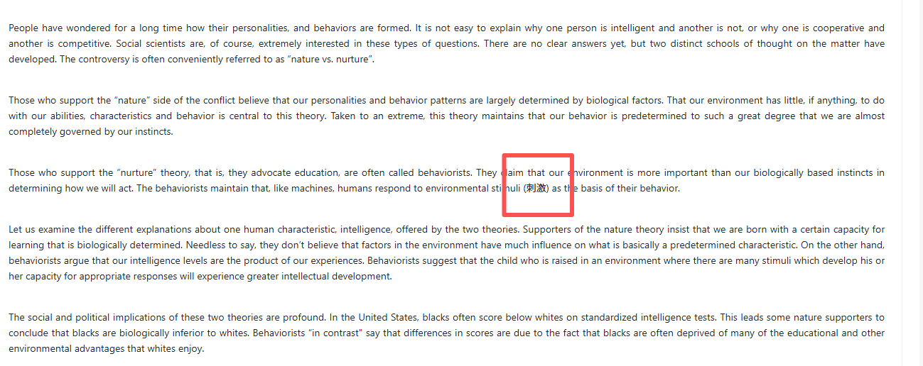

长久以来，人们都在好奇自己的性格与行为是如何形成的。

人们好奇性格形成——为什么有特定性格——由生物因素决定——智力是经验产物——美国黑人？展示两种影响——保持中立

6.
What are social scientists interested in according to this passage?
考试时的选项顺序
- AWhy there is a controversy between nature and nurture theories.
- BWhat are the differences between nature and nurture theories.
- CWhy people have certain personalities and behaviors.（为什么人有特定的性格）
- DWho are more intelligent and cooperative than others.

7.
According to the supporters of the nature side, our personalities and behavior patterns are mainly determined by ____________.
行为由什么决定
考试时的选项顺序
- Aphysical development
- Benvironmental influence
- Cexperience and knowledge
- Dbiological strength（由生物因素决定）
8.
Which of the following is not true about the explanation of intelligence according to the passage? 对智力的解释错的是
考试时的选项顺序
- AThe nature theory believes that intelligence is the product of our experiences.（智力是经验的产物）
- BThe nurture theory believes that intelligence comes mainly from experience.
- CThe nature theory believes that intelligence is biologically determined.
- DThe nurture theory believes that we can improve our intelligence by learning in an environment full of stimuli.
9.
What is the purpose of using the example of American blacks in the passage?用美国黑人举例干嘛
考试时的选项顺序
- ATo show the significance of American blacks for academic research.
- BTo show that American blacks are biologically inferior to whites.
- CTo show that education is important in improving the condition of American blacks.
- DTo show the profound impact brought about by the two theories. （展示两种理论的影响）
10.
What is the author’s attitude toward the two theories in the passage?作者态度
考试时的选项顺序
- AThe author seems to hold a neutral standpoint. 保持中立
- BThe author seems to think that the nurture theory is more reasonable.
- CThe author seems to think that the nature theory is more believable.
- DThe author seems to say no to both theories.

三
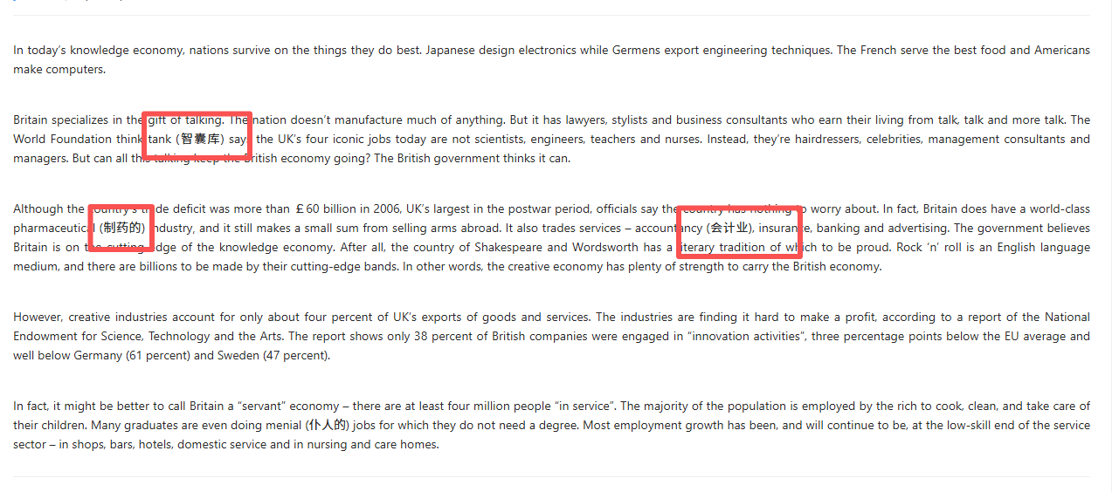
In today’s knowledge economy, nations survive on the things they do best. Japanese design electronics while Germens export engineering techniques. The French serve the best food and Americans make computers.
各国以自身强项立足

国家——国家的最好产品——不担心，因为跟着知识经济，——为什么不创新，因为不赚钱——为什么是服务，因为很多人没技能——作者持怀疑态度

11.
What can be learnt from the first paragraph?
考试时的选项顺序
- AA country has to offer its best products to survive in the knowledge economy.
- BEvery country has its own contribution to today’s knowledge economy.
- CTechnology plays a role in today’s knowledge economy for every country.
- DKnowledge is important for a country’s survival.

12.
Why do some officials say that Britain has nothing to worry about although it suffers a heavy trade deficit?
考试时的选项顺序
- ABecause the creative literary tradition has strength to carry the British economy.
- BBecause they believe Britain still has some world-class industries.
- CBecause they believe Britain is keeping up with the knowledge economy.
- 因为他们认为英国正紧跟知识经济的发展步伐。（不担心贸易经济是因为跟着知识经济？？？）
- DBecause Britain is still making profit from some trade services.

13.
Why were there fewer British companies engaged in “innovation activities”?
考试时的选项顺序
- ABecause creative industries are difficult to make money.（为什么不参与创新活动，是因为不赚钱。）
- BBecause the competition between different economies is fierce.
- CBecause British companies are not good at innovation activities.
- DBecause Britain can rely on other industries to make profits.
14.
What does the author mean by saying Britain’s economy a “servant” one?（为什么称为服务型经济）
考试时的选项顺序
- AMany people are employed to do low-skill jobs.（因为很多人都低技能）
- BMany people are willing to be servants.
- CMany people do not have creative ideas.
- DMany people do not have the ability to earn a degree.
15.
What is probably the author’s attitude toward UK’s current economy?
考试时的选项顺序
- ASneering.
- BDoubtful.（对英国经济状态持怀疑）
- CSympathetic.
- DConfiden

