实验十 Inter-VLAN Routing with an Internal Route Processor and Monitoring CEF Functions

实验目的
Route between VLANs using a 3560 switch with an internal route processor using Cisco Express Forwarding (CEF).
实验拓扑

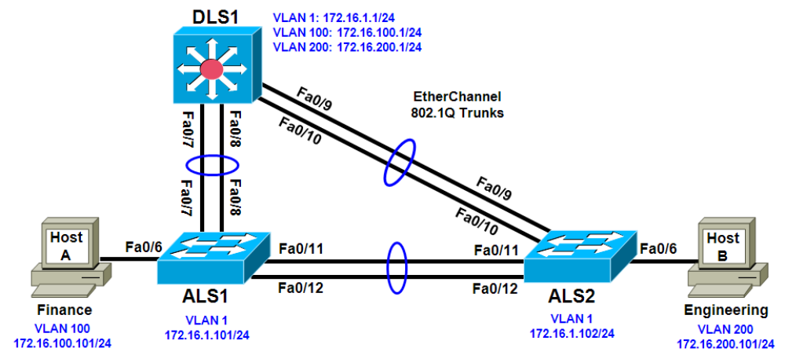

2 Cisco 2960 switches
1 Cisco 3560 switch
实验步骤

Step 1: Configure basic switch parameters.
a. Configure the hostname, password, and optionally, Telnet access on each switch.
Switch(config)# hostname ALS1
ALS1(config)# enable secret cisco
ALS1(config)# line vty 0 15
ALS1(config-line)# password cisco
ALS1(config-line)# login
Switch(config)# hostname ALS2
ALS2(config)# enable secret cisco
ALS2(config)# line vty 0 15
ALS2(config-line)# password cisco
ALS2(config-line)# login
Switch(config)# hostname DLS1
DLS1(config)# enable secret cisco
DLS1(config)# line vty 0 15
DLS1(config-line)#password cisco
DLS1(config-line)# login

b. Configure management IP addresses on VLAN 1 for all three switches according to the diagram.
ALS1(config)# interface vlan 1
ALS1(config-if)# ip address 172.16.1.101 255.255.255.0
ALS1(config-if)# no shutdown
ALS2(config)# interface vlan 1
ALS2(config-if)# ip address 172.16.1.102 255.255.255.0
ALS2(config-if)# no shutdown
DLS1(config)# interface vlan 1
DLS1(config-if)# ip address 172.16.1.1 255.255.255.0
DLS1(config-if)# no shutdown

c. Configure default gateways on the access layer switches. The distribution layer switch will not use a default gateway, because it acts as a Layer 3 device. The access layer switches act as Layer 2 devices and need a default gateway to send management VLAN traffic off of the local subnet.
ALS1(config)# ip default-gateway 172.16.1.1
ALS2(config)# ip default-gateway 172.16.1.1

Step 2: Configure trunks and EtherChannels between switches.
To distribute VLAN and VTP information between the switches, trunks are needed between the three switches. Configure these trunks according to the diagram. EtherChannel is used for these trunks. EtherChannel allows you to utilize both Fast Ethernet interfaces that are available between each device, thereby doubling the bandwidth.

a. Configure the trunks and EtherChannel from DLS1 to ALS1. The switchport trunk encapsulation [isl |dot1q] command is used because this switch also supports ISL encapsulation.
DLS1(config)# interface range fastEthernet 0/7 - 8
DLS1(config-if-range)# switchport trunk encapsulation dot1q
DLS1(config-if-range)# switchport mode trunk
DLS1(config-if-range)# channel-group 1 mode desirable
Creating a port-channel interface Port-channel 1

b. Configure the trunks and EtherChannel from DLS1 to ALS2.
DLS1(config)# interface range fastEthernet 0/9 - 10
DLS1(config-if-range)# switchport trunk encapsulation dot1q
DLS1(config-if-range)# switchport mode trunk
DLS1(config-if-range)# channel-group 2 mode desirable
Creating a port-channel interface Port-channel 2
c. Configure the trunks and EtherChannel between ALS1 and DLS1, and for the trunks and EtherChannel between ALS1 and ALS2.
ALS1(config)# interface range fastEthernet 0/11 - 12
ALS1(config-if-range)# switchport mode trunk
ALS1(config-if-range)# channel-group 1 mode desirable
Creating a port-channel interface Port-channel 1
ALS1(config-if-range)# exit
ALS1(config)# interface range fastEthernet 0/7 - 8
ALS1(config-if-range)# switchport mode trunk
ALS1(config-if-range)# channel-group 2 mode desirable
Creating a port-channel interface Port-channel 2

d. Configure the trunks and EtherChannel between ALS2 and DLS1, and for the trunks and EtherChannel between ALS2 and ALS1.
ALS2(config)# interface range fastEthernet 0/11 - 12
ALS2(config-if-range)# switchport mode trunk
ALS2(config-if-range)# channel-group 1 mode desirable
Creating a port-channel interface Port-channel 1
ALS2(config-if-range)# exit
ALS2(config)# interface range fastEthernet 0/9 - 10
ALS2(config-if-range)# switchport mode trunk
ALS2(config-if-range)# channel-group 2 mode desirable
Creating a port-channel interface Port-channel 2

e. Verify trunking between DLS1, ALS1, and ALS2 using the show interface trunk command on all switches.
DLS1# show interface trunk

f. Use the show etherchannel summary command on each switch to verify the EtherChannels. The following is sample output from ALS1. Notice the two EtherChannels on the access layer switches.
ALS1# show etherchannel summary
Flags: D - down P - in port-channel
I - stand-alone s - suspended
H - Hot-standby (LACP only)
R - Layer3 S - Layer2
U - in use f - failed to allocate aggregator
u - unsuitable for bundling
w - waiting to be aggregated
d - default port
Number of channel-groups in use: 2
Number of aggregators: 2
Group Port-channel Protocol Ports
------+-------------+-----------+---------------------------------------------
1 Po1(SU) PAgP Fa0/11(P) Fa0/12(P)
2 Po2(SU) PAgP Fa0/7(P) Fa0/8(P)
On ALS1, which ports are used for channel group 2?

Step 3: Configure VTP on ALS1 and ALS2.
a. Change the VTP mode of ALS1 and ALS2 to client.
ALS1(config)# vtp mode client
Setting device to VTP CLIENT mode.
ALS2(config)# vtp mode client
Setting device to VTP CLIENT mode.
b. Verify the VTP changes with the show vtp status command. The output on ALS2 is similar to that of ALS1.
ALS2# show vtp status
How many VLANs can be supported locally on the 2960 switch?

Step 4: Configure VTP on DLS1.
a. Create the VTP domain on DLS1 and create VLANs 100 and 200 for the domain.
DLS1(config)# vtp domain SWPOD
DLS1(config)# vtp version 2
DLS1(config)# vlan 100
DLS1(config-vlan)# name Finance
DLS1(config-vlan)# vlan 200
DLS1(config-vlan)# name Engineering

b. Verify VTP information throughout the domain using the show vlan and show vtp status commands.
How many existing VLANs are in the VTP domain?

Step 5: Configure ports.
Configure the host ports for the appropriate VLANs according to the diagram.
ALS1(config)# interface fastEthernet 0/6
ALS1(config-if)# switchport mode access
ALS1(config-if)# switchport access vlan 100
ALS2(config)# interface fastEthernet 0/6
ALS2(config-if)# switchport mode access
ALS2(config-if)# switchport access vlan 200
Ping from the host on VLAN 100 to the host on VLAN 200. Was the ping successful? Why do you think this is the case?

Step 6: Configure VLAN interfaces and enable routing.
a. On DLS1, create the Layer 3 VLAN interfaces to route between VLANs using the interface vlan vlan-id command. These are known as SVIs. You do not need to set up VLAN 1, because this was done in Step 1.
DLS1(config)# interface vlan 100
DLS1(config-if)# ip add 172.16.100.1 255.255.255.0
DLS1(config-if)# no shut
DLS1(config-if)# interface vlan 200
DLS1(config-if)# ip address 172.16.200.1 255.255.255.0
DLS1(config-if)# no shutdown
b. The ip routing command is also needed to allow the switch to act as a Layer 3 device to route between these VLANs. Because the VLANs are all considered directly connected, a routing protocol is not needed at this time.
DLS1(config)# ip routing
c. Verify the configuration using the show ip route command on DLS1.
DLS1# show ip route

Step 7: Verify inter-VLAN routing by the internal route processor.
a. Ping from the Engineering host to the Finance host. Was the ping successful this time?
b. Telnet from one of the hosts to the VLAN 1 IP address of DLS1. Can this switch be remotely accessed from this host?

Step 8: Examine the CEF configuration.
CEF implements an advanced IP lookup and forwarding algorithm to deliver maximum Layer 3 switching performance. CEF is less CPU-intensive than route caching.
In dynamic networks, fast-switching cache entries are frequently invalidated because of routing changes.
This can cause traffic to be process-switched using the routing table, instead of fast-switched using the route cache. CEF uses the Forwarding Information Base (FIB) lookup table to perform destination-based switching of IP packets.
CEF is enabled by default on the 3560 switch.
开启cef 使用命令:ip cef distributed
a. Use the show ip cef command to display the CEF FIB.
DLS1# show ip cef

b. Use the show ip interface command to verify that CEF is enabled on an interface. The following output shows that CEF is enabled on VLAN 100.
DLS1# show ip interface vlan 100

c. Use the show ip cef summary command to display the CEF table summary.
DLS1# show ip cef summary

d. The show ip cef detail command shows CEF operation in detail for the switch.
DLS1# show ip cef detail

