实验六 Static VLANS, VLAN Trunking, VTP Domains and Modes

实验目的
Set up a VTP domain .
Create and maintain VLANS
Configure ISL and 802.1Q trunking
实验拓扑

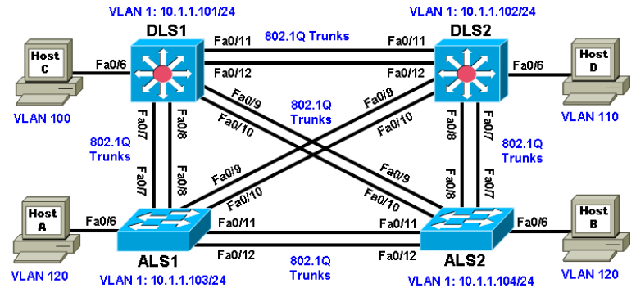

实验步骤

Step 1: Configure basic switch parameters.
Assign each switch a hostname and configure an IP address on the management VLAN according to the diagram. By default, VLAN 1 is used as the management VLAN.
Enter basic configuration commands on each switch according to the diagram.
DLS1 example:
Switch# configure terminal
Enter configuration commands, one per line. End with CNTL/Z.
Switch(config)# hostname DLS1
DLS1(config)# interface vlan 1
DLS1(config-if)# ip address 10.1.1.101 255.255.255.0
DLS1(config-if)# no shutdown
(Optional) On each switch, create an enable secret password and configure the vty lines to allow remote access from other network devices.
DLS1 example:
DLS1(config)# enable secret cisco
DLS1(config)# line vty 0 15
DLS1(config-line)# password cisco
DLS1(config-line)# login

Step 2: Display the switch default VLAN information.
Use the show vlan command in privileged mode on any switch. The following output is for a 2960 switch.
ALS1# show vlan
DLS1# show vlan
Note the default VLAN numbers, names, and associated types, and that all switch ports are automatically assigned to VLAN 1.
You can use the show vlan command to determine the mode of a port. Ports configured for a particular VLAN are shown in that VLAN. Ports configured for trunk mode are not associated with a specific VLAN, and so are not included in the output.

Step 3: Examine VTP information.
Use the show vtp status command on any switch. The output should be similar to the following sample for DLS1.
DLS1# show vtp status

Multiple switches in the VTP domain can be in VTP server mode. These switches can be used to manage all other switches in the VTP domain. This is suitable for small-scale networks where the VLAN information is small and easily stored in all switches. In a large network, the administrator must determine which switches make the best VTP servers. The network administrator should select switches to function as VTP servers. The other switches in the VTP domain can be configured as clients. The number of VTP servers should be consistent based on the amount of redundancy desired in the network.

Step 4: Configure VTP on the switches.
Change the VTP domain name on DLS1 to SWLAB using the vtp domain command. If the VTP version defaults to 1, set it manually to version 2 using the vtp version command.
DLS1(config)# vtp domain SWLAB
Changing VTP domain name from NULL to SWLAB
DLS1(config)# vtp version 2
Set up the switches so that the distribution layer switches are in VTP server mode, and the access layer switches are in VTP client mode. Set the version number to 2 on the DL switches.

DLS1(config)# vtp mode server
Device mode already VTP SERVER.
Because the default mode is server, you receive a message on DLS1 stating that the device mode is already VTP server.
ALS1(config)# vtp mode client
Setting device to VTP CLIENT mode.
Note: You cannot modify the version in VTP client mode

Use the show vtp status command on either of the AL switches. The output should be similar to the following sample for ALS1.
ALS1# show vtp status

Notice that you do not see the VTP domain name that you set up on DLS1. Because no trunks are set up between the switches, they have not started to distribute any VLAN information. There is no IP address (0.0.0.0) or time listed for the last configuration modification.

Step 5: Configure trunking.
The show interfaces switchport command lists the configured mode of each port in detail. The following partial sample output is for a 2960 switch on Fa0/7.
ALS1# show interfaces fastEthernet 0/7 switchport

Configure only the interfaces on DLS1 and ALS1 with the switchport mode trunk command, and leave DLS2 and ALS2 as the default port types for Fast Ethernet interfaces 0/9–0/12. Fast Ethernet 0/7 and 0/8 of DLS2 also need to be configured with the switchport mode trunk command for the trunks connecting DLS2 and ALS2.
The 2960 and 3560 switches have a range command that you can use to designate multiple individual ports or a continuous range of ports for an operation. Use the interface range command to configure all trunk ports at once for trunking.

The following is a sample configuration for the 802.1Q and ISL trunk ports on DLS1.
DLS1(config)# interface range fastEthernet 0/7 - 10
DLS1(config-if-range)# switchport trunk encapsulation dot1q
DLS1(config-if-range)# switchport mode trunk
DLS1(config)# interface range fastEthernet 0/11 - 12
DLS1(config-if-range)# switchport trunk encapsulation dot1q
DLS1(config-if-range)# switchport mode trunk

The following is a sample configuration for the trunk ports on ALS1.
ALS1(config)# interface range fastEthernet 0/7 – 12
ALS1(config-if)# switchport mode trunk

The following is a sample configuration for the trunk ports on DLS2.
DLS2(config)# interface range fastEthernet 0/7 - 8
DLS2(config-if-range)# switchport trunk encapsulation dot1q
DLS2(config-if-range)# switchport mode trunk

Note: This lab uses dynamic trunking protocol (DTP) to negotiate trunking, which can lead to security issues.
In general, when configuring trunks, it is a good practice to deactivate DTP using the switchport nonegotiate command and configure all trunks statically.

Step 6: Verify trunk configuration.
Use the show interfaces fastEthernet 0/7 switchport command on ALS2.
ALS2# show interfaces fastEthernet 0/7 switchport

Notice that administrative mode on Fa0/7 is still the default dynamic auto. Fa0/7 on ALS2 is operating as a trunk, because port Fa0/7 of DLS2 was configured using the switchport mode trunk command. Once this command was issued, trunking was negotiated between the two switch ports.
Use the show interfaces trunk command on DLS1.
DLS1# show interfaces trunk

Note: By default, all VLANs are allowed on all trunks. You can explicitly control which VLANs are allowed on a trunk by using the switchport trunk allowed vlan vlan-id command on the interface at each end of the trunk. In addition, you can specify a native VLAN other than the default VLAN 1, using the switchport trunk native vlan vlan-id command. These two measures can help reduce the possibility of VLAN attacks.
Use the show interfaces trunk command on DLS2.
DLS2# show interfaces trunk

Notice the highlighted portion of the above output from DLS2 where it indicates that these ports became trunks by negotiation. For example, port Fa0/9 mode is Auto and encapsulation is n-802.1q. The “n” indicates the 802.1q encapsulation was negotiated. The connected ports of the respective switches were configured using the switchport mode trunk command.

Step 7: Configure access ports.
A port on the 2960 switch can operate in one of three modes, and a port on the 3560 switch can operate in one of five modes. Use the switchport mode ? command for interface Fast Ethernet 0/6 in interface configuration mode to view the modes.

The Fast Ethernet ports connected to the hosts on the network can be set up as static access because they are not to be used as trunk ports. Use the switchport mode access command to set the access mode on the Fast Ethernet 0/6 port on all four switches in the pod.
The following is a sample configuration for the access port on ALS1.

ALS1(config)# interface fastEthernet 0/6
ALS1(config-if)# switchport mode access

Use the show interfaces command for Fast Ethernet 0/6 to verify the configuration.
The following command is for a 3560 switch.
DLS1# show interfaces fastEthernet 0/6 switchport

Note that administrative mode has now changed to static access and that trunking negotiation is off. The Fast Ethernet 0/6 ports on all four switches are now statically set to connect to a host device.

Step 8: Verify VTP configuration.
Before configuring the VLANs, verify the VTP configuration within the domain by using the show vtp status command on ALS1 and ALS2.
The following sample output is from ALS1.
ALS1# show vtp status

ALS2# show vtp status

At this point, all switches in the lab are in VTP domain SWLAB and have five existing VLANs. All are running VTP version 2. DLS1 and DLS2 are configured as VTP servers, and ALS1 and ALS2 are configured as clients.
Note: You can limit the VLAN traffic passed between switches using VTP pruning. Pruning increases available bandwidth by restricting flooded traffic to those trunk links that the traffic must use to access the destination devices. You can enable VTP pruning on a switch in VTP server mode using the vtp pruning command. For example, if a VLAN is not defined on access switch ALS1 but is defined on distribution switches DLS1 and DLS2, the VLAN will be pruned from the trunk links between ALS1 and the distribution switches but not from the link between the two distribution switches.

Step 9: Configure VLANs by assigning port membership.
VLANs can be configured on a switch in different ways, depending on the type of switch used and the Cisco IOS version.
An older way to configure VLANs is to use the VLAN database. This method is being deprecated and is no longer recommended. However, the VLAN database is still accessible for those who choose to use it. For example, the following command is for a 3560 switch.
DLS1# vlan database

A more current method to create a VLAN is to assign a port to a VLAN that does not yet exist. If the switch is in VTP Server or Transparent mode, it automatically creates the VLAN to the port that it has been assigned to.
VLAN 1 is the management VLAN by default. By default, all ports are set to dynamic mode and their access VLAN is set to 1. There is no need to create a VLAN 1, assign ports to it, or to set the mode of each port.
According to the lab diagram, VLANs 100, 110, and 120 must be created, and port 6 must be assigned to each VLAN. You will create VLANs 100 and 110 on the distribution switches using the port assignment method. You will create VLAN 120 for the access switches using global configuration commands and then assign ports to those VLANs.
Use the switchport access vlan command to assign port 6 on DLS1 and DLS2, according to the diagram.
Port Fast Ethernet 0/6 of DLS1 will be assigned to VLAN 100, and Fast Ethernet 0/6 on DLS2 will be assigned to VLAN 110.

DLS1(vlan)#vlan 100
The following command is for the 3560 switches.
DLS1(config)# interface FastEthernet 0/6
DLS1(config-if-range)# switchport access vlan 100

VLAN 100 was created at the same time port 6 was assigned to it.
Configure DLS2 in the manner similar to DLS1, but this time use VLAN 110.
DLS2(config)# interface FastEthernet 0/6
DLS2(config-if-range)# switchport access vlan 110

Issue the show vlan command on DLS1 to verify that VLANs 100 and 110 have been created. The output should be similar to the following output.
DLS1# show vlan

Step 10: Configure VLANs in configuration mode.
Another way of creating VLANs is to create them in configuration mode without assigning port membership.
You can create a VLAN in global configuration mode using the vlan command. Because ALS1 and ALS2 are configured for VTP client mode and it is not possible to create a VLAN when a switch is in client mode, you must create the VLAN on the switch that is acting as a server for the network. The VLAN then propagates to the other switches that are in client mode.
Issue the vlan command in global configuration mode on DLS1.
DLS1(config)# vlan 120
Ports still need to be assigned to VLAN 120. Port assignment to a VLAN is an interface configuration operation. Use the switchport access vlan command on Fast Ethernet 0/6 of ALS1 and ALS2 to configure ports for VLAN 120.

ALS1(config)# interface fastEthernet 0/6
ALS1(config-if)# switchport access vlan 120

ALS2(config)# interface fastEthernet 0/6
ALS2(config-if)# switchport access vlan 120

Use the show vlan command to verify the creation of VLAN 120, with port Fa0/6 assigned to it. The output should be similar to the following.
ALS1# show vlan

Step 11: Change the VLAN names.
The VLANs have not been named yet. Naming VLANs can help network administrators identify the functionality of those VLANs. To add names, use the name command in VLAN configuration mode. The following is a sample configuration for naming the three VLANs created in the domain.
DLS1(config)# vlan 100
DLS1(config-vlan)# name Server-Farm-1
DLS1(config-vlan)# exit
DLS1(config)# vlan 110
DLS1(config-vlan)# name Server-Farm-2
DLS1(config-vlan)# exit
DLS1(config)# vlan 120
DLS1(config-vlan)# name Net-Eng
DLS1(config-vlan)# exit
Use the show vlan command on DLS1 to verify that the new names have been added.
DLS1# show vlan

Step 12: Change the VLAN status to deactivate ports.
The default status of VLAN 1 and user-created VLANs is “active”. A VLAN can be made locally inactive in the VLAN configuration mode by entering the command shutdown for the particular VLAN (does not apply to an SVI). This will cause all ports on a switch in a particular VLAN to stop transmitting data. Shutting down the VLAN on a switch does not influence its state on other switches in a VTP domain. Shutdown the Net-Eng VLAN 120 on ALS1, wait a few moments, exit vlan configuration mode and then issue the show vlan brief command. The status should change to “act/lshut”.

ALS1(config)# vlan 120
ALS1(config-vlan)# shutdown
ALS1# show vlan brief

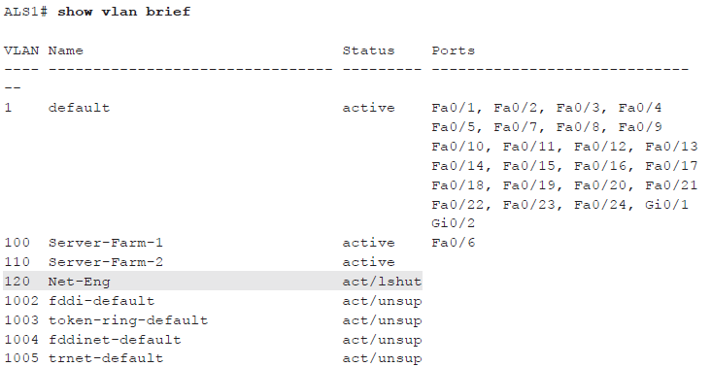

Reactivate all ports in ALS1 Net-Eng VLAN 120 using the no shutdown command in VLAN configuration mode..
ALS1(config)# vlan 120
ALS1(config-vlan)# no shutdown

You can also put a VLAN into “suspend” status. The “suspend” state is configured in the VLAN configuration mode using the command state suspend. Suspending a VLAN causes all ports in that VLAN throughout the VTP domain to stop transferring data.
Suspend Net-Eng VLAN 120 on ALS1, wait a few moments, exit VLAN configuration mode and then issue the show vlan brief command. The status should change to “suspended”.
ALS1(config)# vlan 120
ALS1(config-vlan)# state suspend
ALS1# show vlan brief
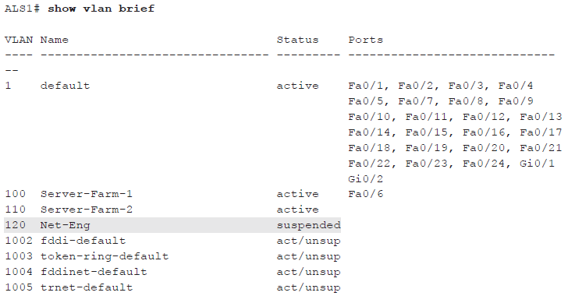
Reactivate VLAN 120 using the state active command in VLAN configuration mode.
ALS1(config)# vlan 120
ALS1(config-vlan)# state active

Note: The suspend state is advertised by VTP while the lshut state is not. The state suspend command can be issued on any switch in the VTP domain. It does not have to be issued on the VTP server.
Both options can be used to temporarily take a particular VLAN out of operation which can be useful in certain scenarios - especially for guests, infrequently used conference rooms and similar deployments.

