Choriocapillaris participate in the progress of age-related macular degeneration by regulating COL10A1 expressed by retina pigment epithelial

Chunyou Yin1*; Chunhui Yin2

## Title page

### Affiliations

1. School of Medicine, Zhejiang University, Hangzhou, Zhejiang 310009, China
2. 51 Job, Shanghai Pudong New Area 201210, China

### Author Contribution

Chunyou conceive, design, conducted the data analysis, and write the manuscripts, Chunhui helps build the computational environment and some help with dimension reduction algorithm.

### Corresponding author

Correspondence to Chunyou Yin ([yinchunyou@zju.edu.cn](mailto:yinchunyou@zju.edu.cn))

## Abstract

The well-known function of the choriocapillaris (CC) is supplying oxygen and nutrients to the out retina and retina pigment epithelial (RPE) while removing wastes. Besides oxygen and nutrients supplied by choriocapillaris is important for RPE’s survival, signals that come from choriocapillaris should also important for maintaining retina pigment epithelial homeostasis. To our knowledge, most studies of the pathogenesis of age-related macular degeneration (AMD) are mainly focused on the RPE itself and largely ignored cells in RPE’s micro-environment that might contribute to the progress of age-related macular degeneration. Recently, Optical coherence tomography angiography (OCTA) and Histopathological studies found that changes have taken place at the choriocapillaris at the early stage of age-related macular degeneration. Understand how the changes take place at choriocapillaris and its impact on the RPE will contribute to the understanding of the pathogenesis of age-related macular degeneration. Here, we take the first attempt to explore how choriocapillaris endothelial cell’s change might contribute to the progress of neovascular age-related macular degeneration and find that TGFB1 expressed by choriocapillaris endothelial cells by regulating the expression of COL10A1 expressed by retina pigment epithelial participate in the progress of neovascular age-related macular degeneration.

Key words: AMD; age-related macular degeneration; neovascular; choriocapillaris; retina pigment epithelial; TGFB1; COL10A1

## Introduction

Age-related macular degeneration (AMD) is a leading cause of severe visual loss and blindness among the elderly population[40]. Its pathogenesis is poorly understood and it appears to involve a complex interaction of metabolic, functional, genetic, and environmental factors[7–9,16,17,40]. Late-stage AMD can be divided into two forms: geographic atrophy (GA; or dry) AMD, and neovascular (wet) AMD. The wet form of AMD comprises approximately 15% of the case, but because of its severity, accounts for the majority of severe visual loss due to AMD[10].

Although anti-vascular endothelial growth factor (anti-VEGF) therapy has revolutionized the treatment of neovascular age-related macular degeneration. Some drawbacks have been reported, such as the treatment is not durable and visual gain was lost even after 2 years of treatment[42], and a significant proportion of patients developed into geographic atrophy after anti-VEGF therapy[4,11]. Genome-Wide Association Studies (GWAS) find dozens of sites associated with AMD, which implies complement activity, lipid metabolism, extracellular matrix remodeling, and angiogenesis is involved in the progress of AMD progression[9,41], but the order which participates earlier in the progress of AMD is not determined and it is important for prevention and valuable for select optimal therapeutic targets, and angiogenesis doesn’t seem to be ahead of others.

In light of the importance of RPE for the survival of photoreceptors, most of the researches about the pathogenesis of AMD is focused on the retina-pigment epithelial (RPE), and ignored the importance of the micro-environment in which RPE might be affected by nearby cells. Histopathological and the recent advancement in imaging technology, Optical coherence tomography (OCT), have found that in the very early stage of AMD, notable changes have been identified at the choriocapillaris, such as reduced blood flow, choriocapillaris dropout[5,26,30,32,38]. This implies that the changes that take place at CC are ahead of RPE degeneration and it might contributes to the onset of AMD. But the mechanism of how CC changes might affect retina degeneration is unexplored to our knowledge. Based on the above findings, here we trying to understand how CC might affect RPE in the progress of AMD, and find that TGFB1 expressed by CC endothelial cells by affecting the expression of AMD related gene, COL10A1, in RPE and this might contribute to the progress of neovascular AMD.

## Materials Methods

### Data and Statistics analysis

Age-relate macular degeneration genes were obtained from RetNet(<https://sph.uth.edu/retnet/home.htm>) and two Genome Wide Association studies[9,41].

To define the background expressed genes and expressed age-related macular degenration genes in RPE, the bulk-seq data mentioned by Kim[18] was used. In that studies they find a siginificant impact on the anti-sense transcripts between the health and early AMD patients compare to the sense transcripts. Differential expression analysis was carried out with edgeR-limma[22,29] R/Bioconductor packages between health and early AMD patients.

CD31 enriched choroidal endothelial cells described by Voigt[37], which characterized the arteriole, vein, and choriocapillaris endothelial cells, and the choriocapillaris endothelial cells was used to define the potential ligands expressed by the choriocapillaris endothelial cells that might regulator macular degeneration related genes expressed by RPE. Single-cell trajectory was conducted on choriocapillaris endothelial cells to find differentially expressed ligands along the trajectory using monocle3[27,28,36], batch effects were removed using the method described by Haghverdi[12].

To find which age-related macular degeneration gene might regulated by the ligands expressed by the choriocapillaris endothelial cells. Network propagation methods was used on the integrated networks to propagate the signal from a ligand, over receptors, signaling proteins and transcriptional regulators, to end at target genes. After that we process the sequencing data we obtained from The Gene Expression Omnibus (GEO) to check if the ligand-target pair was really changed.

### Ethics approval and consent to participate

Not applicable

### Data and Code availability

CD31 enriched choriocapillaris endothelial single-cell RNA-seq data: GSE139522.  
bulk RNA-seq health and early-stage AMD data: GSE99248.  
code and data are available at GitHub: <https://github.com/YinCY123/AMD>

## Results

### ligand-target regulatory pairs

Before inferring ligand-target regulatory pairs, ligands activity needs to be performed on the age-related macular degeneration genes, in other words, assess how well each CC endothelial cells expressed ligands can predict the RPE expressed age-related macular degeneration related genes compared to the background of expressed genes. The top 15 highly active ligands are used to infer ligand-target regulation potential pairs (Figure 1A).

Based on prior knowledge on signaling and gene regulatory networks, by using the network propagation method[3] on the integrated networks to infer active ligands expressed by CC endothelial cells and their gene regulatory effects on RPE, we find few high potential ligand-target regulatory pairs, based on the top 15 highly active ligands (Figure 1B).

### TGFB1 upregulated in choriocapillaris endothelial cells among early AMD patients

To find out which ligands are differentially expressed between normal and early AMD patients, we use the CD31 enriched choriocapillaris endothelial cells data[37] and find that TGFB1 expression higher in the early stage neovascular AMD patients compared to the health (Figure 2A). Then single-cell trajectory analysis was conducted according to the standard precedure[27,28,36], and we indeed find TGFB1 differentially expressed along the pseudotime trajectory, which means from the normal state to a more stress state (early AMD, endothelial cells dropout) TGFB1’s expression is becoming higher (Figure 2B, Figure S1).

To confirm our result is solid, we calculate and plot the percentage of mitochondrial genes in each cell (Figure 3B), indeed we find an elevated percentage of mitochondrial genes along the trajectory, this is consistent with previous reports that choriocapillaris is thinning and dropout in the early stage of AMD[5,6,19,33] and the percentage of mitochondrial genes is elevated in more stress or dying cells[14,15,34].

### COL10A1 differentially expressed among health and early AMD patients

Differential expression analysis between health and early AMD patients was conducted following the standard pipeline of edgeR-limma[22,29] R/Bioconductor package, and we find that TLR4 and COL10A1 were significantly differential expressed between early AMD and health patients (Figure 4, Figure S2). TLR4 participates in the activation of the innate immune system which is consistent with previous Genome-Wide Association studies about the participation of the immune system in the pathogenesis of AMD[9,21,39], although we didn’t notice the difference of IL1B along the trajectory, it might be the immune cells or pericyte in the choroidal secreted the IL1B that affect the expression of TLR4.

According to the classification of Hogan[13], Bruch’s membrane consists of five layers: the basement membrane of the RPE, the inner collagenous layer (ICL), the elastin layer (EL), the outer collagenous layer (OCL) and, the basement membrane of the choriocapillaris. Although it is not exactly clear how Bruch’s membrane is formed, gene expression data indicated that both the choroid and RPE cells are capable of synthesizing the major components of Bruch’s membrane[2,18,25,37]. As Bruch’s membrane is a dynamic tissue[1], the lowered expression of COL10A1 could change the structure of Bruch’s membrane and that might responsible for the deposition of drusen in the Bruch’s membrane. Besides affecting the structure of Bruch’s membrane, several experiments have reported the proteolytic fragments cleaved from collages exhibit anti-angiogenic and anti-tumor properties[24,35], and downregulation of COL10A1 may disturb the balance between inhibitor and simulator of angiogenesis signal and cause neovascularization, which is the character of wet AMD.

To find which transcription regulator might responsible for the downregulate of COL10A1, we integrated the TGFB1 and COL10A1 signaling networks and find four transcription factors RUNX2, SMAD3, AR, and ESR1 that could regulate the expression of COL10A1. Next, we examined the expression of these regulators and find that only RUNX2, SAMD3 and ESR1 expressed after filtering, and RUNX2 was significantly down-regulated between health and early AMD patients (Figure 5, Figure S4), this is consistent with the find of Li and Yoshiaki[20,23], which found that RUNX2/SMAD3 negatively regulate TGFb1 induced gene expression in Vascular Smooth Muscle Cells, and RUNX2 can promote the expression of COL10A1 in mice, thus the lowered expression of RUNX2 could result in the lowered expression of COL10A1.

## Discussion

Although anti-VEGF has brought light for neovascular AMD patients, some side-effects have been reported[4,11,42]. According to the Genome-Wide Association Studies[9,41], complement activity, lipid metabolic, extracellular matrix remodeling, and angiogenesis are involved in the pathogenesis of AMD, but which factor onset ahead of others is not determined, and this is important for prevention and choose the optimal candidates of therapeutic targets. However angiogenesis doesn’t seem to be ahead of others, this implies inhibit neovascularization may not be the best choice for neovascular AMD. Here we find the TGFb1-RUNX2-COL10A1 signaling pathway, among those COL10A1 is a member of the collagen family, that participates in extracellular matrix remodeling, which might responsible for the deposition of drusen, and consistent with the Genome-Wide Association studies, might a better therapeutic target than anti-VEGF for neovascular AMD. Besides participates in extracellular remodeling, many studies have found a number of proteolytic fragments cleaved from collagen have anti-angiogenesis and anti-tumor properties[24]. From this point of view, neovascularization might be the imbalance of stimulating and inhibit signals of angiogenesis. In light of these findings, we anticipate that the changed expression of COL10A1 in one aspect could change the structure of Bruch’s membrane, and cause the deposition of drusen in the Bruch’s membrane, the other way it might imbalanced stimulate and inhibit signals of angiogenesis and that might responsible of the neovascularization.

TLR4, an AMD related gene, also significantly differentially expressed, which participate in activating the innate immune system, but we didn’t see the differentially expressed of its ligand IL1B in choriocapillaris endothelial cells, perhaps it produced by other cells in the choroidal like monocytes, neutrophils infiltrate to the inflammation site. As it is significantly differentially expressed at the early stage of AMD, this implies the innate immune system is also very important for the pathogenesis of AMD and more researches need to be done about how the immune system participates in the progression of AMD.

Another collagen family member, COL18A1, is also deferentially expressed along the trajectory (Figure S3), which has been considered as a critical factor for retina structure[31]. Besides affecting the retina structure studies also reveal the anti-tumor and anti-angiogenesis property of COL18A1[24], which on the other side implies the imbalanced angiogenesis signal, and extracellular matrix remodeling participate in the progress of AMD.

Another important issue to address is the onset order of complement activity, lipid metabolic, extracellular matrix remodeling, and angiogenesis during the progress of AMD, which has been identified by Genome-Width Association Studies[9,41], this is critical for choosing the optimal therapeutic targets and prevention.

## Conclusions

In this work, we provide novel signaling pathway TGFB1-RUNX2-COL10A1, that might responsible for the progress of neovascular AMD, through extracellular matrix remodeling.

## List of abbreviations

CC:Choriocapillaris; AMD: age-related macular degeneration; OCTA: Optical coherence tomography angiography; RPE: retina pigment epithelial; GWAS: Genome-Wide Association Studies; anti-VEGF: anti-vascular endothelial growth factor; [GEO:The](geo:The) Gene Expression Omnibus

## Conflict of interests

The authors declare no competing interests.

## Grant information

The authors receive no funds.

## Figures and Tables

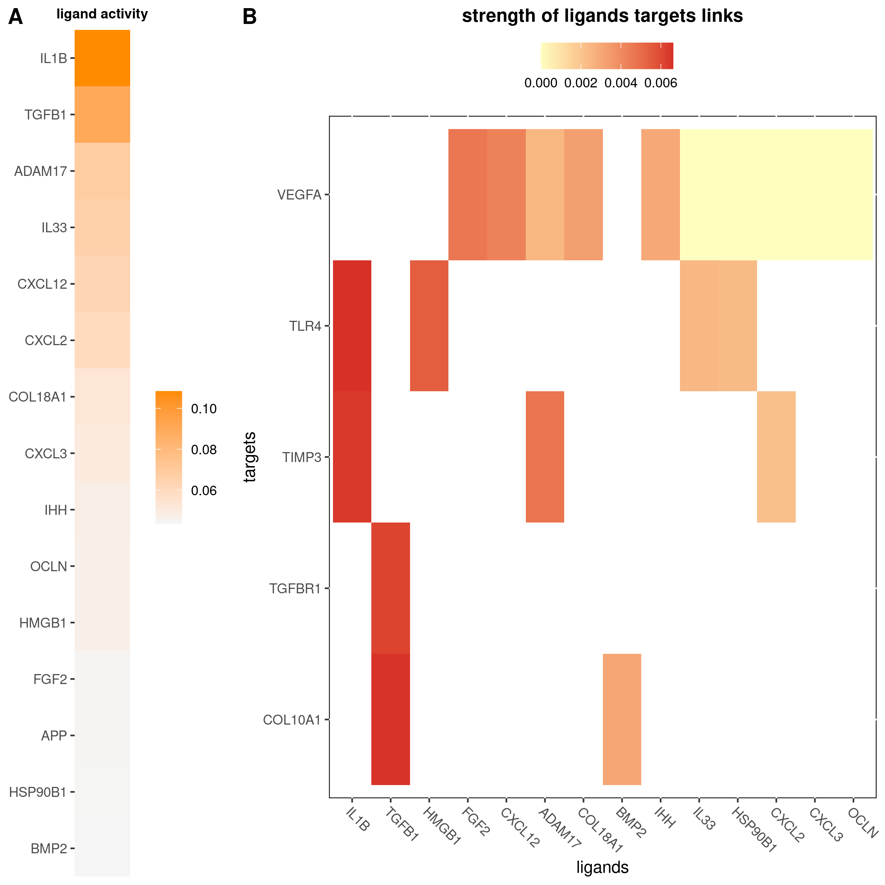

Figure 1: (A) The activity of top 15 ligands. (B) Ligand-target paris was identified by the network propagation methods.

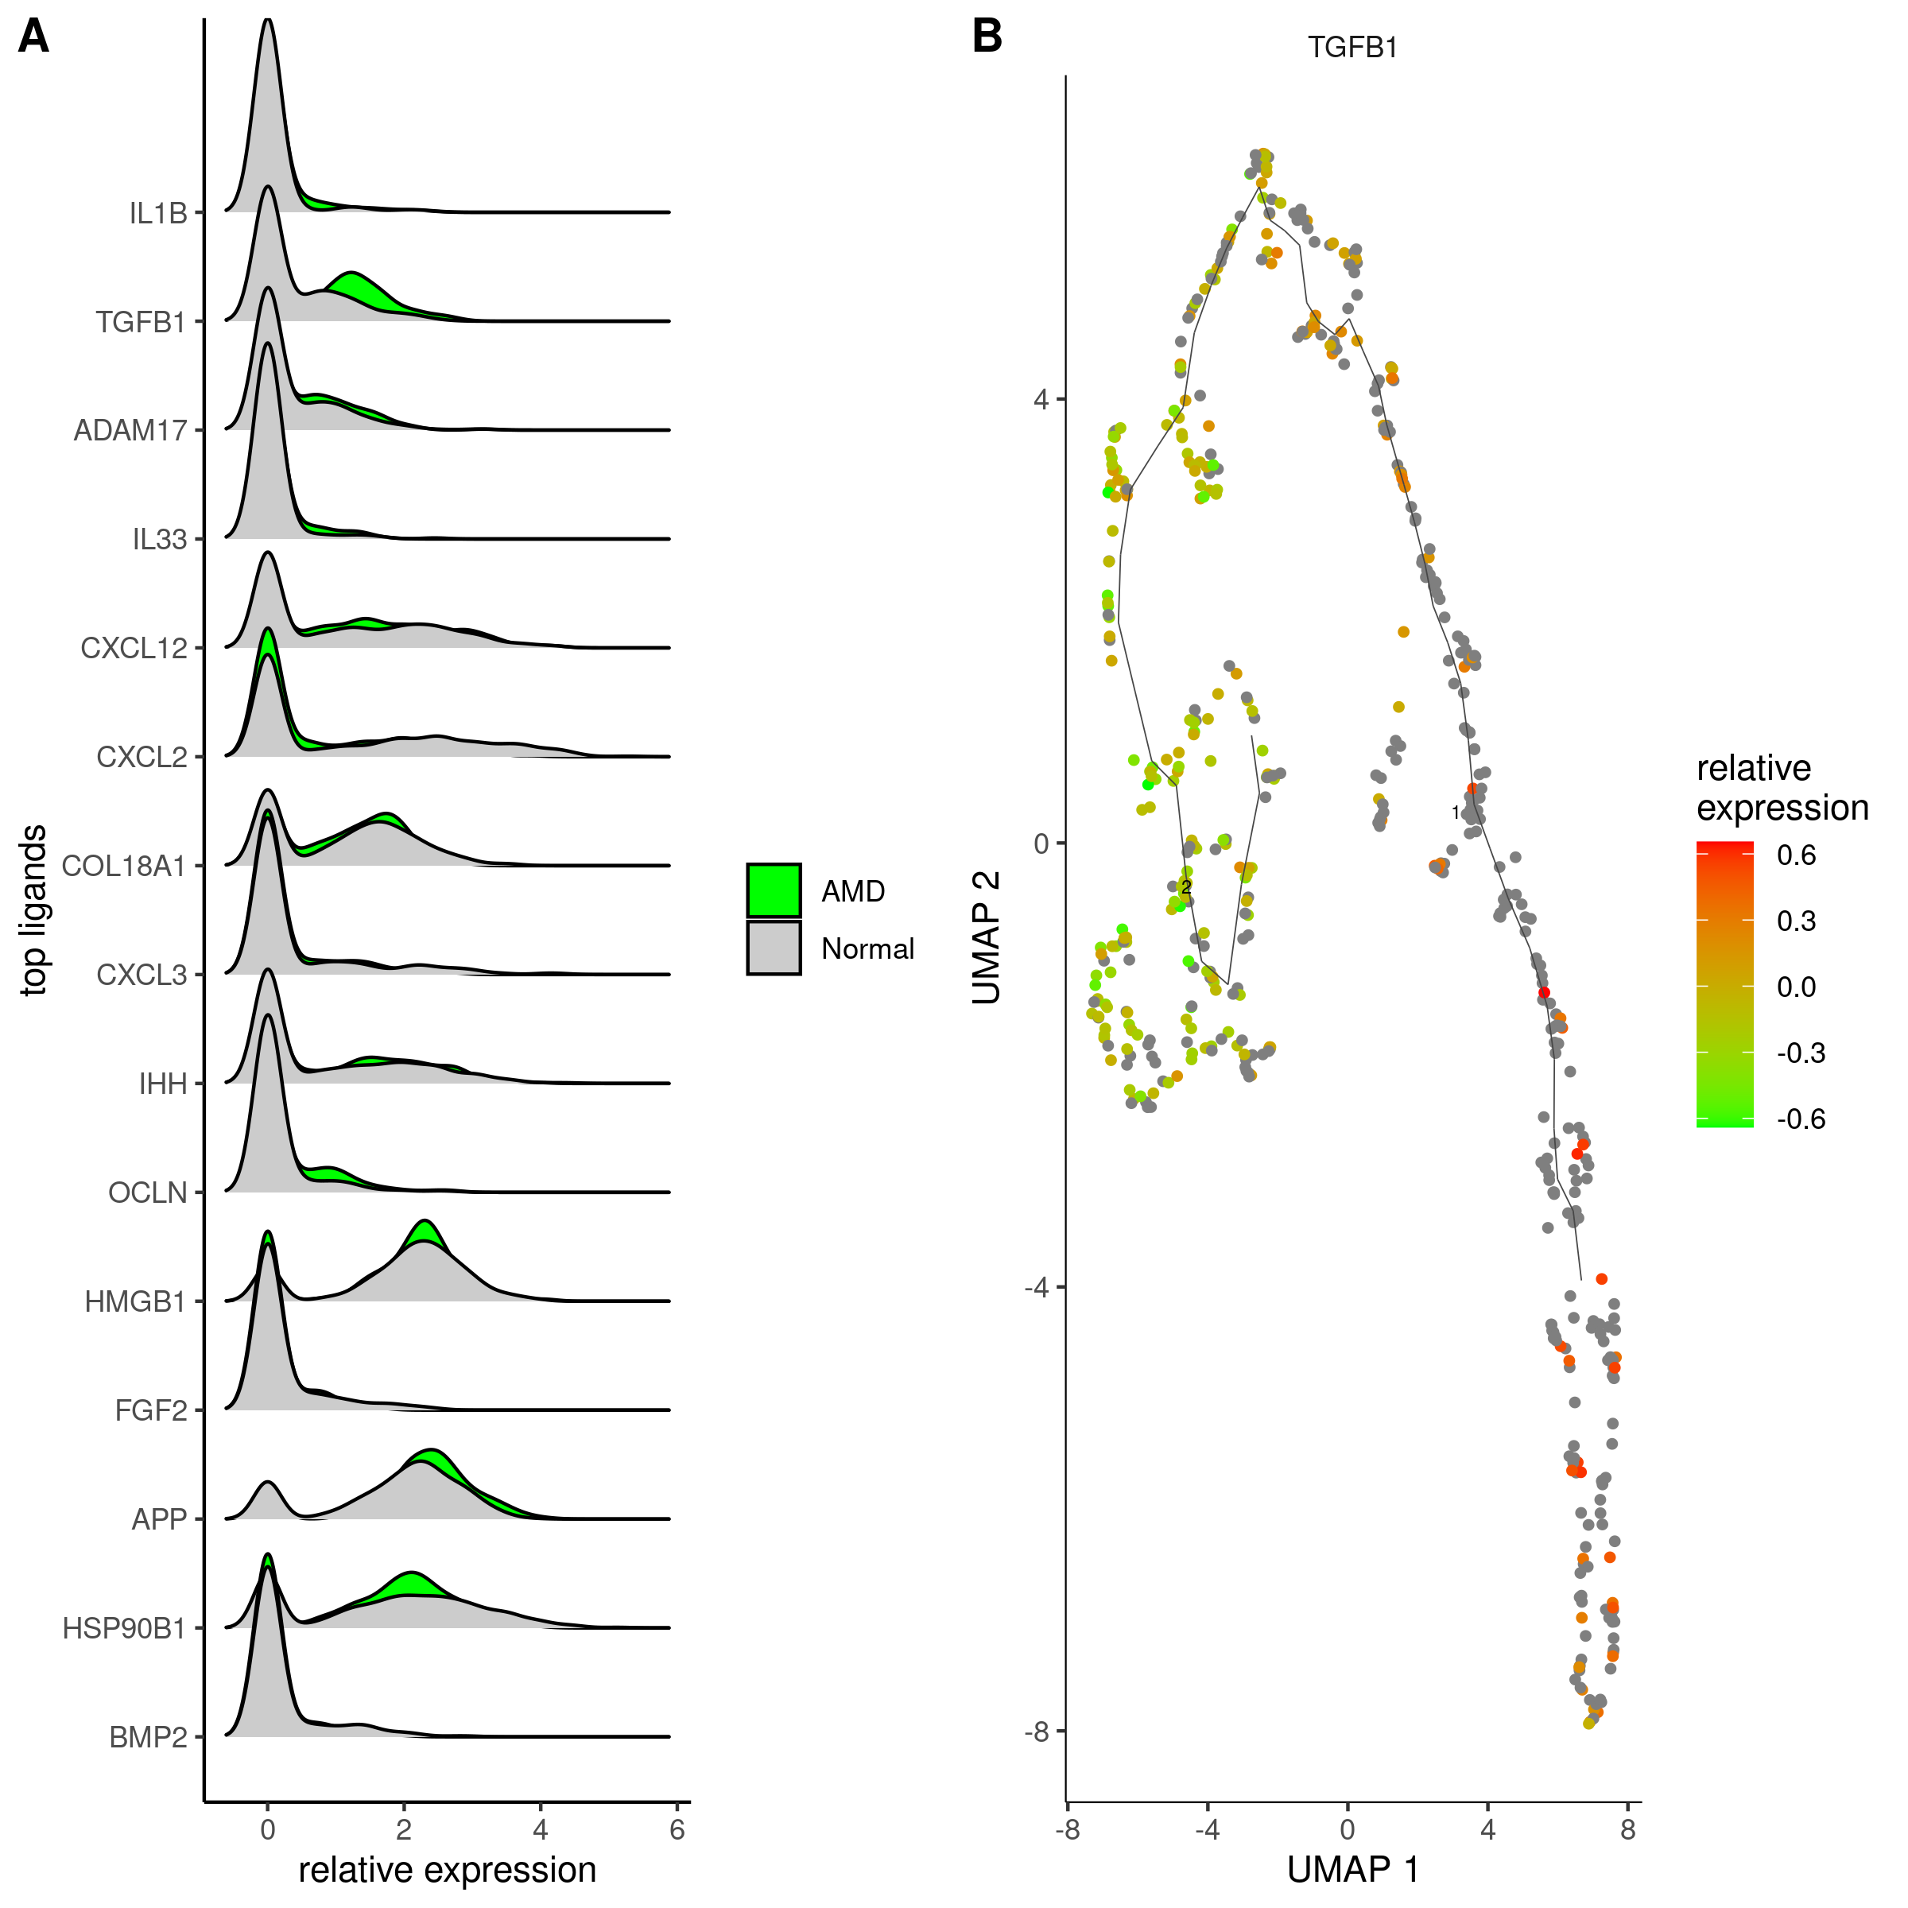

Figure 2: (A) The expression of ligands between early AMD patients (n = 3) and health patients (n = 7). The more shift to the right the higher the expression. (B) The expression of TGFB1 along the trajectory, from the top left to the bottom right the expression of TGFB1 is becoming higher, which is from normal state to early AMD state.

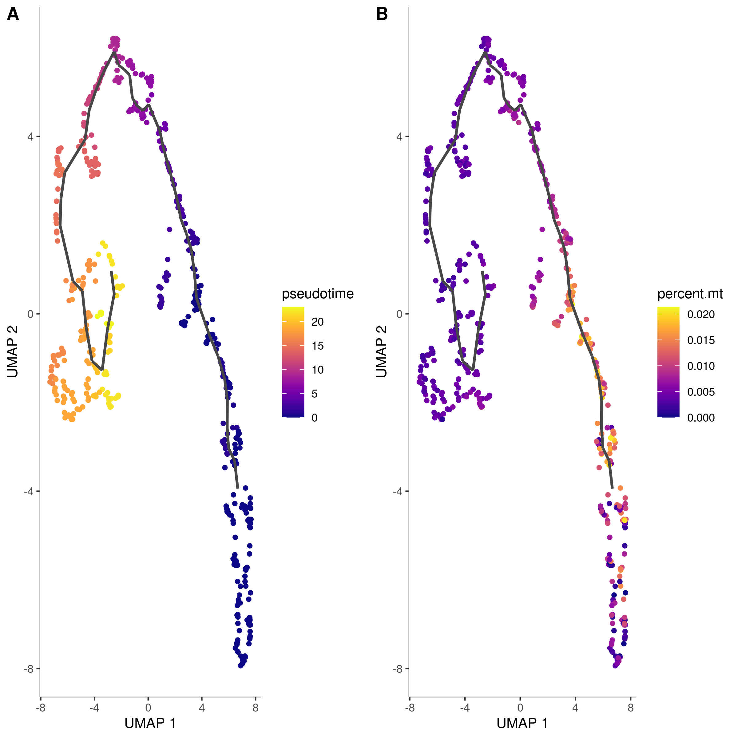

Figure 3: (A) The status of the choriocapillaris endothelial cells changes along the pseudotime trajectory. (B) The percentage of mitochondrial genes expressed by the choriocapillaris endothelial cells along the pseudotime trajectory, which is becoming higher in the early AMD state.

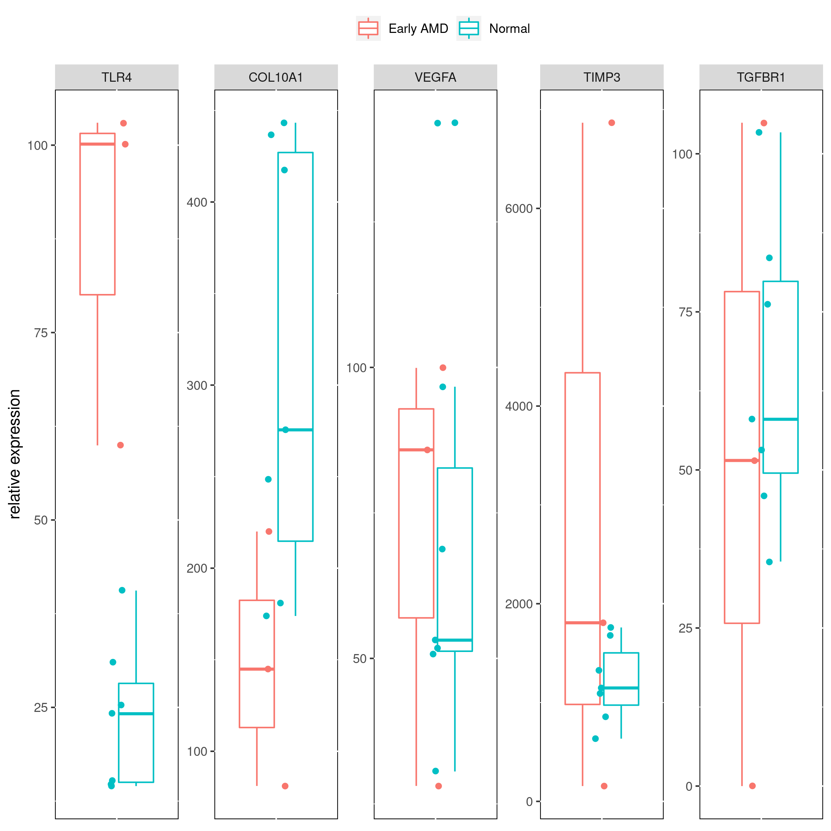

Figure 4: The expression of target genes in early AMD. TLR4, COL10A1 were significantly differential expressed between normal(n = 3) and early AMD patients(n = 7) but VEGF, TIMP3 and TGFBR1 were not.

### expression of transcription regulators

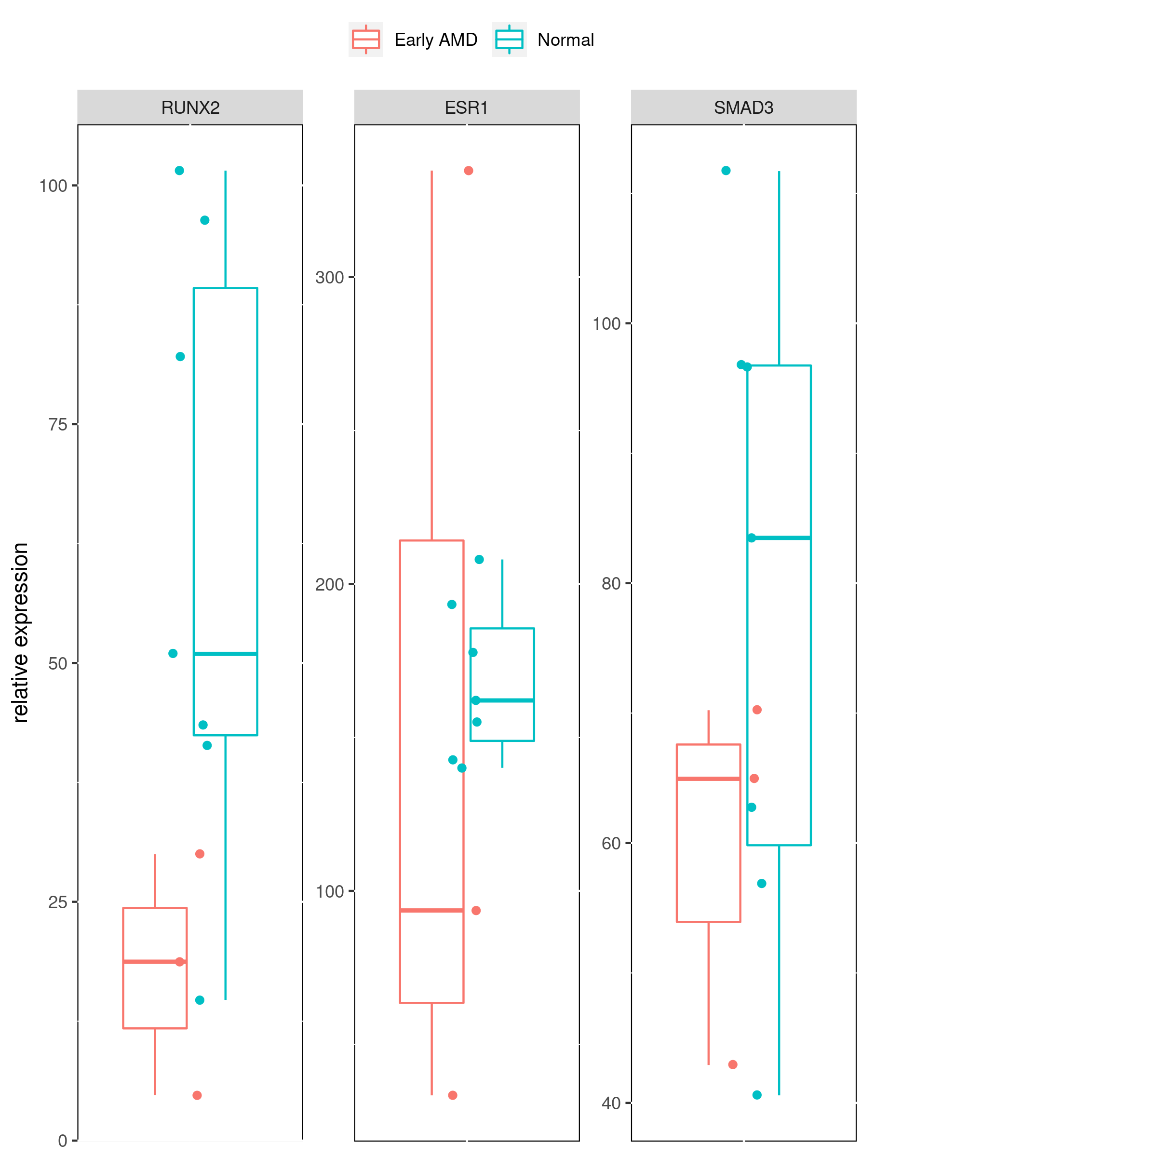

Figure 5: The expression of transcription regulators between health (n = 3) and early AMD patients(n = 7).

## References

[1] J.C. Booij, D.C. Baas, J. Beisekeeva, T.G.M.F. Gorgels, A.A.B. Bergen, The dynamic nature of Bruch’s membrane, Progress in Retinal and Eye Research. 29 (2010) 1–18.

[2] J.C. Booij, S. van Soest, S.M.A. Swagemakers, A.H.W. Essing, A.J.M.H. Verkerk, P.J. van der Spek, T.G.M.F. Gorgels, A.A.B. Bergen, Functional annotation of the human retinal pigment epithelium transcriptome, BMC Genomics. 10 (2009) 1–18.

[3] R. Browaeys, W. Saelens, Y. Saeys, NicheNet: modeling intercellular communication by linking ligands to target genes, Nature Methods. (2019).

[4] U. Chakravarthy, S.P. Harding, C.A. Rogers, S.M. Downes, A.J. Lotery, L.A. Culliford, B.C. Reeves, I. study investigators, Alternative treatments to inhibit VEGF in age-related choroidal neovascularisation: 2-year findings of the IVAN randomised controlled trial., Lancet. 382 (2013) 1258–1267.

[5] I. Chatziralli, G. Theodossiadis, D. Panagiotidis, P. Pousoulidi, P. Theodossiadis, Choriocapillaris Vascular Density Changes in Patients with Drusen: Cross-Sectional Study Based on Optical Coherence Tomography Angiography Findings, Ophthalmology and Therapy. 7 (2018) 101–107.

[6] K.R. Chirco, E.H. Sohn, E.M. Stone, B.A. Tucker, R.F. Mullins, Structural and molecular changes in the aging choroid: Implications for age-related macular degeneration, Eye. 31 (2017) 10–25.

[7] J.R. Evans, Risk Factors for age-related macular degeneration, Progress in Retinal and Eye Research. 20 (2001) 227–253.

[8] S.L. Fine, S. Brook, Senile macular degeneration : a case-control study, AMERICAN JOURNAL OF EPIDEMIOLOGY. 118 (1983) 213–227.

[9] L.G. Fritsche, W. Chen, M. Schu, B.L. Yaspan, Y. Yu, G. Thorleifsson, D.J. Zack, S. Arakawa, V. Cipriani, S. Ripke, R.P. Igo, G.H.S. Buitendijk, X. Sim, D.E. Weeks, R.H. Guymer, J.E. Merriam, P.J. Francis, G. Hannum, A. Agarwal, A.M. Armbrecht, I. Audo, T. Aung, G.R. Barile, M. Benchaboune, A.C. Bird, P.N. Bishop, K.E. Branham, M. Brooks, A.J. Brucker, W.H. Cade, M.S. Cain, P.A. Campochiaro, C.C. Chan, C.Y. Cheng, E.Y. Chew, K.A. Chin, I. Chowers, D.G. Clayton, R. Cojocaru, Y.P. Conley, B.K. Cornes, M.J. Daly, B. Dhillon, A.O. Edwards, E. Evangelou, J. Fagerness, H.A. Ferreyra, J.S. Friedman, A. Geirsdottir, R.J. George, C. Gieger, N. Gupta, S.A. Hagstrom, S.P. Harding, C. Haritoglou, J.R. Heckenlively, F.G. Holz, G. Hughes, J.P.A. Ioannidis, T. Ishibashi, P. Joseph, G. Jun, Y. Kamatani, N. Katsanis, C. N Keilhauer, J.C. Khan, I.K. Kim, Y. Kiyohara, B.E.K. Klein, R. Klein, J.L. Kovach, I. Kozak, C.J. Lee, K.E. Lee, P. Lichtner, A.J. Lotery, T. Meitinger, P. Mitchell, S. Mohand-Saïd, A.T. Moore, D.J. Morgan, M.A. Morrison, C.E. Myers, A.C. Naj, Y. Nakamura, Y. Okada, A. Orlin, M.C. Ortube, M.I. Othman, C. Pappas, K.H. Park, G.J.T. Pauer, N.S. Peachey, O. Poch, R.R. Priya, R. Reynolds, A.J. Richardson, R. Ripp, G. Rudolph, E. Ryu, J.A. Sahel, D.A. Schaumberg, H.P.N. Scholl, S.G. Schwartz, W.K. Scott, H. Shahid, H. Sigurdsson, G. Silvestri, T.A. Sivakumaran, R.T. Smith, L. Sobrin, E.H. Souied, D.E. Stambolian, H. Stefansson, G.M. Sturgill-Short, A. Takahashi, N. Tosakulwong, B.J. Truitt, E.E. Tsironi, A.G. Uitterlinden, C.M. Van Duijn, L. Vijaya, J.R. Vingerling, E.N. Vithana, A.R. Webster, H.E. Wichmann, T.W. Winkler, T.Y. Wong, A.F. Wright, D. Zelenika, M. Zhang, L. Zhao, K. Zhang, M.L. Klein, G.S. Hageman, G.M. Lathrop, K. Stefansson, R. Allikmets, P.N. Baird, M.B. Gorin, J.J. Wang, C.C.W. Klaver, J.M. Seddon, M.A. Pericak-Vance, S.K. Iyengar, J.R.W. Yates, A. Swaroop, B.H.F. Weber, M. Kubo, M.M. Deangelis, T. Léveillard, U. Thorsteinsdottir, J.L. Haines, L.A. Farrer, I.M. Heid, G.R. Abecasis, Seven new loci associated with age-related macular degeneration, Nature Genetics. 45 (2013) 433–439.

[10] J.L. Gottlieb, Age-Related Macular Degeneration, American Medical Association. 288 (2020) 2233–2236.

[11] J.E. Grunwald, E. Daniel, J. Huang, G.S. Ying, M.G. Maguire, C.A. Toth, G.J. Jaffe, S.L. Fine, B. Blodi, M.L. Klein, A.A. Martin, S.A. Hagstrom, D.F. Martin, Risk of geographic atrophy in the comparison of age-related macular degeneration treatments trials, Ophthalmology. 121 (2014) 150–161.

[12] L. Haghverdi, A.T.L. Lun, M.D. Morgan, J.C. Marioni, Batch effects in single-cell RNA-sequencing data are corrected by matching mutual nearest neighbors, Nat. Biotechnol. 36 (2018) 421–427.

[13] M.J. HOGAN, Ultrastructure of the choroid. Its role in the pathogenesis of chorioretinal disease, Transactions of the Pacific Coast Oto-Ophthalmological Society Annual Meeting. 42 (1961) 61–87.

[14] T. Ilicic, J.K. Kim, A.A. Kolodziejczyk, F.O. Bagger, D.J. Mccarthy, J.C. Marioni, S.A. Teichmann, Classification of low quality cells from single-cell RNA-seq data, Genome Biology. (2016) 1–15.

[15] S. Islam, A. Zeisel, S. Joost, G.L. Manno, P. Zajac, M. Kasper, P. Lönnerberg, S. Linnarsson, Quantitative single-cell RNA-seq with unique molecular identifiers, Nature Methods. 11 (2014).

[16] K. Kaarniranta, E. Pawlowska, J. Szczepanska, A. Jablkowska, J. Blasiak, Role of Mitochondrial DNA Damage in ROS-Mediated Pathogenesis of Age-Related Macular Degeneration ( AMD ), Molecular Sciences. (2019).

[17] A. Kauppinen, J.J. Paterno, J. Blasiak, A. Salminen, K. Kaarniranta, Inflammation and its role in age-related macular degeneration, Cellular and Molecular Life Sciences. 73 (2016) 1765–1786.

[18] E.J. Kim, G.R. Grant, A.S. Bowman, N. Haider, H.V. Gudiseva, V.R.M. Chavali, Complete Transcriptome Profiling of Normal and Age-Related Macular Degeneration Eye Tissues Reveals Dysregulation of Anti-Sense Transcription, Scientific Reports. 8 (2018) 1–13.

[19] I. Lengyel, A. Tufail, H. Al Hosaini, P. Luthert, A.C. Bird, G. Jeffery, Association of drusen deposition with choroidal intercapillary pillars in the aging human eye, Investigative Ophthalmology and Visual Science. 45 (2004) 2886–2892.

[20] F. Li, Y. Lu, M. Ding, D. Napierala, S. Abbassi, Y. Chen, X. Duan, S. Wang, B. Lee, Q. Zheng, Runx2 contributes to murine Col10a1 gene regulation through direct interaction with its cis-enhancer, Journal of Bone and Mineral Research. 26 (2011) 2899–2910.

[21] Y. Liao, H. Zhang, D. He, Y. Wang, B. Cai, J. Chen, J. Ma, Z. Liu, Y. Wu, Retinal pigment epithelium cell death is associated with NLRP3 inflammasome activation by all-trans retinal, Investigative Ophthalmology and Visual Science. 60 (2019) 3034–3045.

[22] D.J. McCarthy, Y. Chen, G.K. Smyth, Differential expression analysis of multifactor RNA-Seq experiments with respect to biological variation, Nucleic Acids Research. 40 (2012) 4288–4297.

[23] Y. Ohyama, T. Tanaka, T. Shimizu, H. Matsui, H. Sato, N. Koitabashi, Runx2 / Smad3 Complex Negatively Regulates TGF- -Induced Connective Tissue Growth Factor gene Expression in Vascular Smooth Muscle Cells, Journal of Atherosclerosis and Thrombosis. (2011) 1–13.

[24] M.S. O ’reilly, T. Boehm, Y. Shing, N. Fukai, G. Vasios, W.S. Lane, E. Flynn, J.R. Birkhead, B.R. Olsen, J. Folkman, Endostatin: An Endogenous Inhibitor of Angiogenesis and Tumor Growth, Cell. 88 (1997) 277–285.

[25] L.D. Orozco, H.H. Chen, C. Cox, K.J. Katschke, R. Arceo, C. Espiritu, P. Caplazi, S.S. Nghiem, Y.J. Chen, Z. Modrusan, A. Dressen, L.D. Goldstein, C. Clarke, T. Bhangale, B. Yaspan, M. Jeanne, M.J. Townsend, M. van Lookeren Campagne, J.A. Hackney, Integration of eQTL and a Single-Cell Atlas in the Human Eye Identifies Causal Genes for Age-Related Macular Degeneration, Cell Reports. 30 (2020) 1246–1259.e6.

[26] M. Parviz, H. Esfandiari, N. Behnaz, J. Fatemeh, A. Sima, M. Javadi, Mohammad Ali Kalantarion, Role of the Choroid in Age‑related Macular Degeneration: A Current Review, Journal of Ophthalmic and Vision Research. 12 (2017) 270–274.

[27] X. Qiu, A. Hill, J. Packer, D. Lin, Y.A. Ma, C. Trapnell, Single-cell mRNA quantification and differential analysis with Census, Nature Methods. 14 (2017) 309–315.

[28] X. Qiu, Q. Mao, Y. Tang, L. Wang, R. Chawla, H.A. Pliner, C. Trapnell, Reversed graph embedding resolves complex single-cell trajectories, Nature Methods. 14 (2017) 979–982.

[29] M.E. Ritchie, B. Phipson, D. Wu, Y. Hu, C.W. Law, W. Shi, G.K. Smyth, Limma powers differential expression analyses for RNA-sequencing and microarray studies, Nucleic Acids Research. 43 (2015) e47.

[30] J.M. Seddon, D.S. McLeod, I.A. Bhutto, M.B. Villalonga, R.E. Silver, A.S. Wenick, M.M. Edwards, G.A. Lutty, Histopathological insights into choroidal vascular loss in clinically documented cases of age-related macular degeneration, JAMA Ophthalmology. 134 (2016) 1272–1280.

[31] A.L. Sertié, V. Sossi, A.M.A. Camargo, M. Zatz, C. Brahe, M.R. Passos-Bueno, Collagen XVIII, containing an endogenous inhibitor of angiogenesis and tumor growth, plays a critical role in the maintenance of retinal structure and in neural tube closure (Knobloch syndrome), Human Molecular Genetics. 9 (2000) 2051–2058.

[32] E.H. Sohn, M.J. Flamme-Wiese, S.S. Whitmore, G. Workalemahu, A.G. Marneros, E.A. Boese, Y.H. Kwon, K. Wang, M.D. Abramoff, B.A. Tucker, E.M. Stone, R.F. Mullins, Choriocapillaris Degeneration in Geographic Atrophy, American Journal of Pathology. 189 (2019) 1473–1480.

[33] E.H. Sohn, A. Khanna, B.A. Tucker, M.D. Abràmoff, E.M. Stone, R.F. Mullins, Structural and biochemical analyses of choroidal thickness in human donor eyes, Investigative Ophthalmology and Visual Science. 55 (2014) 1352–1360.

[34] T. Stuart, A. Butler, P. Hoffman, C. Hafemeister, E. Papalexi, W.M.M. III, Y. Hao, M. Stoeckius, P. Smibert, R. Satija, Comprehensive integration of single-cell data, Cell. 177 (2019) 1888–1902.

[35] Y. Su, J.S. Zhu, Canstatin, a endogenous inhibitor of angiogenesis and tumor growth, Chinese Journal of Cancer Research. 16 (2004) 229–234.

[36] C. Trapnell, D. Cacchiarelli, J. Grimsby, P. Pokharel, S. Li, M. Morse, N.J. Lennon, K.J. Livak, T.S. Mikkelsen, J.L. Rinn, The dynamics and regulators of cell fate decisions are revealed by pseudotemporal ordering of single cells, Nature Biotechnology. 32 (2014) 381–386.

[37] A.P. Voigt, K. Mulfaul, N.K. Mullin, M.J. Flamme-Wiese, J.C. Giacalone, E.M. Stone, B.A. Tucker, T.E. Scheetz, R.F. Mullins, Single-cell transcriptomics of the human retinal pigment epithelium and choroid in health and macular degeneration, Proceedings of the National Academy of Sciences of the United States of America. 116 (2019) 24100–24107.

[38] Y. Wakatsuki, A. Shinojima, A. Kawamura, M. Yuzawa, Correlation of aging and segmental choroidal thickness measurement using swept source optical coherence tomography in healthy eyes, PLoS ONE. 10 (2015) 1–14.

[39] S.S. Whitmore, E.H. Sohn, K.R. Chirco, A.V. Drack, E.M. Stone, B.A. Tucker, R.F. Mullins, Complement activation and choriocapillaris loss in early AMD: Implications for pathophysiology and therapy, Progress in Retinal and Eye Research. 45 (2015) 1–29.

[40] W.L. Wong, X. Su, X. Li, C.M.G. Cheung, R. Klein, C.Y. Cheng, T.Y. Wong, Global prevalence of age-related macular degeneration and disease burden projection for 2020 and 2040: A systematic review and meta-analysis, The Lancet Global Health. 2 (2014) e106–e116.

[41] Y. Yu, T.R. Bhangale, J. Fagerness, S. Ripke, G. Thorleifsson, P.L. Tan, E.H. Souied, A.J. Richardson, J.E. Merriam, G.H.S. Buitendijk, R. Reynolds, S. Raychaudhuri, K.A. Chin, L. Sobrin, E. Evangelou, P.H. Lee, A.Y. Lee, N. Leveziel, D.J. Zack, B. Campochiaro, P. Campochiaro, R.T. Smith, G.R. Barile, R.H. Guymer, R. Hogg, U. Chakravarthy, L.D. Robman, O. Gustafsson, H. Sigurdsson, W. Ortmann, T.W. Behrens, K. Stefansson, A.G. Uitterlinden, C.M. van Duijn, J.R. Vingerling, C.C.W. Klaver, R. Allikmets, M.A. Brantley, P.N. Baird, N. Katsanis, U. Thorsteinsdottir, J.P.A. Ioannidis, M.J. Daly, R.R. Graham, J.M. Seddon, Common variants near FRK/COL10A1 and VEGFA are associated with advanced age-related macular degeneration, Human Molecular Genetics. 20 (2011) 3699–3709.

[42] 5-Year Outcomes with Anti-VEGF Treatment of Neovascular Age-related Macular Degeneration (AMD): The Comparison of AMD Treatments Trials., Ophthalmology. 123 (2016) 1751–1761.