Choriocapillaris participate in the progress of age-related macular degeneration by regulating COL10A1 expressed by retina pigment epithelial

Chunyou Yin1*; Chunhui Yin2

# Supplementary Materials

### differential expression of ligands along the trajectory

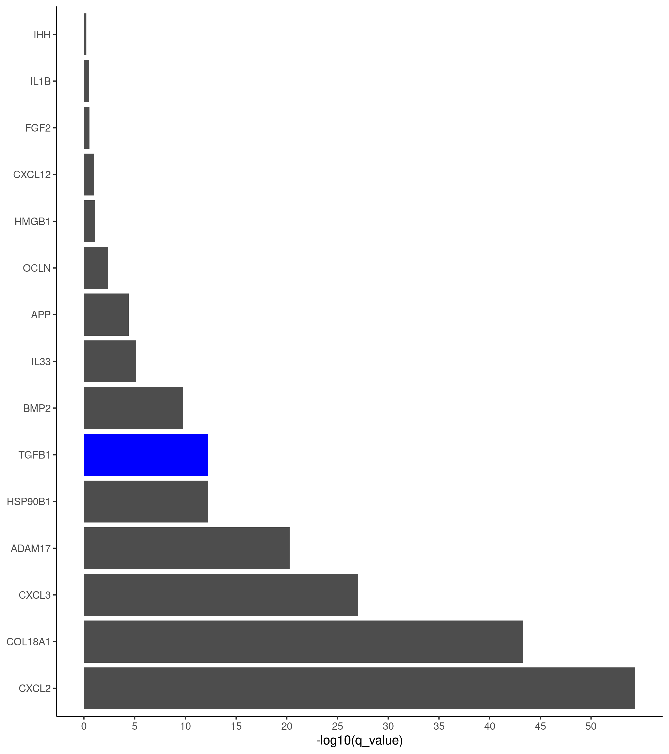

Figure S1: The statistical significance of ligands expressed along the trajectory in the choriocapillaris endothelial cells.

### differential expression of targets

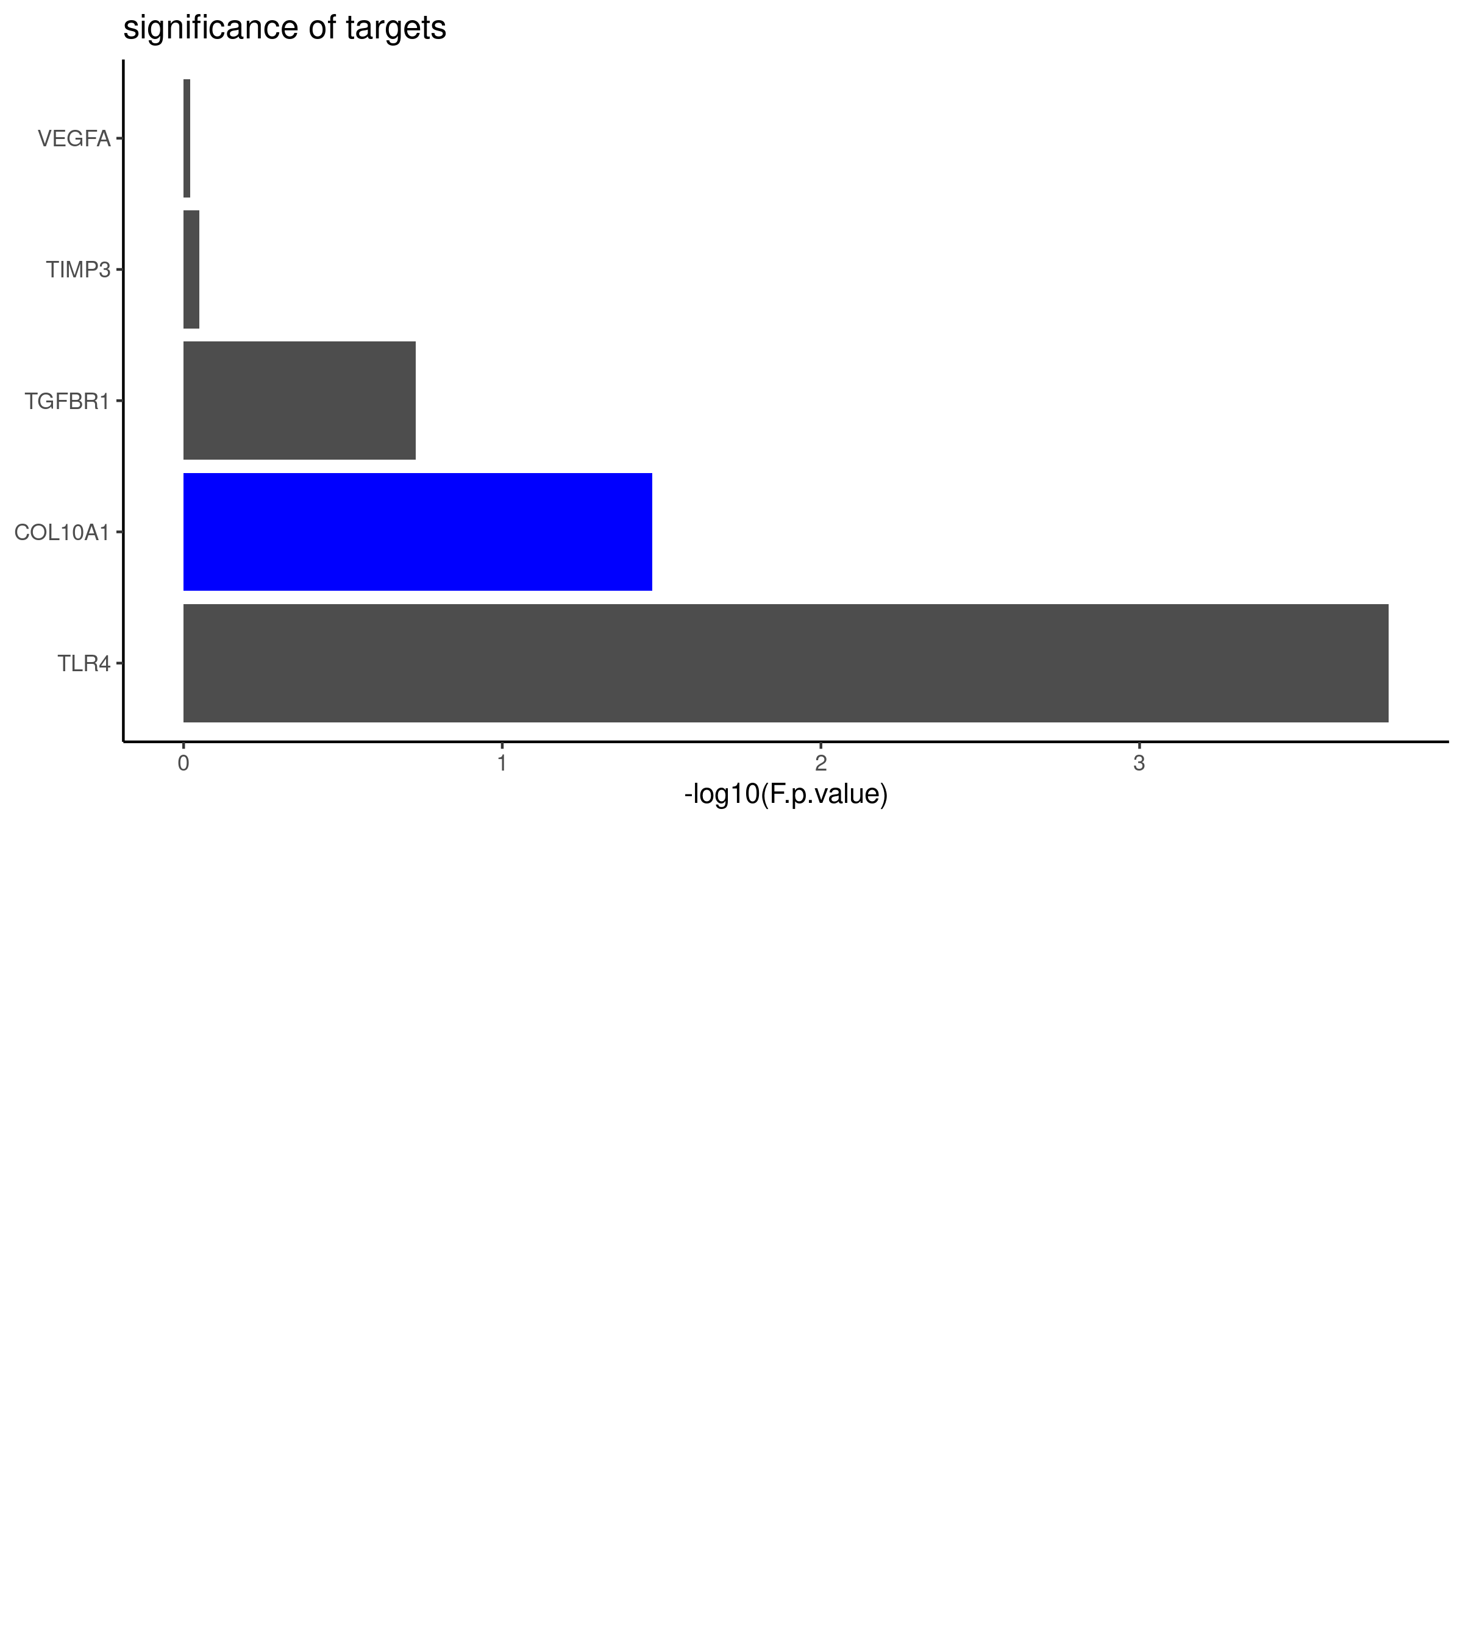

Figure S2: The expression of targets expressed in RPE, only COL10A1 and TLR4 are significantly differentially expressed among health(n = 3) and early AMD patients(n = 7).

### differential expression of COL18A1 in the CC endothelial cells

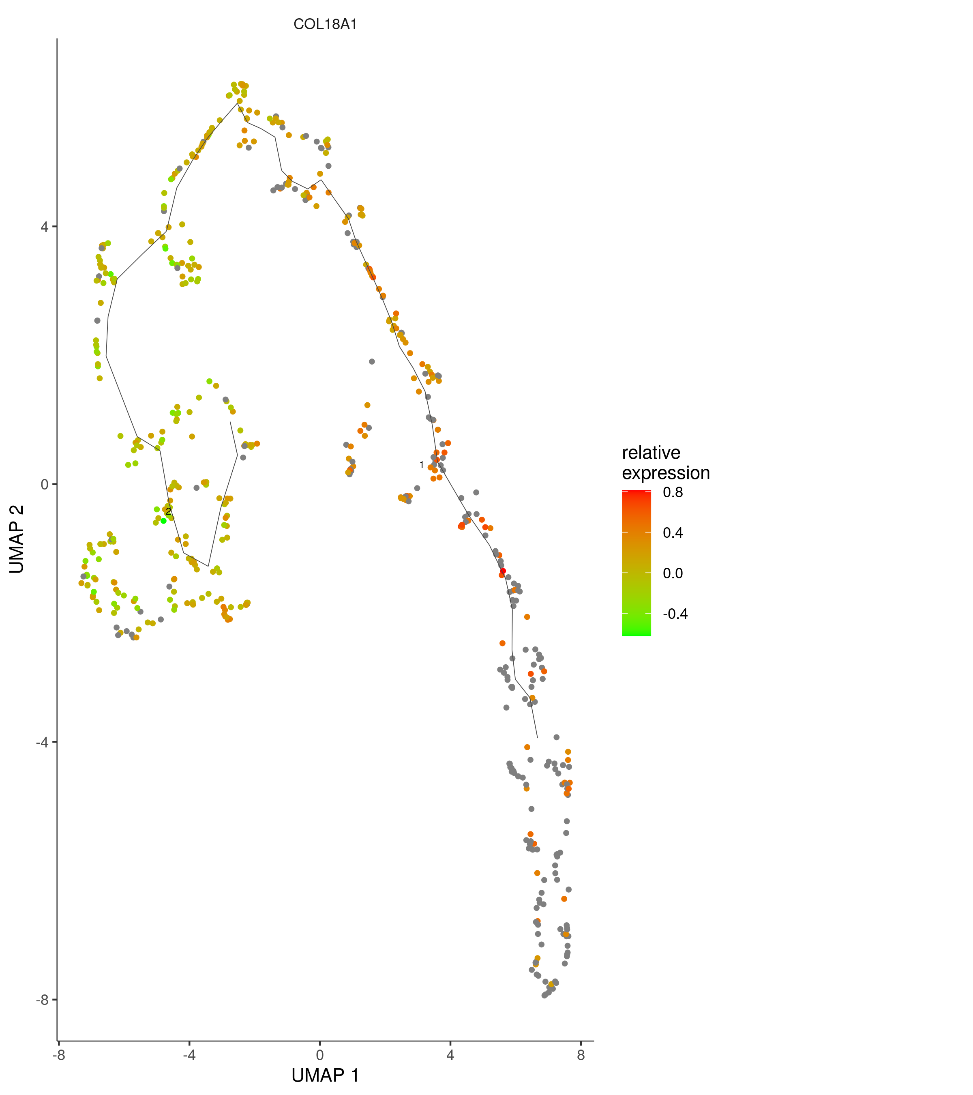

Figure S3: The expression of COL18A1 was elevated in the progress of AMD in the choriocapillaris endothelial cells.

### differential expression of regulators

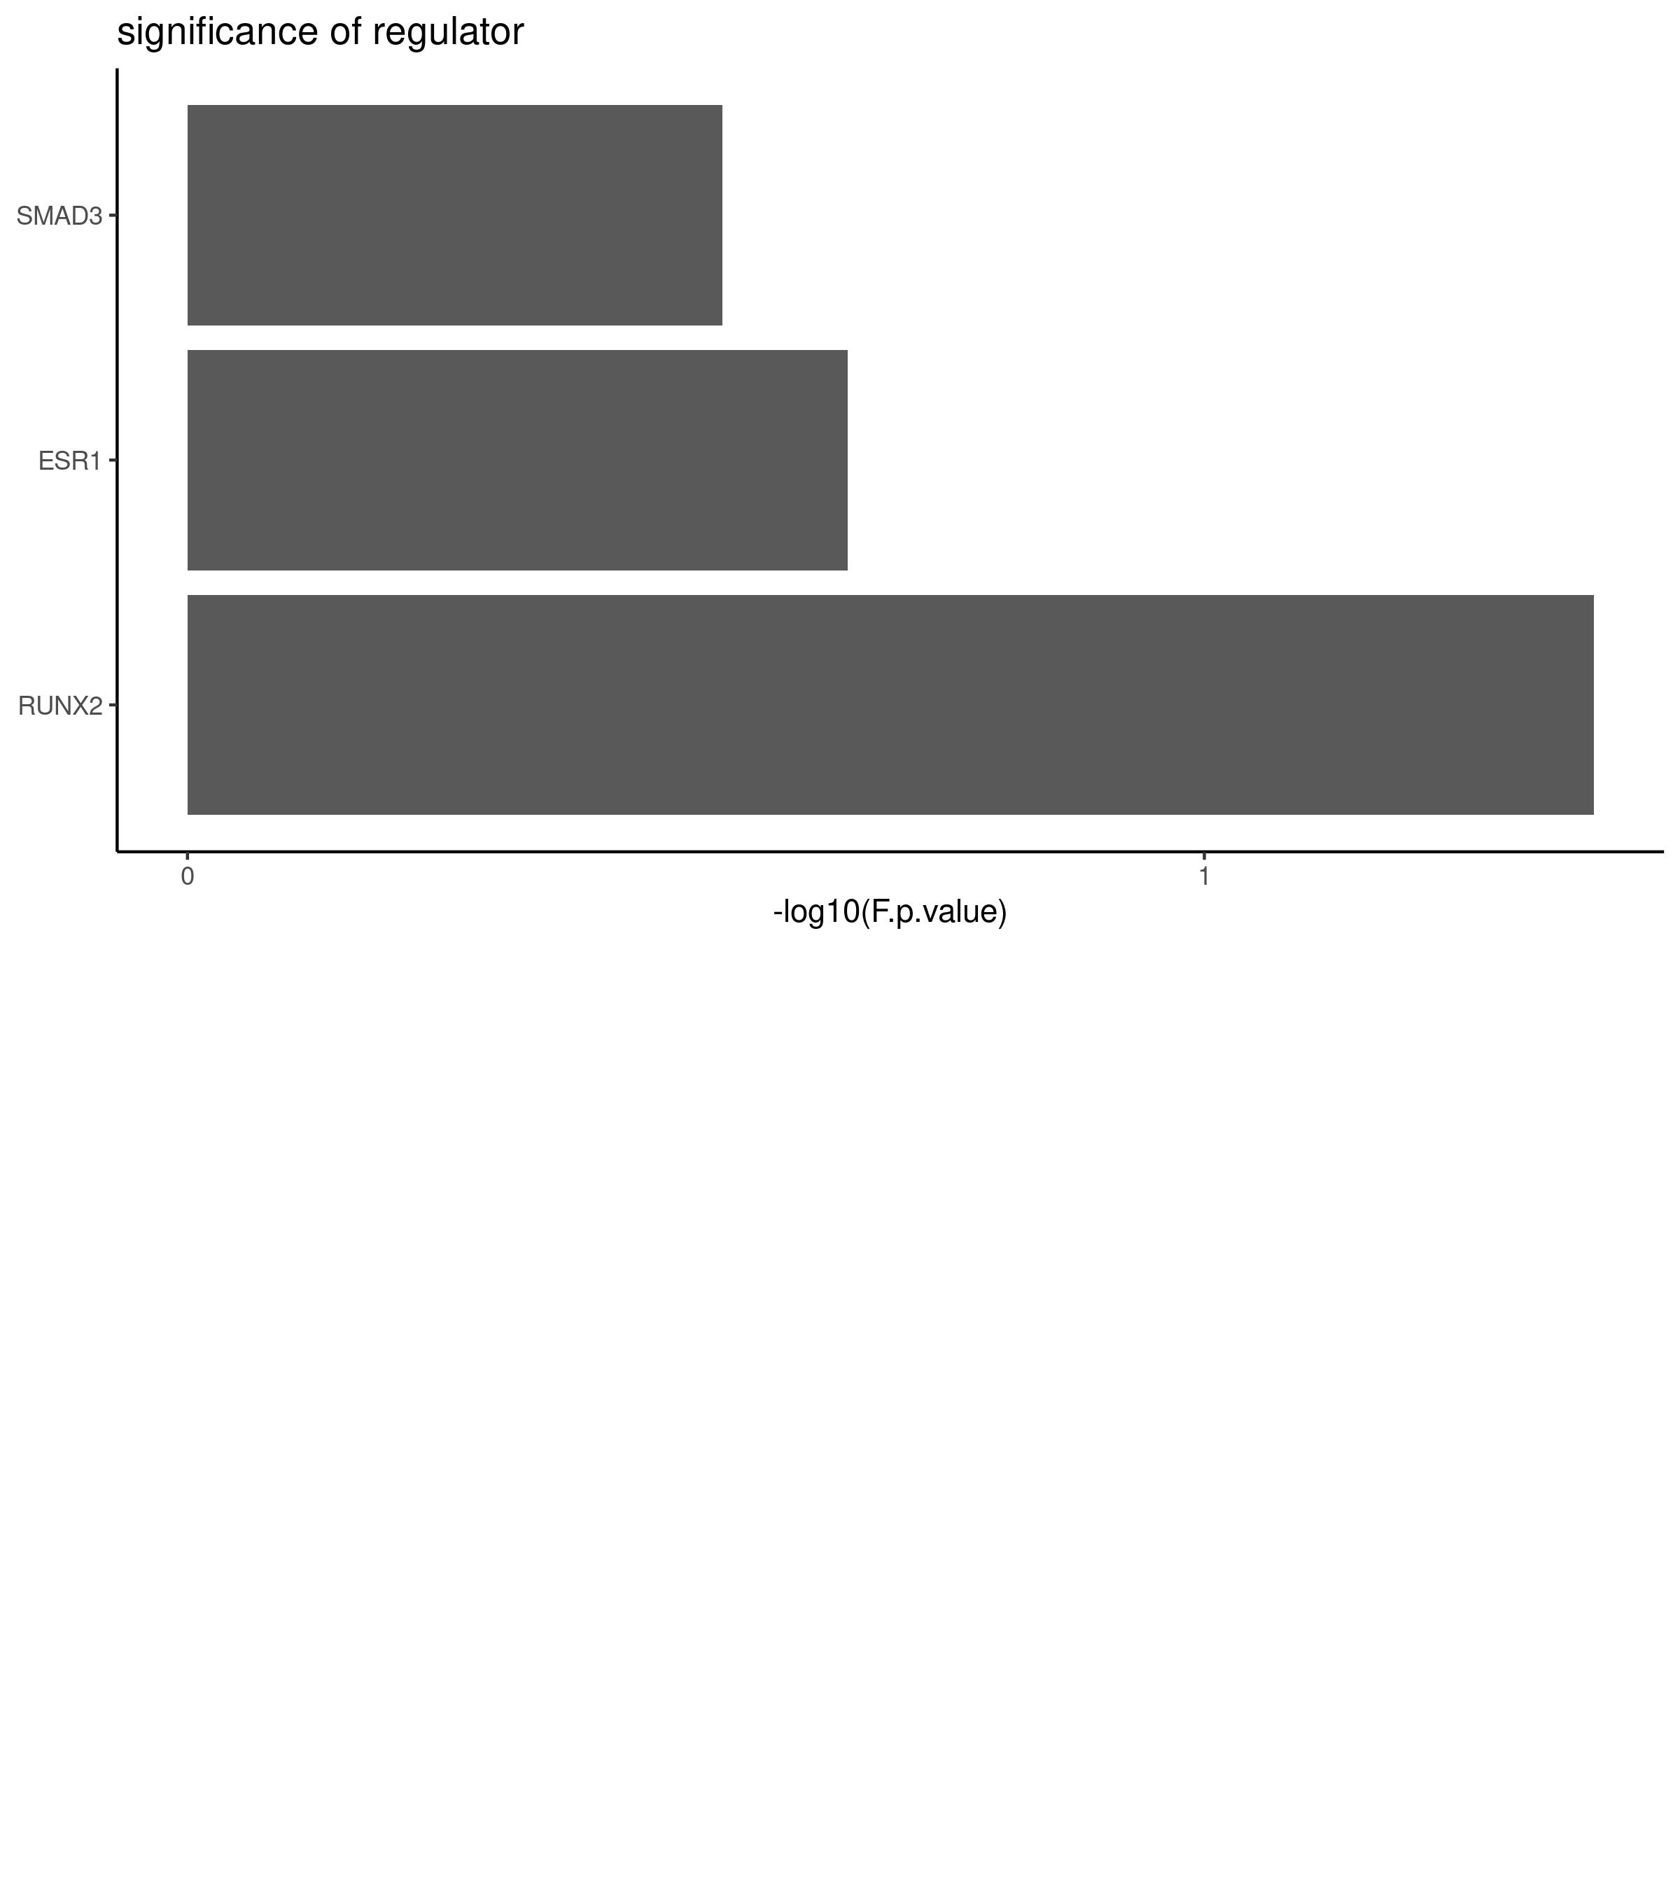

Figure S4: There are 4 transcription regulators that can regulator COL10A1’s expression, after filtering only RUNX2, SMAD3, and ESR1 are expressed, and only RUNX2 significantly down regulated in early AMD pathients(n = 3) compare to the health(n = 7).

### dimensional reduction of bulk-seq health and early AMD patients

Figure 6: Dimensional reduction of bulk-seq health(n = 7) and early AMD patients(n = 3), which show the high quality of the sequencing data, as health and early AMD patients can be clearly separated.

Figure S5: Dimensional reduction of bulk-seq health(n = 7) and early AMD patients(n = 3), which show the high quality of the sequencing data, as health and early AMD patients can be clearly separated.

### Software and R/Bioconductor packages

|  |  |
| --- | --- |
| Name | website |
| R | [https://www.r-project.org](https://www.r-project.org/) |
| RStudio | <https://rstudio.com/> |
| edgeR | <http://www.bioconductor.org/packages/release/bioc/html/edgeR.html> |
| limma | <http://www.bioconductor.org/packages/release/bioc/html/limma.html> |
| monocle3 | <http://cole-trapnell-lab.github.io/monocle-release/> |
| tidyverse | <https://www.tidyverse.org/> |
| cowplot | <https://github.com/wilkelab/cowplot> |
| RColorBrewer | <https://CRAN.R-project.org/package=RColorBrewer> |
| nichenetr | <https://github.com/saeyslab/nichenetr> |
| GEOquery | <http://www.bioconductor.org/packages/release/bioc/html/GEOquery.html> |
| ggridges | <https://CRAN.R-project.org/package=ggridges> |
| EnsDb.Hsapiens.v86 | <http://www.bioconductor.org/packages/release/data/annotation/html/EnsDb.Hsapiens.v86.html> |
| knitr | <https://yihui.org/knitr/> |
| rmarkdown | <https://github.com/rstudio/rmarkdown> |
| bookdown | <https://github.com/rstudio/bookdown> |

### sessionInfo

## R version 3.6.3 (2020-02-29)  
## Platform: x86_64-pc-linux-gnu (64-bit)  
## Running under: Ubuntu 18.04.4 LTS  
##   
## Matrix products: default  
## BLAS: /usr/lib/x86_64-linux-gnu/openblas/libblas.so.3  
## LAPACK: /usr/lib/x86_64-linux-gnu/libopenblasp-r0.2.20.so  
##   
## locale:  
## [1] LC_CTYPE=en_US.UTF-8 LC_NUMERIC=C   
## [3] LC_TIME=en_US.UTF-8 LC_COLLATE=en_US.UTF-8   
## [5] LC_MONETARY=en_US.UTF-8 LC_MESSAGES=en_US.UTF-8   
## [7] LC_PAPER=en_US.UTF-8 LC_NAME=C   
## [9] LC_ADDRESS=C LC_TELEPHONE=C   
## [11] LC_MEASUREMENT=en_US.UTF-8 LC_IDENTIFICATION=C   
##   
## attached base packages:  
## [1] stats4 parallel stats graphics grDevices utils datasets   
## [8] methods base   
##   
## other attached packages:  
## [1] EnsDb.Hsapiens.v86_2.99.0 ensembldb_2.10.2   
## [3] AnnotationFilter_1.10.0 GenomicFeatures_1.38.2   
## [5] AnnotationDbi_1.48.0 circlize_0.4.10   
## [7] igraph_1.2.5 ggridges_0.5.2   
## [9] cowplot_1.0.0 nichenetr_0.1.0   
## [11] monocle3_0.2.1 SingleCellExperiment_1.8.0   
## [13] SummarizedExperiment_1.16.1 DelayedArray_0.12.3   
## [15] BiocParallel_1.20.1 matrixStats_0.56.0   
## [17] GenomicRanges_1.38.0 GenomeInfoDb_1.22.1   
## [19] IRanges_2.20.2 S4Vectors_0.24.4   
## [21] RColorBrewer_1.1-2 GEOquery_2.54.1   
## [23] Biobase_2.46.0 BiocGenerics_0.32.0   
## [25] forcats_0.5.0 stringr_1.4.0   
## [27] dplyr_1.0.0 purrr_0.3.4   
## [29] readr_1.3.1 tidyr_1.1.0   
## [31] tibble_3.0.1 ggplot2_3.3.2   
## [33] tidyverse_1.3.0 edgeR_3.28.1   
## [35] limma_3.42.2   
##   
## loaded via a namespace (and not attached):  
## [1] tidyselect_1.1.0 RSQLite_2.2.0 htmlwidgets_1.5.1   
## [4] grid_3.6.3 pROC_1.16.2 munsell_0.5.0   
## [7] codetools_0.2-16 units_0.6-7 withr_2.2.0   
## [10] batchelor_1.2.4 colorspace_1.4-1 knitr_1.28   
## [13] rstudioapi_0.11 ROCR_1.0-11 pbmcapply_1.5.0   
## [16] labeling_0.3 GenomeInfoDbData_1.2.2 bit64_0.9-7   
## [19] farver_2.0.3 coda_0.19-3 LearnBayes_2.15.1   
## [22] vctrs_0.3.1 generics_0.0.2 ipred_0.9-9   
## [25] xfun_0.14 BiocFileCache_1.10.2 randomForest_4.6-14   
## [28] R6_2.4.1 ggbeeswarm_0.6.0 rsvd_1.0.3   
## [31] locfit_1.5-9.4 bitops_1.0-6 assertthat_0.2.1   
## [34] scales_1.1.1 nnet_7.3-14 beeswarm_0.2.3   
## [37] gtable_0.3.0 timeDate_3043.102 rlang_0.4.6   
## [40] GlobalOptions_0.1.2 splines_3.6.3 lazyeval_0.2.2   
## [43] rtracklayer_1.46.0 ModelMetrics_1.2.2.2 acepack_1.4.1   
## [46] broom_0.5.6 checkmate_2.0.0 reshape2_1.4.4   
## [49] modelr_0.1.8 backports_1.1.8 Hmisc_4.4-0   
## [52] caret_6.0-86 DiagrammeR_1.0.6.1 tcltk_3.6.3   
## [55] tools_3.6.3 lava_1.6.7 spData_0.3.5   
## [58] ellipsis_0.3.1 raster_3.1-5 proxy_0.4-24   
## [61] Rcpp_1.0.4.6 plyr_1.8.6 progress_1.2.2   
## [64] base64enc_0.1-3 visNetwork_2.0.9 zlibbioc_1.32.0   
## [67] classInt_0.4-3 RCurl_1.98-1.2 prettyunits_1.1.1   
## [70] openssl_1.4.1 rpart_4.1-15 deldir_0.1-25   
## [73] viridis_0.5.1 haven_2.3.1 ggrepel_0.8.2   
## [76] cluster_2.1.0 fs_1.4.1 magrittr_1.5   
## [79] data.table_1.12.8 RSpectra_0.16-0 gmodels_2.18.1   
## [82] reprex_0.3.0 RANN_2.6.1 ProtGenerics_1.18.0   
## [85] hms_0.5.3 XML_3.99-0.3 jpeg_0.1-8.1   
## [88] readxl_1.3.1 shape_1.4.4 gridExtra_2.3   
## [91] biomaRt_2.42.1 compiler_3.6.3 scater_1.14.6   
## [94] KernSmooth_2.23-17 crayon_1.3.4 htmltools_0.5.0   
## [97] spdep_1.1-3 tiff_0.1-5 Formula_1.2-3   
## [100] expm_0.999-4 speedglm_0.3-2 lubridate_1.7.9   
## [103] DBI_1.1.0 dbplyr_1.4.4 rappdirs_0.3.1   
## [106] MASS_7.3-51.6 sf_0.9-4 boot_1.3-25   
## [109] leidenbase_0.1.0 Matrix_1.2-18 cli_2.0.2   
## [112] gdata_2.18.0 gower_0.2.1 pkgconfig_2.0.3   
## [115] GenomicAlignments_1.22.1 foreign_0.8-76 sp_1.4-2   
## [118] recipes_0.1.12 xml2_1.3.2 foreach_1.5.0   
## [121] vipor_0.4.5 XVector_0.26.0 prodlim_2019.11.13   
## [124] rvest_0.3.5 digest_0.6.25 RcppAnnoy_0.0.16   
## [127] Biostrings_2.54.0 cellranger_1.1.0 htmlTable_1.13.3   
## [130] uwot_0.1.8 DelayedMatrixStats_1.8.0 curl_4.3   
## [133] Rsamtools_2.2.3 gtools_3.8.2 lifecycle_0.2.0   
## [136] nlme_3.1-148 jsonlite_1.6.1 BiocNeighbors_1.4.2   
## [139] askpass_1.1 viridisLite_0.3.0 fansi_0.4.1   
## [142] pillar_1.4.4 lattice_0.20-41 httr_1.4.1   
## [145] survival_3.2-3 glue_1.4.1 fdrtool_1.2.15   
## [148] png_0.1-7 iterators_1.0.12 bit_1.1-15.2   
## [151] class_7.3-17 stringi_1.4.6 blob_1.2.1   
## [154] BiocSingular_1.2.2 memoise_1.1.0 latticeExtra_0.6-29   
## [157] caTools_1.18.0 irlba_2.3.3 e1071_1.7-3