Lab_5

# Question 1

boxplot(temp ~ gender, data = bodytemp)

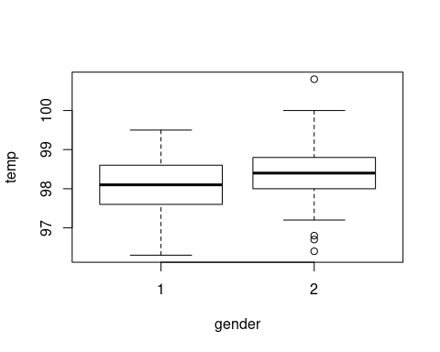

Answer.  
As the plot shows, the female have an higher temperature than male on average.

# Question 2

null hypotheses: there is no difference of the mean body temperature between male and female.  
  
alternative hypothesis: the average temperature of female is not equal to the male's.

H0: xmale = xfemale

Ha: xmale != xfemale

# Question 3

obs_means <- mean(temp ~ gender, data = bodytemp)  
obs_mean_diff <- obs_means[1] - obs_means[2]  
obs_mean_diff

## 1   
## -0.2892308

The means of **obs_mean_diff** is the average temperature of male minus the average temperature of female’s.

# Question 4

diff_means <- numeric(1000)  
set.seed(123)  
  
for(i in 1:1000){  
 gender_shuffle_i <- sample(bodytemp$gender)  
 means_i <- mean(temp ~ gender_shuffle_i, data = bodytemp)  
 diff_means[i] <- means_i[1] - means_i[2]  
}  
  
  
histogram(diff_means, fit = "normal", type = "density")

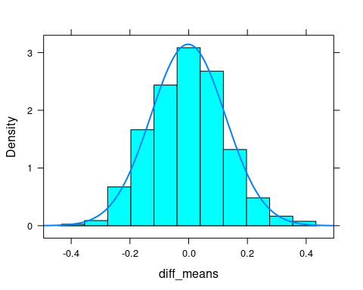

Answer.  
It seems that the null distribution is approximately an normal distribution.

# Question 5

mean(abs(diff_means) > abs(obs_mean_diff))

## [1] 0.023

# Question 6

As the p-value is smaller than the significance level, so we reject the null hypothesis, and accept the alternative hypothesis.

# Question 7

t.test(temp ~ gender, data = bodytemp)

##   
## Welch Two Sample t-test  
##   
## data: temp by gender  
## t = -2.2854, df = 127.51, p-value = 0.02394  
## alternative hypothesis: true difference in means is not equal to 0  
## 95 percent confidence interval:  
## -0.53964856 -0.03881298  
## sample estimates:  
## mean in group 1 mean in group 2   
## 98.10462 98.39385

Answer.

Yes, the simulation-based p-value is very close to the theory-based p-value, and the conclusion draws from the two methods are also same at the significance level of 0.05, which reject the null hypothesis and accepts the alternative hypothesis.

# Question 8

Answer.

The 95% confidence interval says: if the male temperature minus females temperature fall into this interval, we have 95% confidence say their body temperature is difference.

# Question 9

l <- lm(temp ~ hrtrate, data = bodytemp)  
plot(temp ~ hrtrate, data = bodytemp)  
abline(l)

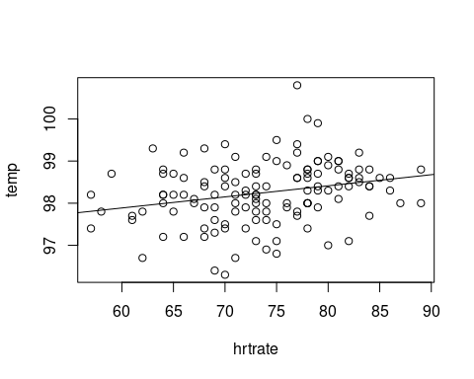

Answer.

It seems that there is an positive relationship between heart rate and body temperature. As there are some outliers, this implies heart rate along can not well explain the body temperature more variables are needed.

# Question 10

c <- cor(temp ~ hrtrate, data = bodytemp)  
c

## [1] 0.2536564

# Question 11

cors <- numeric(1000)  
set.seed(123)  
  
for(i in 1:1000){  
 hrtrate_shuffle_i <- sample(bodytemp$hrtrate)  
 cors[i] <- cor(temp ~ hrtrate_shuffle_i, data = bodytemp)  
}  
  
  
mean(abs(cors) > abs(c))

## [1] 0.002

Answer.

Yes, we have enough evidence to reject the null hypothesis, as the p-value less than 0.01.

# Question 12

cor.test(~ temp + hrtrate, data = bodytemp)

##   
## Pearson's product-moment correlation  
##   
## data: temp and hrtrate  
## t = 2.9668, df = 128, p-value = 0.003591  
## alternative hypothesis: true correlation is not equal to 0  
## 95 percent confidence interval:  
## 0.08519113 0.40802170  
## sample estimates:  
## cor   
## 0.2536564

Answer.

Based on the significance level of 0.05, we have enough evidence to say that there is an strong relationship between body temperature and the heart rate.