#### Cluster

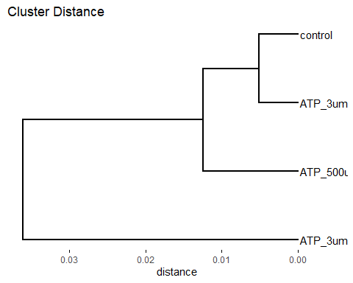

#### Intersect of differential expressed genes



#### Top 20 enriched GO of 3uM ATP vs Control

#### Top 20 enriched GO of 500uM ATP vs Control

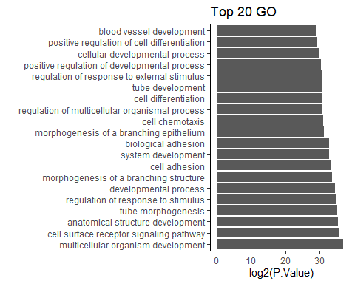

#### KEGG pathway 3uM ATP vs Control

## Pathway N DE  
## 1 Malaria 56 5  
## 2 beta-Alanine metabolism 32 3  
## 3 Metabolic pathways 1545 29  
## 4 Glutathione metabolism 65 4  
## 5 Metabolism of xenobiotics by cytochrome P450 67 4  
## 6 Drug metabolism - cytochrome P450 69 4  
## 7 Chemical carcinogenesis 95 4  
## 8 Glycosphingolipid biosynthesis - lacto and neolacto series 27 2  
## 9 Lipoic acid metabolism 4 1  
## P.DE  
## 1 0.0005107877  
## 2 0.0063179433  
## 3 0.0063225810  
## 4 0.0073458280  
## 5 0.0081676389  
## 6 0.0090476561  
## 7 0.0263925002  
## 8 0.0405771029  
## 9 0.0467621667

mmu05144 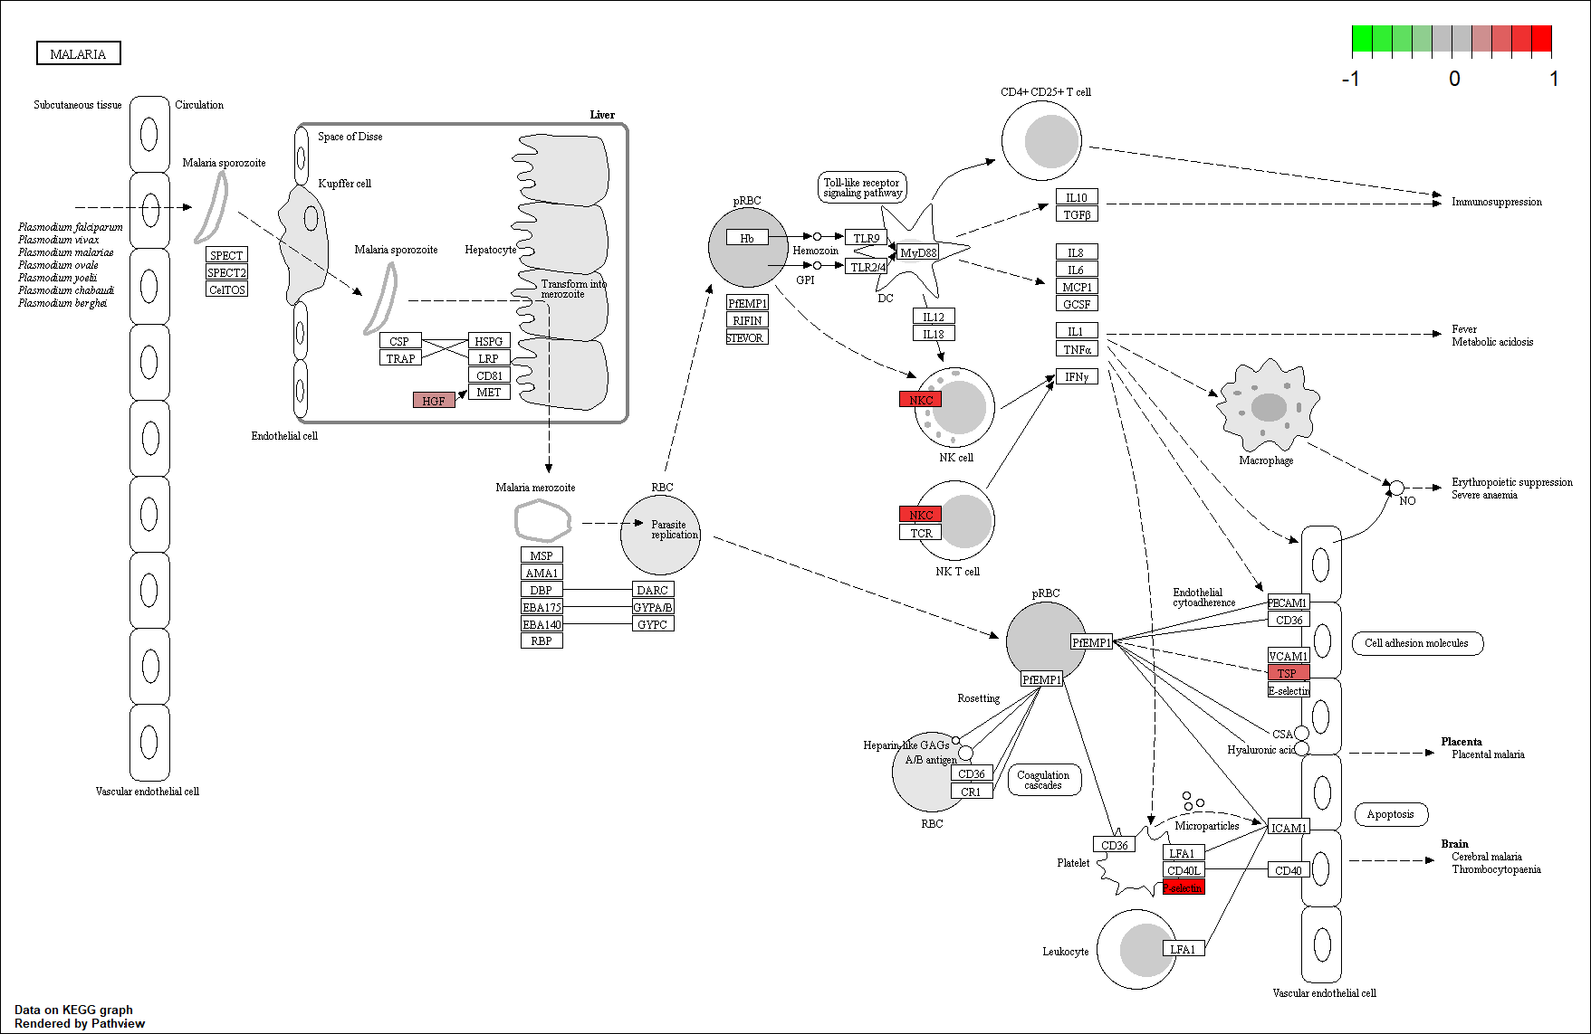

#### KEGG pathway 500uM ATP vs Control

## Pathway N DE P.DE  
## 1 Cytokine-cytokine receptor interaction 296 25 6.578319e-07  
## 2 Hematopoietic cell lineage 95 13 2.007999e-06  
## 3 Malaria 56 10 2.683324e-06  
## 4 Basal cell carcinoma 63 9 5.519389e-05  
## 5 Th17 cell differentiation 102 11 1.182694e-04  
## 6 T cell receptor signaling pathway 103 11 1.292110e-04  
## 7 PD-L1 expression and PD-1 checkpoint pathway in cancer 88 10 1.558490e-04  
## 8 Breast cancer 147 13 2.220358e-04  
## 9 Hippo signaling pathway 154 13 3.510416e-04  
## 10 Primary immunodeficiency 36 6 4.228236e-04

mmu04060 