tumor macropahge

2020-11-04

**This project is to study how dividing macrophage in tumor promoter tumor progression**.

## type of virus

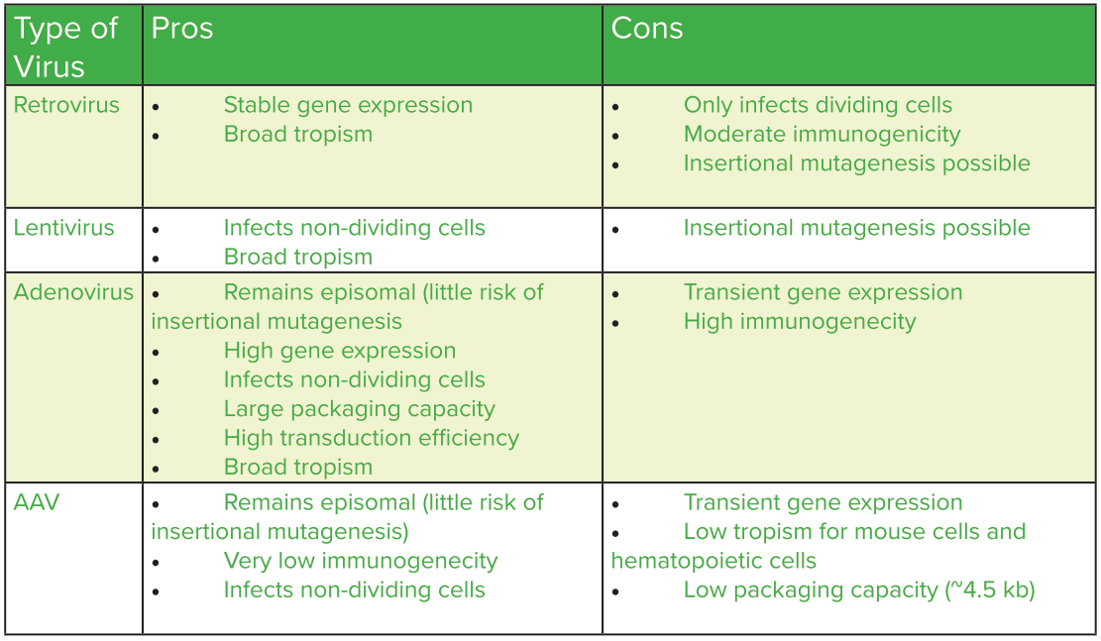

retrovirus can only infects dividing cells, this can be using to infect self-maintaining macrophage.

## by using macrophage specifc promoter to knock-down/knock-out gene in self-maintaining macrophage

We can use retrovirus to delivery Cas9 or shRNA to interfer genes expressed in self-maintaining macropage by using macropage specific promoter.

