how peripheral nervous system regulate tumor progression

2020-11-04

## Virus can specificly infect peripheral nervous system

This paper discrebe an AAV can specificly infects peripheral nervous system with high efficency.

knitr::include_graphics("AAV-PHP.S.png")



knitr::include_graphics("addgene-PHP.S.PNG")

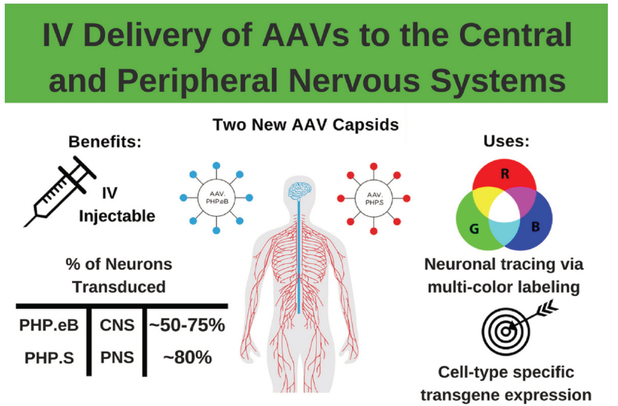

## which type of nervs inflence tumor progression

if surgically ablate all type of nerves in kidney can slow tumor progression

### sympathetic nerve

* 6OHDA ablate sympathetic nerve

### parasympathetic nerve

* botulinum toxin A (Botox) denervate both sensory and parasympathetic nerve

### sensor nerve

* capsaicin denervate sensor nerve

## read out

* tumor volumn
* metastasis
* tumor stem cell
* maliganance

## Science paper 2013

knitr::include_graphics("autonomic-nerve.PNG")

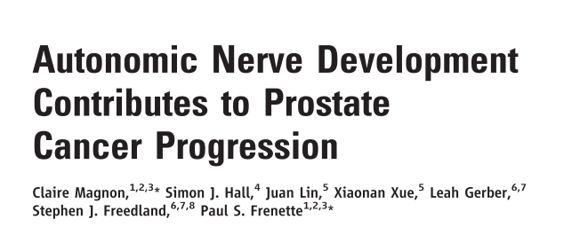

* sympathetic nerve are critical at early stage of tumor development
* sympathetic nerve influence tumor progress by Adrβ2 and Adrβ3
* Sympathectomy had no effect on tumorigenesis after tumor has onset
* synpathetic nerve mainly innervated normal tissue surrounding the tumor
* parasympathetic nerve influence tumor metastasis
* parasympathetic nerve exert is effect through *Chrm1*, cholinergic receptor.
* parasympathetic nerve mainly in the tumor