20211106

kidney PB3 Pdgfrb
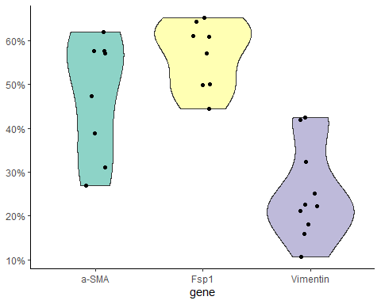

Kidney LPS
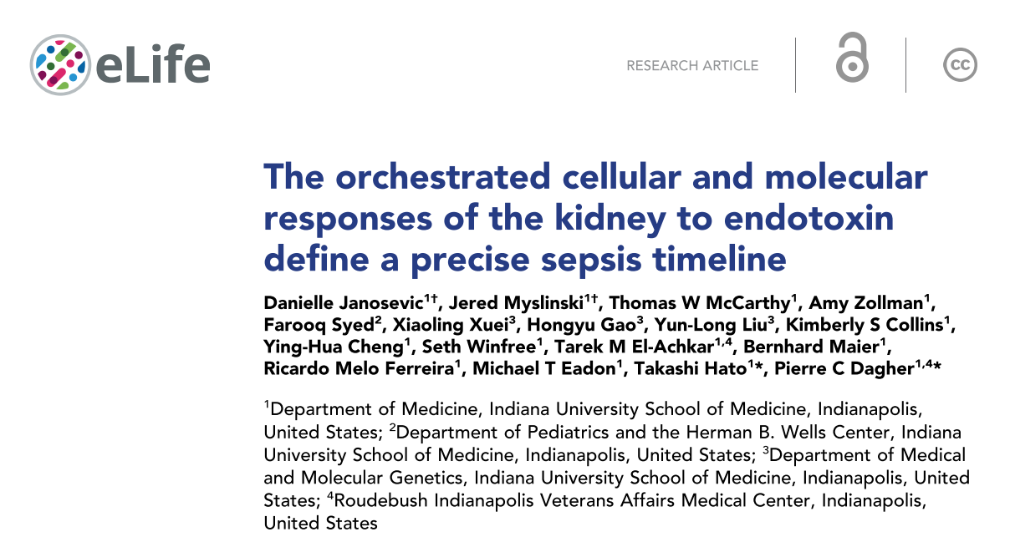
- time points: 0, 1, 4, 16, 27, 36, 48 hours
- tail vein injection LPS 5mg/kg
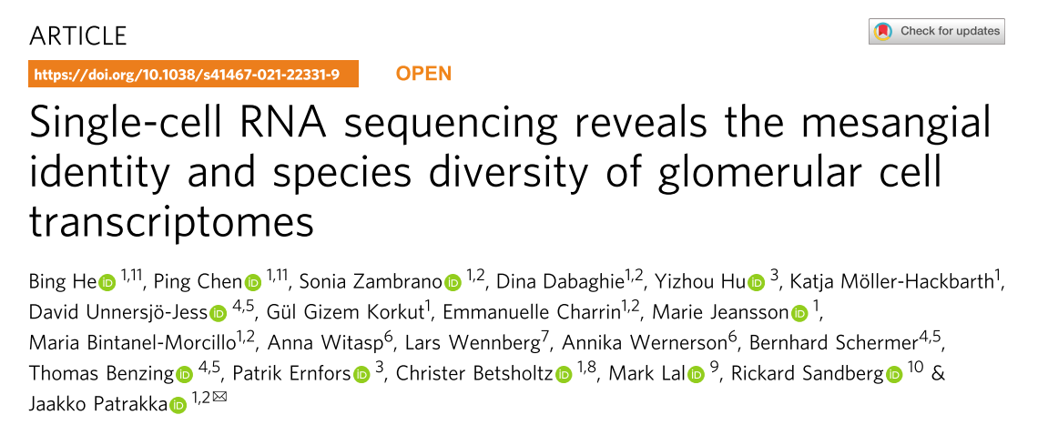

kidney macrophage
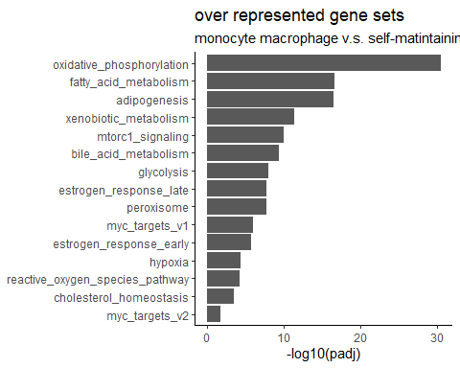
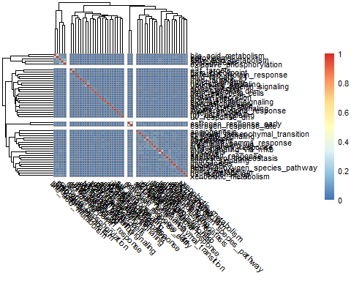
SYMBOL | GENENAME
Acaa2 | acetyl-Coenzyme A acyltransferase 2 (mitochondrial 3-oxoacyl-Coenzyme A thiolase)
Acadm | acyl-Coenzyme A dehydrogenase, medium chain
Aco2 | aconitase 2, mitochondrial
Decr1 | 2,4-dienoyl CoA reductase 1, mitochondrial
Dld | dihydrolipoamide dehydrogenase
Ech1 | enoyl coenzyme A hydratase 1, peroxisomal
Echs1 | enoyl Coenzyme A hydratase, short chain, 1, mitochondrial
Idh1 | isocitrate dehydrogenase 1 (NADP+), soluble
Idh3g | isocitrate dehydrogenase 3 (NAD+), gamma
Mdh2 | malate dehydrogenase 2, NAD (mitochondrial)
Retsat | retinol saturase (all trans retinol 13,14 reductase)
Sdhc | succinate dehydrogenase complex, subunit C, integral membrane protein
Suclg1 | succinate-CoA ligase, GDP-forming, alpha subunit

geneID | blood_mac_1 | blood_mac_2 | blood_mac_3 | sm_mac_1 | sm_mac_2 | sm_mac_3 | logFC | PValue
Acaa2 | 2707 | 1459 | 1853 | 778 | 855 | 822 | -0.8632390 | 0.0000358
Acadm | 5049 | 3388 | 4195 | 1520 | 1940 | 1753 | -0.8722525 | 0.0000000
Aco2 | 10181 | 7105 | 8671 | 3132 | 4986 | 3624 | -0.7620774 | 0.0000005
Decr1 | 1790 | 1040 | 1302 | 485 | 555 | 512 | -0.9905498 | 0.0000029
Dld | 3936 | 2406 | 3357 | 1119 | 1947 | 1498 | -0.7035111 | 0.0000168
Ech1 | 3338 | 2392 | 2606 | 1067 | 1545 | 1103 | -0.7781687 | 0.0000020
Echs1 | 2380 | 1636 | 1837 | 810 | 1006 | 758 | -0.7801954 | 0.0000196
Idh1 | 6815 | 2900 | 4967 | 1469 | 1705 | 1448 | -1.2247431 | 0.0000001
Idh3g | 3435 | 2840 | 3323 | 1412 | 2317 | 1935 | -0.3906869 | 0.0081094
Mdh2 | 5776 | 3928 | 4343 | 1803 | 2827 | 2113 | -0.6750871 | 0.0000193
Retsat | 2221 | 1389 | 1732 | 584 | 789 | 667 | -0.9854523 | 0.0000000
Sdhc | 2565 | 1796 | 2044 | 793 | 1141 | 912 | -0.7799920 | 0.0000011
Suclg1 | 2837 | 1792 | 2038 | 707 | 1035 | 745 | -1.0279730 | 0.0000000

Tumor nerve
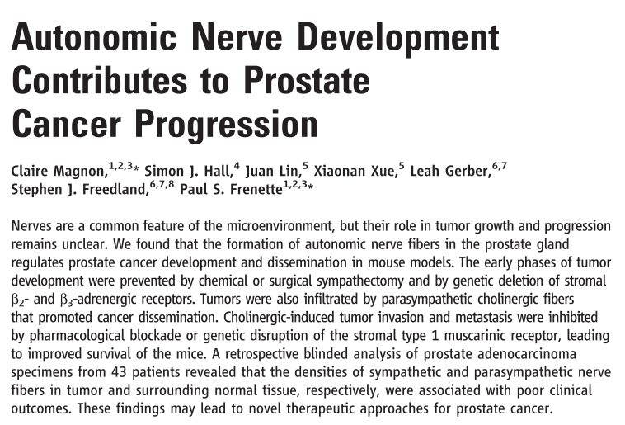
- sympathetic nerve are critical at early stage of tumor development
- sympathetic nerve influence tumor progress by Adrβ2 and Adrβ3
- Sympathectomy had no effect on tumorigenesis after tumor has onset
- synpathetic nerve mainly innervated normal tissue surrounding the tumor

- parasympathetic nerve influence tumor metastasis
- parasympathetic nerve exert is effect through Chrm1, cholinergic receptor.
- parasympathetic nerve mainly in the tumor

