Chris Redding

Influences on Student’s Expectation for Future Educational Attainment

December 4, 2012

LPO 3921

Dr. Will Doyle

Peabody College

Vanderbilt University

**Introduction**

High expectations for future educational attainment are treated as a self-fulfilling prophecy (Goldenberg & Gallimore, 2001). To have high expectations for future educational success is a necessary (but perhaps insufficient) requirement for sustained academic performance. Yet, the formation of educational aspirations is a dynamic process that is influenced by parental, peer, school, and societal pressures (Benner & Mistry, 2007; Goyette, 2008). To explore these issues, this study addresses the following question: in what ways are school factors, individual risk factors, and test performance associated with students’ goals for future educational attainment?

**Description of Variables and Dataset**

In this study, the dependent variable is based on student responses to the question of how far in school the student thinks (s)he will get. This dependent variable will be analyzed by the influence of three categories of independent variables: school-based factors, student risk factors, and student performance data. School-based factors include measures of school size, racial and economic demographics, and urbanicity. Student risk factors is a composite variable of six criteria associated with a student dropping out. Student performance data will be measured by a composite score of the sampled student’s performance on standardized math and reading tests (See Appendix 2 for more details on each variable).

I hypothesize that a larger number of school factors and individual risk factors and a lower test score will all be associated with lower expectations for future academic achievement. Similarly, a smaller number of school and student risk factors and a higher test score will be associated with higher expectations for future academic attainment. To address this hypothesis, the current study uses measures from the Educational Longitudinal Study of 2002. ELS:2002 used a longitudinal cohort-based design to track the factors that influenced students’ progression through high school and pursuance of employment or postsecondary school. Students were sampled and surveyed in 2002 when they were in tenth grade, with follow-ups in 2004 and 2006.

ELS:2002 utilized a two-stage sampling procedure. First, approximately 27,000 schools were stratified based on region and urbanicity. 1,221 eligible schools were randomly selected, of which 752 participated in the study (68.7%). Second, participating schools provided researchers with rosters from which researchers selected approximately 26 tenth grade students. The sample of students was meant to match the target population (which oversampled Hispanic and Asian students). With 17,591 eligible sophomores, 15,362 participated in the study (87.3%). As some ethnic/racial groups were oversampled and nonresponse was higher for some groups, school and student weights were used. In the base year survey, these weights sought to overcome bias by comparing nonresponse rates for certain characteristics between respondents and nonrespondents (Ingels, Pratt, & Rogers, 2004). In giving student responses different weights, the summative responses would match the target population.

To apply the student probability weights, this study uses Taylor series linearized estimates of variance. The linearized estimates are developed in two parts. The primary sampling unit (PSU) indicates the school from which the student was sampled and the strata (STRAT_ID) indicated student’s code within a school. The PSU and STRAT_ID allow for the series of approximations to be made around each student’s specific weighting. These estimates of variance give a more realistic estimate for student responses and larger standard errors that allow for greater ability to detect change in the dependent variable.

**Limitations**

As this study is using cross-sectional data from the base year of ELS:2002, the relational direction of the variables will be difficult to establish. Furthermore, since ELS: 2002 sampled tenth grade students, there is no way to evaluate the formative causes on their expectations for future academic attainment in the first year and a half of high school (or before). Additional limitations come from two of the independent variables. The measure for student risk factors had a very low response rate (73.9%) compared to the other measures in the study (94.12% for student expectations and 98.12% for the composite test score). The measure for school factors was not an initial measure in ELS:2002 and instead was imputed from other variables. As most measures in this composite variable were aggregated using tenth grade student data, this variable risks misrepresenting the school’s actual demographics.

**Results**

Of the primary variables in the study, the measures for student expectations for future education, school factors, and student risk factors were all ordinal variables. For the measure of how far students think they will get in school, graduating from a four-year college is the most common aspiration (35.78%). An additional 35.79% of respondents thought they would either earn a Master’s PhD, MD, or other advanced degree. In regards to school factors, the majority of schools (57.42%) had either zero factors (meaning the school was small and located in a rural or suburban area without large enrollments of ethnic minorities or students on FRPL) or one school factor (usually size or urbanicity). Only 8.14% of schools had four school risk factors. For student risk factors, 41.49% of students had no individual risk factors and 30.63% had only one risk factor. Only 10.97% of students had three or more risk factors. Lastly, the composite score for reading and math test performance is a continuous variable that is normally distributed, has a mean of 50.87191, and standard deviation of 9.930231.

Before looking at the individual relationships between each independent variable and the dependent variable, Table 1 provides a helpful overview of the relational direction that school factors, student risk factors, and test performance all have on student’s expectations of future academic attainment. While the mean is not the best measure for ordinal measures, this table shows that for both school and student risk factors, a smaller average number of factors is associated with increased expectations for how far the student thinks they will get in school (including pursuing a two-year degree). A higher number of school and student risk factors are also associated with decreased educational expectations. For test scores, the higher a student’s average test score, the more likely they are to report wanting to pursue higher levels of education. Not surprisingly, the lowest average test scores are associated with students who expect to dropout or only graduate from high school.

In regards to school factors, the directional hypothesis holds more strongly for low educational expectations than for high (see Table 2 and Figure 1.1). Students in schools with three and four risk factors report the highest levels of expecting to drop out or only graduate from high school. Figure 1.3 depicts a similar relationship between high risk factors and low educational aspirations. When looking at school factors by each academic level, little overall variation exists between the set of graphs. The graph that differs most noticeably from this pattern shows students who do not expect to graduate from high school. While students from schools with one and two risk factors have the highest proportion of student’s who expect to drop out, the proportion of students in schools with three or four risk factors are proportionally higher than any comparable educational level.

Yet, it is unclear whether a higher number of school risk factors impacts student’s aspirations to pursue higher educational levels. Students in schools with four factors report the lowest levels of educational aspirations, with 16.02% of students planning to earn a Master’s degree and 13.53% of students planning to earn a PhD, MD, or other advanced degree. However, 17.86% of students in schools with three factors report that they plan to pursue an advanced degree, the highest proportion across all school factors. Lastly, for students in schools at each factor level, the proportion of those who seek to graduate from college is remarkably similar.

Compared to school factors, a higher number of student risk factors have a stronger association with expectations for high and low educational attainment. For students with four risk factors and above, 9.044% report that they plan to earn a Master’s degree and 9.387% report they plan to earn a PhD, MD, or other advanced degree (see Table 3). For students in schools with four risk factors, the proportions increase to 16.02% and 13.53%, respectively (see Table 2). Individual risk factors also have a stronger association with low academic aspirations (see Figure 1.1 and 1.2). In particular, Figure 1.4 shows how fewer risk factors is related to student’s aspirations to attend postsecondary education. Of those who report that they plan to pursue an advanced academic degree, nearly 50% of students have no risk factors whereas less than 5% have four risk factors or more.

The relationship between test scores and desired educational levels is the most straightforward. Higher test scores are consistently associated with higher expectations for future academic attainment (see Figure 1.5 and 1.6). Also of note, in Figure 1.6, outliers tend to be most concentrated around higher educational levels, indicating that planning on pursuing high levels of education may be the norm for a large portion of students.

In general, all three independent variables in this study have an association with student expectations of future educational attainment. While similar patterns exist for graduating from college across each variable, student risk factors and the composite test score have stronger associations with student’s expectations for future academic attainment than school-based factors.

**Appendix 1: Figures and Tables**









****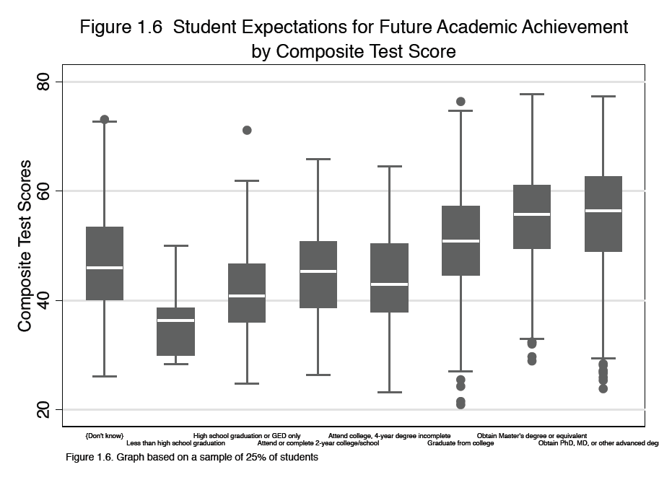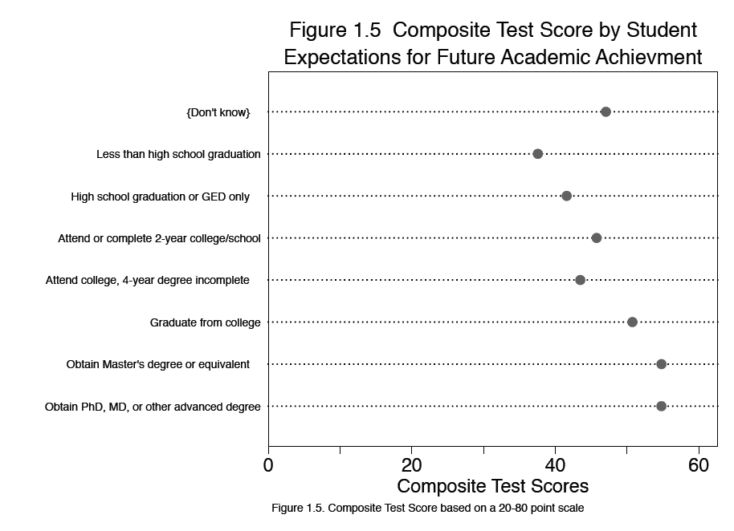

**Appendix 2: Codebook**

|  |  |  |
| --- | --- | --- |
| **Variable** | **Label** | **Description** |
| Dependent Variable | | |
| BYSTEXP | How far in school student thinks will get-composite | How far student thinks he/she will get in school. Based on student questionnaire variable BYS56.  1-Don’t know  1-Less than high school graduation  2-High school graduation or GED only  3-Attend or complete 2-year college/school  4-Attend college, 4-year degree incomplete  5-Graduate from college  6-Obtain Master’s degree or equivalent  7-Obtain PhD, MD, or other advanced degree  Variable Obs Mean Std. Dev. Min Max  ----------------------------------------------------------------------  BYSTEXP 15244 4.606731 2.27144 -1 7  Median-5 |
| Independent Variables | | |
| BYTXCSTD | Standardized test composite score-math/reading | The composite score is the average of the math (BYTXMSTD) and reading (BYTXRSTD) standardized scores, re-standardized to a national mean of 50.0 and standard deviation of 10.0.  Variable Obs Mean Std. Dev. Min Max  ----------------------------------------------------------------------  BYTXCSTD 15892 50.65777 9.880031 20.91 81.04 |
| BYRISKFC | Number of academic risk factors in 10th grade | This variable indicates the number of academic risk factors associated with each sample member. Academic risk factors include whether the sample member: (1) comes from a single-parent household; (2) has two parents without a high school diploma; (3) has a sibling who has dropped out of school; (4) has changed schools two or more times (excluding changes due to school promotions); (5) has repeated at least one grade; and (6) comes from a household with an income below the federal threshold for poverty. Variable was recoded from “Five or more risk factors” to “Four or more risk factors.”  Variable Obs Mean Std. Dev. Min Max  ----------------------------------------------------------------------  BYRISKFC 11966 .9816981 1.078258 0 4  Median-1 |
| SCHOOLFACTORS | School Factors | This variable indicates the number of school risk factors associated with each student’s school. School factors include whether or not: (1) the school is located in an urban area; (2) the school has a majority of students on free or reduced lunch; (3) the school is large; and (4) the school has a majority of non-White/Asian students. This variable is a composite variable of URBAN, FRPLMAJORITY, LARGESCHOOL and MAJORITYRACE.  Variable Obs Mean Std. Dev Min Max  ----------------------------------------------------------------------  SCHOOLFACTORS 16197 1.402297 1.15769 0 4  Median-1 |
| URBAN | Urban School | Recoded BYURBAN as a dummy variable with 1=Urban and 0= Suburban and Rural.  Variable Obs Mean Std. Dev. Min Max  ----------------------------------------------------------------------  URBAN 16197 .3387047 .4732839 0 1 |
| FRPLMAJORITY | Majority of 10th graders on FRPL | Recoded BY10FLP as a dummy variable with 1=50% or more of students on Free or Reduced Lunch and 0=Less than 50% of students on Free or Reduced Lunch. The variable aggregated 10th grade student data as representative for the entire school.  Variable Obs Mean Std. Dev. Min Max  ----------------------------------------------------------------------  FRPLMAJORITY 16197 .3506822 .4771983 0 1 |
| LARGESCHOOL | 300 10th graders and above | Recoded BYG10EP as a dummy variable with 1=300 students or more in the sophomore class and 0=less than 300 students in the sophomore class. The variable aggregated 10th grade student data as representative for the entire school.  Variable Obs Mean Std. Dev. Min Max  ----------------------------------------------------------------------  LARGESCHOOL 16197 .4718158 .4992204 0 1 |
| MAJORITYRACE | Majority of students are ethnic minorities | This variable aggregates the sampled sophomore students’ race/ethnicity as representative of the racial makeup of the entire school. Schools with more than half non-White/Asian students were coded as 1 and schools with less than half non-White/Asian students were coded as 0.  Variable Obs Mean Std. Dev. Min Max  ----------------------------------------------------------------------  MAJORITYRACE 16197 .241094 .4277604 0 1 |
| BYURBAN | School Urbanicity | Urbanicity of school locale as indicated in the source data for  sampling.  1-Urban  2-Suburban  3-Rural  Variable Obs Mean Std. Dev. Min Max  ---------------------------------------------------------------------  BYURBAN 16197 1.843243 .7043506 1 3  Median-2 |
| BY10FLP | Grade 10 percent free lunch | Categorical variable for the percent of 10th graders receiving free or reduced price lunch.  1 0-5 percent  2 6-10 percent  3 11-20 percent  4 21-30 percent  5 31-50 percent  6 51-75 percent  7 76-100 percent  Variable Obs Mean Std. Dev. Min Max  ----------------------------------------------------------------------  BY10FLP 14834 3.169745 1.946022 1 7  Median-3 |
| BYG10EP | Grade 10 enrollment-2001/02 school roster | Categorical variable for the 10th grade enrollment-2001/02 school roster.  1 1-99 students  2 100-199 students  3 200-299 students  4 300-399 students  5 400-549 students  6 550-699 students  7 700 or more students  Variable Obs Mean Std. Dev. Min Max  ---------------------------------------------------------------------  BYG10EP 16197 3.479718 1.856493 1 7  Median-3 |
| BYRACE | Student’s race/ethnicity-composite | The race/ethnicity variable is obtained from the student questionnaire, when available; sampling roster, if missing on the questionnaire; or parent questionnaire, if missing on the sampling roster and parent respondent is biological parent.  1 American Indian/Alaska Native, non-Hispanic  2 Asian, Hawaii/Pacific Islander, non-Hispanic  3 Black or African American, non-Hispanic  4 Hispanic, no race specified  5 Hispanic, race specified  6-More than one race, non-Hispanic  7 White, non-Hispanic  Variable Obs Mean Std. Dev. Min Max  ----------------------------------------------------------------------  BYRACE 15244 5.535489 1.906215 1 7  Median-7 |
| General Variables/Weights | | |
| STU_ID | Student ID | Composed of the 4-digit School ID (which consists of the 3-digit Stratum and 1-digit PSU) and a 2-digit sequential student code within school. |
| SCH_ID | School ID | Includes the 3-digit STRAT_ID variable and 1-digit PSU concatenated together. |
| STRAT_ID | Stratum | This variable is a component of the first three digits of the ELS:2002 school ID. It indicates the analysis stratum to be used for computing Taylor Series variance estimates. |
| PSU | Primary Sampling Unit | This variable is a component of fourth digit of the ELS:2002 school ID. It indicates the analysis primary sampling unit (PSU, i.e., School) to be used for computing Taylor Series variance estimates. |
| BYSTUWT | Base Year Student Weight | Student final weight for all base year responding students |

*Note*. Unweighted means listed for each variable. Each observation is out of 16197 sampled students. Medians listed for each ordinal variable.

**Bibliography**

Benner, A., & Mistry, R. (2007). Congruence of mother and teacher educational expectations and low-income youth’s academic competence. *Journal of Educational Psychology*, *99*(1), 140–153.

Goldenberg, C., & Gallimore, R. (2001). Cause or effect? A longitudinal study of immigrant Latino parents’ aspirations and expectations, and their children's school performance. *American Educational Research Journal*, *38*(3), 547–582.

Goyette, K. (2008). College for some to college for all: Social background, occupational expectations, and educational expectations over time. *Social Science Research*, *37*(2), 461–484.

Ingels, S., Pratt, D., Rogers, J., Siegel, P., & Stutts, E. (2004). Educational Longitudinal Study of 2002: Base Year Data File User’s Manual. NCES 2004-405. Washington, DC: National Center for Education Statistics.