**1.引言**  
S-AES(简化AES)算法是一个面向教育的加密算法。它与AES的性质和结构类似，但其只使用了16位的明文和16位的密钥进行加密。

**2. 软件概述**  
**2.1目标**

基于S-AES算法编程实现加、解密程序。  
**2.2功能**

二进制加密、二进制解密、ASCII加密、ASCII解密、双重加密、双重解密、三重加密、三重解密

**2.3 UI设计**

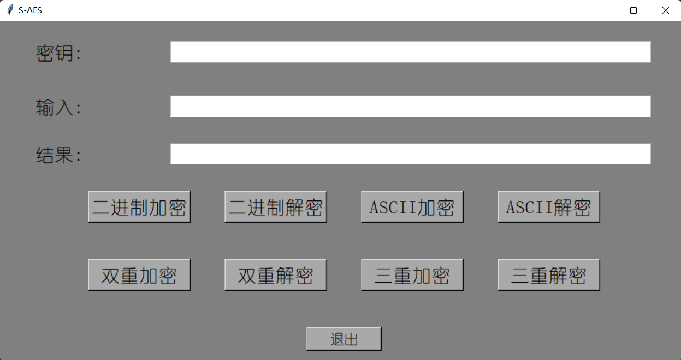  
  
**3. 开发工具**

Python、pycharm  
  
**4. 算法实现**

①轮密钥加：16bits的状态矩阵和16bits的轮密钥按位进行XOR运算。

def change_LandR(w):  
 w_left=w[0:4]  
 w_right=w[4:8]  
 temp=w_left  
 w_left=w_right  
 w_right=temp  
 ans=w_left+w_right  
 return ans  
  
def xor(a,b):  
 c=""  
 for i in range(len(a)):  
 temp1=int(a[i])  
 temp2=int(b[i])  
 c+=str(temp1^temp2)  
 return c

②半字节代替：状态矩阵中每个半字节的左边两位确定行值，右边两位确定列值，然后查表进行代替，加密的时候查S盒，解密的时候查逆S盒。

def S_change(s,w):  
 w_1=w[0:2]  
 w_2=w[2:4]  
 w_3=w[4:6]  
 w_4=w[6:8]  
 w1=two_to_ten(w_1)  
 w2=two_to_ten(w_2)  
 w3=two_to_ten(w_3)  
 w4=two_to_ten(w_4)  
 w_s=s[w1][w2]+s[w3][w4]  
 return w_s  
  
def g1(w1):  
 R1="10000000"  
 w1_1=change_LandR(w1)  
 w1_1_s=S_change(s_0,w1_1)  
 w1_1_s_r=xor(w1_1_s,R1)  
 return w1_1_s_r  
def g2(w1):  
 R2="00110000"  
 w1_1=change_LandR(w1)  
 w1_1_s=S_change(s_0,w1_1)  
 w1_1_s_r=xor(w1_1_s,R2)  
 return w1_1_s_r

def ban_change(s,ming):  
 ming0=ming[0:4]  
 ming1=ming[4:8]  
 ming2=ming[8:12]  
 ming3=ming[12:16]  
 ming0_1=(S_change(s,ming0+ming1))[0:4]  
 ming1_1=(S_change(s,ming0+ming1))[4:8]  
 ming2_1=(S_change(s,ming2+ming3))[0:4]  
 ming3_1=(S_change(s,ming2+ming3))[4:8]   
 ming_new=ming0_1+ming1_1+ming2_1+ming3_1  
 return ming_new

③行移位：对状态矩阵的第一行保持不变，第二行循环左移半个字节。

def hang_change(ming):  
 ming0=ming[0:4]  
 ming1=ming[4:8]  
 ming2=ming[8:12]  
 ming3=ming[12:16]  
 temp=ming1  
 ming1=ming3  
 ming3=temp  
 ming_new=ming0+ming1+ming2+ming3  
 return ming_new

④列混淆：列混淆函数在各列上执行

def lie_change(ming):  
 a1 = int(ming[0]) ^ int(ming[6])  
 a2 = int(ming[1]) ^ int(ming[4]) ^ int(ming[7])  
 a3 = int(ming[2]) ^ int(ming[4]) ^ int(ming[5])  
 a4 = int(ming[3]) ^ int(ming[5])  
 s00 = str(a1) + str(a2) + str(a3) + str(a4)

b1 = int(ming[2]) ^ int(ming[4])  
 b2 = int(ming[0]) ^ int(ming[3]) ^ int(ming[5])  
 b3 = int(ming[0]) ^ int(ming[1]) ^ int(ming[6])  
 b4 = int(ming[1]) ^ int(ming[7])  
 s10 = str(b1) + str(b2) + str(b3) + str(b4)  
  
 c1 = int(ming[8]) ^ int(ming[14])  
 c2 = int(ming[9]) ^ int(ming[12]) ^ int(ming[15])  
 c3 = int(ming[10]) ^ int(ming[12]) ^ int(ming[13])  
 c4 = int(ming[11]) ^ int(ming[13])  
 s01 = str(c1) + str(c2) + str(c3) + str(c4)

d1 = int(ming[10]) ^ int(ming[12])  
 d2 = int(ming[8]) ^ int(ming[11]) ^ int(ming[13])  
 d3 = int(ming[8]) ^ int(ming[9]) ^ int(ming[14])  
 d4 = int(ming[9]) ^ int(ming[15])  
 s11 = str(d1) + str(d2) + str(d3) + str(d4)

ming_new = s00 + s10 + s01 + s11

return ming_new

**5.拓展功能**

**①ASCII加解密**

def convert_to_8bit(string):  
 result = ""  
 for char in string:  
 ascii_code = bin(ord(char))[2:].zfill(8)  
 result += ascii_code  
 if len(string)%2!=0:  
 print("字符数量不能两两分组")  
 result="00000000"+result  
 return result  
def fenzu(string):  
 num_of_group=len(string)/16  
 group=[0 for i in range(int(num_of_group))]  
 for i in range(int(num_of_group)):  
 group[i]=string[i*16:(i+1)*16]  
 print(group[i])  
 return group  
def bit_to_convert(fenzu):  
 result = ""  
 for i in fenzu:  
 i_1=i[0:8]  
 i_2=i[8:16]  
 ascii_code_1 = chr(two_to_ten(i_1))  
 ascii_code_2 = chr(two_to_ten(i_2))  
 ascii_code=ascii_code_1+ascii_code_2  
 result += ascii_code  
 return result

**②双重加解密**

def two_encropt(mingwen,key):  
 key1=key[0:16]  
 key2=key[16:32]  
 first=encropt(mingwen,key1)  
 second=encropt(first,key2)  
 return second  
def two_decropt(miwen,key):  
 key1=key[0:16]  
 key2=key[16:32]  
 first=decropt(miwen,key2)  
 second=decropt(first,key1)  
 return second

**③三重加解密**

def three_encropt(mingwen,key):  
 key1=key[0:16]  
 key2=key[16:32]  
 key3=key[32:48]  
 first=encropt(mingwen,key1)  
 second=decropt(first,key2)  
 third=encropt(second,key3)  
 return third  
def three_decropt(miwen,key):  
 key1=key[0:16]  
 key2=key[16:32]  
 key3=key[32:48]  
 first=decropt(miwen,key3)  
 second=encropt(first,key2)  
 third=decropt(second,key1)  
 return third

**④中间相遇攻击**

def center_attack(mingwen, miwen):  
 maybe_key = []  
 num = len(mingwen)  
 center_value1 = []  
 center_value2 = []  
 for i in range(2**16):  
 key = bin(i)[2:].zfill(16)  
 str1=""  
 str2=""  
 for j in range(num):  
 temp=encropt(mingwen[j],key)  
 str1+=temp  
 center_value1.append(str1)  
 for k in range(num):  
 temp=decropt(miwen[k],key)  
 str2+=temp  
 center_value2.append(str2)  
 for k in range(2 ** 16):  
 for h in range(2 ** 16):  
 if center_value1[k] == center_value2[h]:  
 maybe_key.append((k, h))  
 for m in maybe_key:  
 key1=bin(m[0])[2:].zfill(16)  
 key2 = bin(m[1])[2:].zfill(16)  
 key_real=str(key1)+str(key2)  
 print(key_real)  
 return key_real

**6.CBC模式**

def CBC_encropt(mingwen, key, IV):  
 temp_Miwen = ["0" for i in range(len(mingwen))]  
 for i in range(len(mingwen)):  
 if i == 0:  
 temp_Miwen [i] = (S_AES_16bits.encropt(S_AES_16bits.xor(mingwen[i], IV), key))  
 else:  
 temp_Miwen [i] = (S_AES_16bits.encropt(S_AES_16bits.xor(mingwen[i], temp_Miwen [i - 1]), key))  
 return temp_Miwen  
def CBC_decropt(miwen,key,IV):  
 temp_decropt=[]  
 temp_mingwen=[]  
 ans=[]  
 for i in miwen:  
 temp_decropt.append(S_AES_16bits.decropt(i,key))  
 for i in range(len(miwen)-1,-1,-1):  
 if i !=0:  
 temp_mingwen.append(S_AES_16bits.xor(temp_decropt[i],miwen[i-1]))  
 if i==0:  
 temp_mingwen.append(S_AES_16bits.xor(temp_decropt[i],IV))  
 for i in reversed(temp_mingwen):  
 ans.append(i)  
 return ans

**7.交叉测试结果**

二进制加解密

加密：

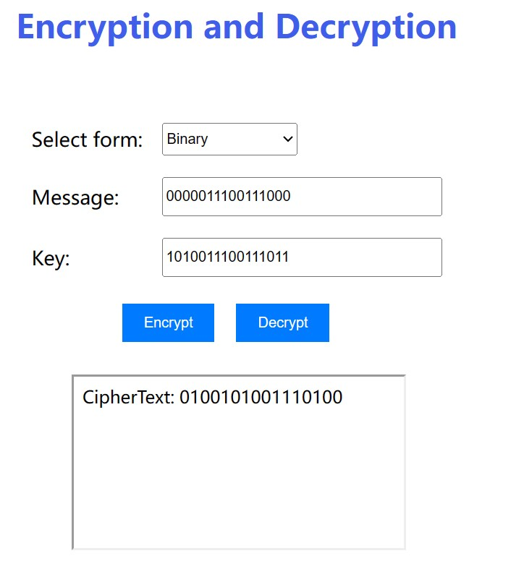

解密：

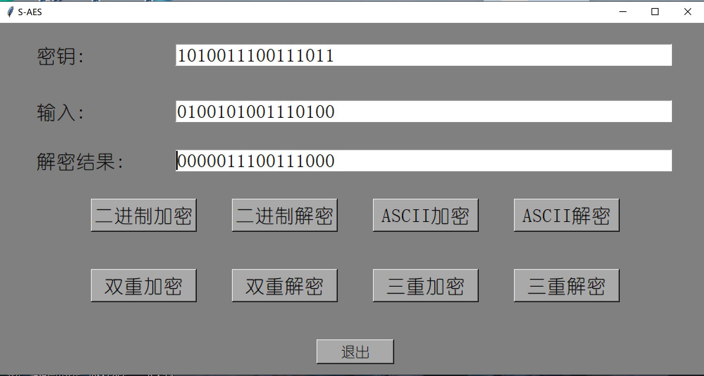

加密

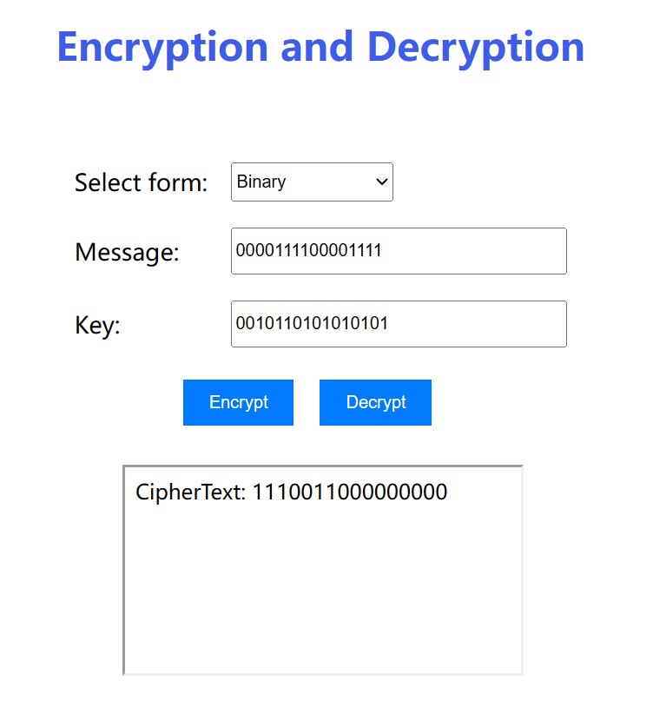

解密

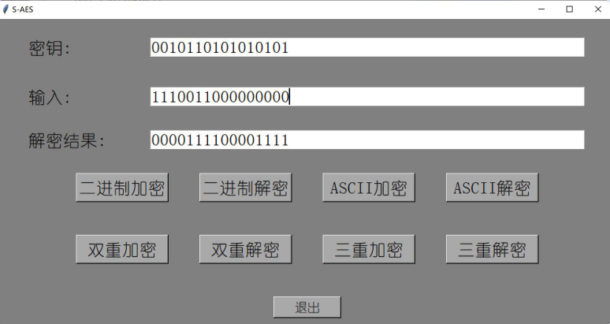

ASCII加密

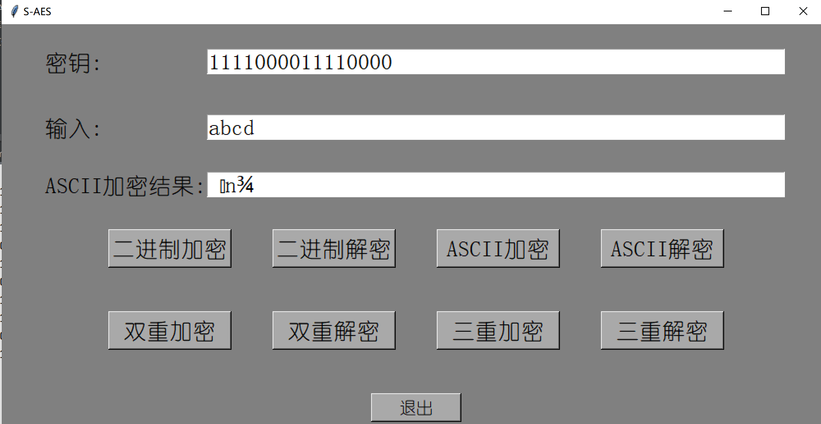

ASCII解密

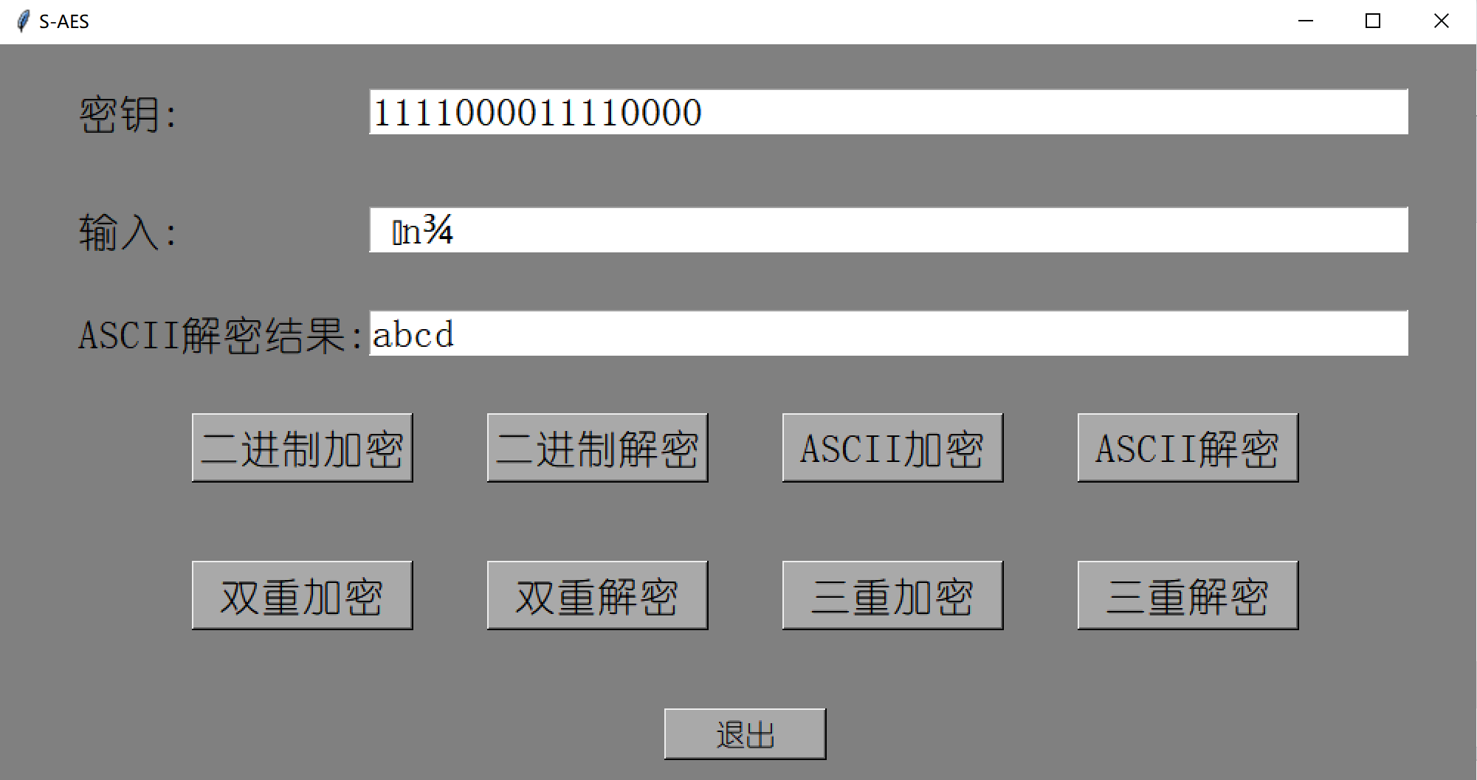

二重加密

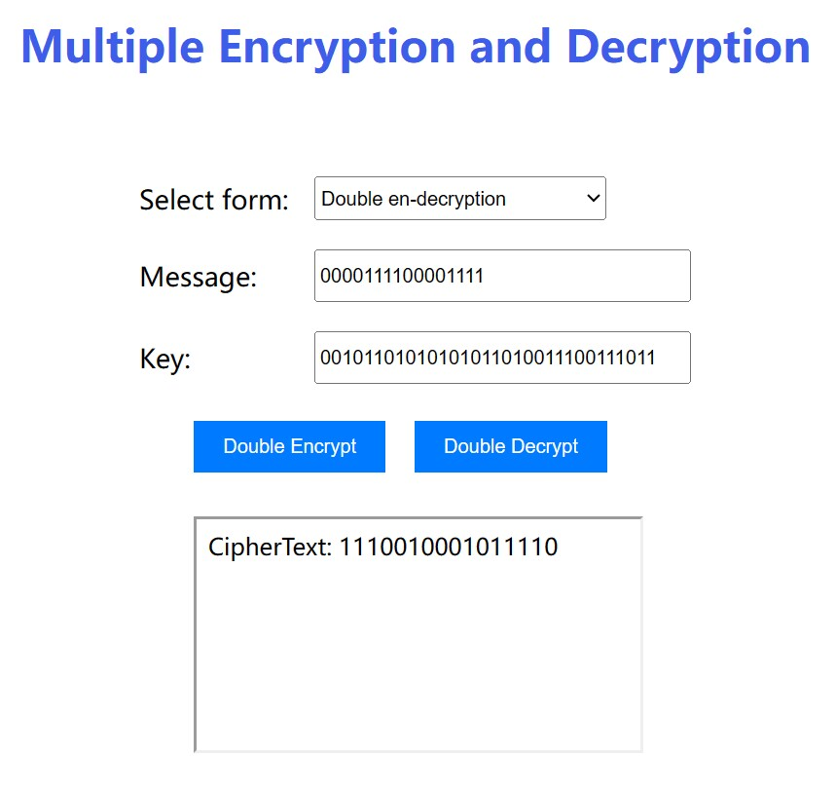

二重解密

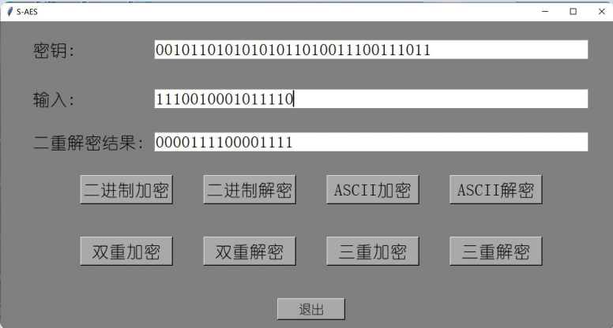

三重加密

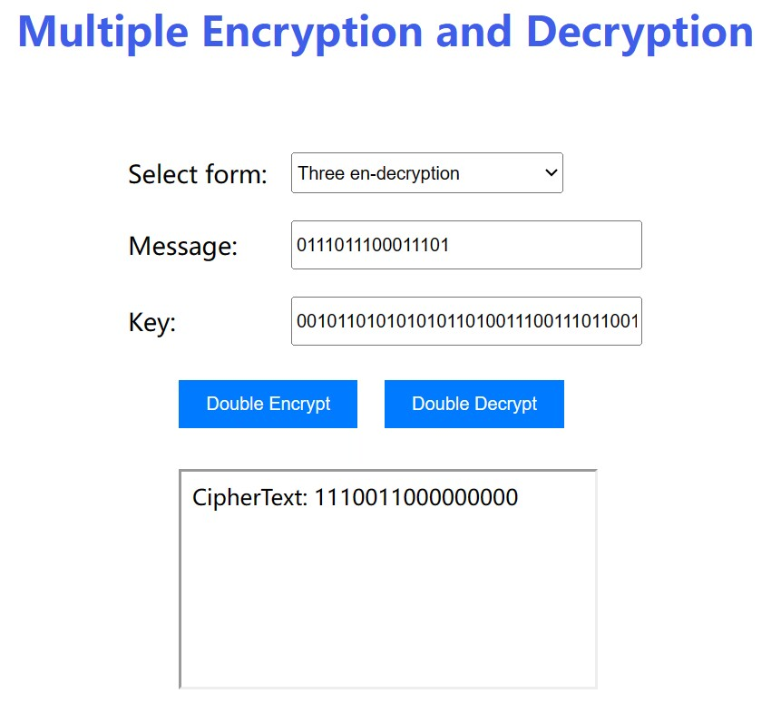

三重解密

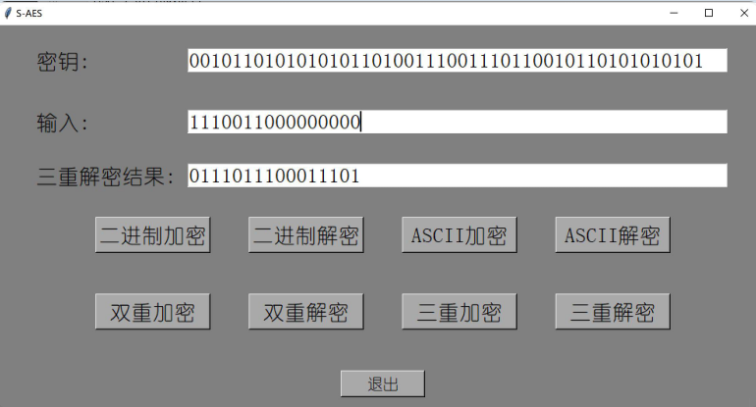

中间相遇攻击

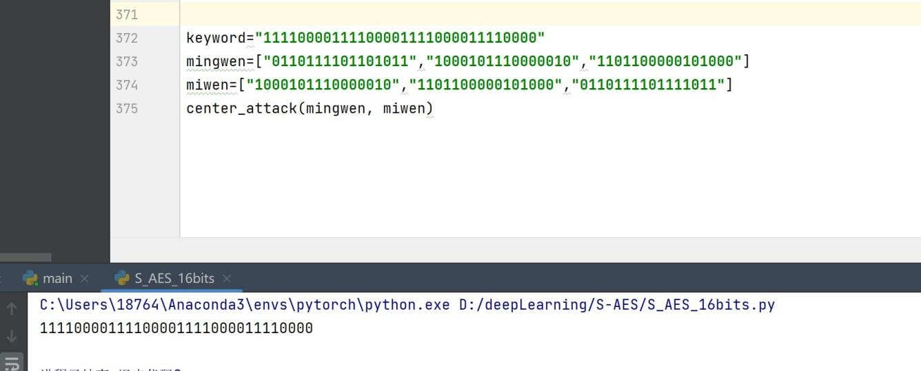

CBC模式

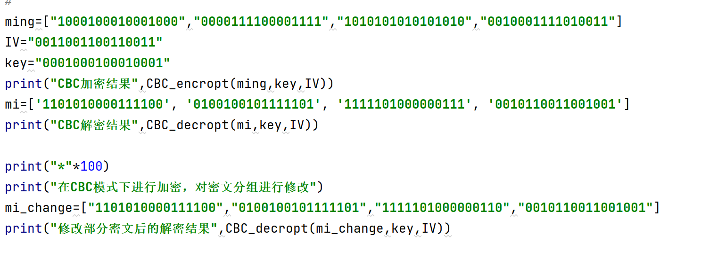

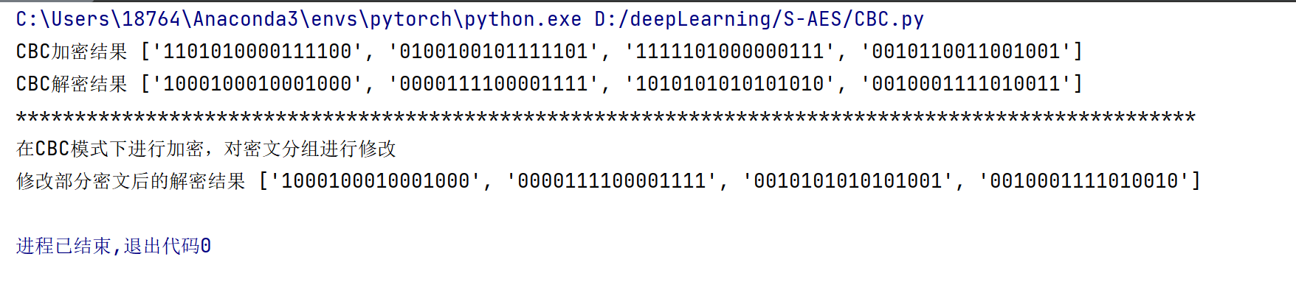

修改中间的密文，导致的结果是在这个密文分组之前的解密结果没有影响，在这个密文分组之后的解密结果错误。