Gender Classification based on Image and Generative Modeling

Table of Contents
Gender Classification based on Image and Generative Modeling 1
1. Introduction 2
2. Dataset Description 2
3. Data Preprocessing 3
4. Model Architecture and Training 3
5. Evaluation Results 5
6. Interpretability with Grad-CAM 5
7. Generative Modeling Insights 6
8. User Interaction and Meta Llama Analysis 8
9. Discussion 9
10. Conclusion and Future Work 9
11. References 9

1. Introduction
This report documents the development of a gender classification and generative face modeling system using PyTorch. We implement and compare a custom CNN and a fine-tuned ResNet‑18 classifier on a subset of the CelebA dataset, and integrate generative modeling (DCGAN, CycleGAN, Stable Diffusion) for data augmentation and style transfer. Grad-CAM is used for model interpretability, and user interaction is enabled through image uploads and Meta Llama 4 Maverick analyses.

2. Dataset Description
The CelebA dataset contains over 200,000 celebrity images labeled with 40 attributes. We randomly selected a balanced subset of 10,000 images focusing on the "Male" attribute for binary classification, split into 8,000 training, 1,000 validation, and 1,000 test samples.

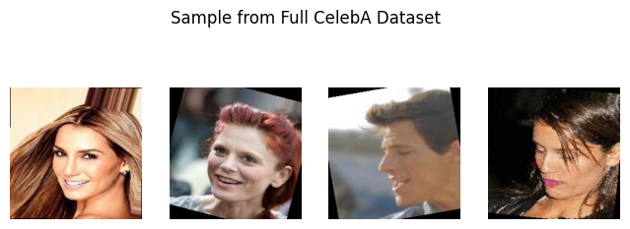
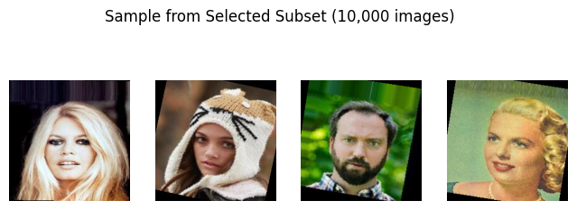

3. Data Preprocessing
Images were resized to 224×224 pixels and normalized using ImageNet statistics. Data augmentation included random horizontal flips and ±15° rotations. Additional synthetic "happy" face images were generated via Hugging Face StableDiffusionPipeline to enhance robustness.
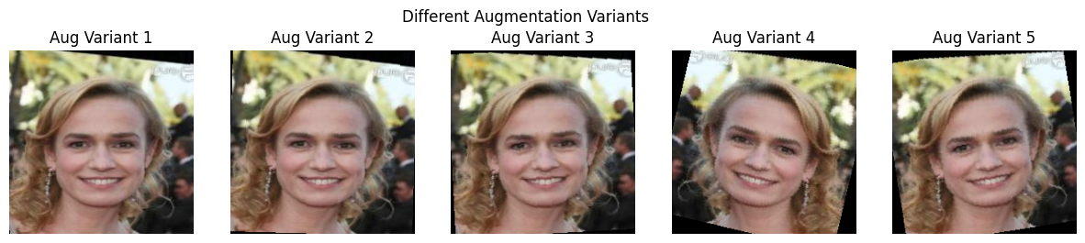

4. Model Architecture and Training
• SimpleCNN: Three convolutional blocks with BatchNorm, ReLU, and pooling, followed by a linear output layer. Trained with BCEWithLogitsLoss and Adam (lr=1e‑3) for up to 10 epochs with early stopping (patience=3).
• ResNet‑18: Pre-trained on ImageNet; final layer replaced for binary output. Fine-tuned using Adam (lr=2e‑4) under the same training regime.
• DCGAN: Generator and discriminator networks trained for synthetic face generation on 64×64 inputs (5 epochs).
• CycleGAN: ResNet-based generators for photo-to-cartoon translation (5 epochs).
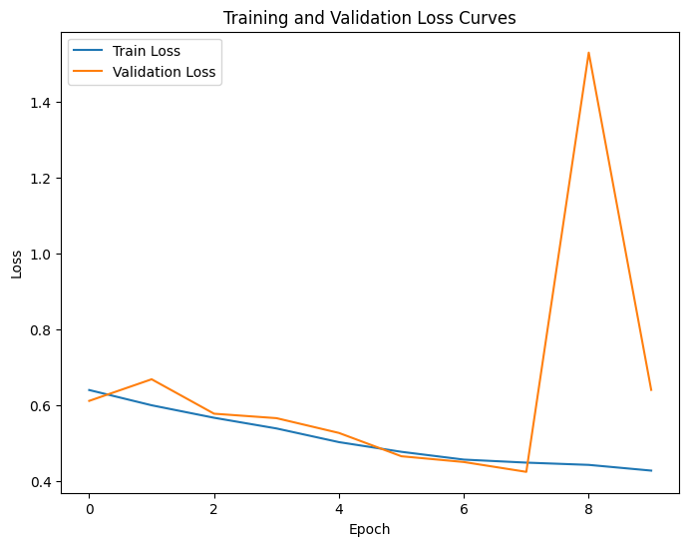
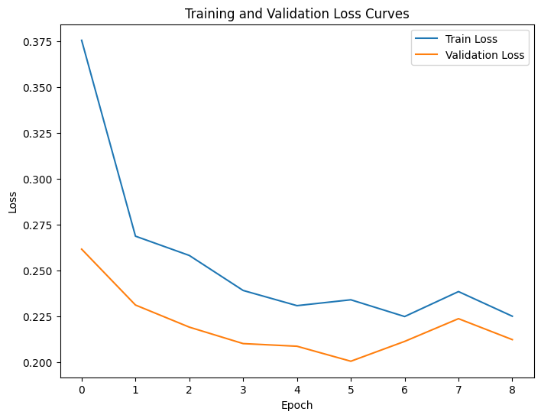

5. Evaluation Results
Classification Performance on Test Set:
- SimpleCNN: Accuracy = 0.6710, Precision = 0.5594, Recall = 0.9662, F1 = 0.7086.
- ResNet‑18: Accuracy = 0.9110, Precision = 0.8788, Recall = 0.9106, F1 = 0.8944.
Synthetic images from Stable Diffusion improved classification consistency on edge cases.

6. Interpretability with Grad-CAM
Grad-CAM visualizations highlighted facial regions (eyes, jawline) critical for gender classification. Especially SimpleCNN showed focused attention on relevant areas, aiding in model validation and bias detection.

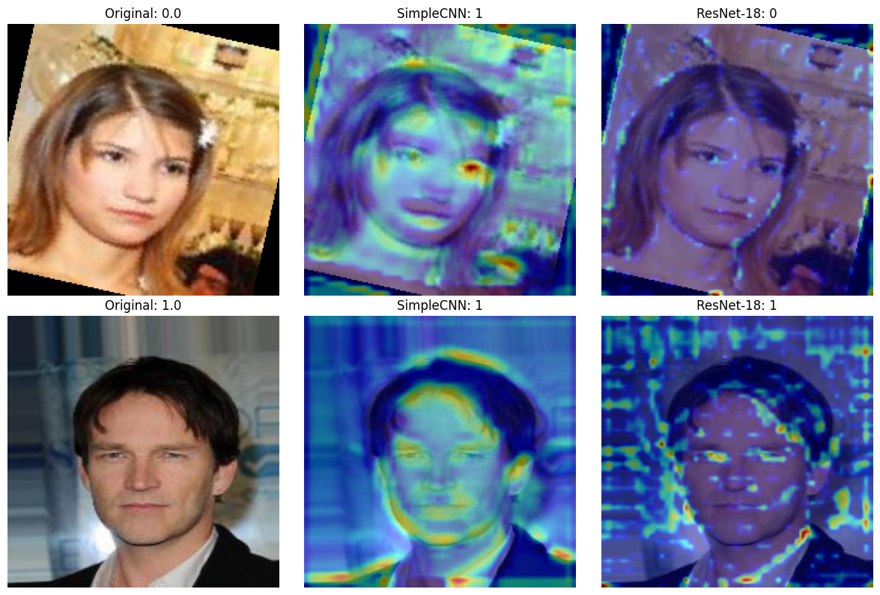

7. Generative Modeling Insights
DCGAN failed to produce realistic face samples, so CycleGAN could not generate cartoonized images (Garbage-In and Garbage-out).
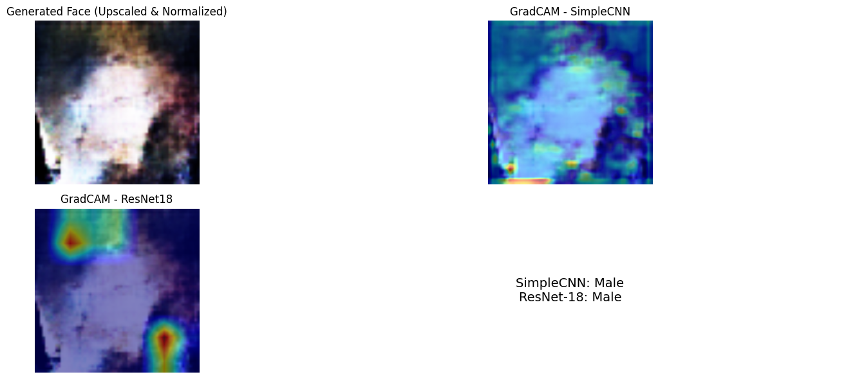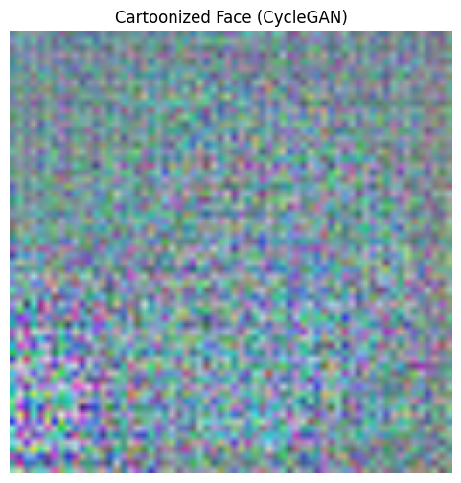

Stable Diffusion generated high-quality "happy" faces used to augment training data, demonstrating applicability for data diversification.

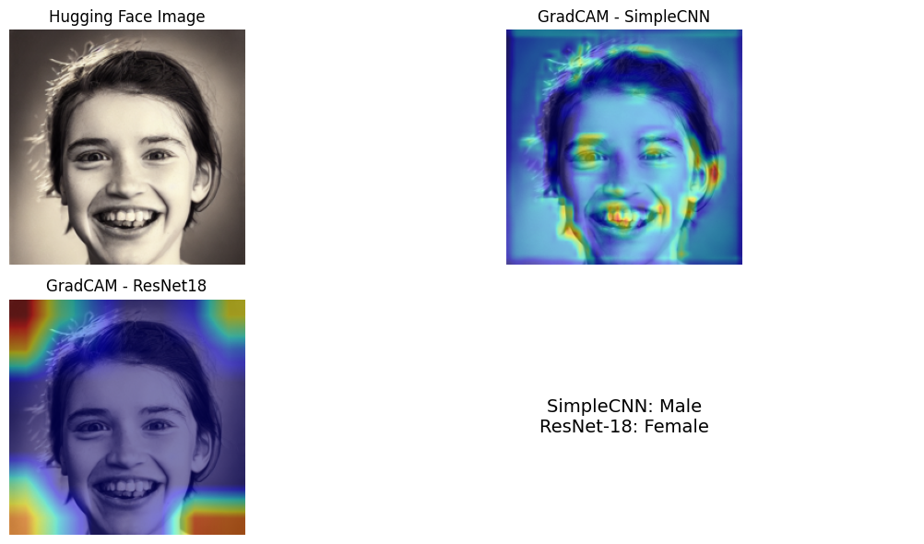

8. User Interaction and Meta Llama Analysis
Users can upload custom images through the interface. Uploaded images are classified by both models, and results are compared with Meta Llama 4 Maverick analyses via OpenRouter, providing a comprehensive evaluation and enhancing user engagement.

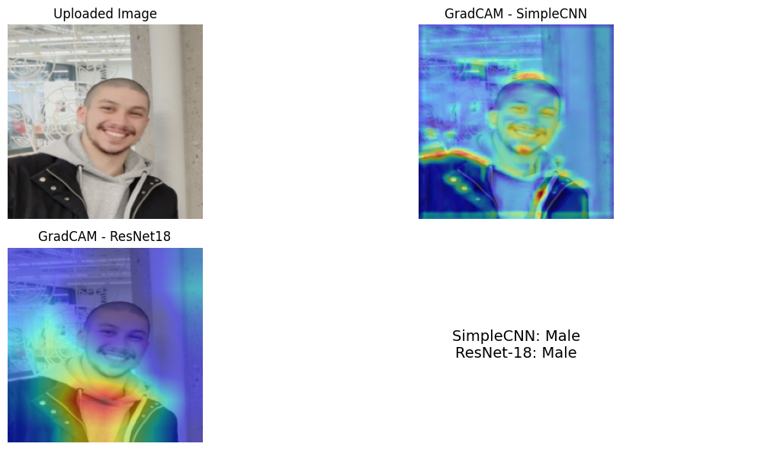
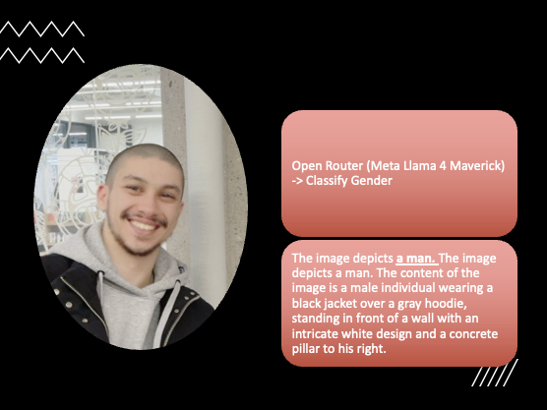

9. Discussion
Transfer learning with ResNet‑18 outperformed the custom CNN, underscoring the value of pre-trained features. Generative augmentations and interpretability techniques improved model robustness and transparency. User-centric features demonstrate system versatility for real-world deployment.

10. Conclusion and Future Work
This project showcases an end-to-end deep learning pipeline integrating classification, generative modeling, and interpretability. Future work includes multi-attribute classification, high-resolution GAN training, advanced explainability, and deployment as a user-friendly web application.

11. References
- Torchvision documentation, https://pytorch.org/vision
- Grad-CAM paper, https://arxiv.org/abs/1610.02391
- DCGAN paper, https://arxiv.org/abs/1511.06434
- CycleGAN paper, https://arxiv.org/abs/1703.10593
- https://huggingface.co/docs/diffusers/en/api/pipelines/stable_diffusion/text2img
- https://www.youtube.com/watch?v=RxRD818Baos
- https://openrouter.ai/meta-llama/llama-4-maverick:free

