Mod 5 Assignment

Yinan Guo

02/16/2022

1. Lace
2. Time series, ACF & PACF

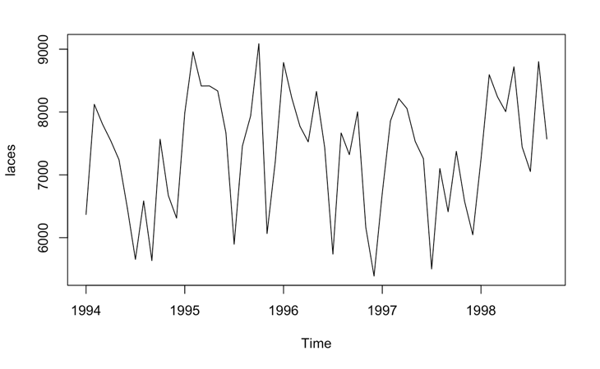

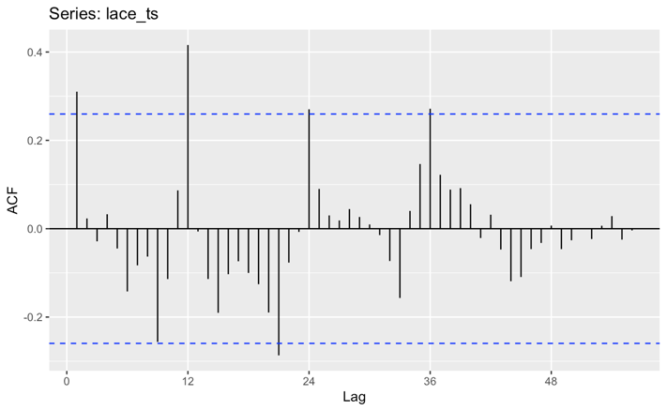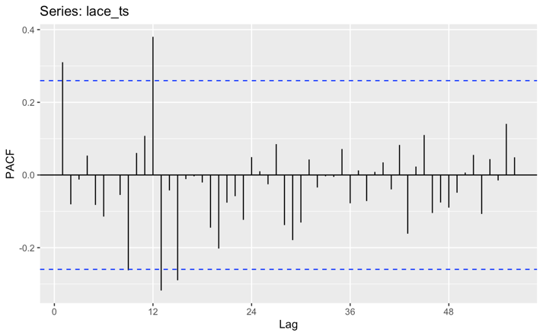

We can see from these plots that lace has seasonality of 12 months but no trend.

1. ADF test

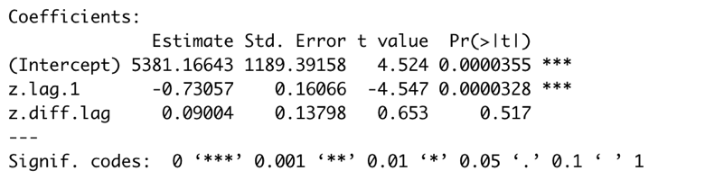

p-value for ADF test is lower than 0.05, which reject the null hypothesis and shows that it is stationary.

1. Choose models

Since the TS has seasonality, we can choose ETS, Holt winters and ARiMA models.

1. ETS

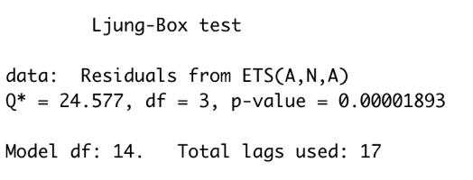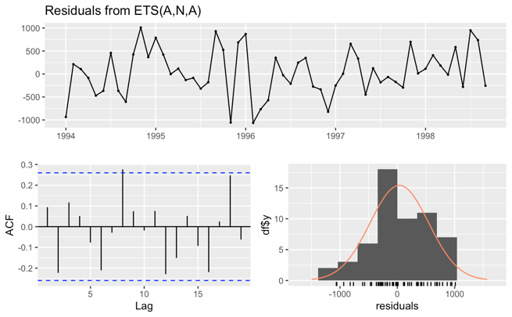

ETS(A,N,A) is chosen by model ZZZ, which means additive for error, none for trend and additive for seasonality.

The p-value for Ljung-Box test of residuals is lower than 0.05, which reject the null hypothesis and shows that the residuals are not white noise.

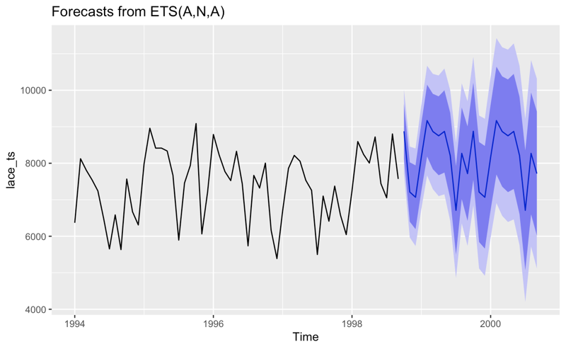

The forecasted plot shows a seasonality similar to previous time series, which could be a good forecasted result.

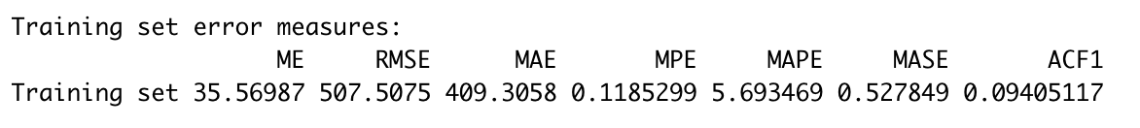

MAPE=5.6935, RMSE=507.5075

1. Holt-Winters’ additive method

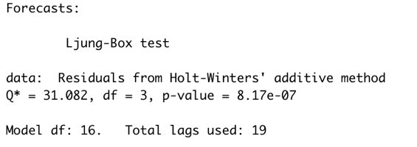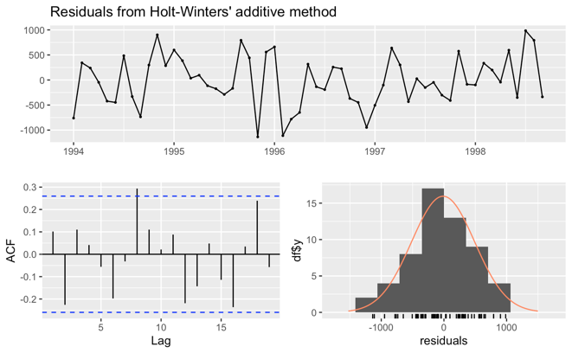

The p-value for Ljung-Box test of residuals is lower than 0.05, which reject the null hypothesis and shows that the residuals are not white noise.

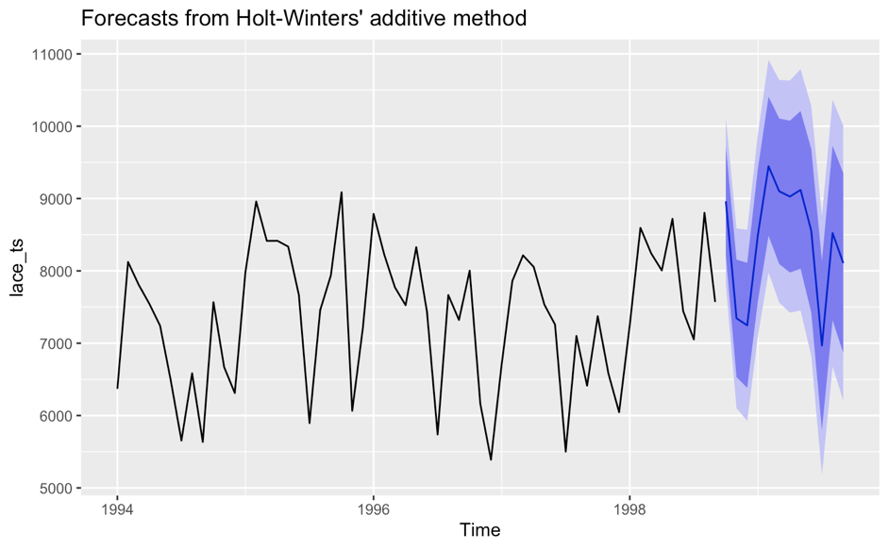

The forecasted plot shows a seasonality similar to previous time series, which could be a good forecasted result. However, the forecasted part is a little bit higher than previous plot.

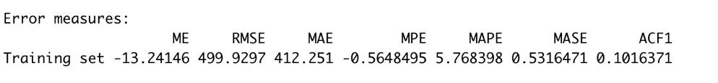

MAPE=5.7684, RMSE=499.9297

1. Holt-Winters’ multiplicative method

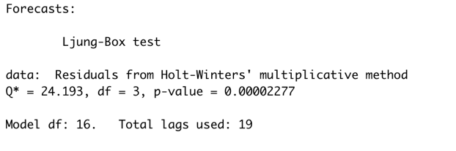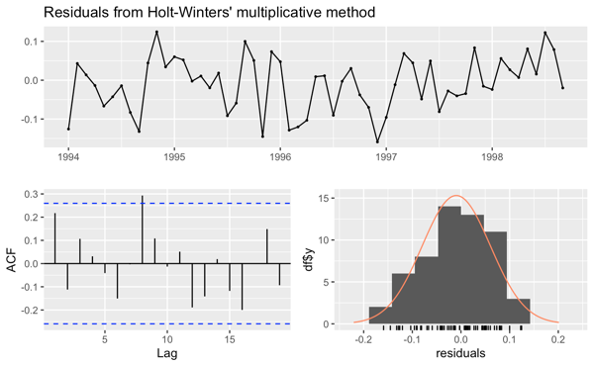

The p-value for Ljung-Box test of residuals is lower than 0.05, which reject the null hypothesis and shows that the residuals are not white noise.

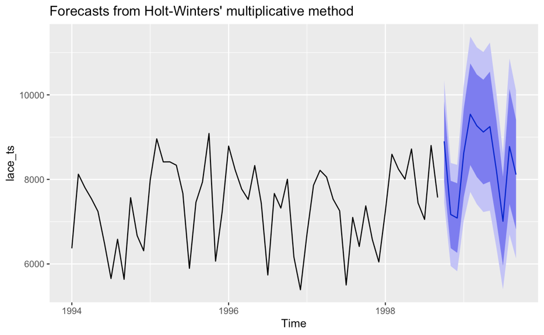

The forecasted plot shows a seasonality similar to previous time series, which could be a good forecasted result. Also similar to additive method, the forecasted part is a little bit higher than previous plot.

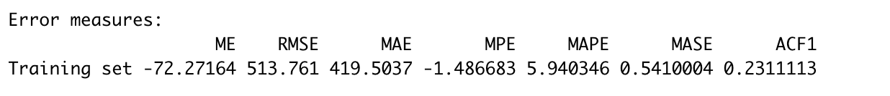

MAPE=5.9403, RMSE=513.761

1. Auto ARiMA model

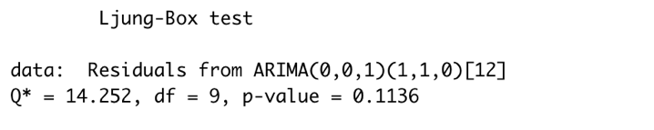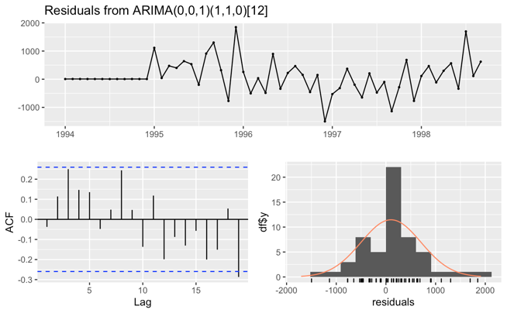

The p-value for Ljung-Box test of residuals is higher than 0.05, which do not reject the null hypothesis and shows that the residuals are white noise.

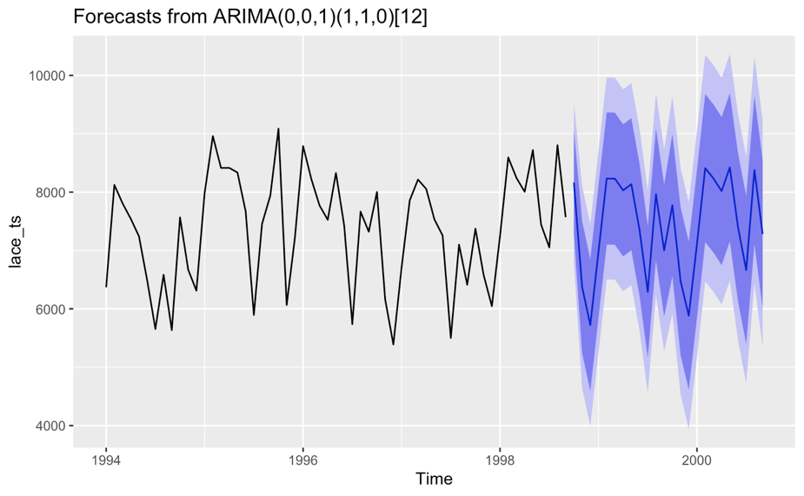

The forecasted plot shows a seasonality similar to previous time series, which could be a good forecasted result.

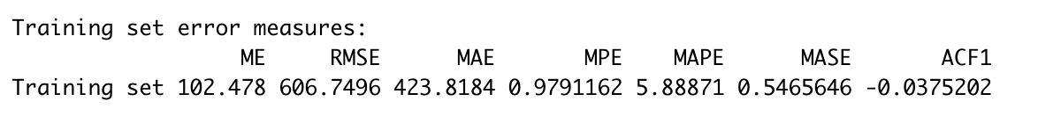

MAPE=5.8887, RMSE=606.7496

1. Model comparation

|  |  |  |  |  |  |
| --- | --- | --- | --- | --- | --- |
| Date | Actual | ETS | Winter Additive | Winter Multiplicative | ARiMA |
| 1-Oct-98 | 9729.8 | 8875.335 | 8961.782 | 8901.989 | 8164.143 |
| 1-Nov-98 | 6576.2 | 7212.041 | 7344.387 | 7169.937 | 6373.645 |
| 1-Dec-98 | 6075.3 | 7068.571 | 7247.217 | 7085.806 | 5722.811 |

The average absolute difference (%) of between forecasted and actual value are:

|  |  |  |  |
| --- | --- | --- | --- |
| ETS | Winter Additive | Winter Multiplicative | ARiMA |
| 17.40% | 19.43% | 17.08% | 12.49% |

(Average absolute difference = Sum(|(Forecasted-Actual)/Actual|)/3

According to the forecasted value, ARiMA model has the nearest value to the actual value. Also, only ARiMA model has residuals of white noise. Thus, though ARiMA model will be more complicated and has larger RMSE and MAPE, I choose ARiMA model as my final model.

1. Blouse
2. Time series, ACF & PACF

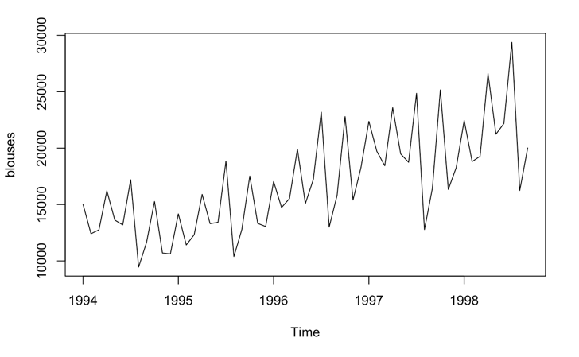

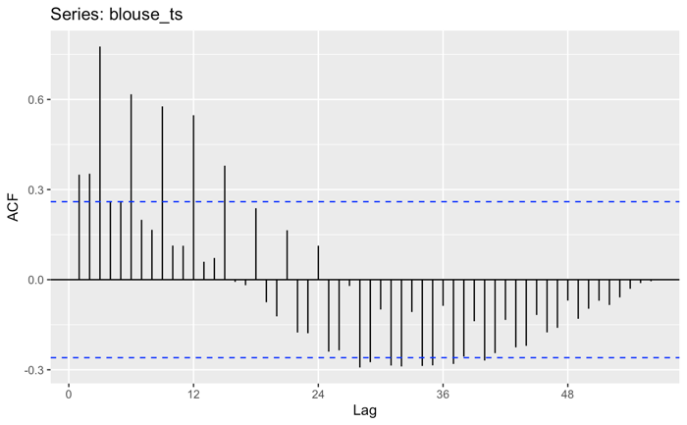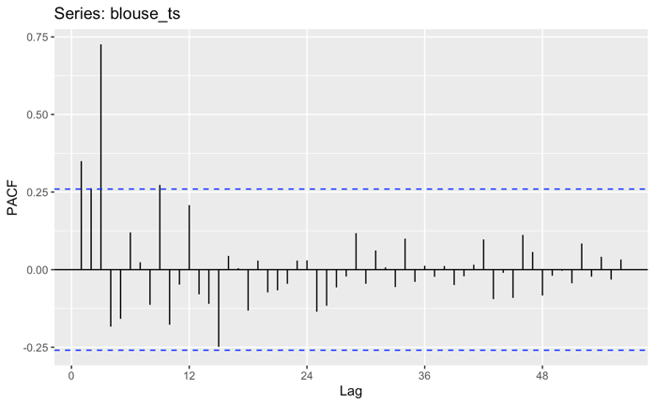

We can see from these plots that lace has seasonality of 12 months and trend.

1. ADF test

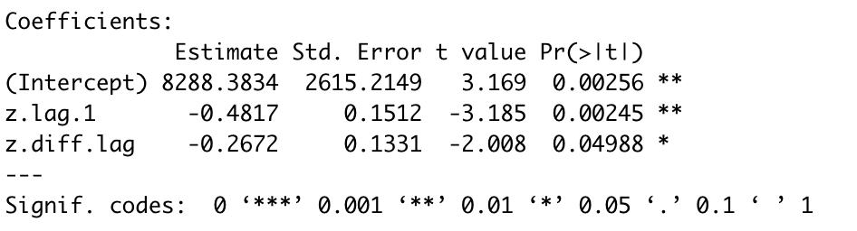

p-value for ADF test is lower than 0.05, which reject the null hypothesis and shows that it is stationary.

1. Choose models

Since the TS has seasonality and trend, we can choose ETS, Holt winters and ARiMA models.

1. ETS

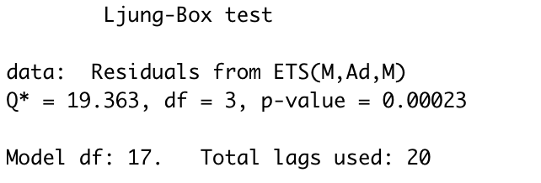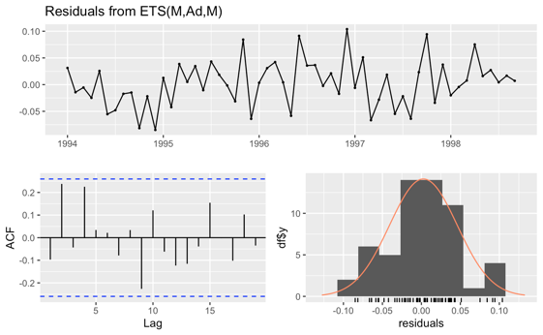

ETS(M,A,M) is chosen by model ZZZ, which means multiplicative for error, additive for trend and multiplicative for seasonality.

The p-value for Ljung-Box test of residuals is lower than 0.05, which reject the null hypothesis and shows that the residuals are not white noise.

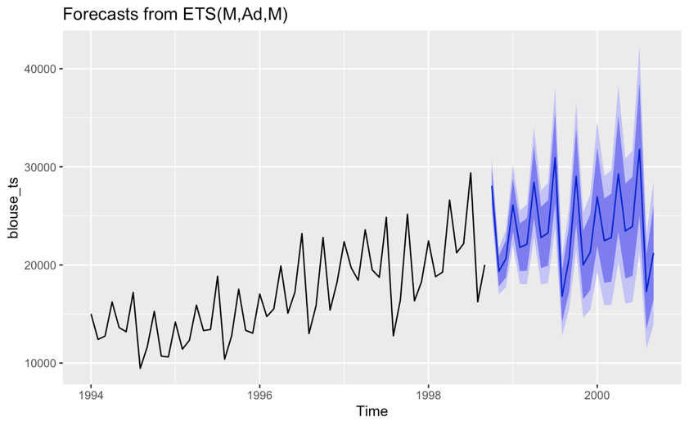

The forecasted plot shows a seasonality similar to previous time series, and it shows an upward trend. Also, the swing become larger than previous, which is in line with past trends.

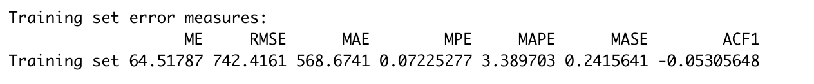

MAPE=3.3897, RMSE=742.4161

1. Holt-Winters’ additive method

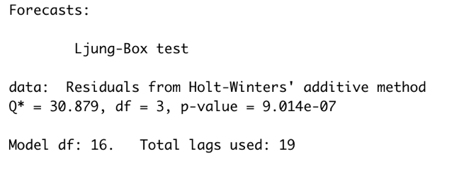 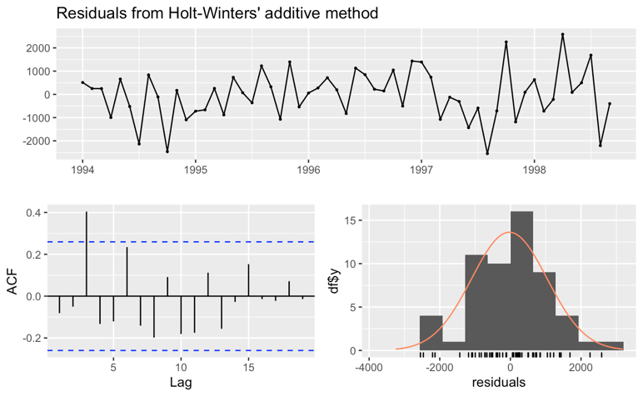

The p-value for Ljung-Box test of residuals is lower than 0.05, which reject the null hypothesis and shows that the residuals are not white noise.

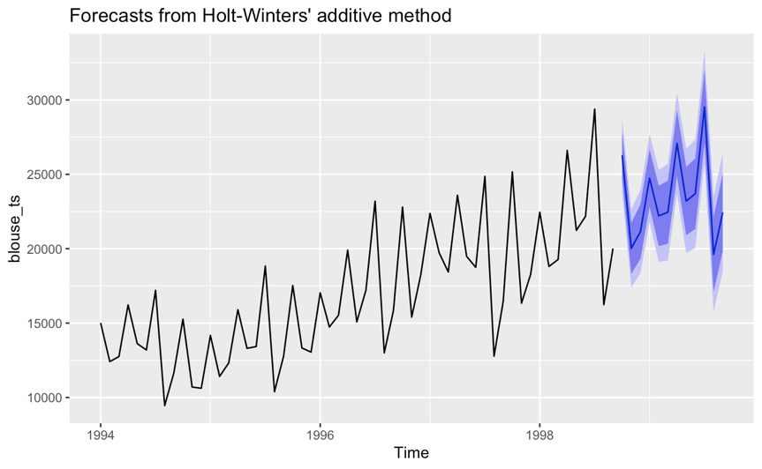

The forecasted plot shows a seasonality similar to previous time series, and it shows an upward trend. The top-bottom just like recent.

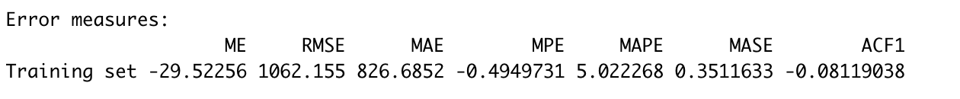

MAPE=5.0223, RMSE=1062.155

1. Holt-Winters’ multiplicative method

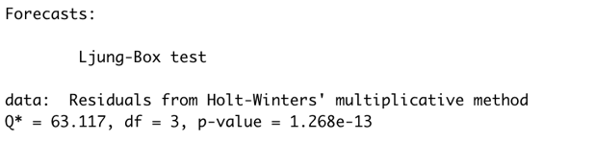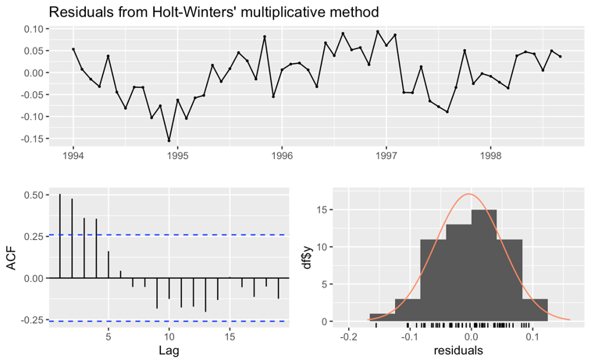

The p-value for Ljung-Box test of residuals is lower than 0.05, which reject the null hypothesis and shows that the residuals are not white noise.

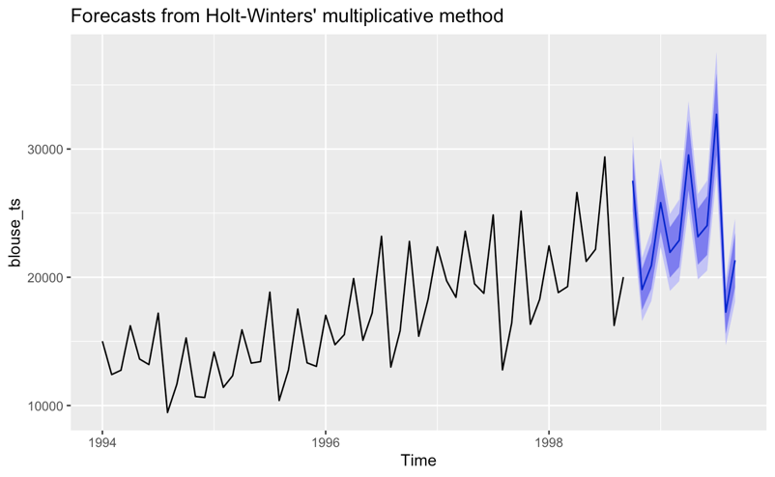

The forecasted plot shows a seasonality similar to previous time series, and it shows an upward trend.

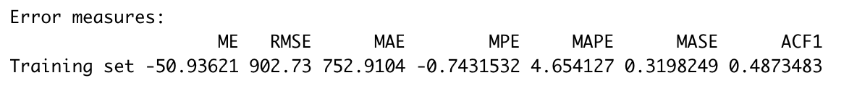

MAPE=4.6541, RMSE=902.73

1. Auto ARiMA model

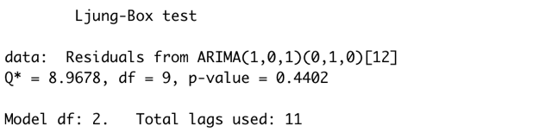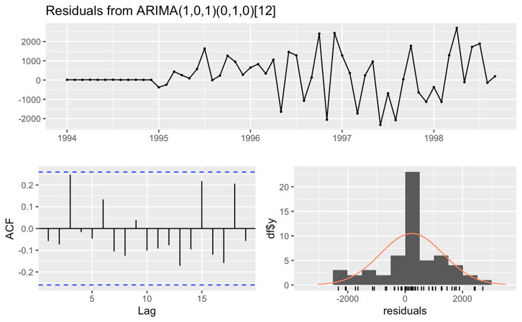

The p-value for Ljung-Box test of residuals is higher than 0.05, which do not reject the null hypothesis and shows that the residuals are white noise.

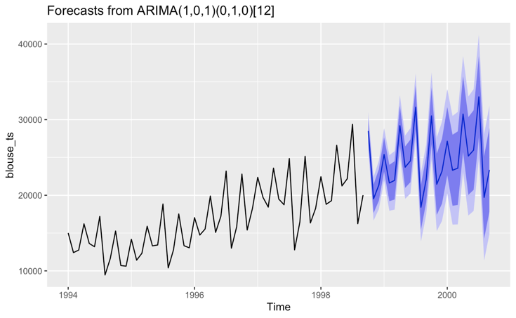

The forecasted plot shows a seasonality similar to previous time series, and it shows an upward trend.



MAPE=4.2803, RMSE=1106.891

1. Model comparation

|  |  |  |  |  |  |
| --- | --- | --- | --- | --- | --- |
| Date | Actual | ETS | Winter Additive | Winter Multiplicative | ARiMA |
| 1-Oct-98 | 28459 | 28064.92 | 26279.63 | 27534 | 28501.79 |
| 1-Nov-98 | 23251 | 19355.38 | 20027.77 | 19043.85 | 19538.67 |
| 1-Dec-98 | 22044 | 20619.33 | 21147.82 | 20905.34 | 21345.41 |

The average absolute difference (%) of between forecasted and actual value are:

|  |  |  |  |
| --- | --- | --- | --- |
| ETS | Winter Additive | Winter Multiplicative | ARiMA |
| 8.20% | 8.53% | 8.84% | 6.43% |

(Average absolute difference = Sum(|(Forecasted-Actual)/Actual|)/3

According to the forecasted value, ARiMA model has the nearest value to the actual value. Also, only ARiMA model has residuals of white noise. Thus, though ARiMA model will be more complicated and has larger RMSE and MAPE, I choose ARiMA model as my final model.