1. Dickey-Fuller test results for the LN_LOANS series

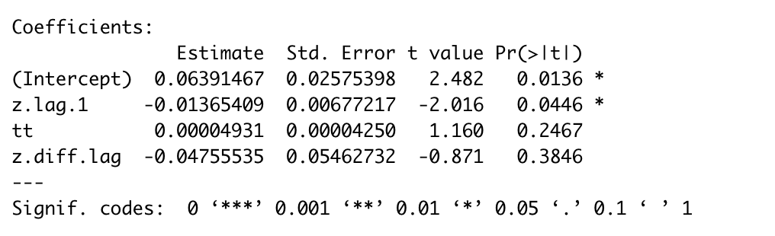

Ho: This series is non-stationary and need 1st difference. Ha: This series is stationary.

The p-value for ADF is 0.0446, which is larger than 0.01. Thus, it doesn’t reject the null hypothesis and indicates that this is a non-stationary series and need 1st difference.

1. Time series plot, ACF Plot and PACF plot.

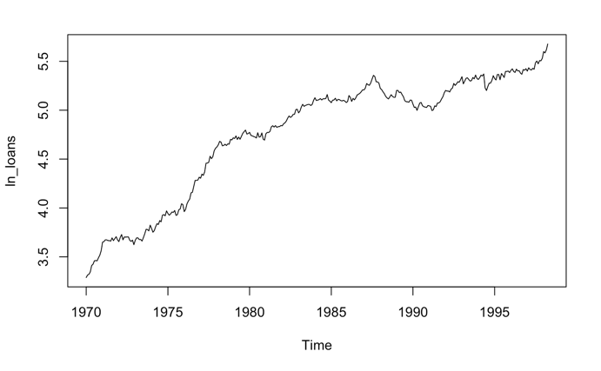

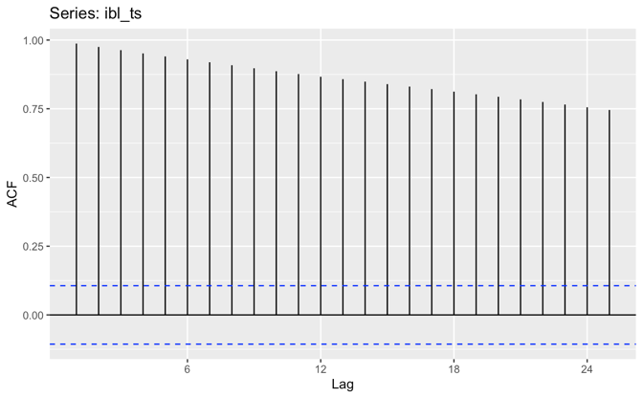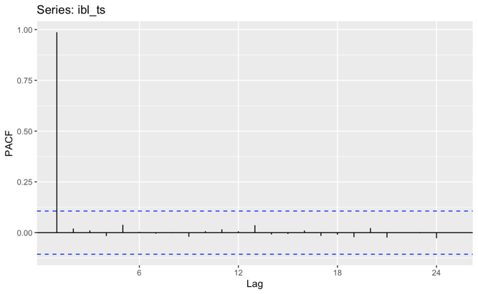

1. Chosen Model

I choose ARIMA(2,2,2)(1,0,0)[12] (p=2, d=2,q=2)as my final model, which is the auto.arima model.

I tried arima(2,1,2) on my own and the residuals for this model are all white noise (p-value<0.05), and p-value for ar1, ar2, ma1, ma2 are lower than 0.05, which shows that it is a right model. The RMSE is 0.0296, and the MAPE is 0.497.

For the auto.arima model, p-values for ar1, ar2, ma1, ma2 are lower than 0.05, and all residuals has p-value<0.05, which shows that it is a right model. The auto.arima model has an RMSE of 0.287 and MAPE of 0.481, which shows that it is a better model.

1. A table of parameter estimates for the chosen model

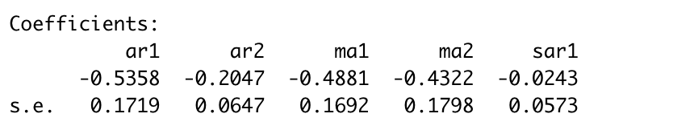

1. Residual plots for the chosen model

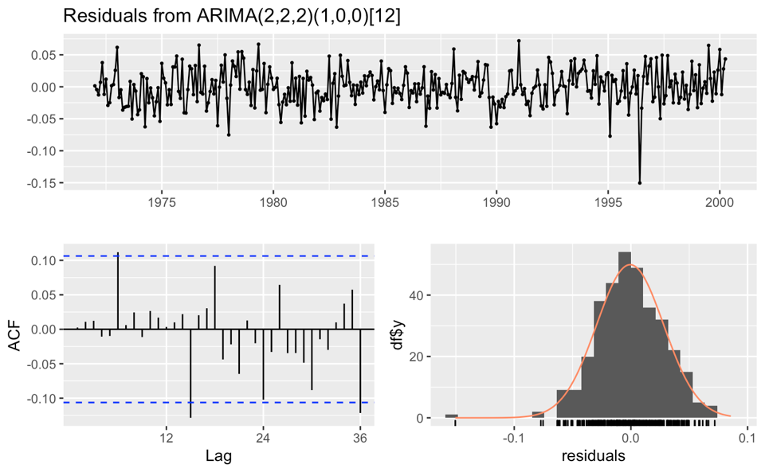

1. A test of white noise for the residuals

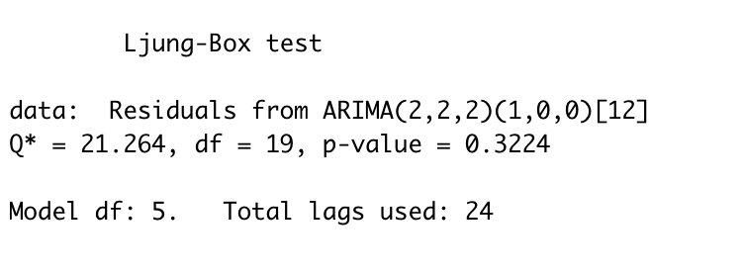

p-value > 0.05, which proves that all residuals are white noise.

1. The values of the RMSE and MAPE for the chosen model

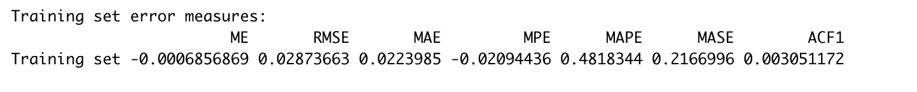

RMSE:0.0287

MAPE:0.4818

1. A forecast plot and the forecast values for the 3 time periods requested above.

