* Introduction

This is a climate data visualization APP. Eight charts show the historical global temperature and co2 changement in different ways. Also, the user can make customized views by including various charts, and the user can share the link.

* Developers

Second-year students from OAMK:

Elias Linna, Nenna-Leena Hänninen, Yinan Li.

* How to use

1. Link:
2. Create and delete a user account:
3. Create and delete customized data views:

* Technologies

1. UI: HTML & CSS, Bootstrap
2. Front-end Frame: React.js
3. Back-end: Node.js
4. Database: Mysql
5. Deployment: Google Cloud Platform

* Tools

1. UI design: Figma
2. Code editor: Visual Studio Code
3. Database: Workbench
4. Version control: Git & GitHub

* ArchitectureDiagram

  Description automatically generated
* UI

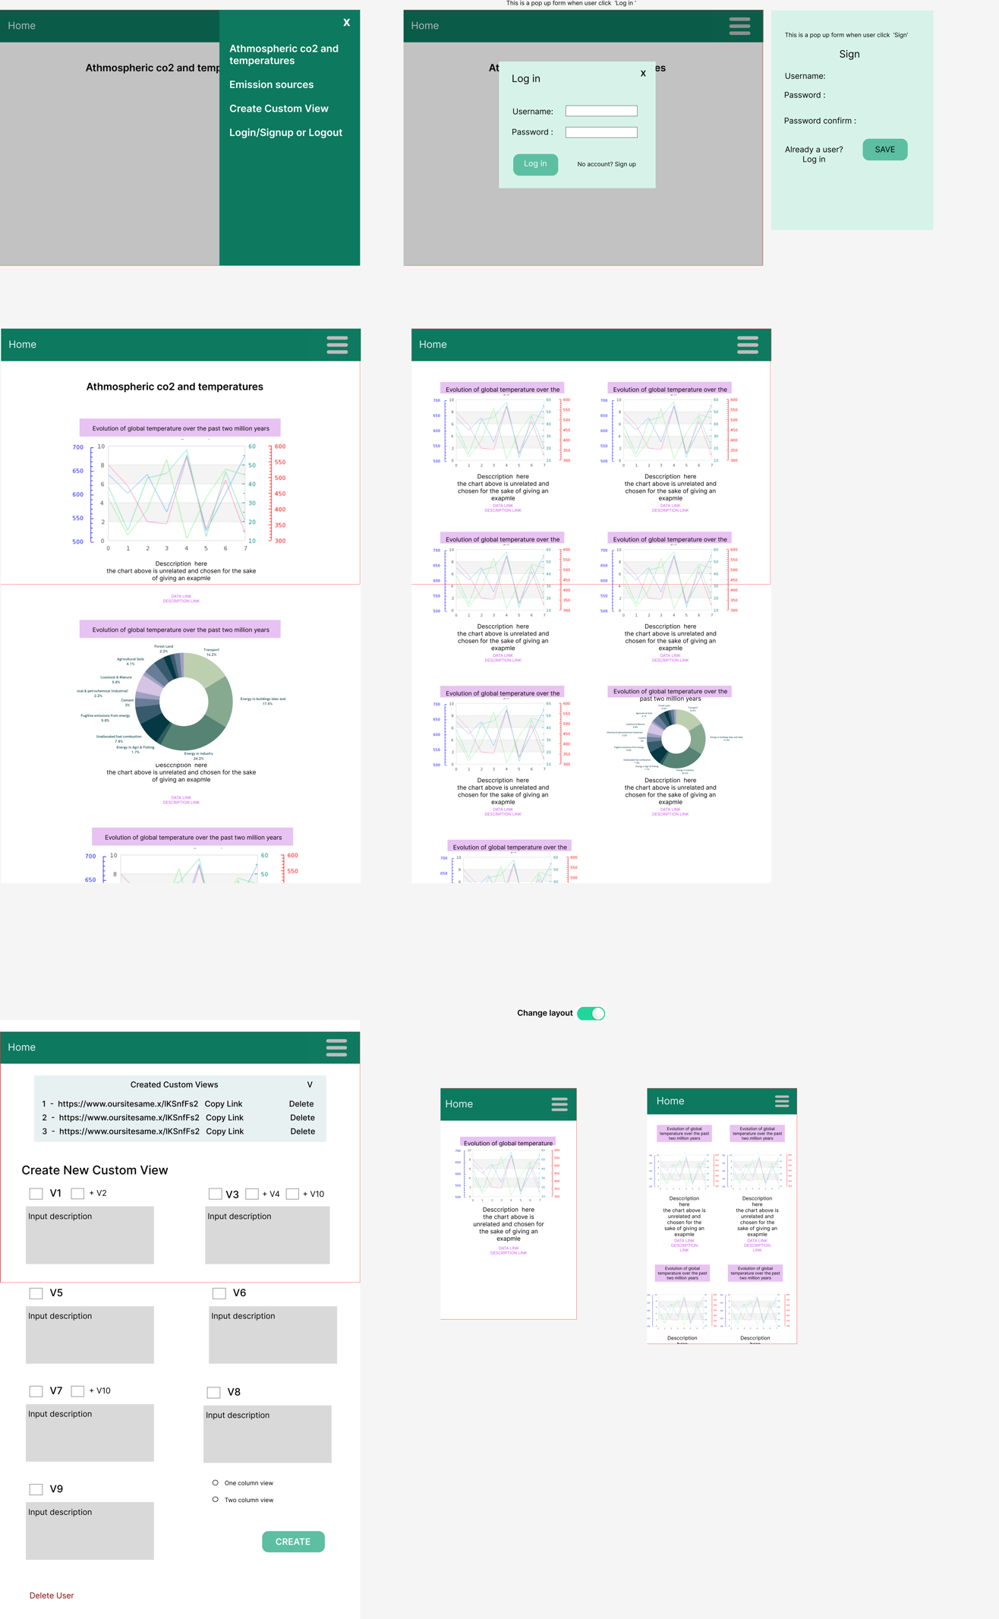

* Database
* Summary