Fieldnotes — Desktop Prototype
COMP5241 · GenAI-powered learning platform · 21 October 2026
Sample prototype · No live AI. Desktop screenshots only. The sample uses original, prewritten learning content and illustrative progress; it does not represent live AI generation or measured learning outcomes.

1. Study Overview
The sample study dashboard introduces the current mini-course, learning loop, whole-mini-course roadmap and AI Fluency 4D principles.
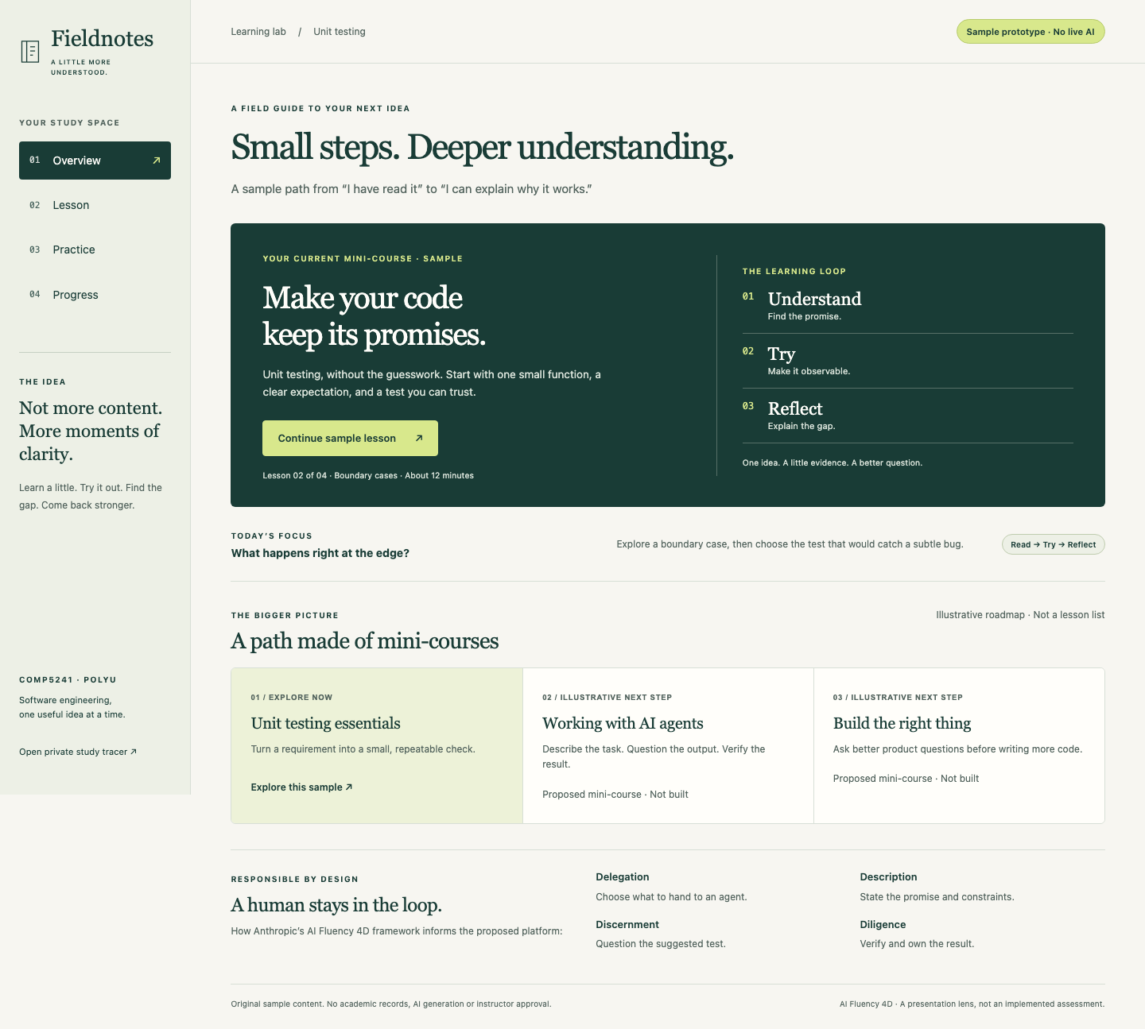
Study overview — desktop screenshot

2. Mini-course Lesson
An original unit-testing lesson explains a free-delivery threshold, boundary cases and the Arrange–Act–Assert pattern. Code is displayed as an example, not executed.
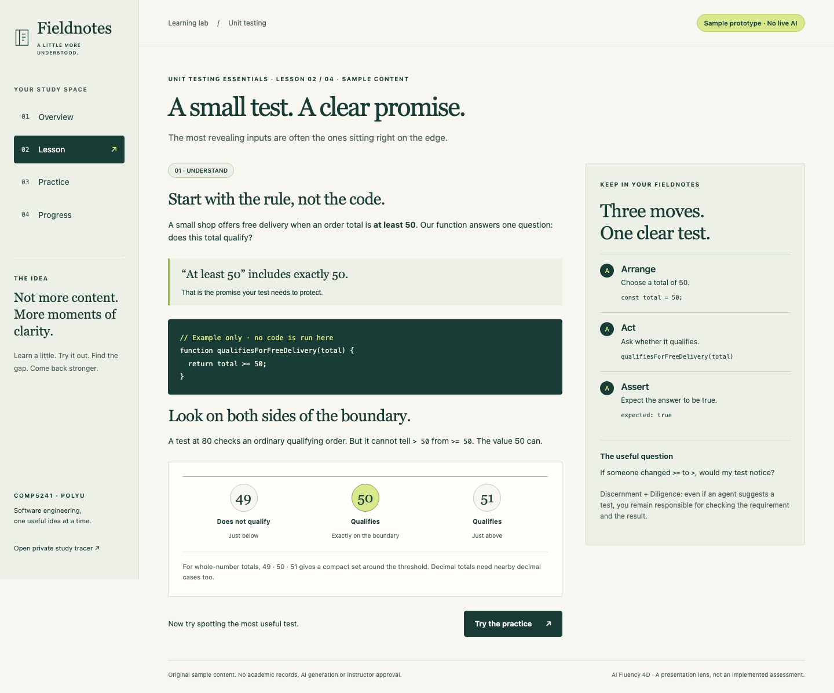
Unit-testing lesson — desktop screenshot
Sample prototype · No live AI · Prewritten lesson content

3. Practice Question
The learner chooses a test case before checking the answer. This is sample, assisted, unscored practice—not a graded assessment.
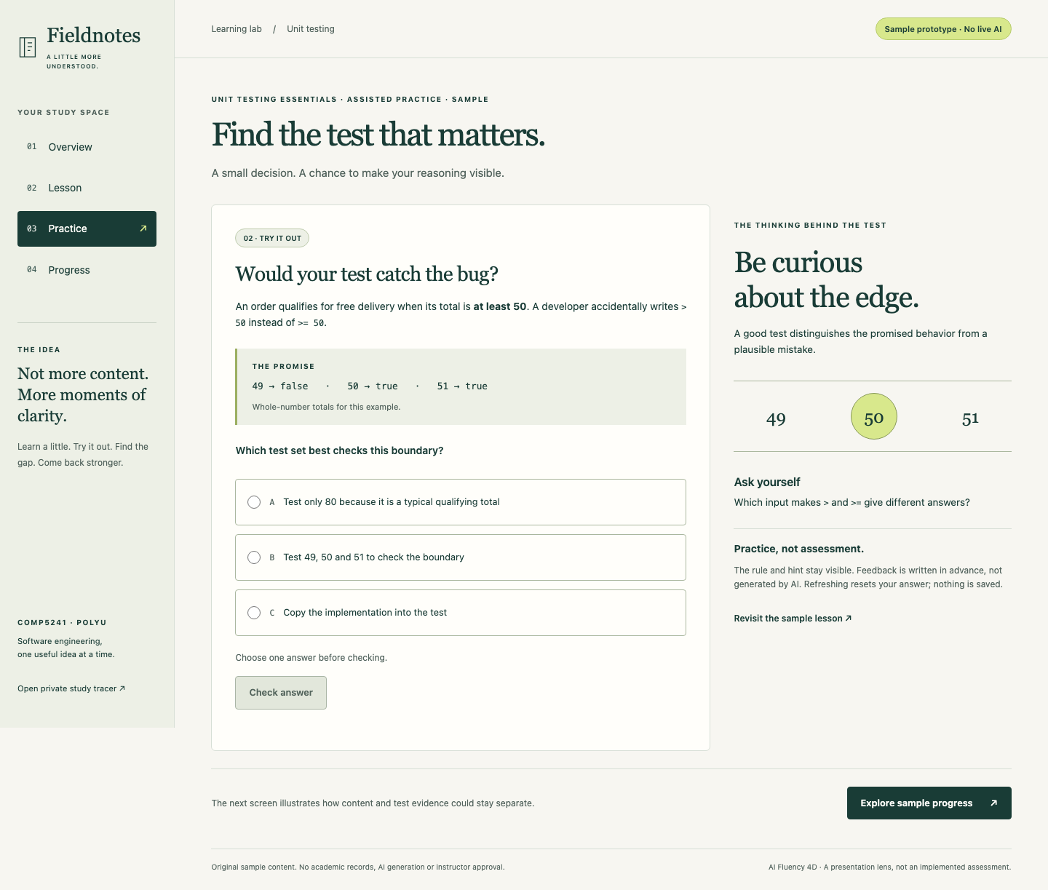
Practice question — desktop screenshot
Sample prototype · No live AI · No academic record is created

4. Practice Feedback
Prewritten feedback explains the selected answer and the boundary condition. Practice state is temporary and resets on retry or refresh.
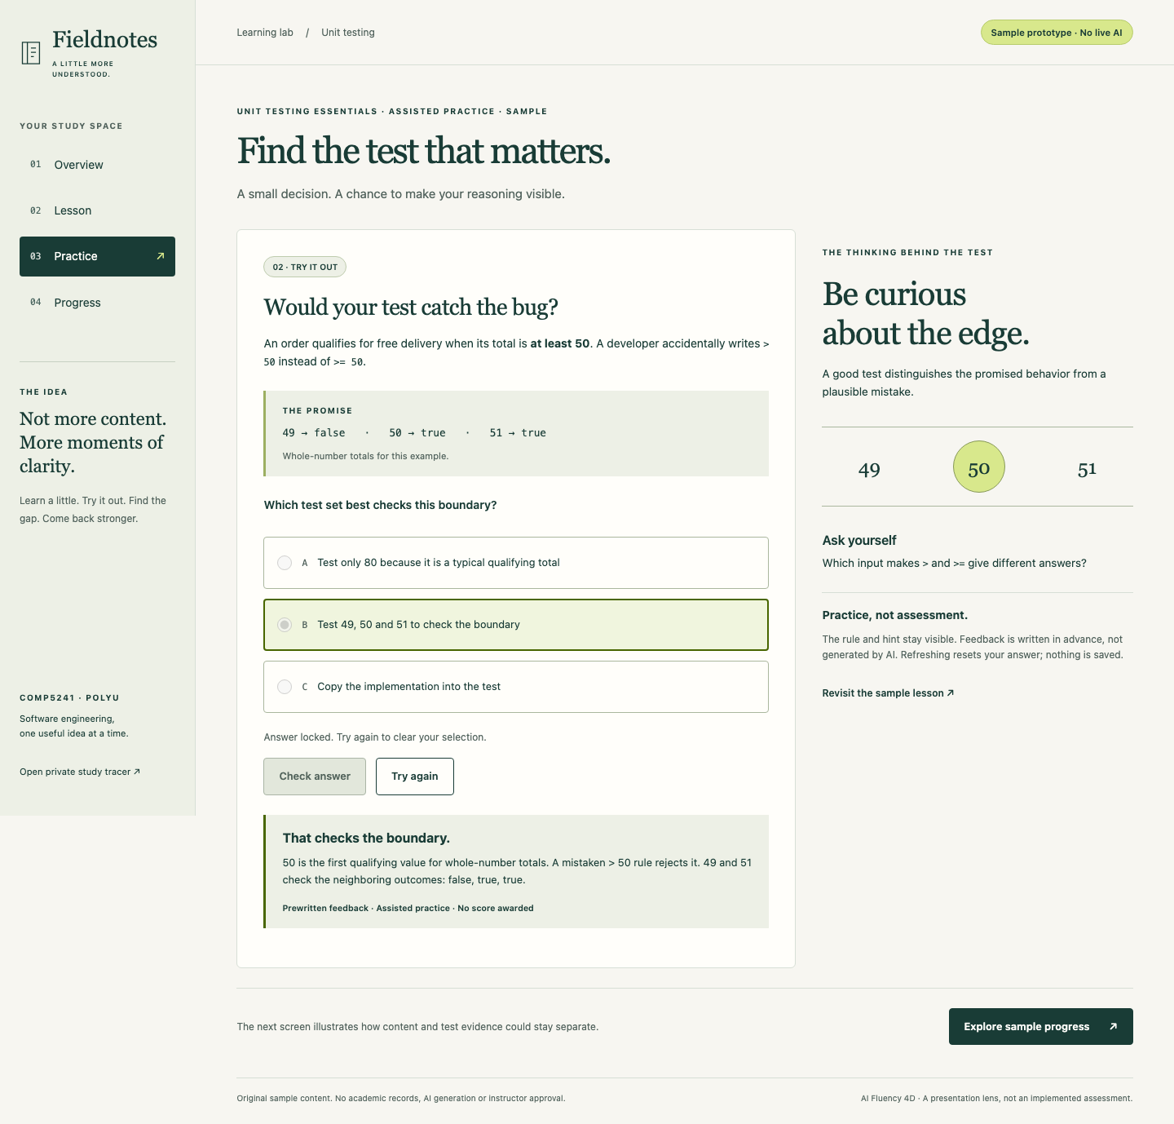
Practice feedback — desktop screenshot
Sample prototype · No live AI · Prewritten, assisted feedback

5. Progress View
The sample progress screen illustrates the intended presentation of study activity, test/recovery status and next steps. All progress values are illustrative, not measured learner results.
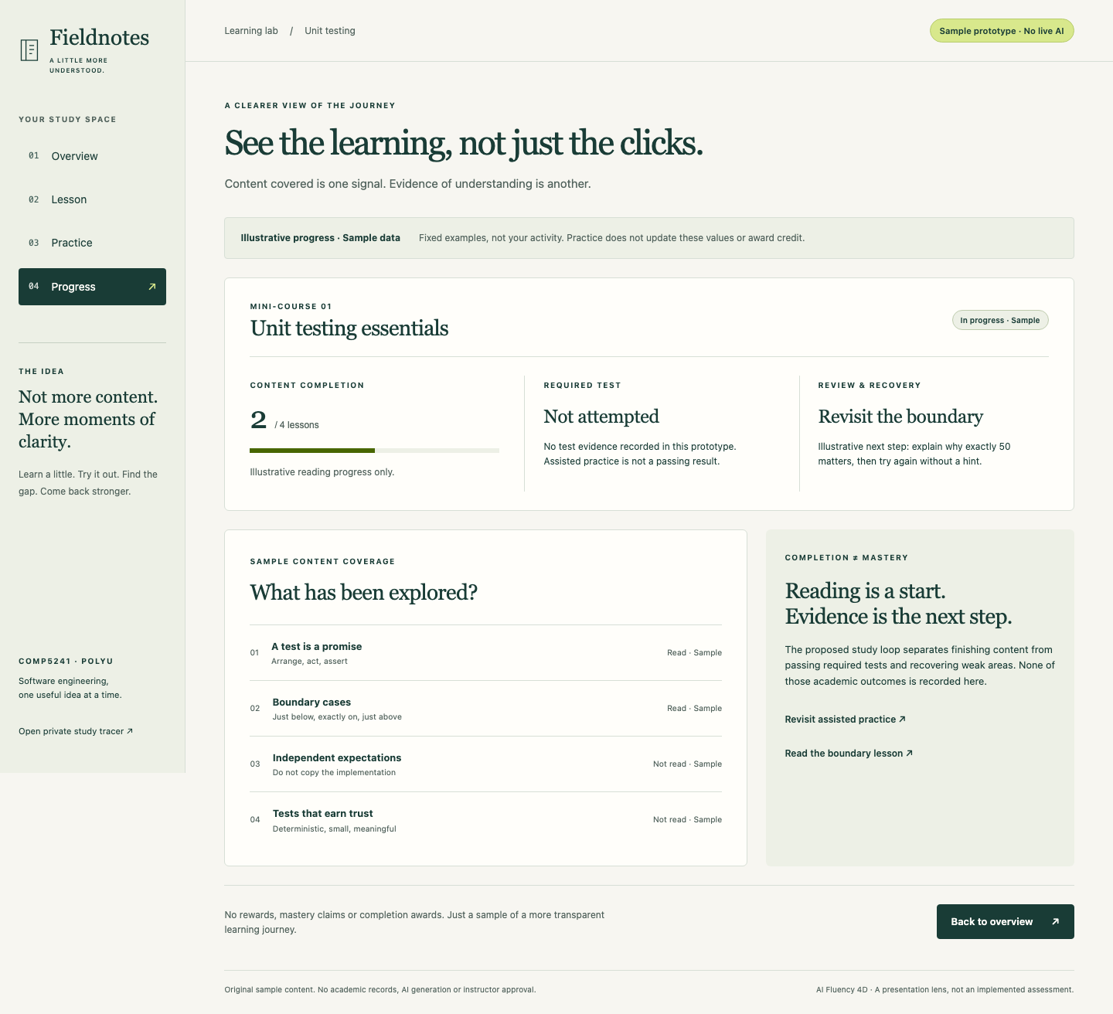
Illustrative progress — desktop screenshot
Sample prototype · No live AI · Illustrative progress only

