Assignment 1 - Part B
Neural Networks with PyTorch
Kuzushiji-MNIST Classification Report

25729500 Ying-Kai Liao

94691 - Deep Learning | Semester 1, 2026

1. Introduction
This report documents the iterative development of fully-connected neural network classifiers for the Kuzushiji-MNIST (KMNIST) dataset using PyTorch. Through six hypothesis-driven experiments, each motivated by specific observations from the previous, the architecture, training strategy, and data pipeline were progressively refined from a baseline of 87.75% to a final best test accuracy of 95.96%.

2. Dataset Presentation
The KMNIST dataset contains 70,000 images (60k train, 10k test) of handwritten Hiragana characters, each 28x28 grayscale pixels flattened to 784-dimensional vectors. The 10 classes correspond to Hiragana rows: o, ki, su, tsu, na, ha, ma, ya, re, and wo. Pixel values were normalised to [0, 1] and labels one-hot encoded.

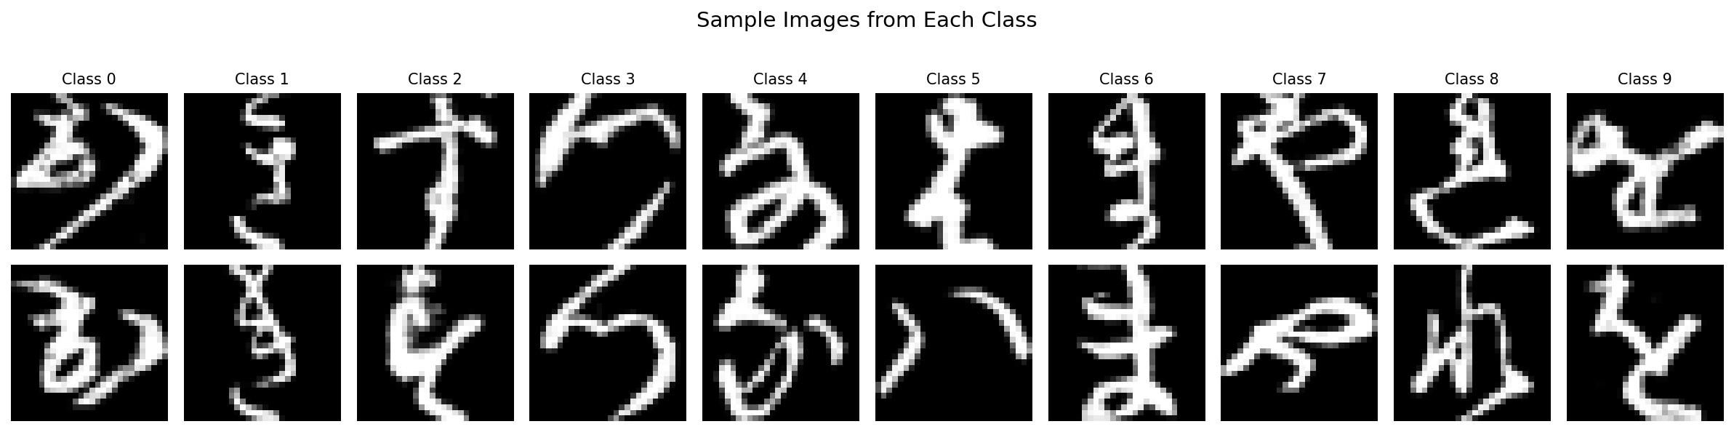
Figure 1: Sample images from each of the 10 classes
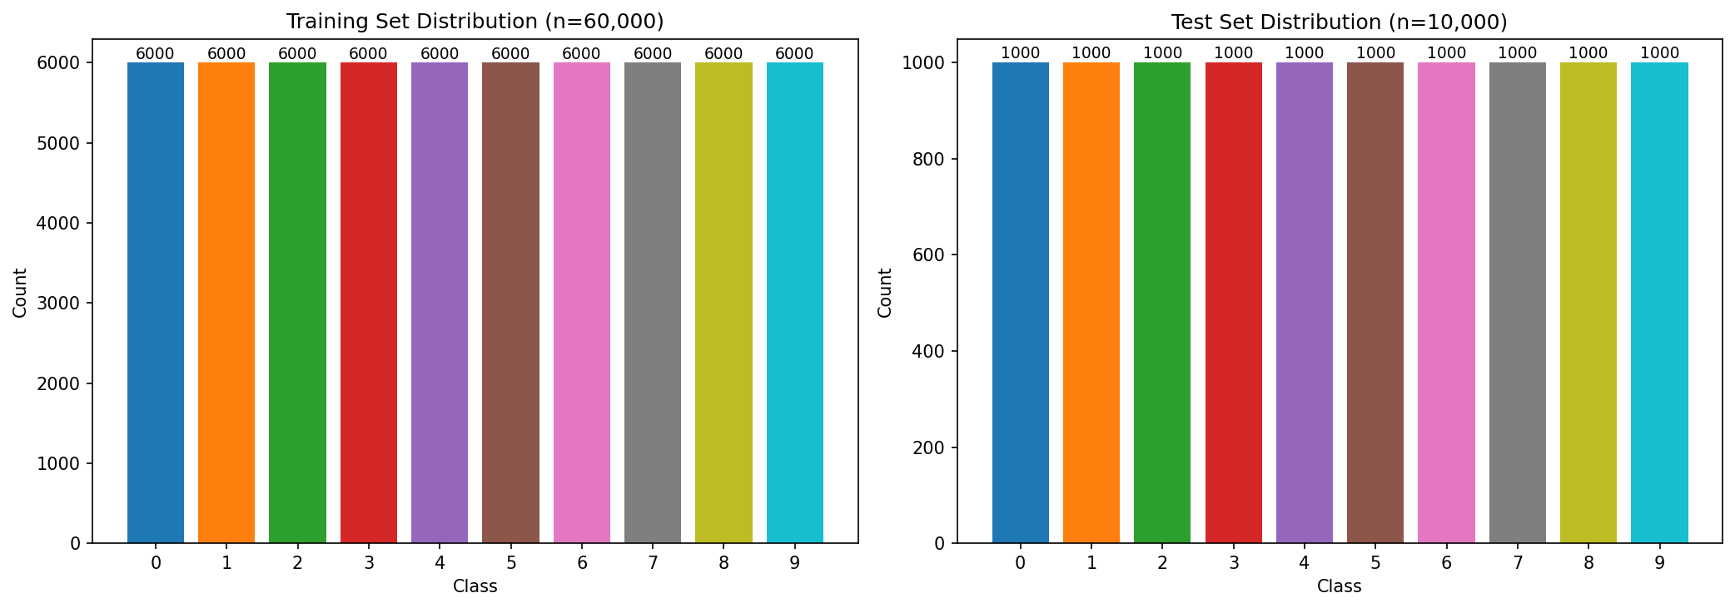
Figure 2: Class distribution in training and test sets
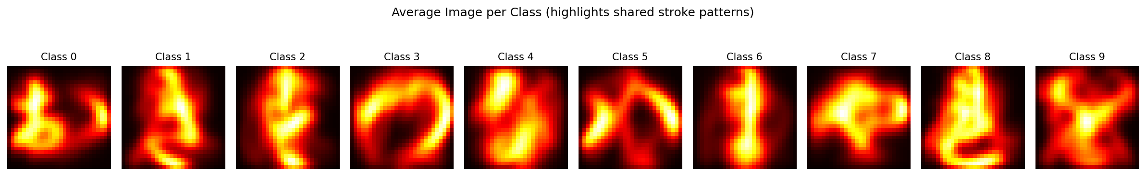
Figure 3: Average image per class — highlights shared stroke patterns between classes
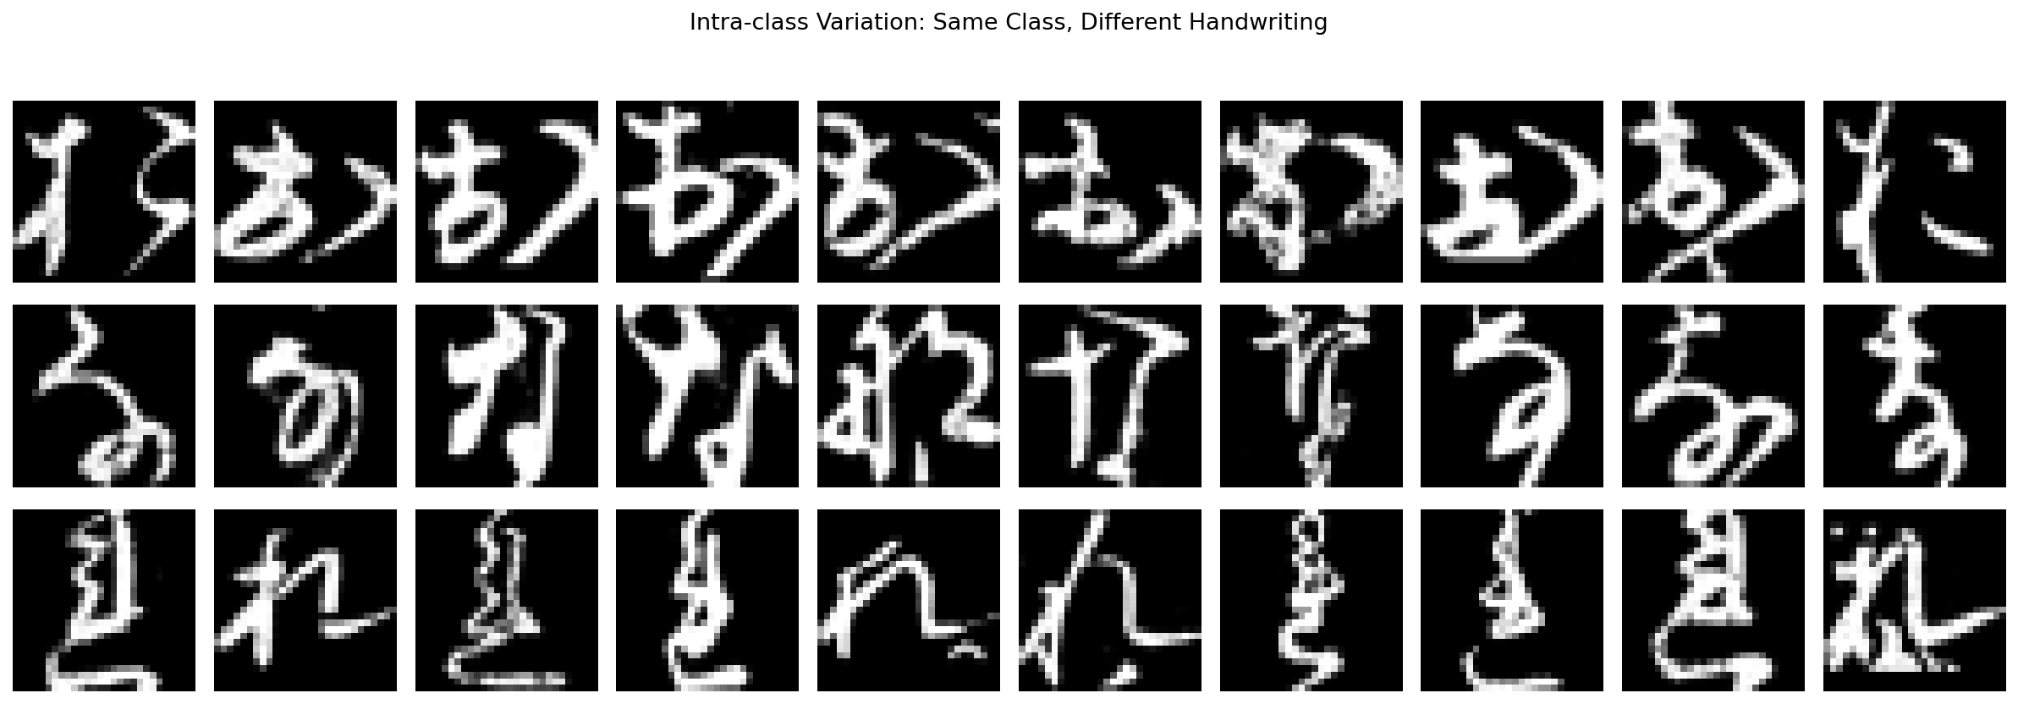
Figure 4: Intra-class variation — same class, different handwriting styles
The dataset is balanced with 6,000 training and 1,000 test samples per class. The average images reveal that several classes share similar stroke patterns (e.g., Classes 2 and 8), explaining why inter-class confusion is a persistent challenge. The intra-class variation shows significant diversity in handwriting style, motivating data augmentation to expose the model to more variation.

3. Experiments
Each experiment was designed to address a specific limitation observed in the previous one, using a null hypothesis framework.

3.1 Experiment 1: Shallow Baseline
- 784 → 256 → 10 (203,530 params). SGD (lr=0.01), no regularisation, 100 epochs
Results: Train 96.87%, Test 87.75%, Gap 9.12%
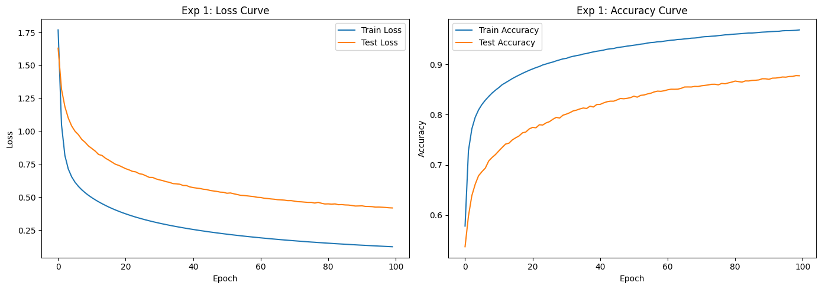
Figure 5: Experiment 1 — Loss and accuracy curves
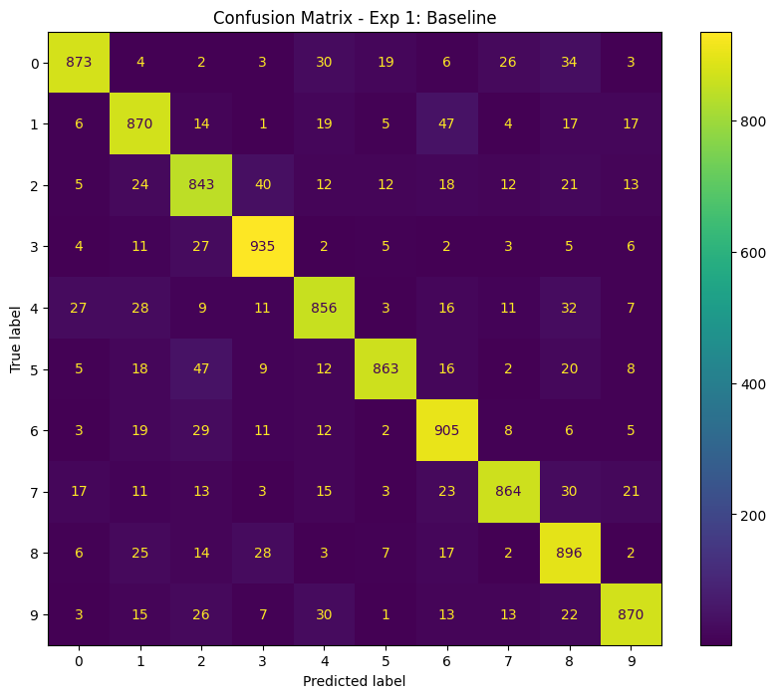
Figure 6: Experiment 1 — Confusion matrix
The baseline exceeds the 80% target but overfits significantly (9.12% gap). The confusion matrix reveals frequent misclassifications between visually similar classes.

3.2 Experiment 2: Deeper Network with Dropout
- 784 → 512 → 256 → 10 (535,818 params).
- SGD (lr=0.01),
- Dropout(0.5),
- 200 epochs
H0: Adding depth and Dropout(0.5) will not significantly reduce the generalisation gap.
Results: Train 98.13%, Test 90.87%, Gap 7.26%
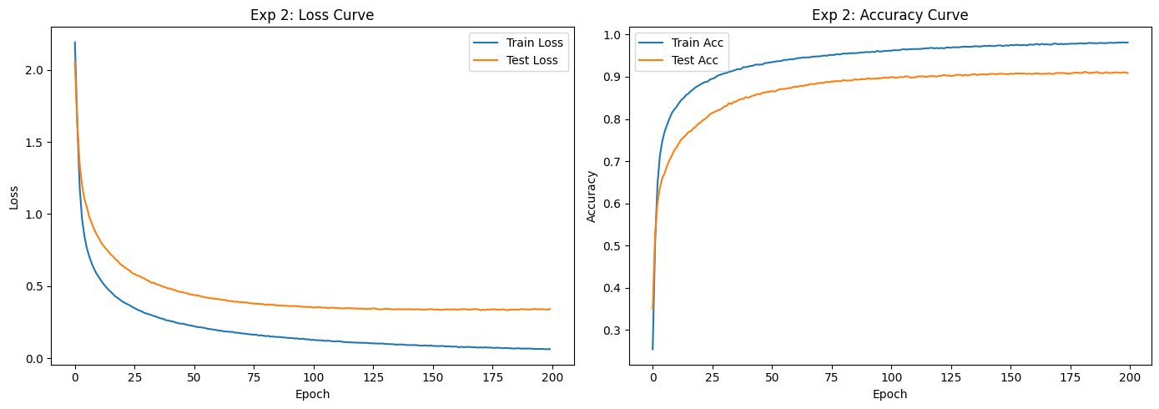
Figure 7: Experiment 2 — Loss and accuracy curves
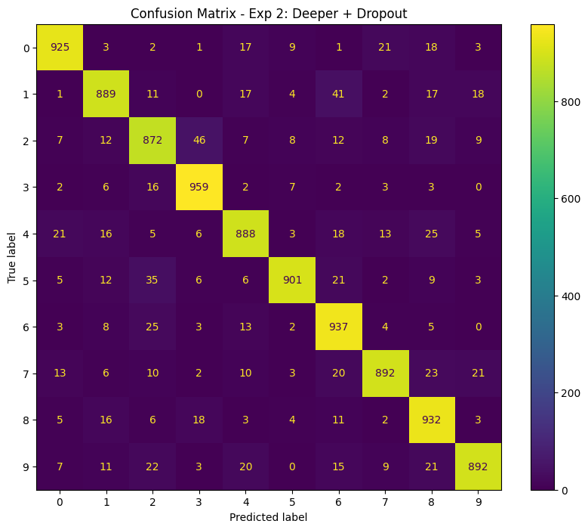
Figure 8: Experiment 2 — Confusion matrix
H0 rejected. Test accuracy improved by 3.12 points and the gap narrowed from 9.12% to 7.26%. Dropout is effective but the 0.5 rate may be constraining capacity.

3.3 Experiment 3: Optimised Architecture
- 784 → 1024 → 512 → 256 → 10 (1,462,538 params)
- AdamW (lr=0.001, weight_decay=1e-4),
- label smoothing 0.1,
- ReduceLROnPlateau,
- grad clip,
- 200 epochs

H0: Wider layers with AdamW, label smoothing, and LR scheduling will not improve test accuracy beyond 90.87%.
Results: Train 99.97%, Test 93.39% (best 93.61%), Gap 6.58%
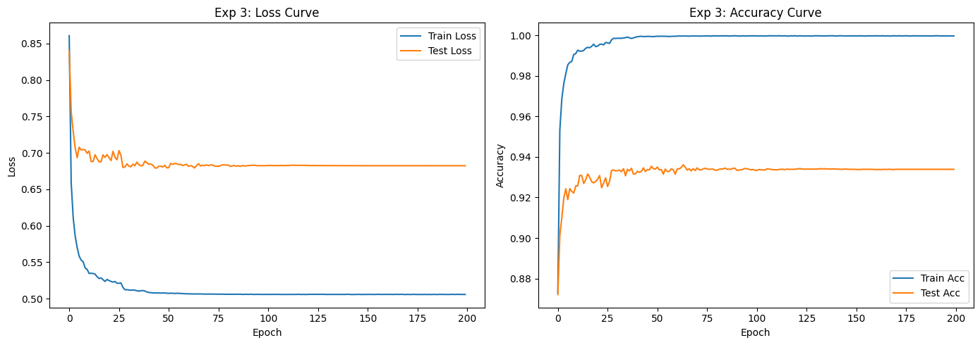
Figure 9: Experiment 3 — Loss and accuracy curves (note: train loss floors at ~0.506 due to label smoothing)
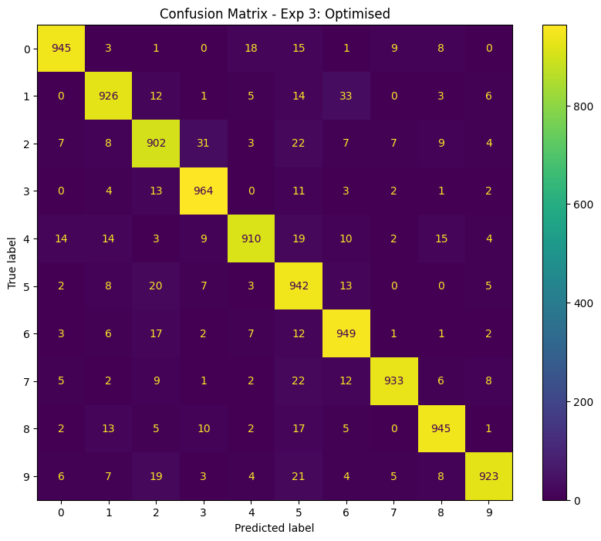
Figure 10: Experiment 3 — Confusion matrix
H0 rejected. Test accuracy reached 93.39%, but 99.97% train accuracy reveals near-complete memorisation. The parameter-to-data ratio of 24.4:1 is identified as the root cause (Zhang et al., 2017).

3.4 Experiment 4: 3x Augmentation
- Same architecture. 3x pre-generated augmented copies (180k images). Ratio: 8.1:1
H0: 3x augmentation (ratio 8.1:1) will not significantly reduce memorisation.
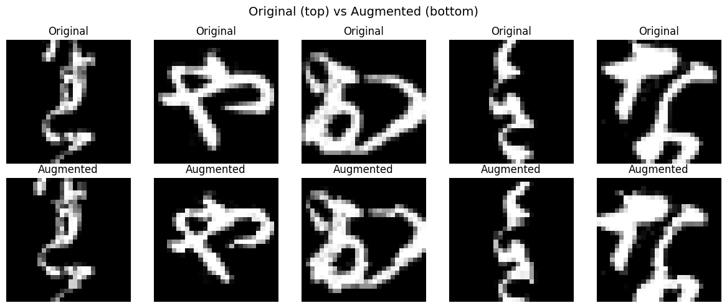
Figure 11: Original vs augmented samples (rotation, affine transform)
Results: Train 99.81%, Test 93.32% (best 93.56%), Gap 6.49%
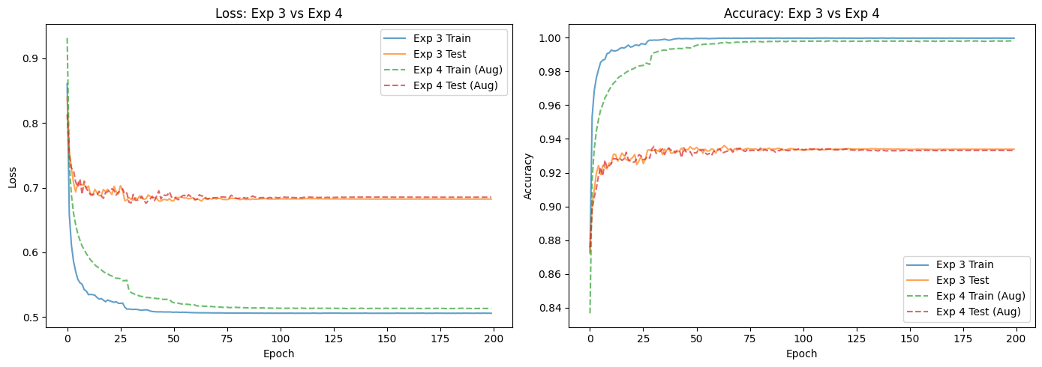
Figure 12: Experiment 4 — Loss and accuracy curves

However, this is a crucial result that reveals the potential of scaling the dataset size. Comparing the training loss of Experiment 4 to Experiment 3, the augmented model has clearly more loss remaining before reaching the overfitting floor. It has not yet fully memorised the data at the same training stage. This indicates that while 3x is insufficient, increasing the augmentation multiplier further could push the model into a regime where memorisation is no longer feasible, motivating the next experiment with a much larger dataset.
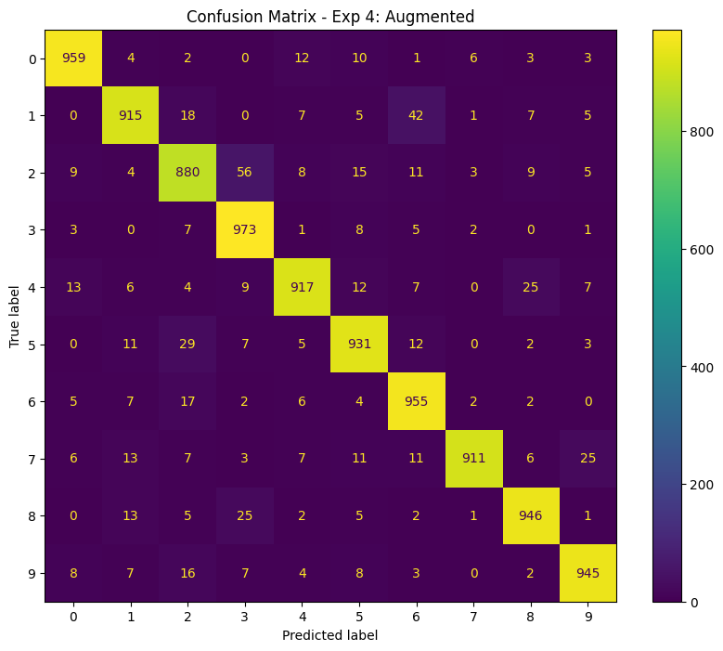
Figure 13: Experiment 4 — Confusion matrix
H0 not rejected. 3x augmentation (180k, ratio 8.1:1) was insufficient. The model memorised all 180k fixed copies (99.81% train). A much larger multiplier is needed.

3.5 Experiment 5: 12x Augmentation
- Same architecture. 12x pre-generated copies (720k images). Ratio: 2.03:1
H0: 12x augmentation will not produce meaningful improvement beyond Experiments 3/4.
Results: Train 99.18%, Test 95.34%, Gap 3.84%
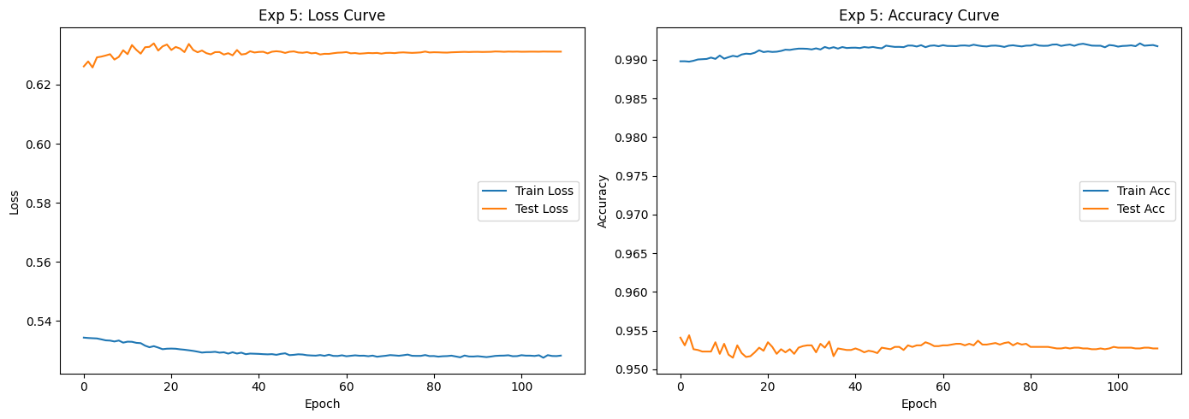
Figure 14: Experiment 5 — Loss and accuracy curves
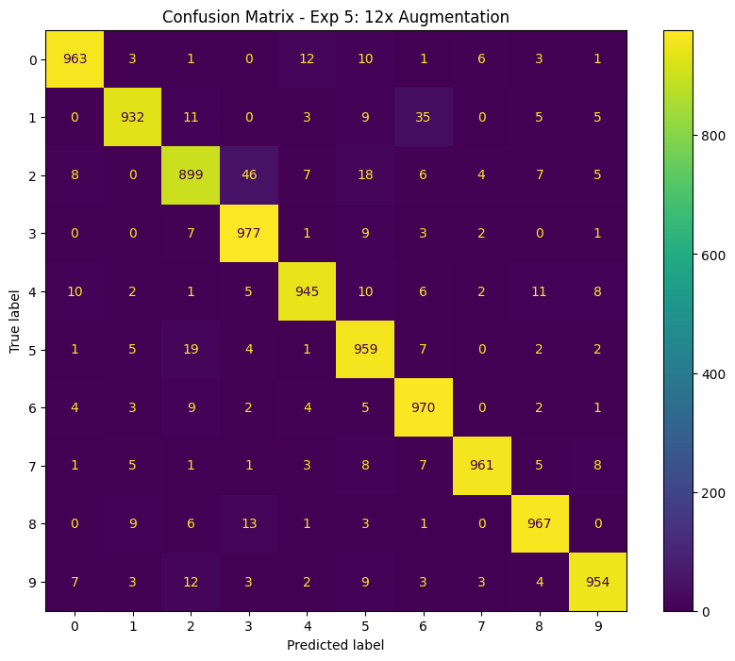
Figure 15: Experiment 5 — Confusion matrix
H0 rejected. Test accuracy jumped to 95.34% (+2.02 points). The gap narrowed from 6.49% to 3.84%. A critical threshold was crossed at ratio 2.03:1 where memorisation is significantly disrupted.

3.6 Experiment 6: 18x Augmentation (50 epochs)
- Same architecture.
- 18x pre-generated copies (1.08M images).
- Ratio: 1.35:1. 50 epochs
H0: 18x augmentation with 50 epochs will not improve beyond Experiment 5.
Results: Train 98.64%, Test 95.80% (best 95.96%), Gap 2.84%
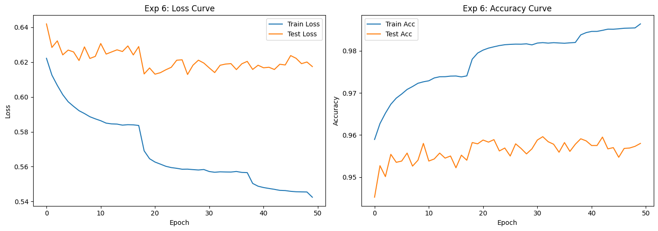
Figure 16: Experiment 6 — Loss and accuracy curves
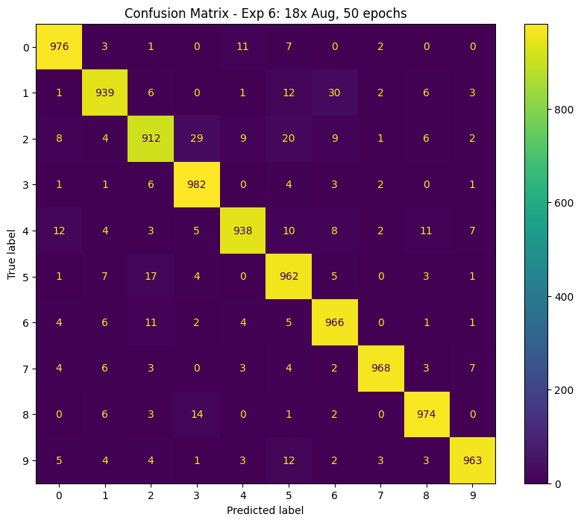
Figure 17: Experiment 6 — Confusion matrix
H0 rejected. Test accuracy improved to 95.80% (best 95.96%) with the smallest gap (2.84%). Diminishing returns from 12x→18x (+0.46 vs +2.02 points) suggest approaching the FC ceiling.

4. Performance Analysis
Table 1: Summary of all experiments
Exp | Train | Test | Best | Gap | Params | Data | Ratio | H0
1: Baseline | 96.87 | 87.75 | - | 9.12 | 204k | 60k | 3.4:1 | -
2: +Dropout | 98.13 | 90.87 | - | 7.26 | 536k | 60k | 8.9:1 | Rej.
3: Optimised | 99.97 | 93.39 | 93.61 | 6.58 | 1.46M | 60k | 24.4:1 | Rej.
4: +3x Aug | 99.81 | 93.32 | 93.56 | 6.49 | 1.46M | 180k | 8.1:1 | N.R.
5: +12x Aug | 99.18 | 95.34 | 95.34 | 3.84 | 1.46M | 720k | 2.0:1 | Rej.
6: +18x/50e | 98.64 | 95.80 | 95.96 | 2.84 | 1.46M | 1.08M | 1.4:1 | Rej.
H0 column: Rej. = null hypothesis rejected, N.R. = not rejected
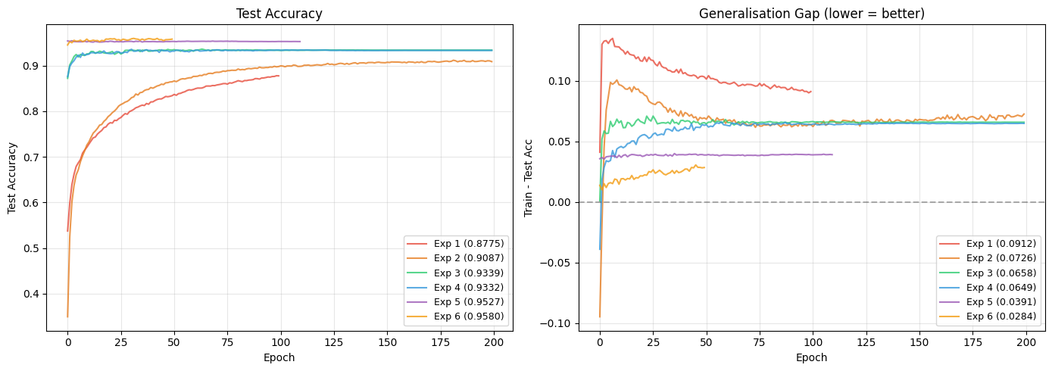
Figure 18: Test accuracy and generalisation gap across all experiments
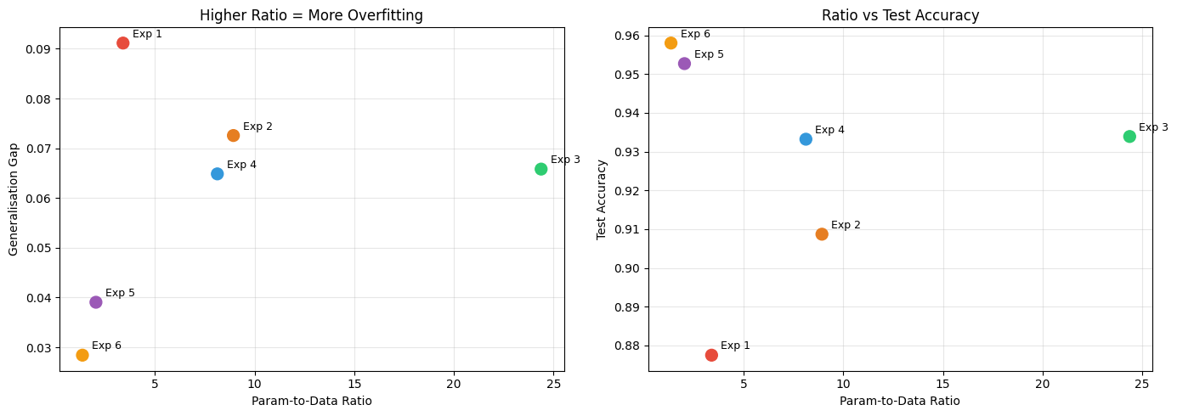
Figure 19: Parameter-to-data ratio vs test accuracy and generalisation gap
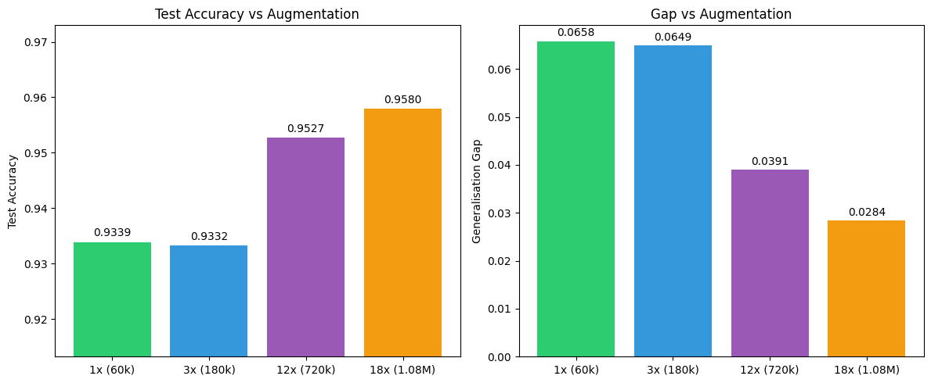
Figure 20: Effect of augmentation multiplier on test accuracy and gap
Parameter-to-data ratio and memorisation:
Zhang et al. (2017) demonstrated that overparameterised networks memorise datasets when parameters exceed training samples. Our results quantify this: at ratios above 8:1 (Experiments 3 and 4), the model achieves near-perfect training accuracy regardless of dataset size. Only at ratio 2.0:1 (Exp 5) does memorisation decrease meaningfully, with further improvement at 1.4:1 (Exp 6). Experiment 4 proves the ratio threshold matters more than absolute dataset size.
Critical augmentation threshold:
The most striking finding is the non-linear relationship between augmentation and performance. Going from 1x to 3x produced no improvement, while 3x to 12x yielded a 2.02-point jump. This suggests a critical threshold around ratio 2-3:1 where the model's memorisation capacity is exceeded. Arpit et al. (2017) showed networks learn generalisable patterns before memorising; once augmentation exceeds this threshold, useful learning is preserved while memorisation is disrupted.
Diminishing returns:
The improvement from 12x to 18x (+0.46 points) is much smaller than 3x to 12x (+2.02 points). With pre-generated augmentation, the practical ceiling for FC networks on KMNIST appears to be approximately 96%.

5. Limitations and Recommendations
Loss of spatial information:
Flattening images discards spatial relationships. Hiragana strokes encode meaning in position and curvature, fundamentally limiting FC accuracy.
Pre-generated vs on-the-fly augmentation:
Pre-generated copies are fixed and can eventually be memorised. On-the-fly augmentation provides infinite diversity but was prohibitively slow due to CPU-bound transforms. GPU-native augmentation (e.g., Kornia) could combine speed with infinite diversity.
Recommendations:
- On-the-fly augmentation: GPU-native on-the-fly augmentation (Kornia) for infinite diversity without CPU bottleneck.
- Model ensembling: Training multiple models with different seeds and averaging predictions.
- Convolutional networks: CNNs preserve spatial structure and achieve >95% on KMNIST benchmarks.

6. Conclusion
Through six hypothesis-driven experiments, a fully-connected network achieving 95.96% best test accuracy was developed on KMNIST with a generalisation gap of 2.84%. The key findings are: (1) dropout and depth improve baseline performance (H0 rejected); (2) wider architecture with modern optimisation pushes to 93%+ but causes memorisation (H0 rejected); (3) insufficient augmentation fails despite tripling data (H0 not rejected); (4) a critical threshold exists around ratio 2:1 where memorisation is disrupted (H0 rejected); and (5) further augmentation yields diminishing but measurable returns (H0 rejected). The parameter-to-data ratio governs memorisation in overparameterised FC networks, confirming Zhang et al. (2017) and Arpit et al. (2017).

References
Zhang, C., Bengio, S., Hardt, M., Recht, B., & Vinyals, O. (2017). Understanding deep learning requires rethinking generalization. ICLR 2017. arXiv:1611.03530
Arpit, D., Jastrzebski, S., Ballas, N., et al. (2017). A closer look at memorization in deep networks. ICML 2017. arXiv:1706.05394
Shorten, C., & Khoshgoftaar, T. M. (2019). A survey on image data augmentation for deep learning. Journal of Big Data, 6(1), 1-48.

