**Abstract**

Blended learning, which combines online and face-to-face instruction, has emerged as a promising educational approach that harnesses the benefits of both traditional and digital learning environments. However, achieving the optimal blend of online and face-to-face instruction remains a critical challenge for educators and instructional designers. This research aims to bridge this knowledge gap by investigating the factors influencing the blend, examining the effects of different instructional ratios on student engagement and learning outcomes, and providing evidence-based recommendations for designing and implementing effective blended learning models.

Using a mixed-methods research approach, qualitative data was collected through interviews and focus group discussions with educators and administrators experienced in blended learning. Thematic analysis revealed key factors influencing the blend, including learner characteristics, instructional goals, technological considerations, and pedagogical strategies. These qualitative insights formed the foundation for the subsequent quantitative phase.

A survey questionnaire was administered to a diverse sample of students enrolled in blended learning courses. Quantitative analysis, including descriptive statistics, correlation analysis, and regression analysis, examined the relationships between instructional ratios, student engagement, and learning outcomes. The results indicated that the blend of online and face-to-face instruction significantly influenced student engagement levels and learning outcomes.

By integrating the qualitative and quantitative findings, this research provides a comprehensive understanding of the optimal blend of online and face-to-face instruction in blended learning environments. Based on the research outcomes, evidence-based recommendations are proposed to guide educators and policymakers in designing and implementing effective blended learning models that maximize student engagement and foster positive learning outcomes.

This study contributes to the field of blended learning by addressing the existing knowledge gap and offering valuable insights into instructional design decisions. The findings provide a foundation for enhancing instructional practices and inform the development of effective blended learning models. By optimizing the blend of online and face-to-face instruction, educators can create engaging and impactful learning experiences that promote student success in blended learning environments.

**Introduction**

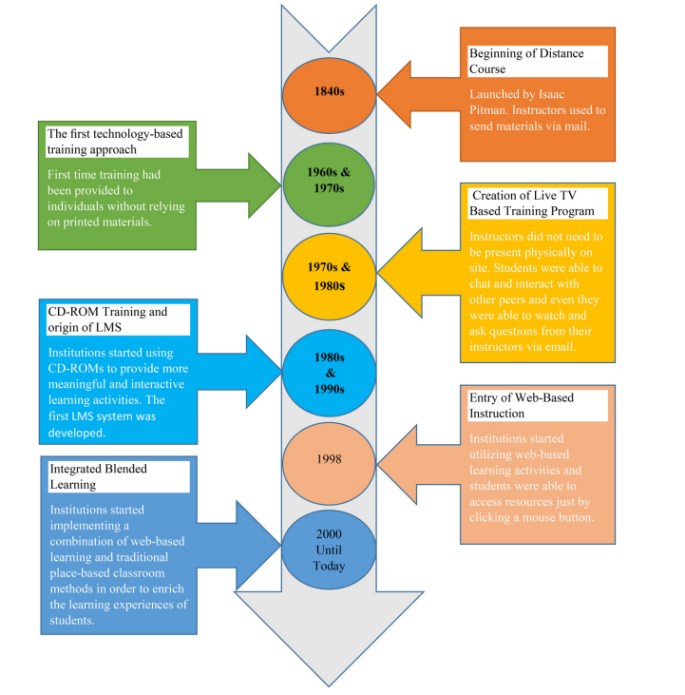Blended learning has gained widespread acceptance as an educational approach that combines traditional face-to-face instruction with online learning activities (Kang & Kim, 2021). It offers flexibility, personalization, improved engagement, enhanced collaboration, and better outcomes for students (Kang & Kim, 2021; Bordoloi et al., 2021). Especially during the year of 2020 to 2021, the COVID-19 pandemic has accelerated the adoption of blended learning all around the world included Malaysia. With the need for remote learning and social distancing measures, educators and institutions have explored blended learning models to ensure continuity in education delivery. Many universities and colleges in Malaysia have incorporated blended learning approaches into their programs. This includes a combination of face-to-face classes, online lectures, virtual discussions, and interactive online activities. Blended learning allows students to learn at their own pace and provides individualized teaching opportunities (Xu et al., 2021). However, there is still a need for further research to understand the factors influencing the optimal blend of online and face-to-face instruction in blended learning environments (Kang & Kim, 2021).

Figure 1: Evolution of Blended Learning (Source: Singh et al., 2021)

While existing studies have investigated the impact of blended learning on learning outcomes, most of them are context-specific and focused on specific disciplines or populations (Kang & Kim, 2021). Therefore, it is essential to explore the effectiveness of blended learning in various educational contexts to inform instructional practices (Müller & Mildenberger, 2021). Additionally, previous research on blended learning has primarily focused on student behaviours and patterns, overlooking other crucial factors such as learning context, teachers' behaviours, and access to learning materials (Xu et al., 2021). Understanding these factors is vital for designing and implementing effective blended learning models (Xu et al., 2021).

Moreover, while blended learning has shown promising results, there are limitations in the existing literature. For instance, Kang and Kim's (2021) study focused solely on nursing students in a public healthcare course, limiting the generalizability of the findings to other contexts. Furthermore, the two-year interval between the experimental and control groups in their study may have introduced variability into the results. Similarly, Xu et al. (2021) analysed only a limited number of factors influencing blended learning performance, neglecting the broader range of influential factors. Thus, understanding a comprehensive set of factors that influence the optimal blend is essential for informed decision-making by instructional designers and educators.

In light of these research gaps, this study aims to contribute to the advancement of blended learning practices. It seeks to investigate the factors influencing the optimal blend of online and face-to-face instruction, explore the effects of different instructional ratios on student engagement and learning outcomes, and provide evidence-based recommendations for designing and implementing effective blended learning models. By conducting a comprehensive examination of learner characteristics, instructional goals, subject matter, and technological considerations, this research aims to provide insights into the elements that contribute to an effective blend in blended learning environments.

In conclusion, this research will bridge the existing gaps in knowledge and contribute to the enhancement of instructional practices and the design of effective blended learning models that promote student engagement and enhance learning outcomes. By understanding the optimal blend of online and face-to-face instruction, educators can create meaningful learning experiences that cater to the diverse needs of students in different educational contexts.

**Section 1**

**Problem Statement**

Blended learning has become a promising instructional approach that combines online and face-to-face educational instruction, offering flexibility and enhanced learning experiences for students. However, while existing research has explored various aspects of blended learning, there are still significant gaps that need to be addressed to inform effective design and implementation of blended learning models. The research study by Bordoloi et al. (2021) highlights the need to understand the perceptions of students and educators towards online/blended learning during the COVID-19 pandemic in the Indian context. However, there is limited research that comprehensively investigates the factors influencing the optimal blend of online and face-to-face instruction in blended learning environments.

In order to design effective blended learning models, it is crucial to investigate the effects of different instructional ratios on student engagement and learning outcomes. The research study by Heilporn et al. (2021) examines the strategies employed by teachers to foster student engagement in blended learning in higher education, but there is still a need to explore the impact of different ratios of online and face-to-face instruction on student engagement and learning outcomes in various educational contexts. Additionally, the study by Kang and Kim (2021) focuses on the impact of blended learning, particularly the flipped classroom with team-based learning, on learning outcomes in the healthcare education course. However, more research is needed to examine the effects of different instructional approaches and ratios on learning outcomes across different disciplines and educational settings.

Besides, a comprehensive understanding of the effectiveness of replacing classroom time with online learning is essential for designing flexible blended learning models. The systematic review conducted by Müller and Mildenberger (2021) sheds light on this aspect. However, further research is required to examine the effectiveness of this approach and its implications for flexible learning in higher education. Moreover, the study by Singh et al. (2021) discusses the combination of online and face-to-face learning in a post-pandemic educational landscape and this provides insights into the potential of blended learning. However, additional research is needed to explore best practices, strategies, and models for effective blending of online and face-to-face instruction in diverse educational contexts.

By addressing these research gaps, this study aims to contribute to the existing knowledge base on blended learning. It seeks to explore the perceptions of students and educators towards online/blended learning beyond the pandemic context, understand the factors influencing the optimal blend of online and face-to-face instruction, investigate the effects of different instructional ratios on student engagement and learning outcomes, and provide evidence-based recommendations for designing and implementing effective blended learning models. By synthesizing and integrating the findings from the studies conducted by Bordoloi et al. (2021), Heilporn et al. (2021), Kang and Kim (2021), Müller and Mildenberger (2021), and Singh et al. (2021), this research aims to fill the gaps in the literature and provide valuable insights for educators, instructional designers, and policymakers.

To conclude, this research will contribute to the ongoing discourse on blended learning by offering a comprehensive examination of the factors influencing the optimal blend, the effects of different instructional ratios on student engagement and learning outcomes, and evidence-based recommendations for effective blended learning models. By addressing the identified research gaps and considering the unique characteristics of the research context, this study aims to advance our understanding of blended learning and provide practical insights that can inform instructional practices, enhance student learning experiences, and improve educational outcomes.

**Section 2**

**Research Question**

1. What are the main factors influencing the optimal blend of online and face-to-face instruction in blended learning environments in higher educations?
2. How do different ratios of online and face-to-face instruction affect student engagement and learning outcomes in blended learning for higher educations?
3. What are the evidence-based recommendations can be provided on designing and implementing effective blended learning models?

**Section 3**

**Research Objective**

1. Identify the main factors influencing the optimal blend of online and face-to-face instruction in blended learning environments.
2. To investigate the effects of different ratios of online and face-to-face instruction on student engagement and learning outcomes in blended learning.
3. To provide evidence-based recommendations on designing and implementing effective blended learning models.

**Section 4**

**Research Methodology**

This study aims to investigate the optimal blend of online and face-to-face instruction in blended learning environments. To achieve this goal, a mixed-methods research approach will be employed, integrating qualitative and quantitative data collection and analysis methods. The research methodology consists of the following key components:

1. Research Design:

A sequential exploratory design will be adopted, commencing with qualitative data collection and analysis, followed by quantitative data collection and analysis. This approach allows for an in-depth exploration of the factors influencing the blend and provides a foundation for subsequent quantitative analysis to examine the effects of different ratios of online and face-to-face instruction.

1. Qualitative Phase:
2. Data Collection:

Semi-structured interviews and focus group discussions will be conducted with educators, instructional designers, students, and administrators who have experience with blended learning. These qualitative data collection methods will provide insights into the factors influencing the optimal blend, such as learner characteristics, instructional goals, and learning strategies.

Below are some field that we can gather and collect for qualitative data, which are:-

1. Experiences: Share experiences with blended learning and describe specific instances or courses where blended learning was encountered.
2. Perceptions: Explore how participants perceive the blend of online and face-to-face instruction, highlighting advantages and challenges.
3. Factors for Effectiveness: Identify factors that contribute to an effective blend and understand their impact on learning outcomes and engagement.
4. Strategies: Collect examples of specific strategies that have enhanced the learning experience in blended learning environments.
5. Preferences: Determine participants' preferred modes of instruction and their reasons for choosing one over the other or a combination of both.
6. Flexibility: Investigate how the flexibility offered by blended learning affects the learning process and accommodates other commitments.
7. Engagement and Outcomes: Examine participants' observations of differences in engagement levels and learning outcomes compared to fully online or traditional classroom-based courses.
8. Digital Resources: Assess the role of digital resources, such as online platforms and multimedia materials, in enhancing understanding and retention of course content.
9. Collaboration: Explore the impact of collaborative activities and group work on the learning experience, considering both online and face-to-face settings.
10. Recommendations: Gather participants' recommendations to improve the design and implementation of blended learning models.
11. Data Analysis:

Analysis will involve identifying and interpreting patterns, themes, and key factors influencing the blend of online and face-to-face instruction. The qualitative data analysis will encompass the iterative process of coding, categorizing, and identifying emerging themes.

1. Quantitative Phase:
2. Data Collection:

A survey questionnaire will be administered to a larger sample of students at the University of Malaya, encompassing them from different faculties and courses. The survey will gather data on student engagement levels, learning outcomes, and the perceived effectiveness of different ratios of online and face-to-face instruction. The survey involved 10 sections which as shown below:-

1. Demographics: Collect demographic information such as age, gender, educational background, and prior experience with blended learning.
2. Learning Preferences: Assess participants' preferred modes of instruction (online, face-to-face, or blended) and their reasons for selecting a particular mode.
3. Engagement Levels: Measure participants' engagement in blended learning by asking about their involvement in online activities, class discussions, and group projects.
4. Learning Outcomes: Evaluate participants' perceived learning outcomes and academic performance in blended learning compared to traditional classroom-based instruction.
5. Online Resources: Determine the effectiveness and usefulness of online resources, such as multimedia materials, interactive modules, and discussion forums.
6. Interaction and Collaboration: Assess participants' perceptions of interaction and collaboration with peers and instructors in both online and face-to-face components of blended learning.
7. Flexibility and Convenience: Measure participants' satisfaction with the flexibility and convenience offered by blended learning, including the ability to access materials and participate in learning activities at their own pace.
8. Support and Guidance: Evaluate participants' perceptions of the support and guidance provided by instructors in blended learning, such as feedback on assignments and availability for consultations.
9. Technological Readiness: Assess participants' comfort and proficiency in using technology tools and platforms for blended learning.
10. Overall Satisfaction: Measure participants' overall satisfaction with the blended learning experience and their likelihood of recommending it to others.
11. Data Analysis:

Descriptive statistics, correlation analysis, and regression analysis will be conducted to examine the relationships between instructional ratios, student engagement, and learning outcomes. The quantitative analysis will yield valuable evidence on the effects of different blends on student success in blended learning environments.

1. Integration and Interpretation:

The qualitative and quantitative findings will be integrated and interpreted to gain a comprehensive understanding of the optimal blend of online and face-to-face instruction. The qualitative insights will help contextualize and enrich the quantitative findings, providing a deeper understanding of the factors influencing the blend and their impact on student engagement and learning outcomes.

1. Recommendations:

Based on the research findings, evidence-based recommendations will be developed for designing and implementing effective blended learning models. These recommendations will offer practical guidance to educators and policymakers on optimizing the blend of online and face-to-face instruction to enhance student engagement and promote positive learning outcomes.

**Reference**

Bordoloi, R., Das, P., & Das, K. (2021). Perception towards online/blended learning at the time of Covid-19 pandemic: an academic analytics in the Indian context. *Asian Association of Open Universities Journal*, *ahead-of-print*(ahead-of-print).

Heilporn, G., Lakhal, S., & Bélisle, M. (2021). An examination of teachers’ strategies to foster student engagement in blended learning in higher education. *International Journal of Educational Technology in Higher Education*, *18*(1). https://doi.org/10.1186/s41239-021-00260-3

Kang, H. Y., & Kim, H. R. (2021). Impact of blended learning on learning outcomes in the public healthcare education course: a review of flipped classroom with team-based learning. *BMC Medical Education*, *21*(1). https://doi.org/10.1186/s12909-021-02508-y

Müller, C., & Mildenberger, T. (2021). Facilitating Flexible Learning by Replacing Classroom Time With an Online Learning Environment: A Systematic Review of Blended Learning in Higher Education. *Educational Research Review*, *34*, 100394.

Singh, J., Steele, K., & Singh, L. (2021). Combining the best of online and face-to-face learning: Hybrid and blended learning approach for COVID-19, post vaccine, & post-pandemic world. *Journal of Educational Technology Systems*, *50*(2).

Xu, Z., Yuan, H., & Liu, Q. (2021). Student Performance Prediction Based on Blended Learning. *IEEE Transactions on Education*, *64*(1), 66–73.