**CMSC203 Assignment 0**

Class: CMSC203 CRN 47229

 Program: Assignment 0

Instructor: Dr. Grinberg

 Summary of Description: (Give a brief description for each Program) A program that requires you to use functions to calculate the volume of a box and the volume of a Sphere.

 Due Date: 06/07/2021

 Integrity Pledge: I pledge that I have completed the programming assignment independently.

 I have not copied the code from a student or any source.

**Complete the following five parts of Assignment 0:**

**Part1: Setup GitHub:** Provide the screen shots of your GitHub account with Assignment 0 file is uploaded here:

**Part 2 -Install JDK, Test java Application from Command Line**

Provide the screen shots from Step 1 and 2 here:

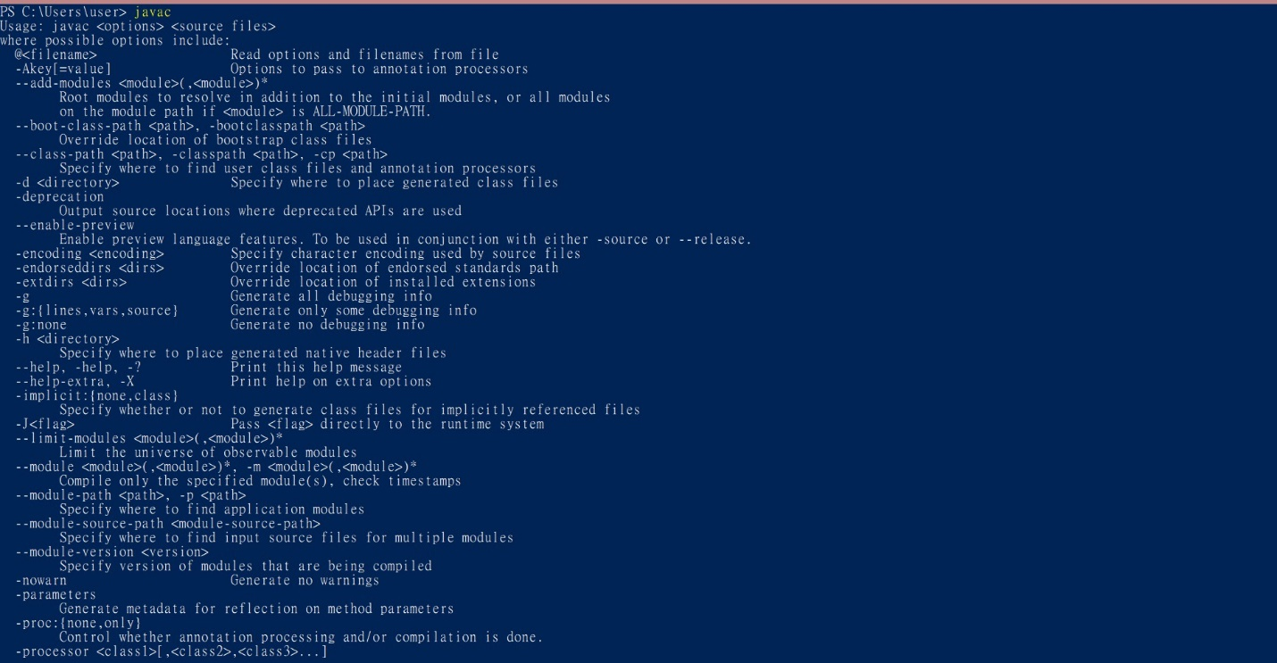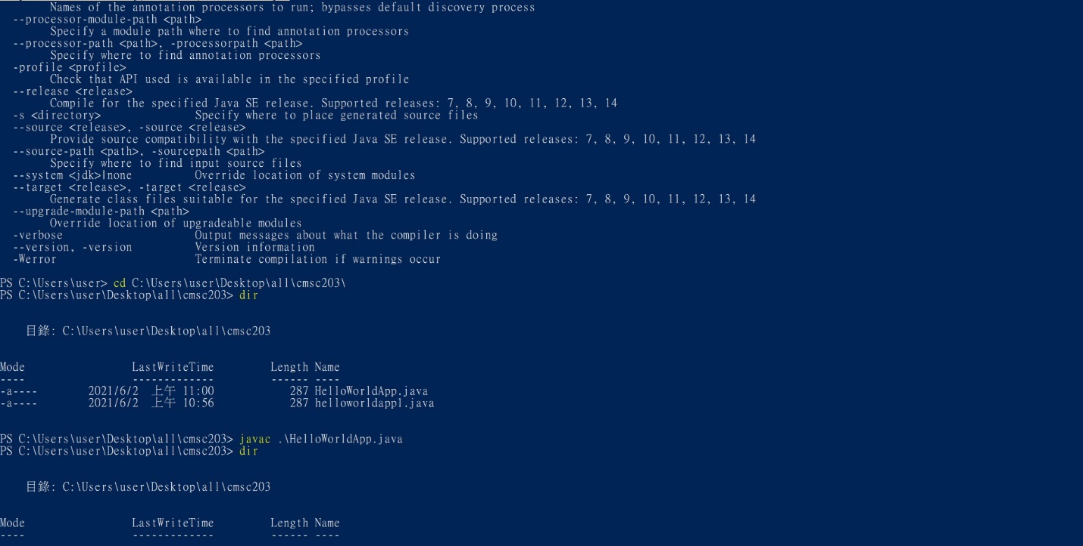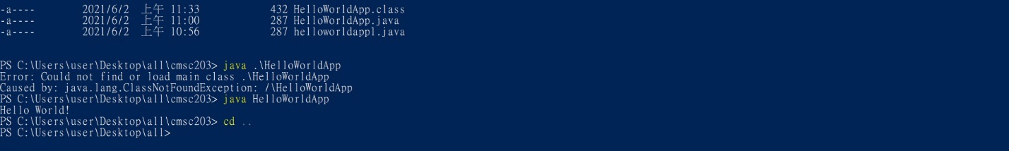

**Part 3 - Install Eclipse, Test Eclipse Java Application**

Provide the screen shots from Step 1 and 2 here:

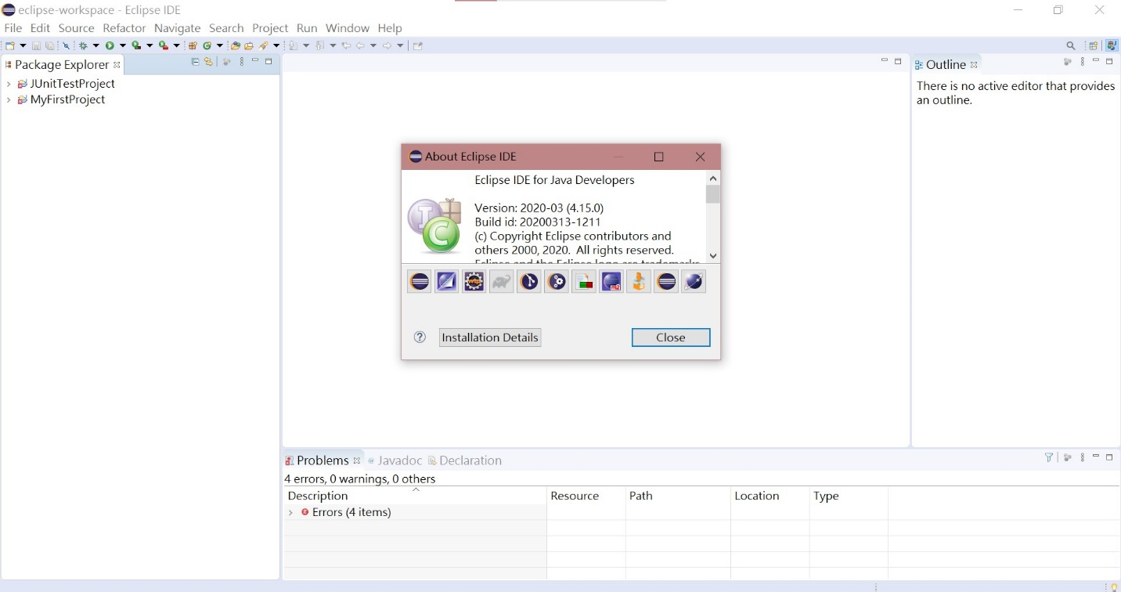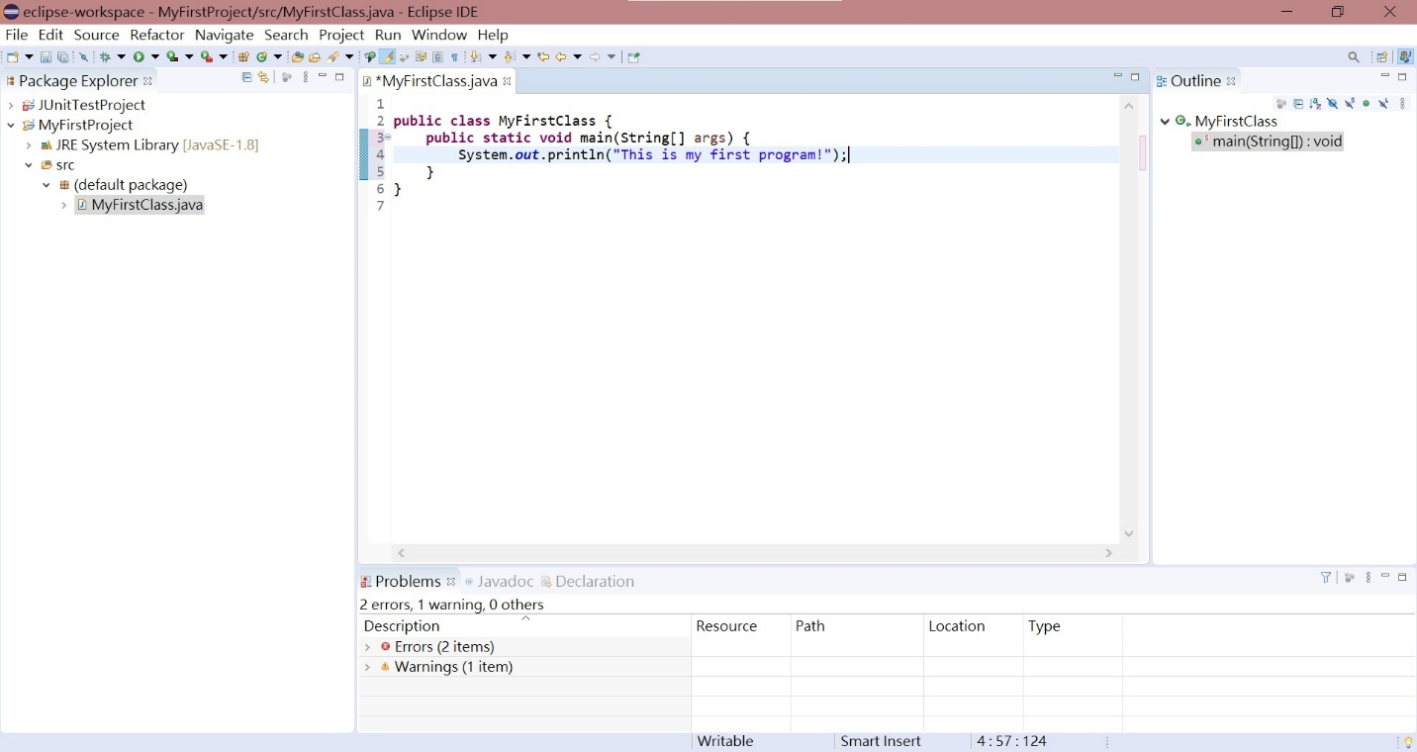

**Part 4 - Install, Setup, Test Junit Program.**

Provide the screen shots showing:

* 1. Eclipse with working JUnit Test example
  2. Project screenshot
  3. Running example screenshot

**Part 5 - Install, Setup, and Test JavaFX Application.**

Provide the screen shots showing:

1. JavaFX Project screenshot
2. Running example screenshot
3. Java Source Code File

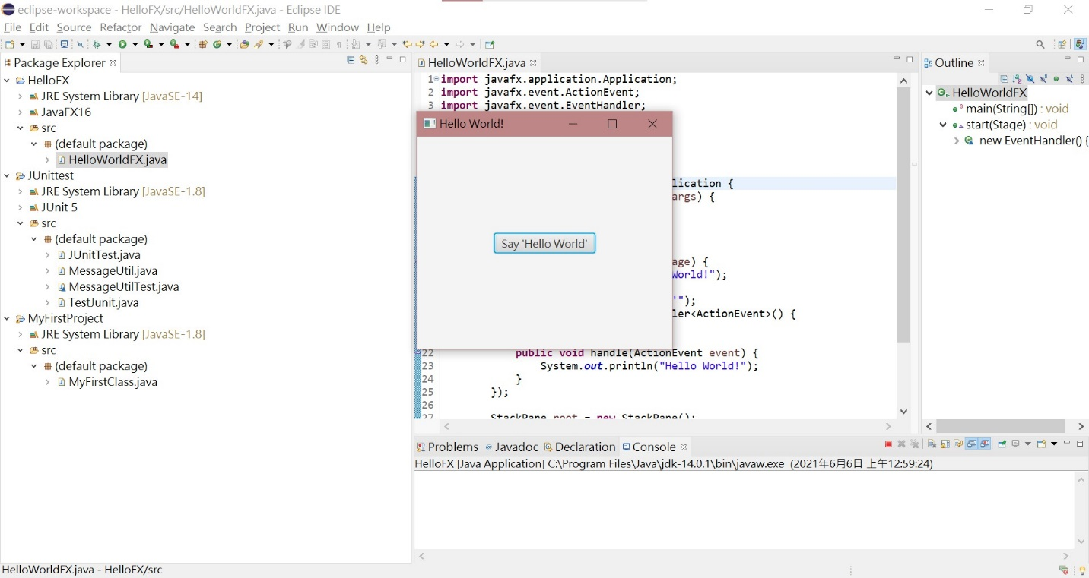

**Lessons Learned** <Provide answers to the questions listed below>**:**

Write about your Learning Experience, highlighting your lessons learned and learning experience from working on this assignment.

What have you learned?

Java is a programming language that I have never learned or touched. During the installation process, I felt that this would be a difficult project. In the first week of the course, I learned how to install Eclipse and other related tasks. I also learned a lot of basic knowledge about Java and the difference between the C language and Java.

What did you struggle with?

During the learning process, I was struggling the most with installing Eclipse and completing quizzes. I found that there are many versions that must be installed or downloaded are not found. I spent a lot of time doing this work. This makes me feel exhausted, I can only find the closest version to install and download. In addition, the quiz is also part of my struggle. When I submit my answer, the system will not tell me where the error is, I can only know correct or incorrect. Sometimes I check repeatedly and still cannot find out where my mistake is. These are the difficulty I struggled in the first week.

What parts of this assignment were you successful with, and what parts (if any) were you not successful with?

I think my only success is to complete most of the work, but my unsuccessful place is to spend too much time on the installation. It took me several days to complete these installations because many unexplainable problems came up during the installation process.

Provide any additional resources/links/videos you used to while working on this assignment.

This link helped me complete this assignment.

**<https://stackoverflow.com/questions/44067738/what-is-the-javafx-runtime>**

**Check List:** <Provide answers to the column Y/N or N/A >**:**

|  |  |  |  |
| --- | --- | --- | --- |
| **#** |  | **Y/N** | **Comments** |
|  | **Assignment files:** |  |  |
|  | * FirstInitialLastName_Assignment0.docx/pdf | **Yes or No** |  |
|  | * Source java files | **Yes or No** |  |
|  | **Program compiles** | **Yes or No** |  |
|  | **Program runs with desired outputs related to a Test Plan** | **Yes or No** |  |
|  | **Documentation file: Screenshots of** |  |  |
|  | * Part1: Setup GitHub | **Yes or No** |  |
|  | * Part 2 -Install JDK, Test java Application from Command Line | **Yes or No** |  |
|  | * Part 3 - Install Eclipse, Test Eclipse Java Application | **Yes or No or N/A** |  |
|  | * Part 4 - Install, Setup, Test Junit Program | **Yes or No or N/A** |  |
|  | * Part 5 - Install, Setup, and Test JavaFX Application. | **Yes or No or N/A** |  |
|  | * Lessons Learned | **Yes or No** |  |
|  | * Checklist is completed and included in the Documentation | **Yes or No** |  |