Binary

In binary (base 2), we use powers of two instead of tens to represent numbers.

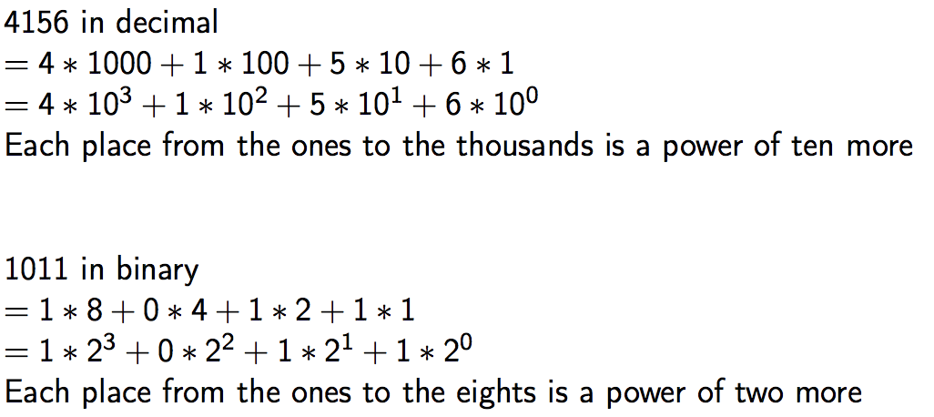



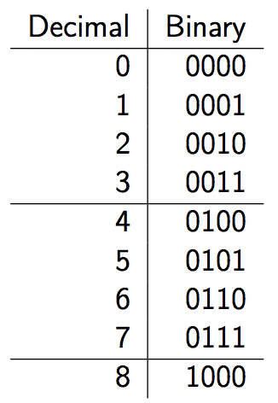

binary-to-decimal

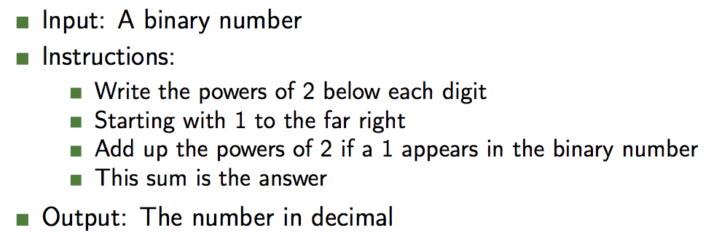

decimal-to-binary

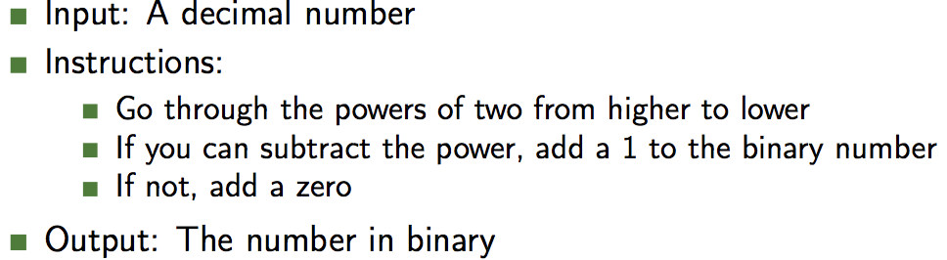

addition

To add binary, just perform normal addition, but instead of carrying the one at 10, carry it at 2.

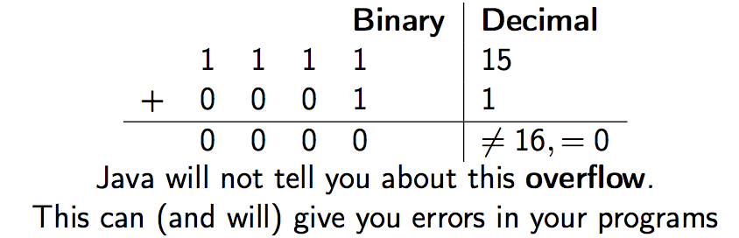

Letters in Java are called **characters**. These characters must also be represented in binary.

Java maps each character to a number, and automatically converts when needed. *(ASCII table)*

*nstead of looking at binary, much easier to look at hexadecimal. Hexadecimal is base 16: 0-9, A-F to represent 0-1.*

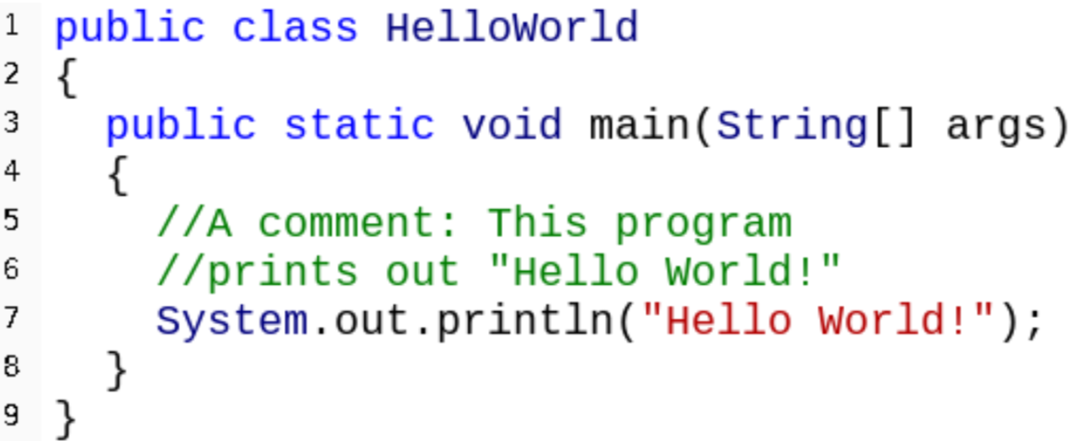

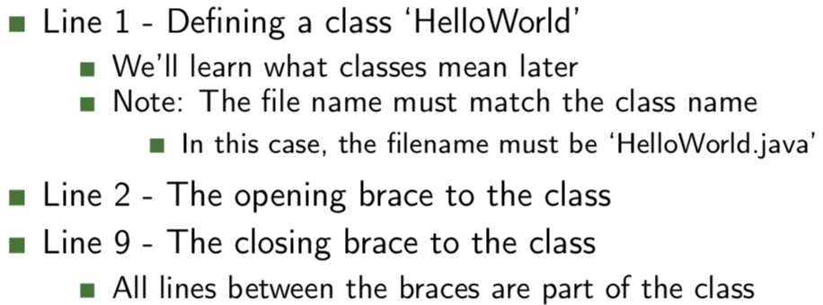

Two steps in Java

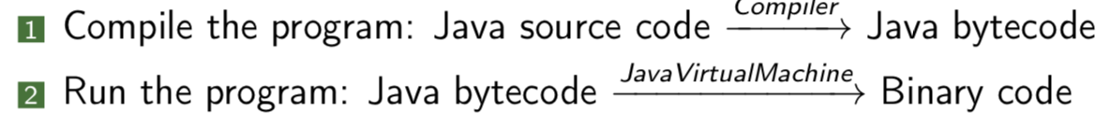

camelcase used in java----expensiveChairPrice

snake-case used in Python----expensive_chair_price