* Loop

A **while statement** repeatedly executes the instructions in the **while block** for as long as the **while condition** is true. (hit *reset* to stop the program)

* Components of iteration

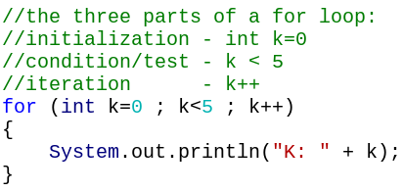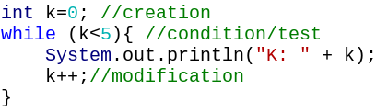

Creation - We create an iteration variable and assign it a starting value

Condition - We define the test for how many times the loop should run

Modification - We change the iteration variable

(Shortcut for k=k+1: k++ / k+=1; Shortcut for k=k-1: k--)

* Blastoff!

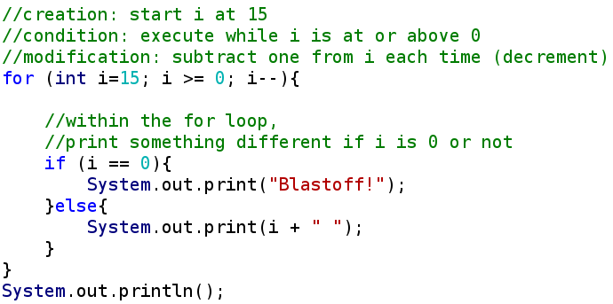



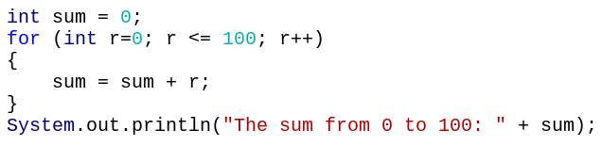

Scope : r doesn’t exist outside the braces

* Prime

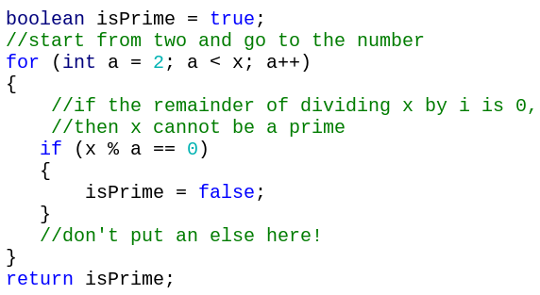

* String Method

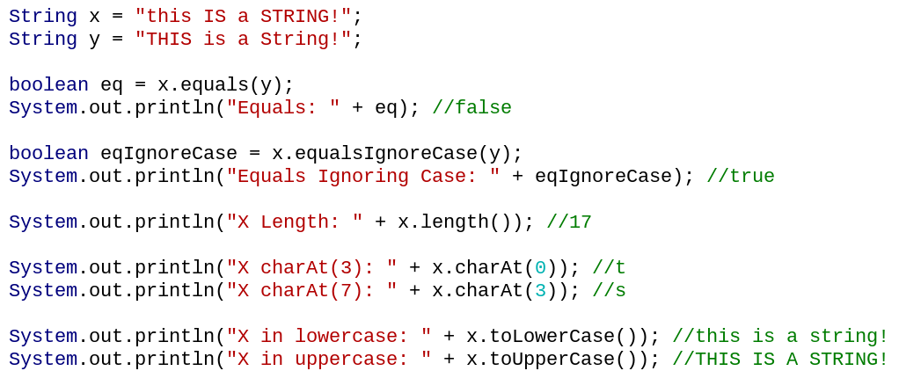

* String Length--------------s.length()

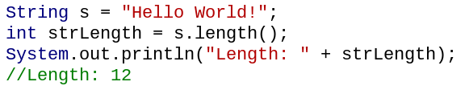

* char

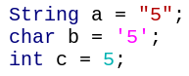 They’re not equal.

* Get the Character--------s.charAt(0)

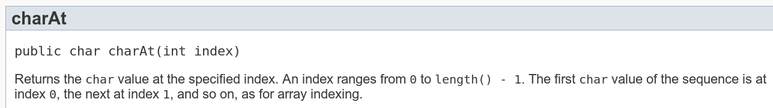

index error

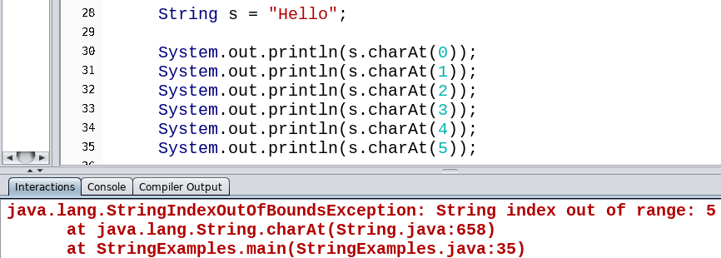

char c = s.charAt(s.length() - 1); is the last character in the String

* Compare chars

We can use == to see if two chars are equal.

We also can compare characters using < and >.

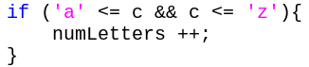 *This test sees if c is a lower-case letter.*

* Reverse Strings

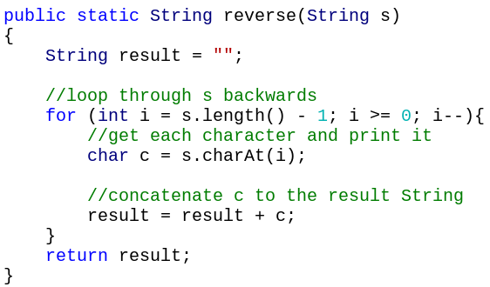

* Converting Binary-to-Decimal

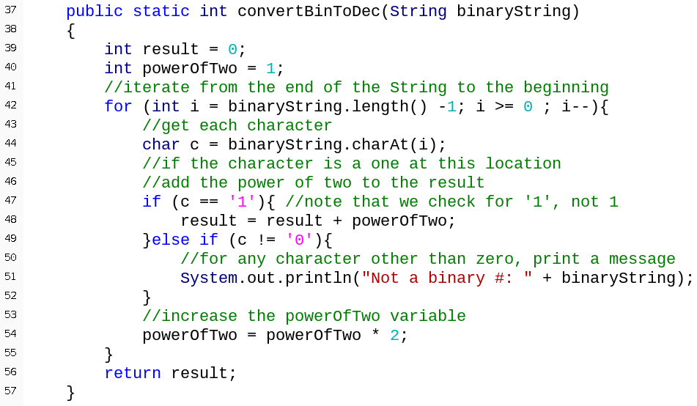

* Both break and continue can only be used within a loop
* Break : Stops the loop immediately

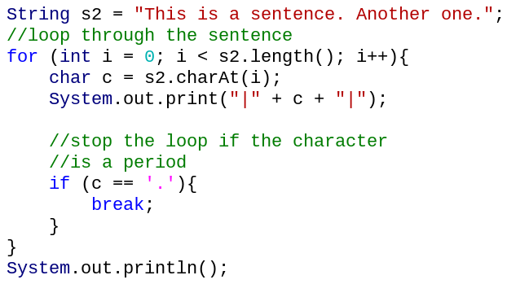

* Continue: Skips the rest of the instructions in the iteration, moves to the next iteration of the loop

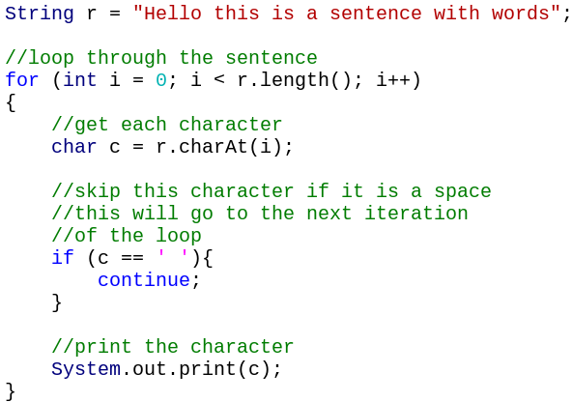

* Nested loop

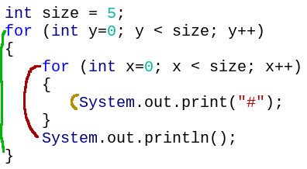

The **outer for loop** has five iterations

The **inner for loop** has five iterations for every iteration of the outer for loop

So the System.out.print statement executes 25 times

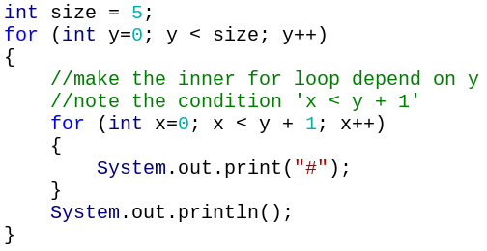 

Coordinate system

