* Logic Error

Instructions are valid, but the result is “wrong”

* the print statement
* debugger
* Style Error

The program is correct, but is hard to understand.

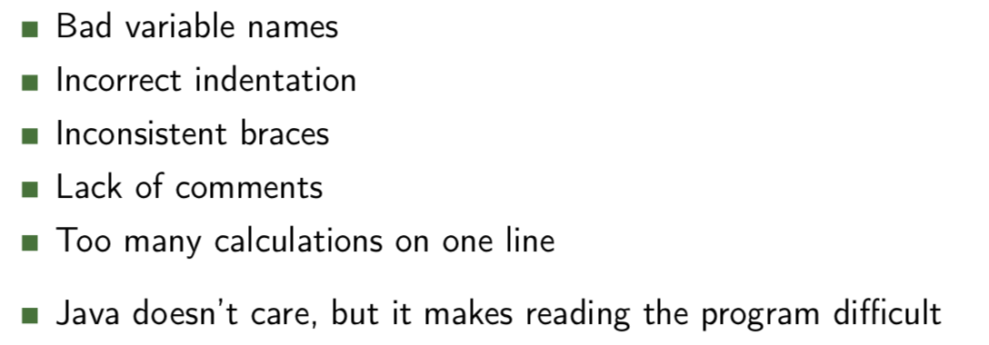

* Compiler Error

Mostly related to variable types, syntax errors, or typos

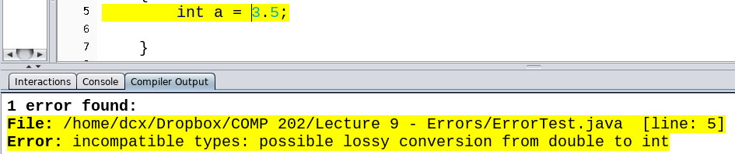

* Run-time Error

Most run-time errors depend on values of variables

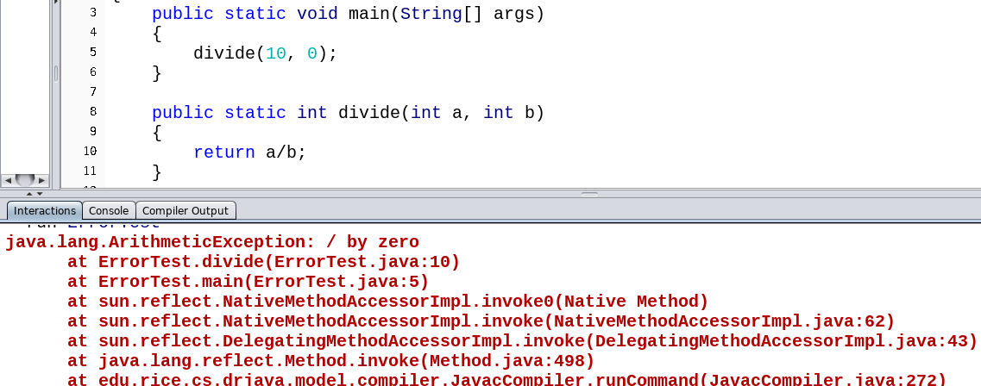

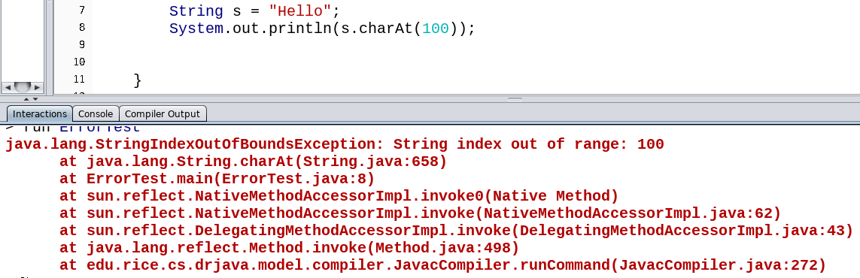

stack trace

The top line is the precise error: StringIndexOutOfBoundsException

The next line is the spot in Java code where the error occurred

The next line is where in your code the error happened - at ErrorTest.main(ErrorTest.java:8)

* There are two ways we can handle **bad values**:

StringIndexOutOfBoundsException

NumberFormatException

ArithmeticException

IllegalArgumentException

ArrayIndexOutOfBoundsException

NullPointerException

* Check for a bad value before we do an operation

Ex: Check for division by zero before doing it

* Try the operation and catch the error
* Try/Catch

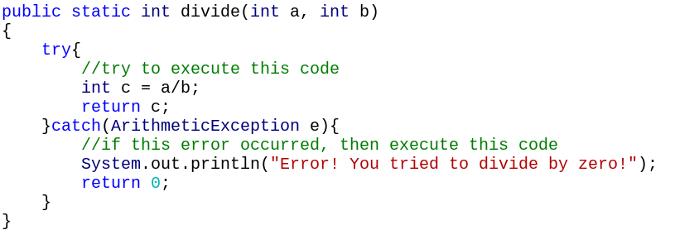

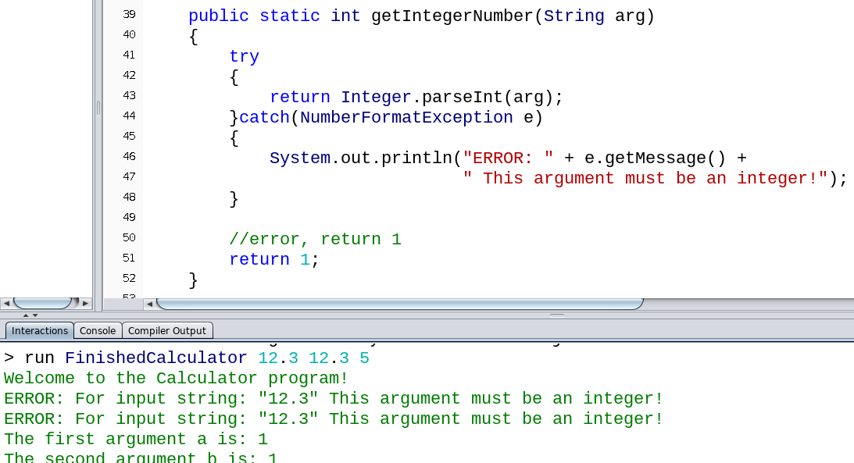

e.printStackTrace();

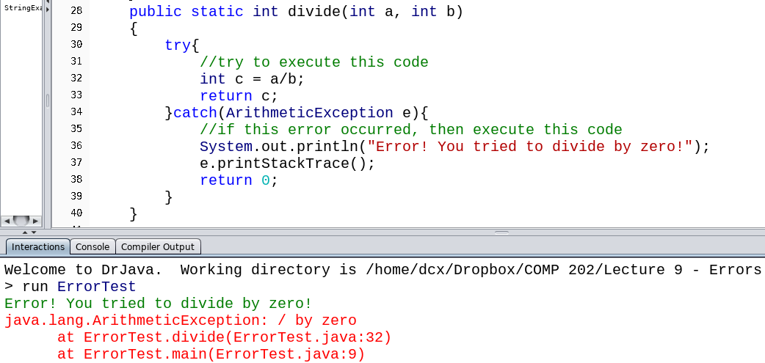

Adds a stack trace for the user to understand the problem

Note that because we caught the Exception, the program can continue

* Throw exceptions

