COMP250-Heap

*Priority Queue (ADT)*

Like a queue, but now we have a more general definition of which element to remove next, namely the one with highest priority.

Assume a set of comparable elements or “keys”.

(Comparable means that there is an ordering, as in the Java Comparable interface.)

* add(element)
* removeMin() //“highest” priority = “number 1” priority

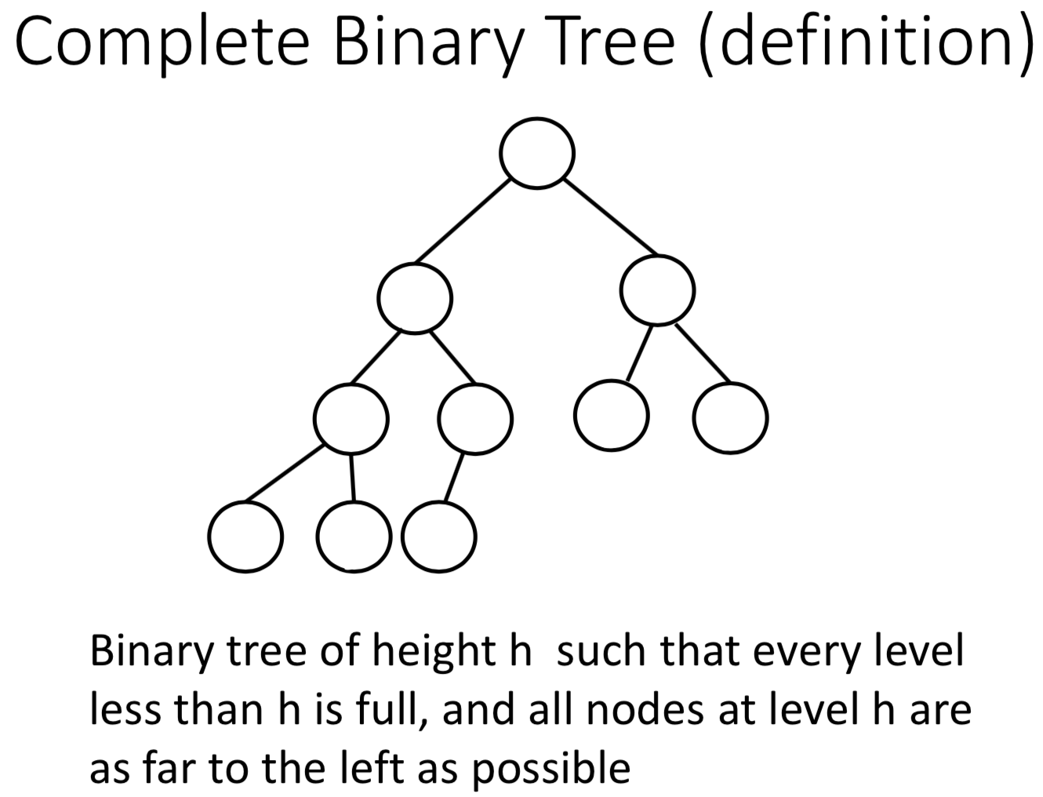 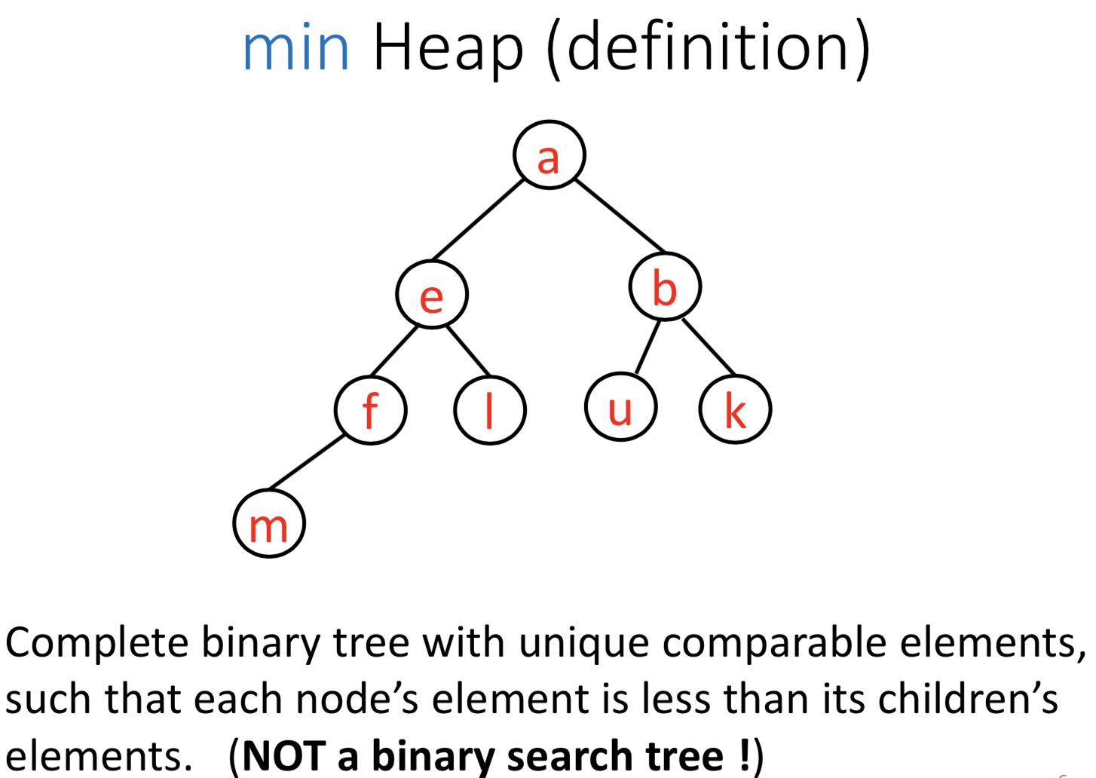

no sibling relationship

* *add(c)*

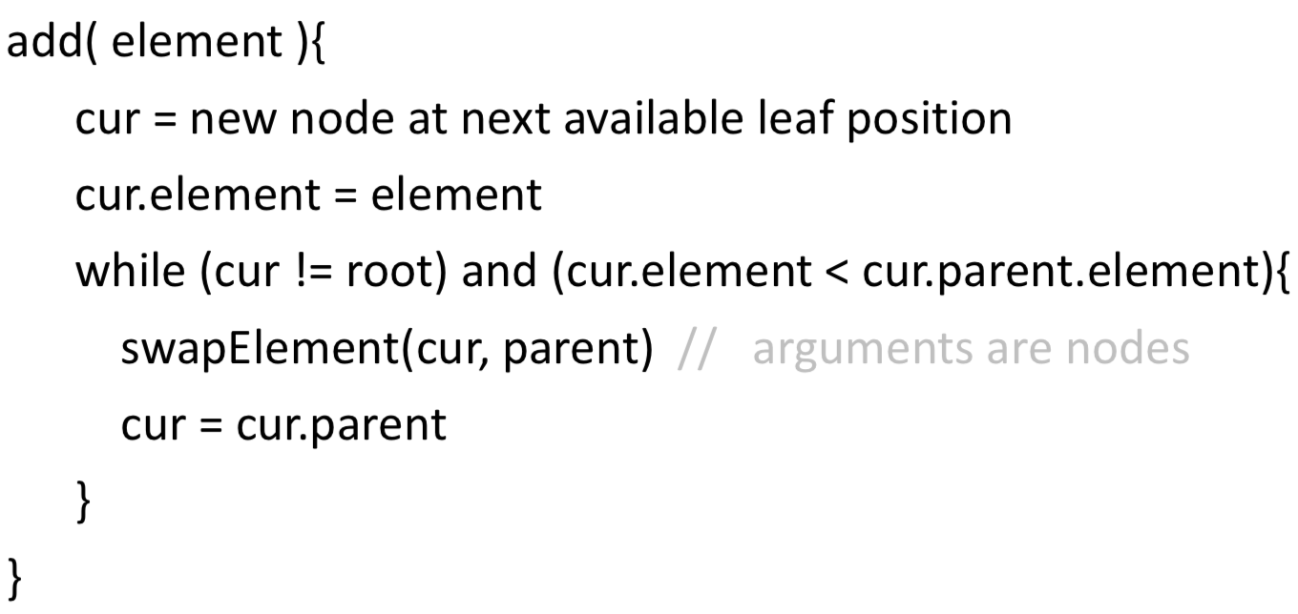

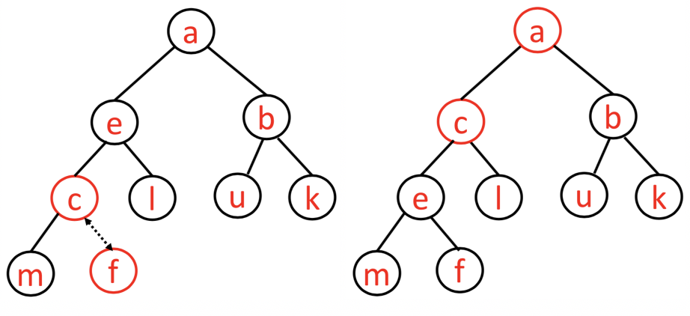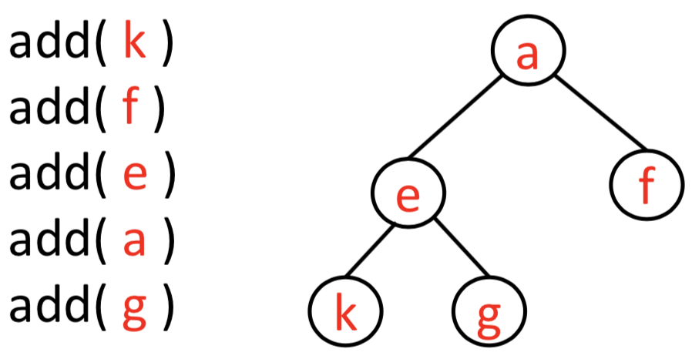

* *removeMin()*

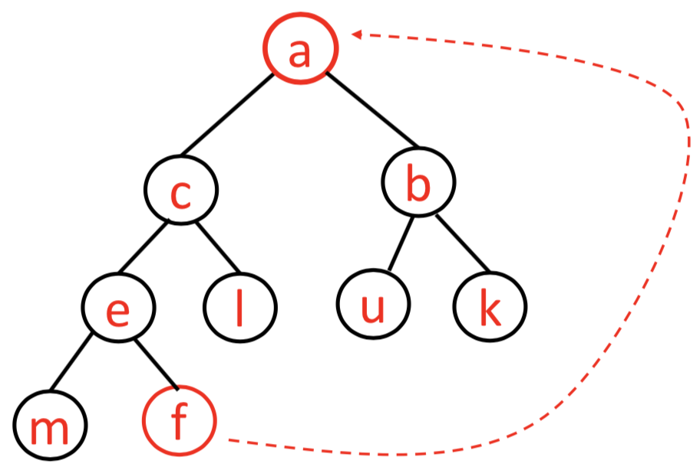 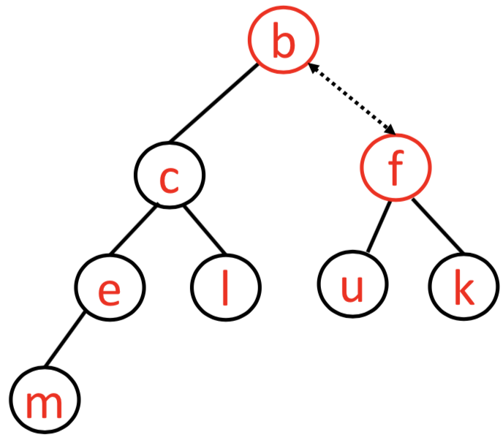

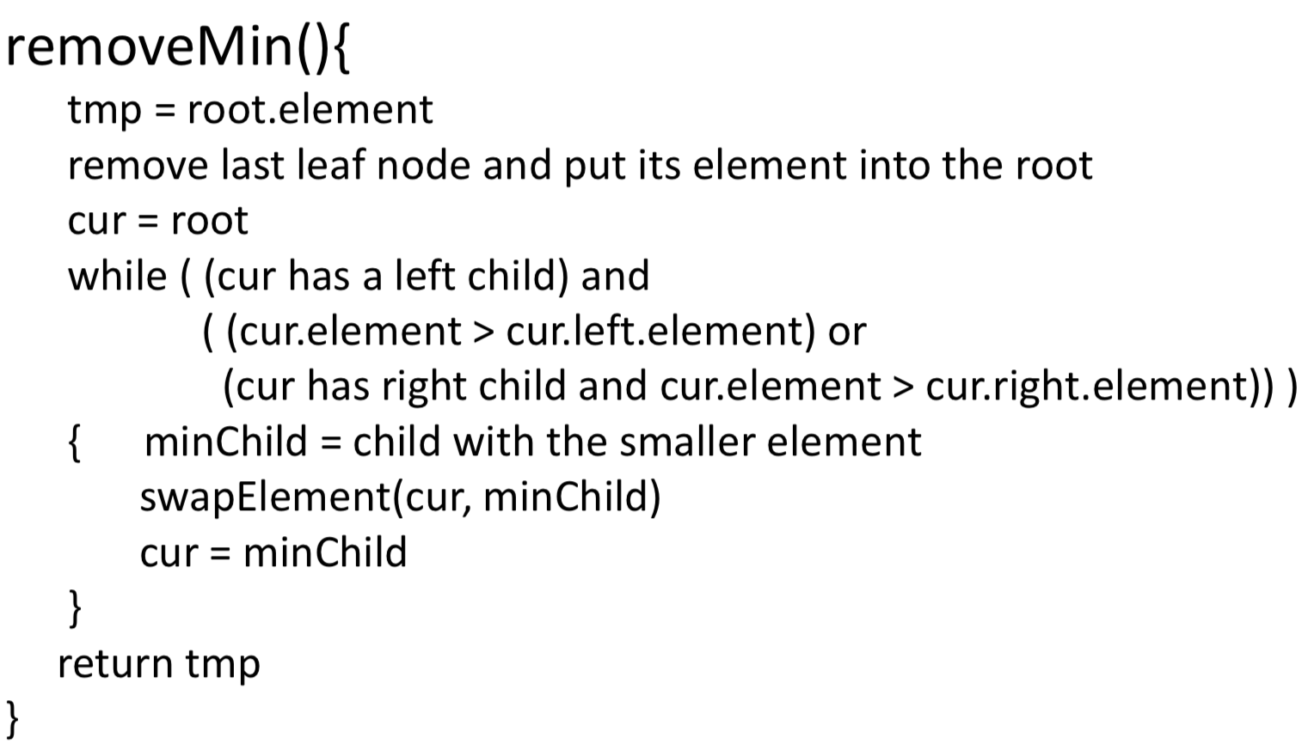

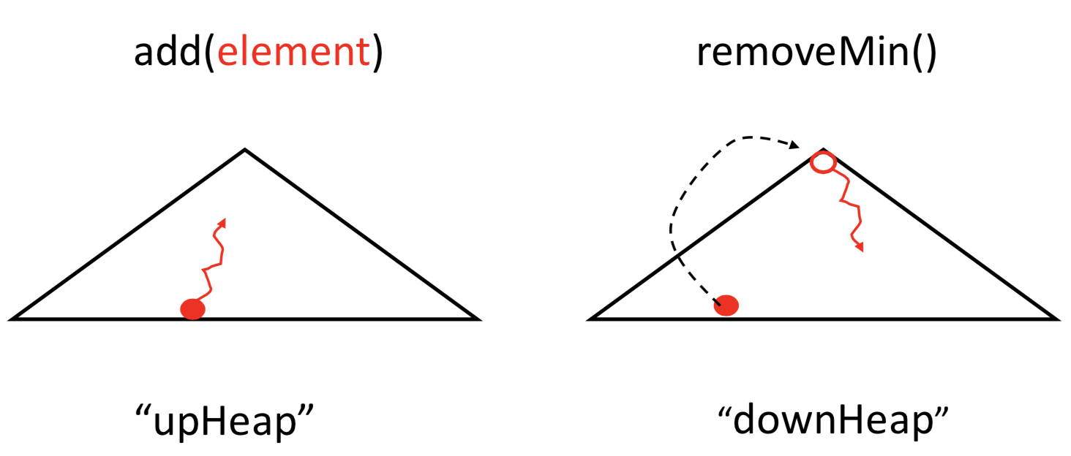

***Heap(array implementation)***

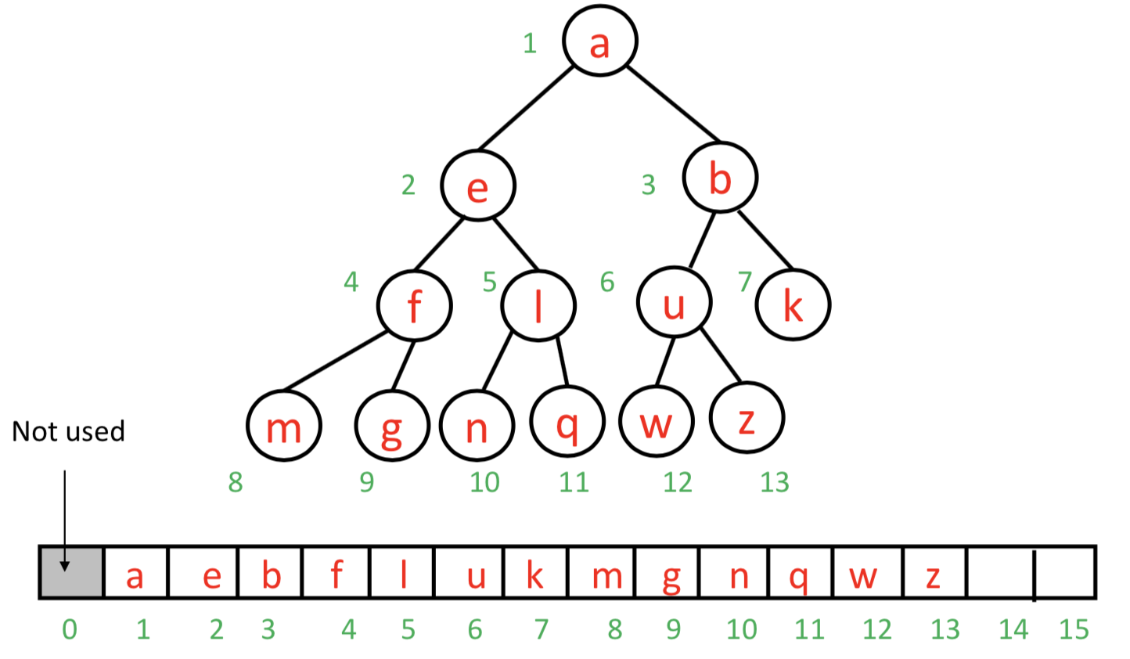

parent = child / 2

left = 2*parent

right = 2*parent + 1

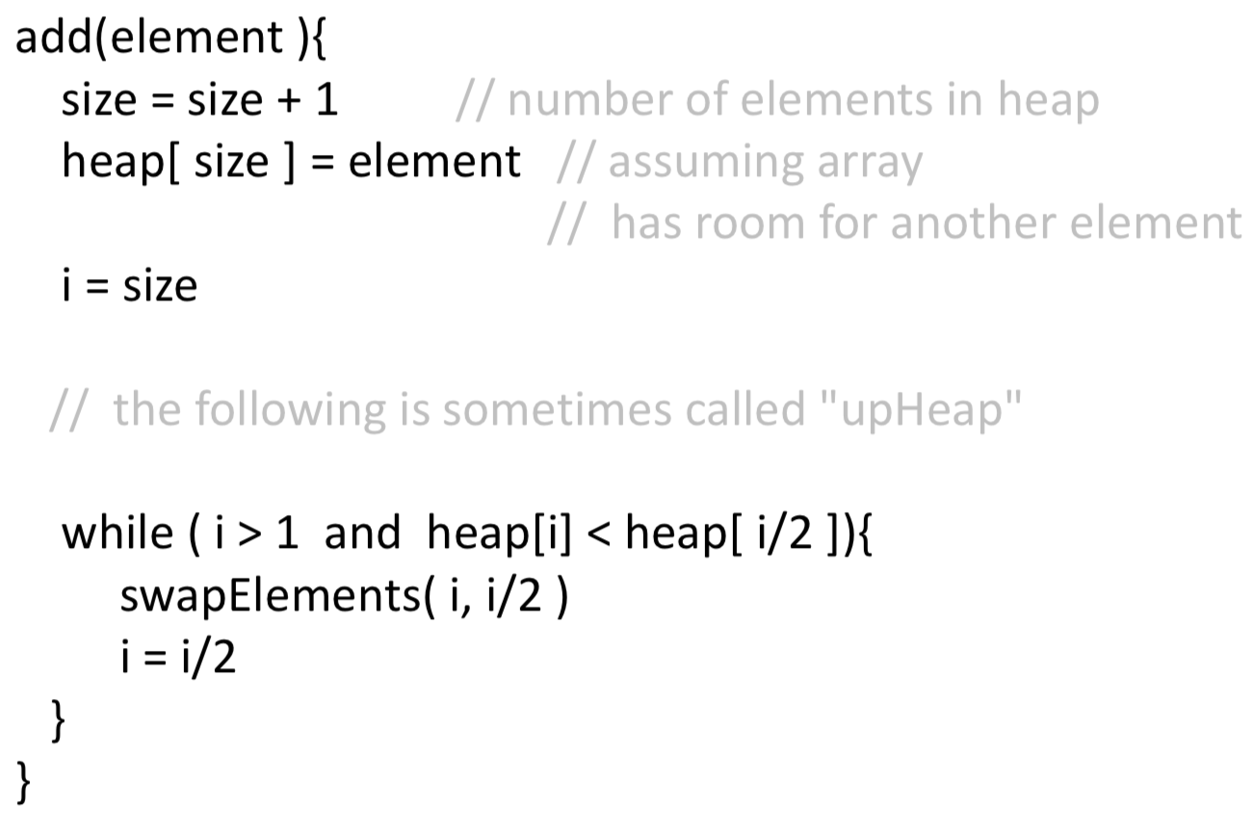

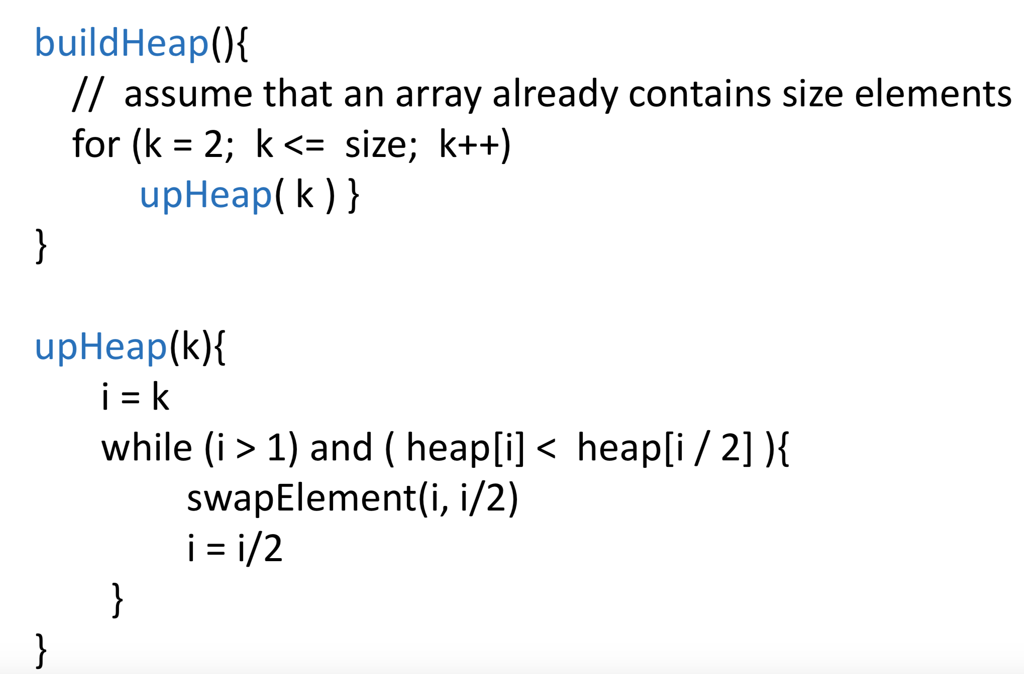

Best case of buildHeap is O(𝑛)

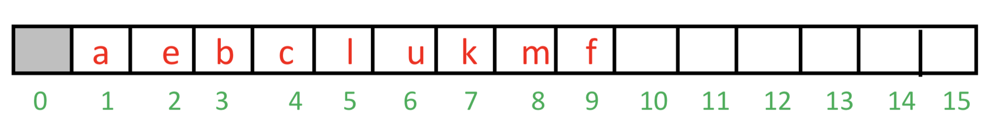

In the best case, the elements happen to already satisfy the heap parent-child ordering constraint, and no swaps are necessary.

Worse case of buildHeap is

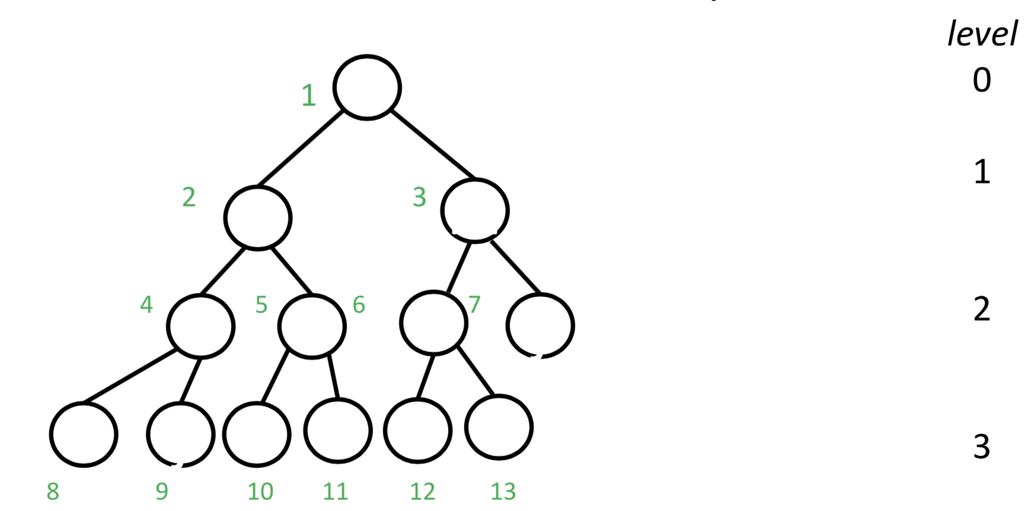

How many upHeap swaps do we need for element 𝑖 ? Element 𝑖 is at level, such that:

2𝑙𝑒𝑣𝑒𝑙 ≤ 𝑖 < 2𝑙𝑒𝑣𝑒𝑙 +1

𝑙𝑒𝑣𝑒𝑙≤ 𝑙𝑜𝑔2𝑖 <𝑙𝑒𝑣𝑒𝑙+1

Thus, 𝑙𝑒𝑣𝑒𝑙 = 𝑓𝑙𝑜𝑜𝑟( 𝑙𝑜𝑔2 𝑖 )

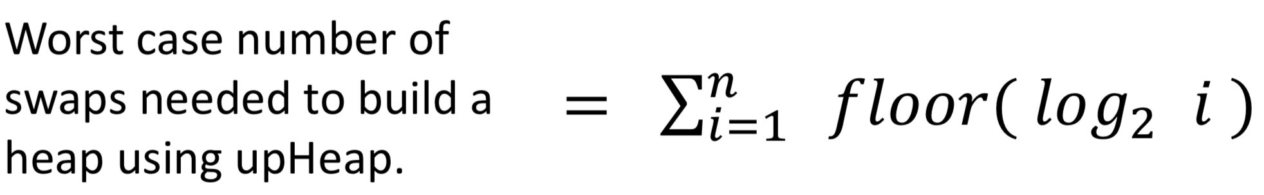

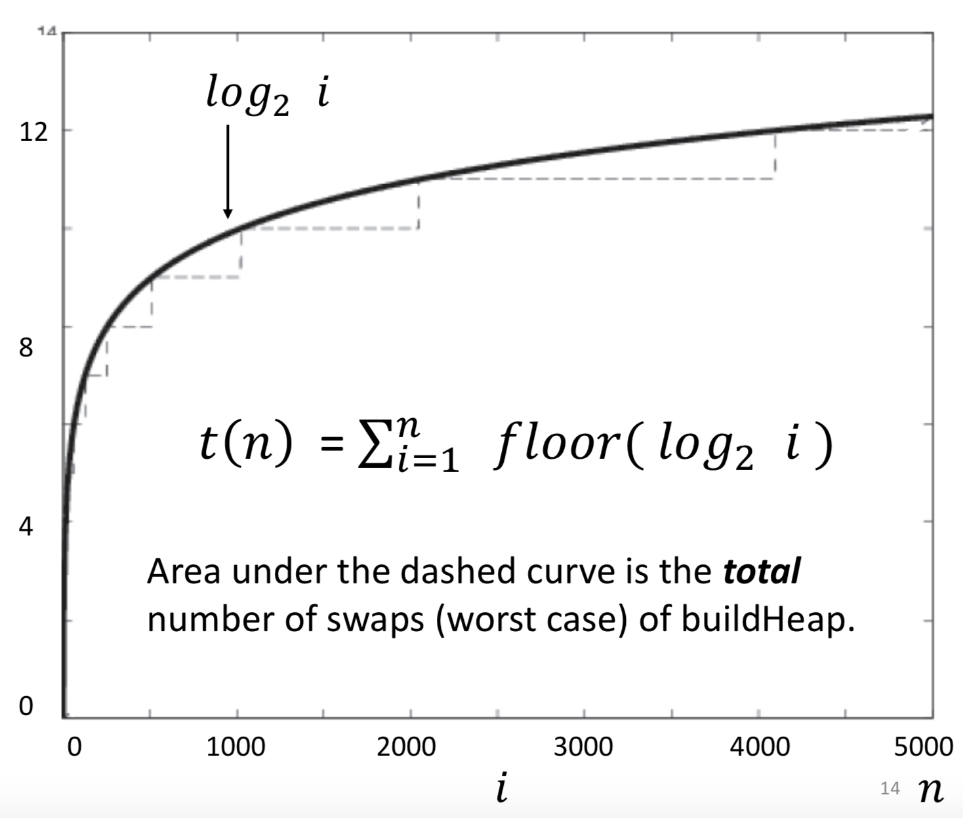

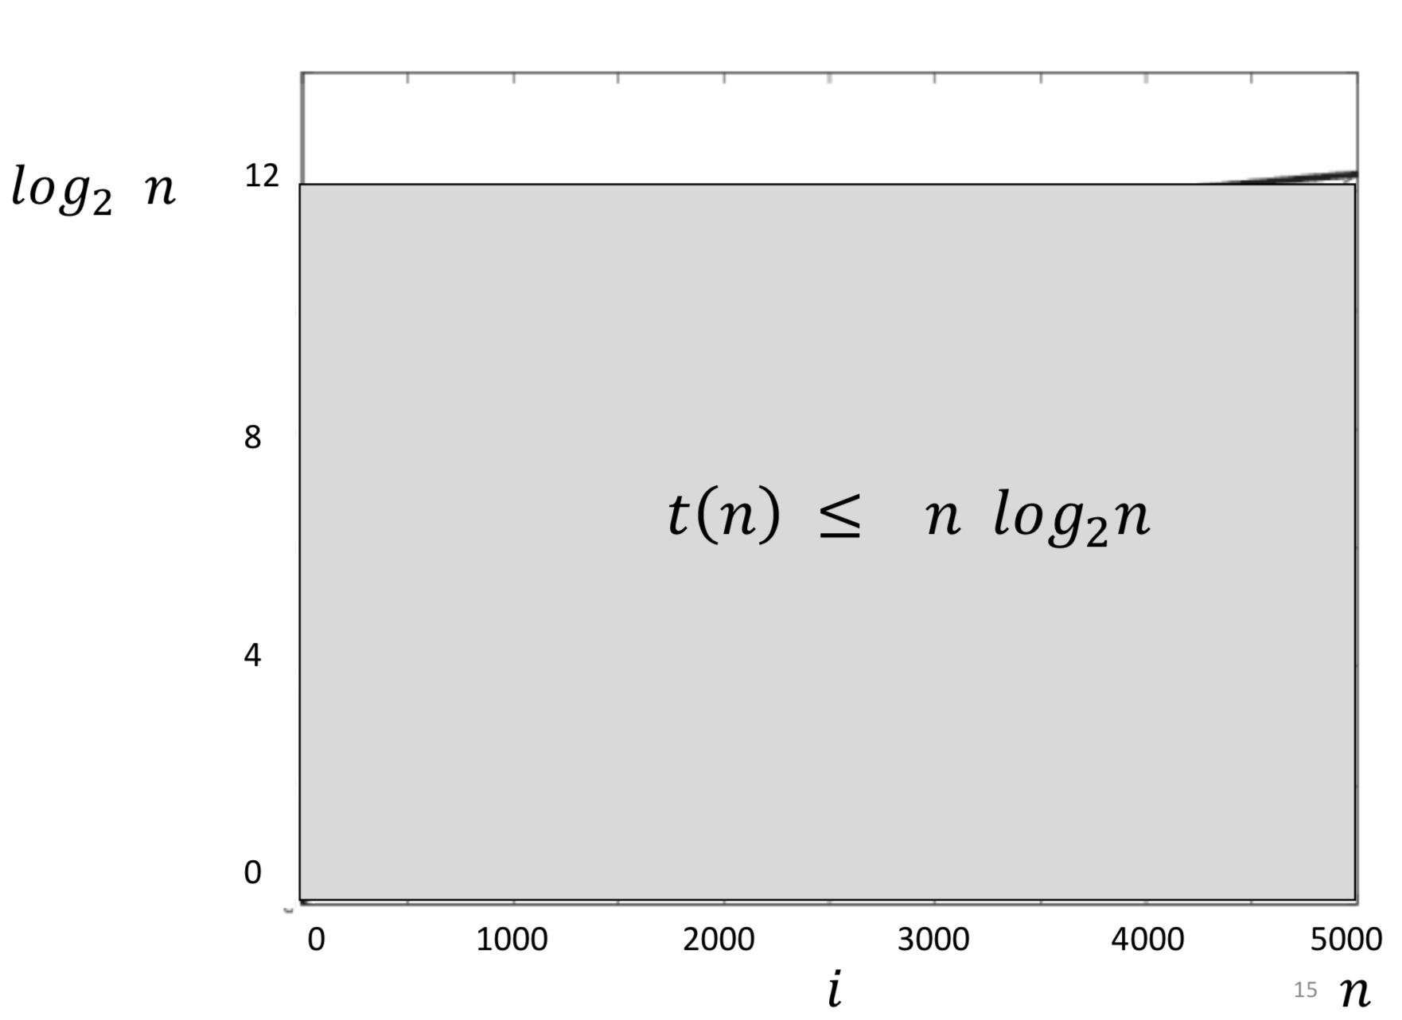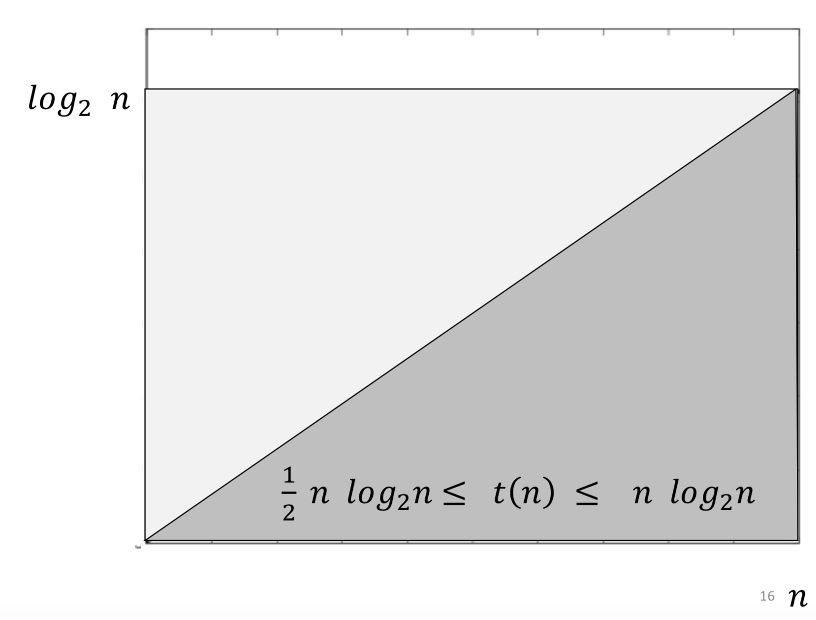

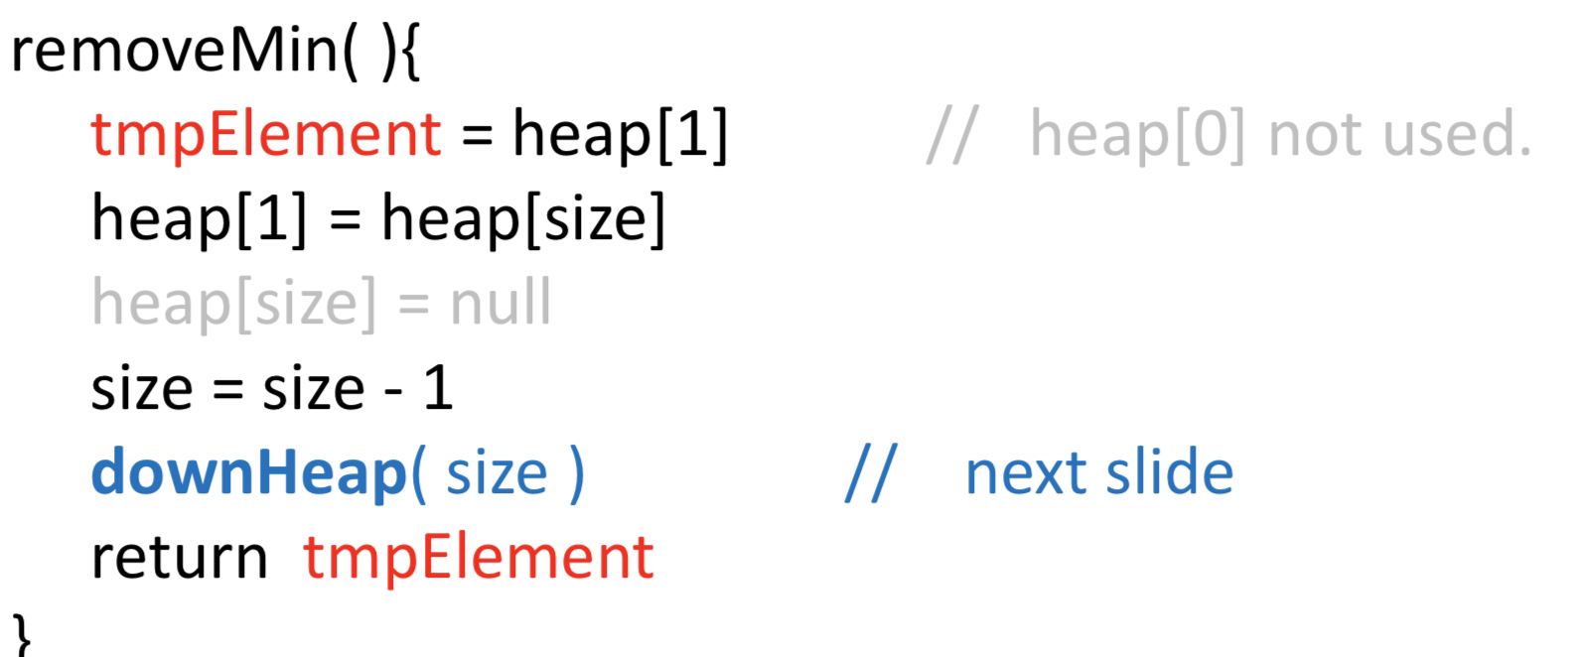

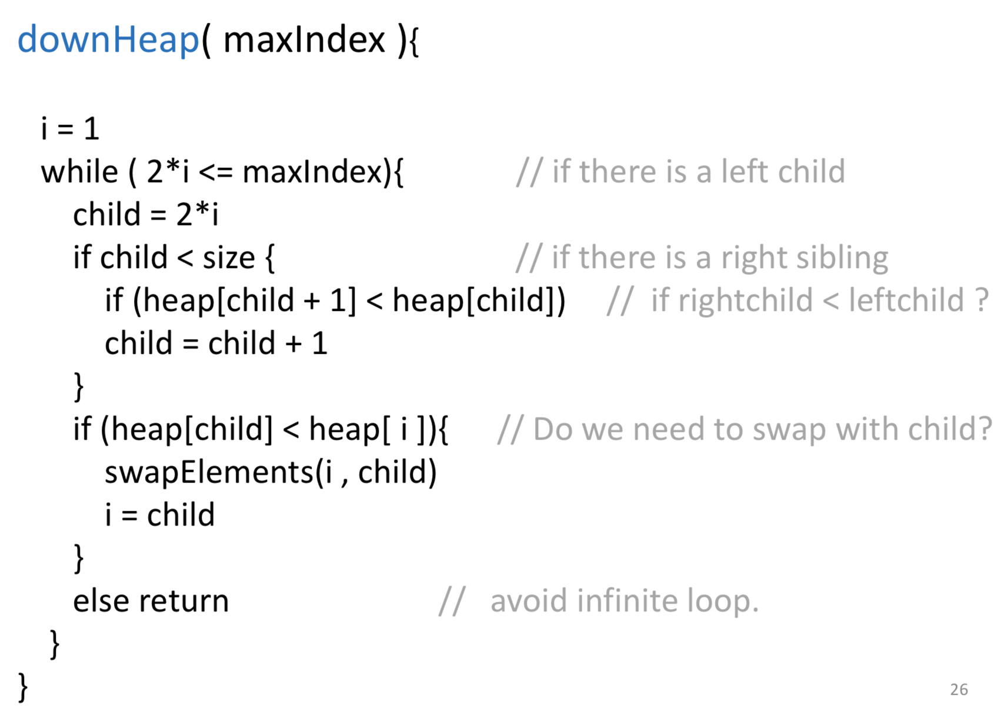

Heapsort

Given a list with 𝑛 = size elements: Build a heap.

Call removeMin() 𝑛 times.

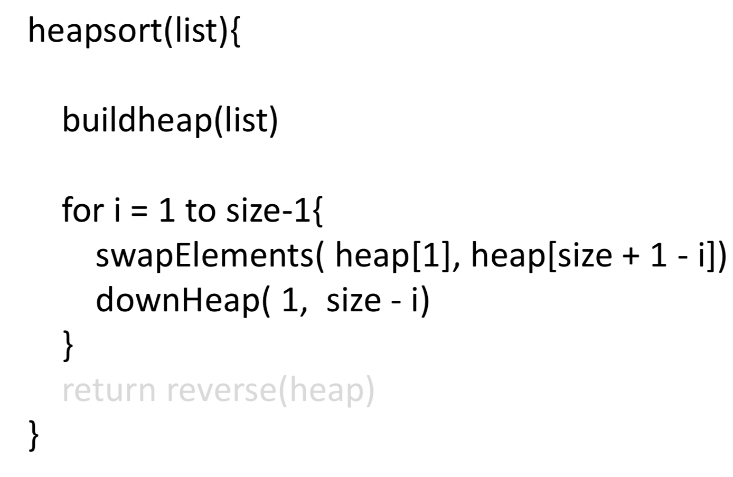

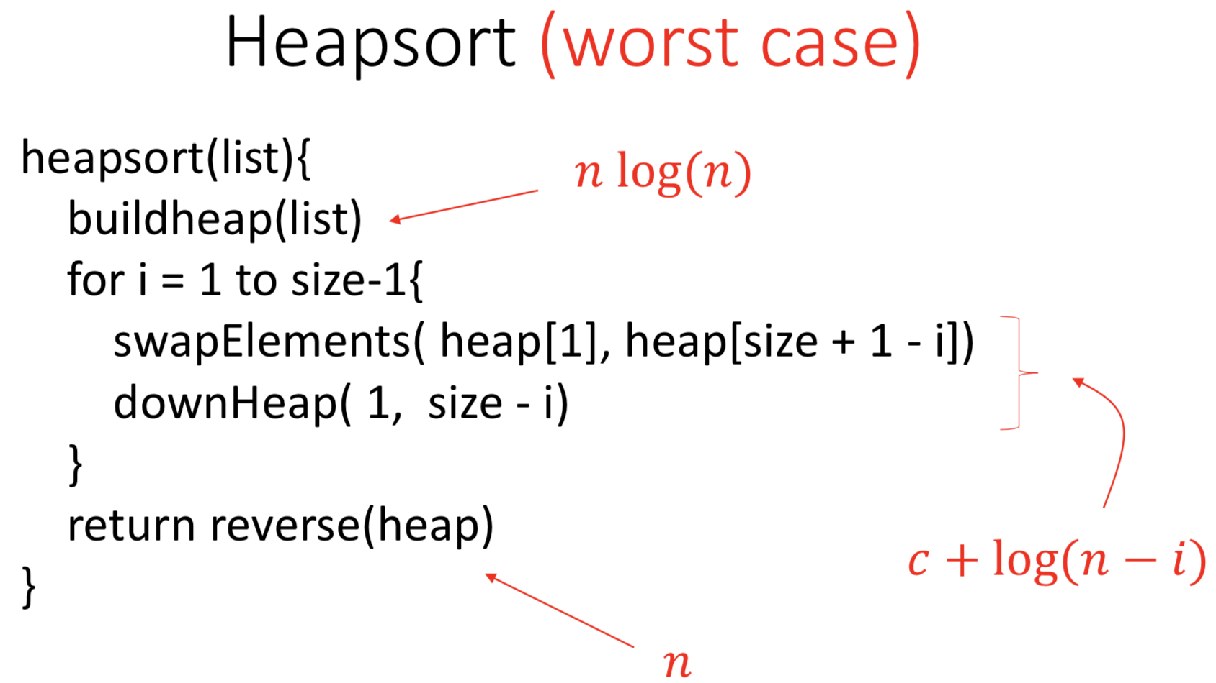

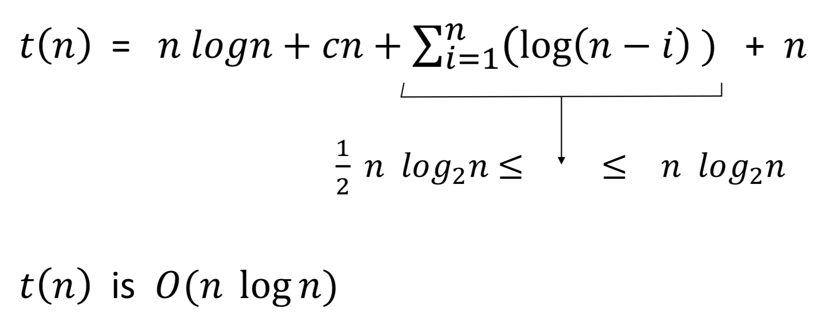

don’t about base(constant)