Chapter 5

Unit Testing

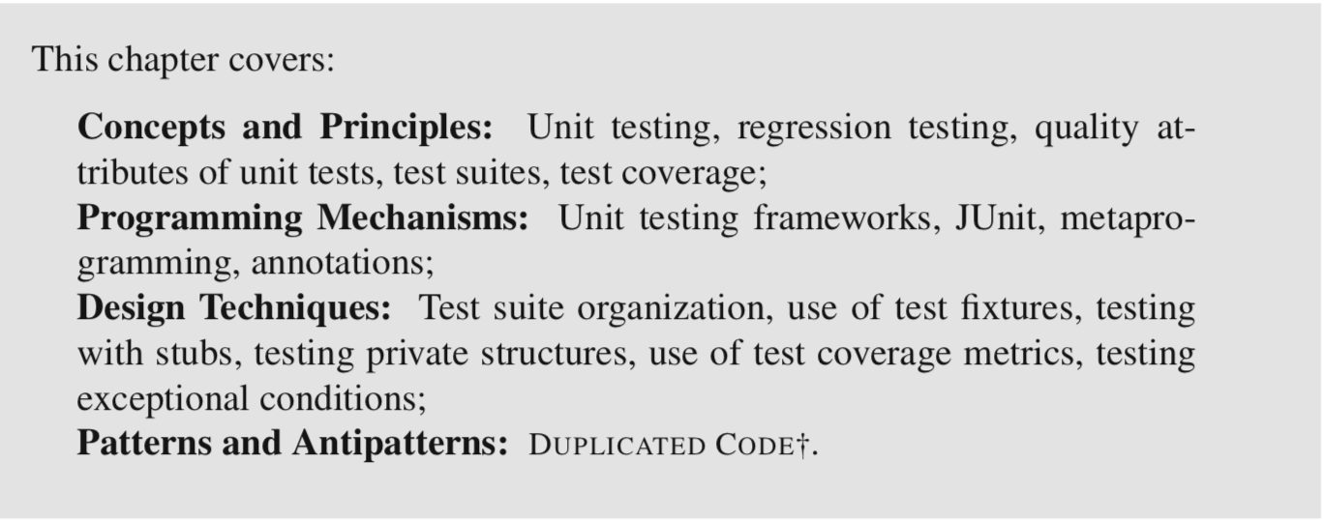

5.1 Intro

A unit test consists of one or more executions of a *unit under test (UUT*) with some input data and the comparison of the result of the execution against some *oracle*. A UUT is whatever piece of the code we wish to test in isolation. UUTs are often methods, but in some cases they can also be entire classes, initialization statements, or certain paths through the code. The term oracle designates the correct or expected result of the execution of a UUT.

The comparison of the result of executing the UUT with the oracle is also called an *assertion*.

e.g. Tthe statement: Math.abs(5) == 5; technically qualifies as a test. Here the UUT is the library method Math.abs(int), the input data is the integer literal 5, and the oracle is, in this case, also the value 5.

When testing **non-static** methods, it is important to remember that the input data includes the *implicit argument* (the object that receives the method call).

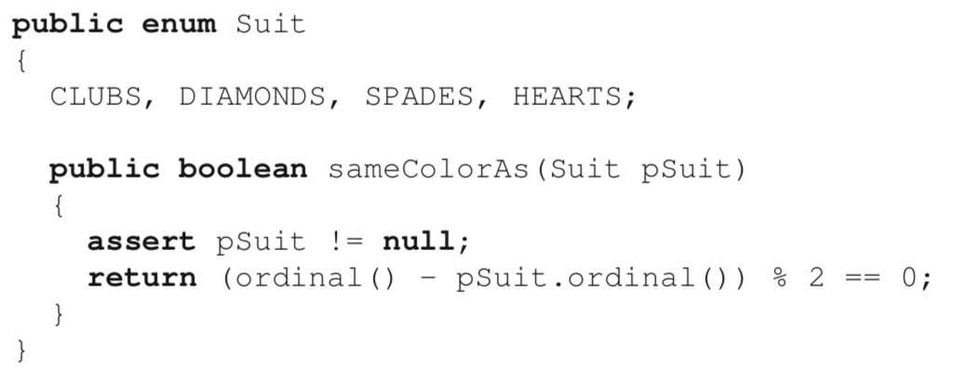

This main method qualifies as a unit test: it includes a UUT (Suit.sameColorAs), some input data (CLUBS and HEARTS), an oracle (**false**), and an assertion that compares the result with the oracle.

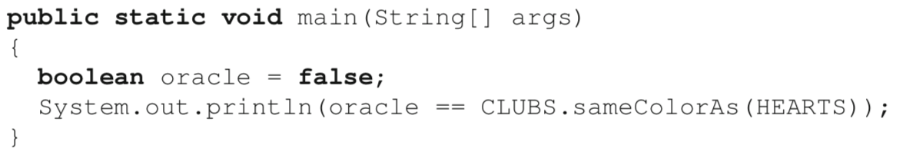

implicit argument

If we reorder the suits as CLUBS, SPADES, DIAMONDS, HEARTS; In this case, running the test again will immediately reveal a bug introduced by the fact that sameColorAs relies on an undocumented and unchecked assumption about the order of enumerated values.

This example illustrates the second major benefit of unit tests: in addition to helping detect bugs in new code, they can also check that tested behavior that used to meet some specific expectation still does meet that expectation even after the code changes. Running tests to ensure what was tested as correct still is (or for detecting new bugs caused by changes) is called regression testing.

Note: Unit testing cannot verify code to be correct! When a test passes, it only shows that the one specific execution of the code that is being tested behaves as expected.

5.2 Unit Testing Framework Fundamentals

The major constructs supported by testing frameworks are *test cases, test suites, test fixtures* and *assertions.*

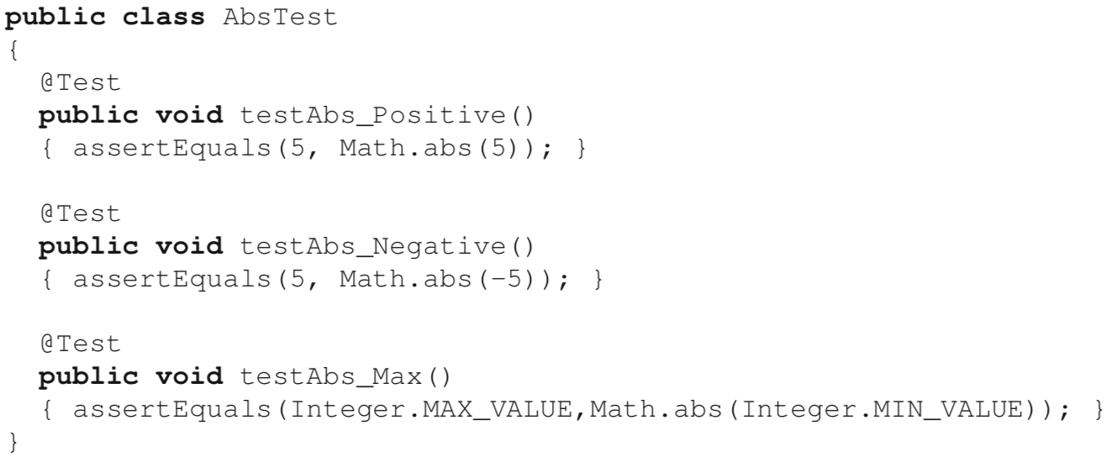

The @Test *annotation instance* indicates that the annotated method should be run as a unit test. The code example above shows a *test class* that defines three tests, all intended to test the library method Math.abs(int).

To constitute proper tests, test methods should contain at least one execution of a unit under test. The way to automatically verify that the execution of a unit under test has the expected effect is to execute various calls to *assert methods*. Assert methods are different from the **assert** statement in Java. They are declared as static methods of the class org.junit.Assert and all they do is basically verify a predicate and, if the predicate is false, report a *test failure*. The JUnit framework includes a graphical user interface component called a *test runner*, which automatically scans some input code, detects all the tests in the input, executes them, and then reports whether the tests passed or failed.

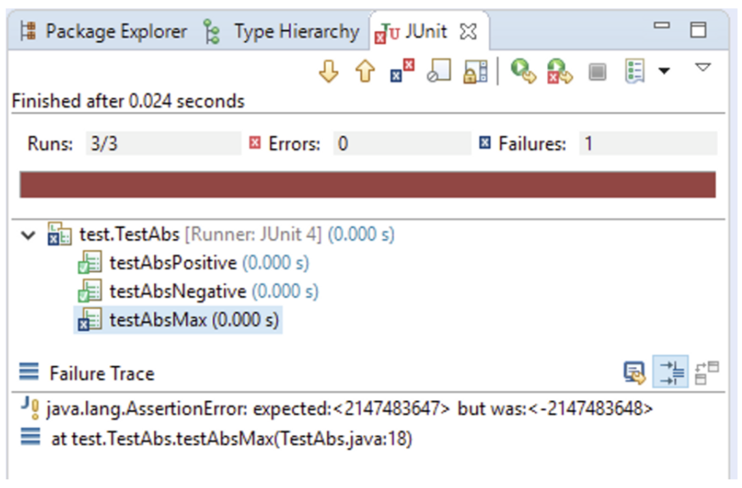

[Javadoc]

Note that if the argument is equal to the value of Integer.MIN VALUE, the most negative representable int value, the result is that same value, which is negative.

The reason for this design choice is imposed by physical constraints: because one bit of information is used to encode 0, there is simply no space left available to encode the absolute value of Integer.MIN_VALUE in a 32-bit int type.

5.3 Organizing Test Code

A collection of tests for a project is known as a *test suite*.

By default, a project’s test suite consists of all the unit tests for the production code in the project. However, for various reasons, it may be desirable to run only a subset of different tests at different times (for example, to focus on a specific feature, or save some time).

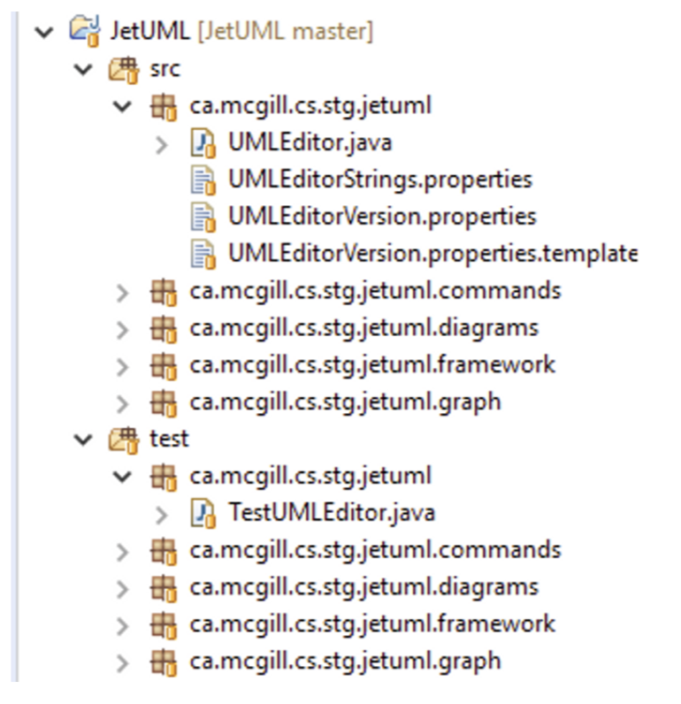Common approaches:

* One test class per project class, where the test class collects all the tests that test methods or other usage scenarios that involve the class.
* Locate all the testing code in a different source folder with a package structure that mirrors the package structure of the production code.

[The rationale for this organization is that in Java classes with the same package name are in the same *package scope* independently of their location in a file system. This means that classes and methods in the test package can refer to non-public (but non-private) members of classes in the production code, while still being separated from the production code.]

5.4 Metaprogramming

In the previous section, we saw that to mark a method as a test, we annotate it with the string @Test. The unit testing framework can then rely on this annotation to detect which methods are tests, and then proceed to execute these methods as part of the execution of the test runner. This general approach, employed by most unit testing frameworks, is a bit special in that in requires the code to manipulate other code. Specifically, the testing framework first scans the code to detect tests, and then executes the code, without having any explicit code for calls to test methods.

This strategy is an illustration of a general programming feature called metaprogramming. The idea of metaprogramming is to *write code that operates on a representation of a program’s code*

In Java, metaprogramming is called reflection, and library support for metaprogramming features is available through the class java.lang.Class and the package java.lang.reflect.

**Introspection**

The most basic metaprogramming task is to obtain a *reference* to an object that represents a piece of code to learn about it, a procedure called introspection. In Java, the class Class<T> is the main access point for metaprogramming.

1. forName library method

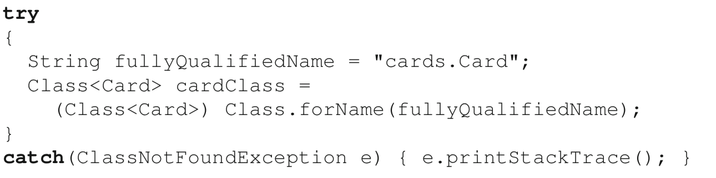

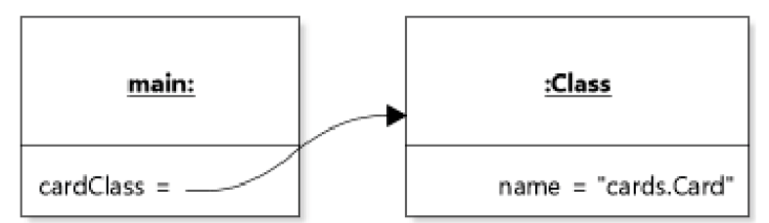The call to Class.forName returns a reference to an instance of class Class that represents class Card

Note: any string can be supplied as argument to Class.forName

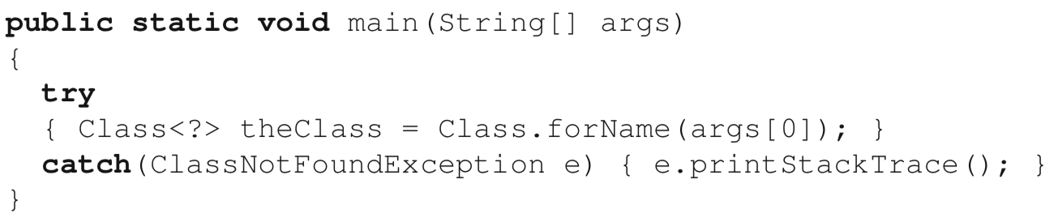

*type wildcard* as the instance of the type parameter in the type declaration of the variable that receives the reference supplied by forName.

1. class literals

In Java, a *class literal* is a literal expression that consists of the name of a class followed by the suffix .class, and that refers to a reference to an instance of class Class that represents the class named before the suffix. So, Card.class refers to the instance of class Class that represents class Card. Because, in the case of class literals, the argument T to the type parameter of Class<T> is guaranteed to be known at compile time, we can include it in the variable declaration. Class literals are the least brittle way to obtain a reference to an instance of class Class, but they require that we know the exact class to instrospect at compile time.

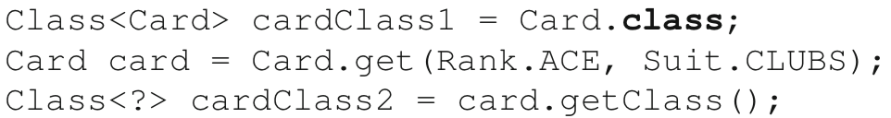

1. an instance of the class of interest.

It is possible to call method getClass() on any object in a Java program, and the method will return a reference to an instance of class Class that represents the run-time type of the object. Because of polymorphism, this type is not known at compile time, so in this case also we have to use the *type wildcard* in the declaration of the variable. However, because any call to getClass() is guaranteed to return a valid reference to an instance of Class, the method does not declare to throw an exception.



<Property of class Class>

Its instances are unique. Indeed, class Class has no accessible constructor, and its instances can be considered to be unique flyweight objects.

With metaprogramming, we can introspect any class, including class Class. This may at first seem contrived, but it is actually not a special case: class Class is just another class.



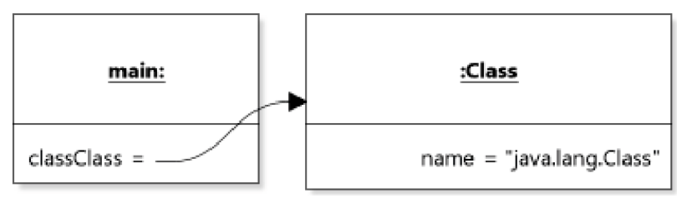

Other usages of class Class

// prints the name of all the methods declared in class String. [class Method ]

// Similar classes exist to represent constructors (Constructor) and fields (Field) ]

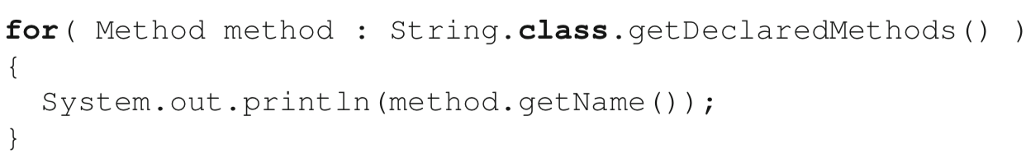

**Program Manipulation**

In Java it is possible to use metaprogramming features to *change the accessibility of class members, set field values, create new instances of objects, and invoke methods.*

Assuming that our implementation of class Card is a realization of the FLY- WEIGHT design pattern and has a private constructor, we will use metaprogramming to “cheat” the pattern and create a duplicate ace of clubs.

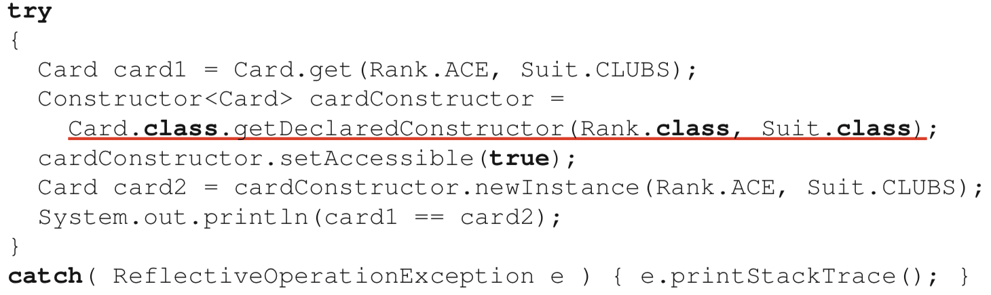

a new instance of the declaring class of the constructor *represented* by the Constructor instance, as opposed to a new instance of class Constructor

a reference to an instance of class Constructor that represents the (private) constructor of class Card

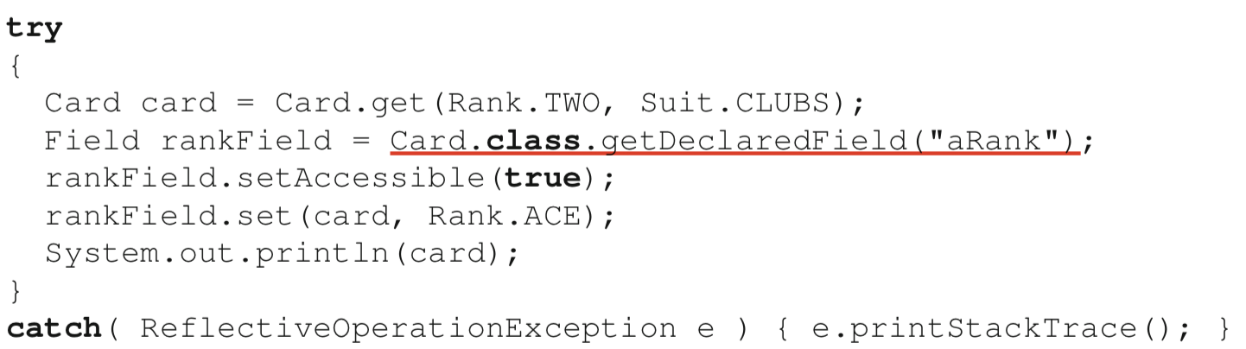

Because rankField represents a *field* of class Card, as opposed to an *instance* of the class, the call to set needs to know on *which instance* the field should be as- signed a value. Thus, the first argument to set is the instance of Card on which we want to assign a new value to the field aRank, and the second argument is the actual value we want to assign.

**Program Metadata**

With metaprogramming, it is possible for code to operate not only on data that consists of code elements (e.g., classes, methods, fields), but also on metadata about these code elements.

Java provides a system of annotations that can be attached to various code locations. In Java, an annotation type is declared similarly to an interface, for example:



Then, *annotation instances* can be added to the code, in the form @Test. The main advantage of annotations in Java is that they are typed and checked by the compiler. The @Test annotation used to flag unit tests in JUnit is thus a type annotation provided by the JUnit library, and its use is checked by the compiler. For example, writing @test (with a lowercase ‘t’) will result in a compilation error.

5.5 Structuring Tests

* **Fasts**. Unit tests are intended to be run often, and in many cases within a programming-compilation-execution cycle. For this reason, whatever test suite is executed should be able to complete in the order of a few seconds. Otherwise, developers will be tempted to omit running them, and the tests will stop being useful. This means that unit tests should avoid long-running operations such as intensive device I/O and network access, and leave the testing of such function- ality to tests other than unit tests. These could include, for example, acceptance tests or integration tests.
* **Independent**. Each unit test should be able to execute in isolation. This means that, for example, one test should not depend on the fact that another test executes before to leave an input object in a certain state. First, it is often desirable to ex- ecute only a single test. Second, just like code, test suites evolve, with new tests being added and (to a minimum extent) some tests being removed. Test indepen- dence facilitates test suite evolution. Finally, JUnit and similarly designed testing frameworks provide no guarantee that tests will be executed in a predictable order. In practice, this means that each test should start with a fresh initialization of the state used as part of the test.
* **Repeatable**. The execution of unit tests should produce the same result in different environments (for example, when executed on different operating systems). This means that test oracles should not depend on environment-specific proper- ties, such as display size, CPU speed, or system fonts.
* **Focused**. Tests should exercise and verify a slice of code execution behavior that is as narrow as reasonably possible. The rationale for this principle is that the point of unit tests is to help developers identify faults. If a unit test comprises 500 lines of code and tests a whole series of complex interactions between objects, it will not be easy to determine what went wrong if it fails. In contrast, a test that checks a single input on a single method call will make it easy to home in on a problem. Some have even argued that unit tests should comprise a single assertion. My opinion is that in many cases this is too strict and can lead to inefficiencies. However, tests should ideally focus on testing only *one aspect of one unit under test*. If that unit under test is a method, we can refer to it as the focal method for the test.
* **Readable**. The structure and coding style of the test should make it easy to iden- tify all the components of the test (unit under test, input data, oracle), as well as the rationale for the test. Are we testing the initialization of an object? A special case? A particular combination of values? Choosing an appropriate name for the test can often help in clarifying its rationale.

For example, let us write some unit tests for a method canMoveTo of a hypothetical class FoundationPile that could be part of the design of the Solitaire example application. The method should return true only if it is possible to move the input pCard to the top of the pile that an instance of the class represents. According to the rules of the game, this is only possible if the pile is empty and the input card is an ace, or if the input card is of the same suit as the top of the pile, and of a rank immediately above the top of the pile (e.g., you can only put a three of clubs on top of a two of clubs).

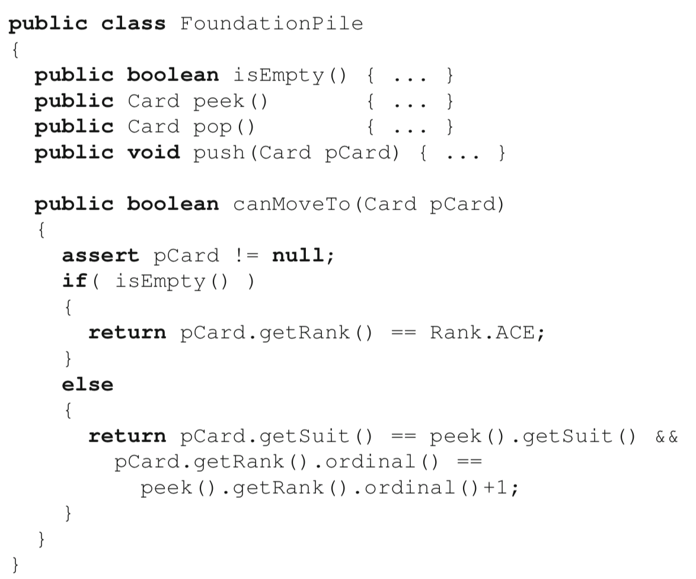

As our first test, we will keep things small and only test for the case where the pile is empty:

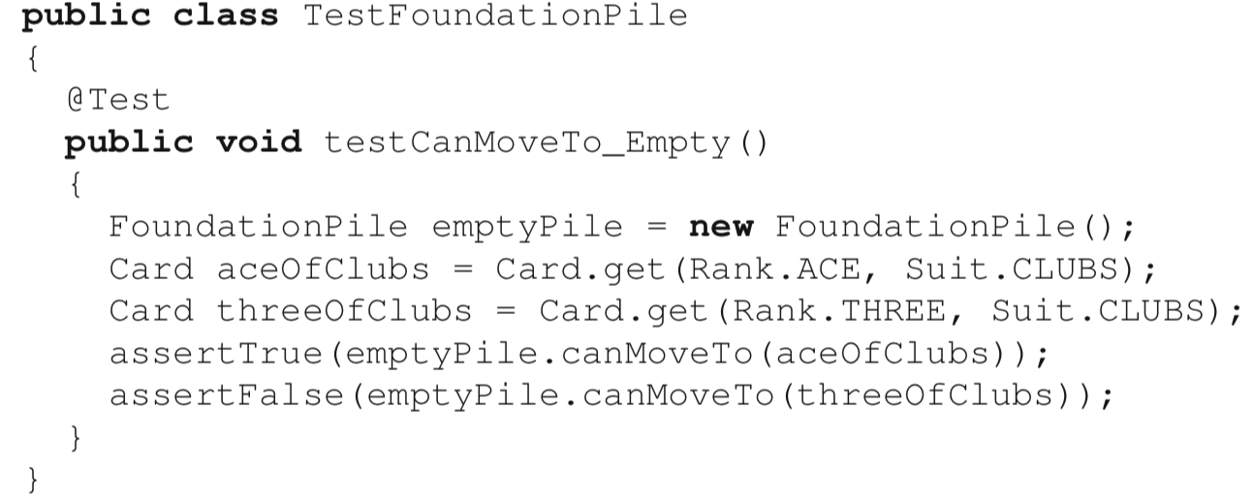

This test respects our five desired properties. It will execute with lightning speed, be independent from any other test that could exist, and is not affected by any environment properties. It is also focused, not only on a single method, but also on a specific input combination for the method. Finally, many properties of this test add to its readability. First, *the name of the test* encodes both the focal method and the input of interest. Second, the *names of the variables* describe their content. Finally, the assertion statements are self-evident. Reading the last line of the test, for exam- ple, we see clearly that calling canMoveTo with a three of clubs on an empty pile will return false, which is correct.

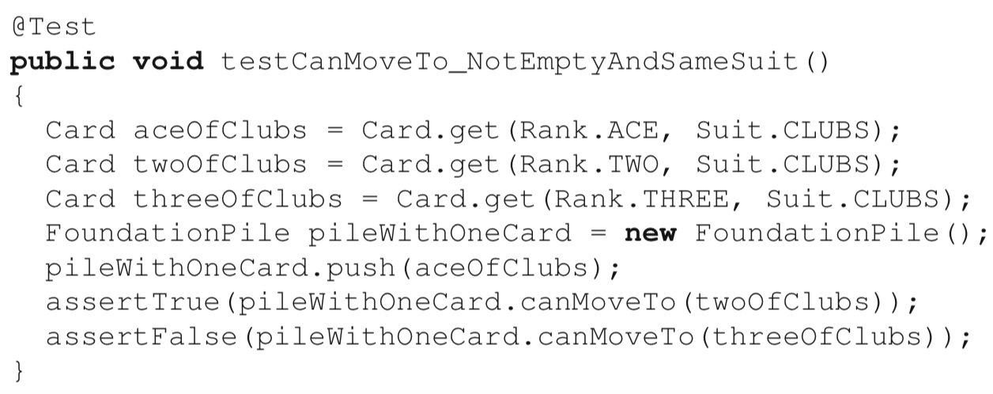

However, we already note a lot of redundant code between the two tests, namely, the code to create an instance of FoundationPile, and the code to create cards. In test classes that group multiple test methods, it will often be convenient to define a number of “default” objects or values to be used as receiver objects, explicit parameters, and/or oracles. This practice avoids the duplication of setup code in each test method, which constitutes DUPLICATED CODE†.

Baseline objects used for testing are often referred to as a *test fixture*, and declared as fields of a test class. However, for the reasons discussed above, and in particular because JUnit provides no ordering guarantee of any test execution, it is crucial to preserve test independence. This implies that no test method should rely on the fixture being left in a given state by another test. In most cases, this precludes the use of the test class constructor to initialize the fixture, because the constructor is only called once when the test class is instantiated by the framework. The workaround is to nominate a method of the test class to execute before any test method, and initialize all the required structures afresh. Conveniently, JUnit provides a feature to perform this method call without requiring the test code to include an explicit method call.

By using the @Before annotation, we indicate to JUnit to execute the method before the execution of any test. Similarly, it is also possible to use the @After annotation to mark a method that needs to run after every single test (for instance to free up some resources). Of course, immutable objects do not need to be reinitialized, so they can be stored as static fields of the class. The code below shows the improvement to our test class TestFoundationPile, which now uses a test fixture.

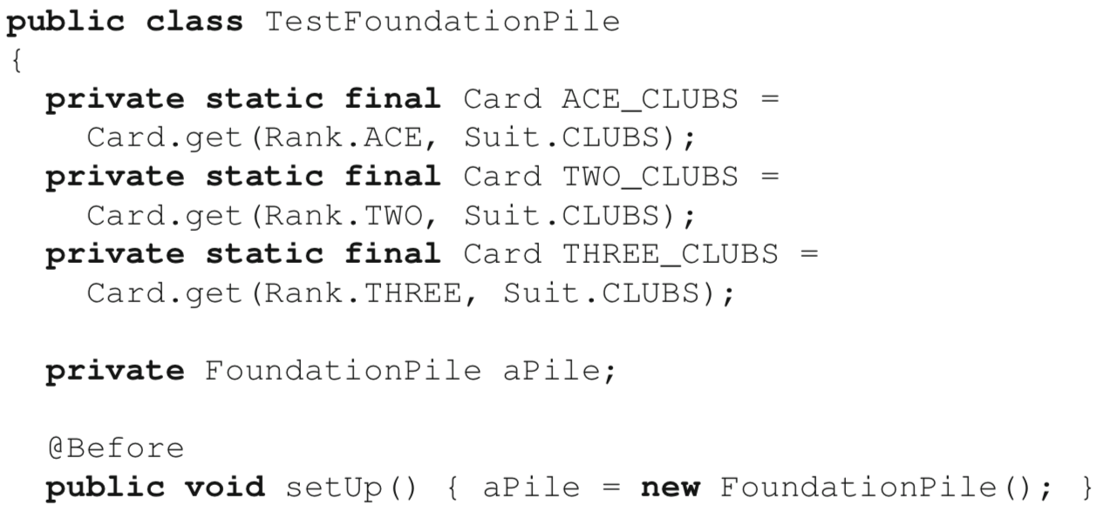

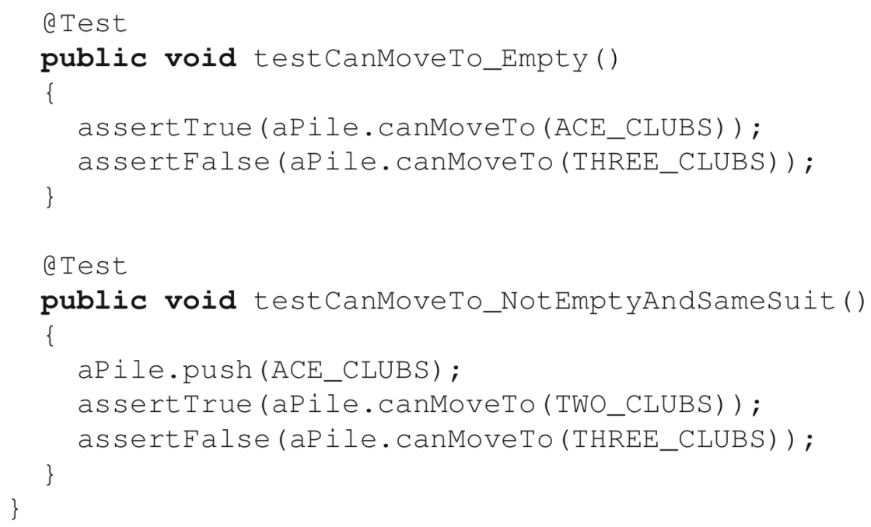

5.6 Tests and Exceptional Conditions

An important point when writing unit tests is that what we are testing is that the unit under test does what it is expected to. This means that when using design by contract, it does not make sense to test code with input that does not respect the method’s preconditions, because the resulting behavior is unspecified.

For example, let us consider a version of method peek of class FoundationPile which returns the top of the pile.

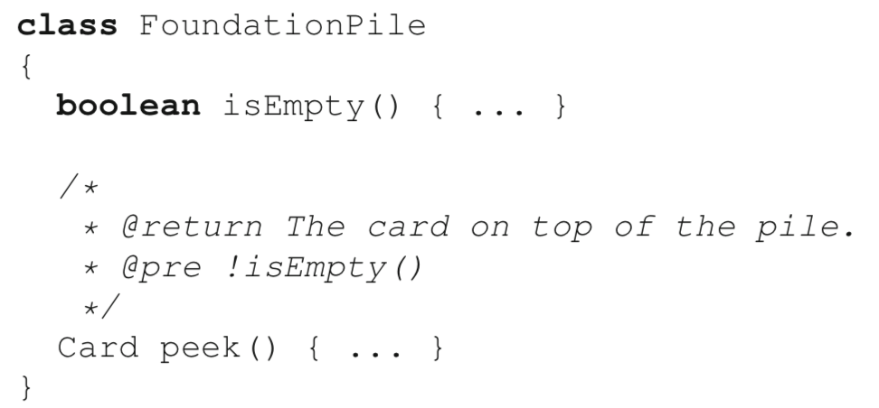

The documented precondition implies that the method cannot be expected to fulfill its contract (to return the top card) if the precondition is not met. Thus, if we call the method on an empty pile, there is no expectation to test. The situation is different, however, when raising exceptions is explicitly part of the interface. Let us consider the following slight variant of method peek():

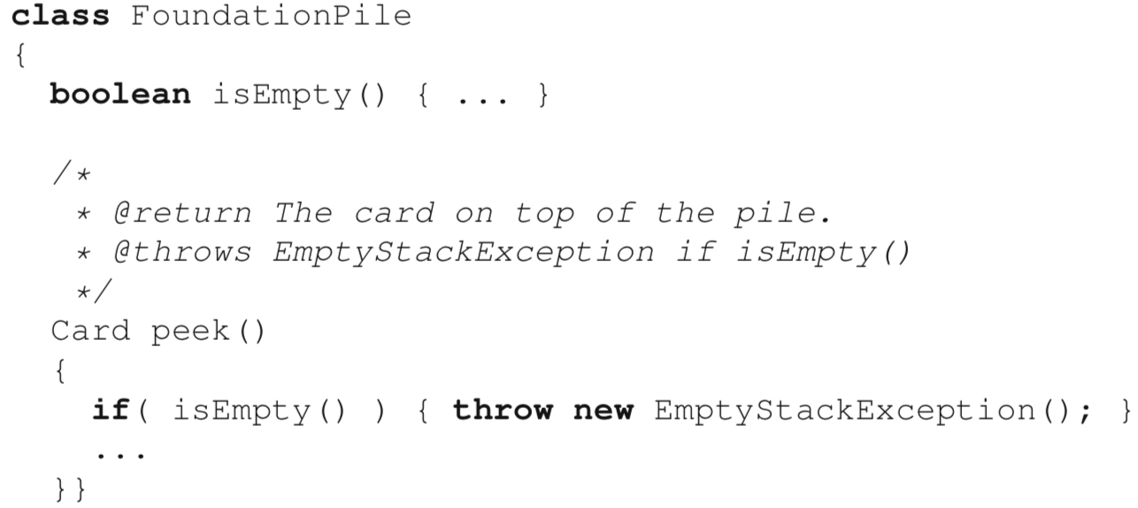

In this case, calling peek on an empty pile should result in an EmptyStackException. This is part of the specified, expected behavior, and should be tested.

* expected property of the @Test annotation (This idiom is replaced with the static method assertThrows in JUnit 5)

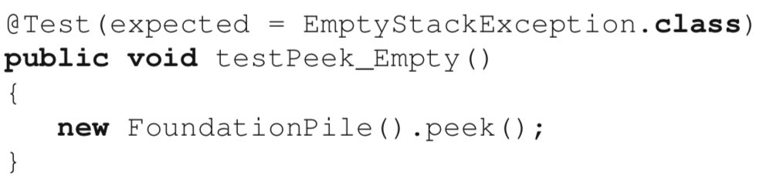

Limit: Exceptional behavior must be the last thing to happen in the test.

* More flexibility

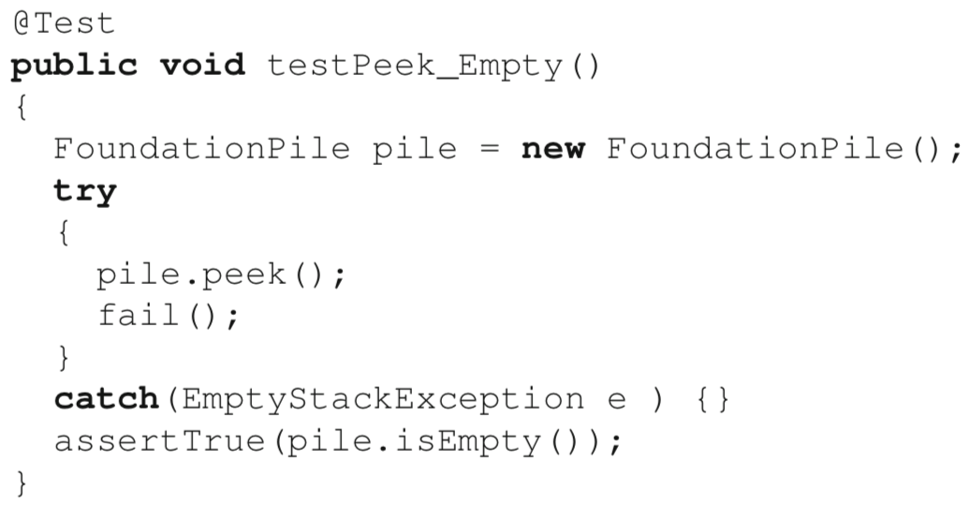

If the unit under test (the peek method here) is faulty in the sense that it does not raise an exception when it should, the code will keep executing normally and reach the following statement, which will force a test failure using JUnit’s fail() method. If the unit under test is (at least partially) correct in that it does raise the exception when it should, control flow will immediately jump to the catch clause, thereby skipping the fail(); statement. It is then possible to add additional code below the catch clause, as illustrated.

5.7 Encapsulation and Unit Testing

A typical solution when an interface does not include a method that would be convenient for testing, is to provide the desired functionality in the form of a *helper method* in the testing class instead.

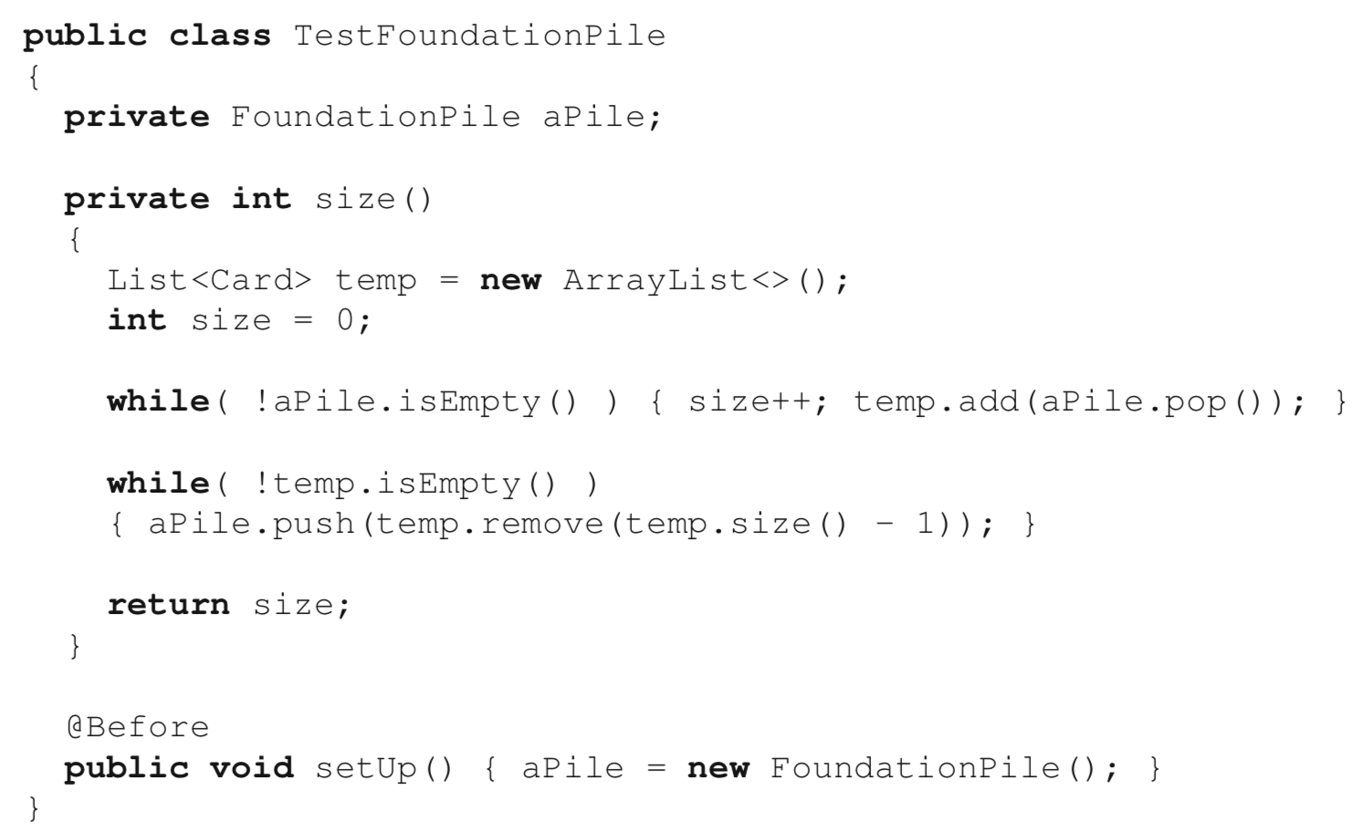

[Test Private Method or not]

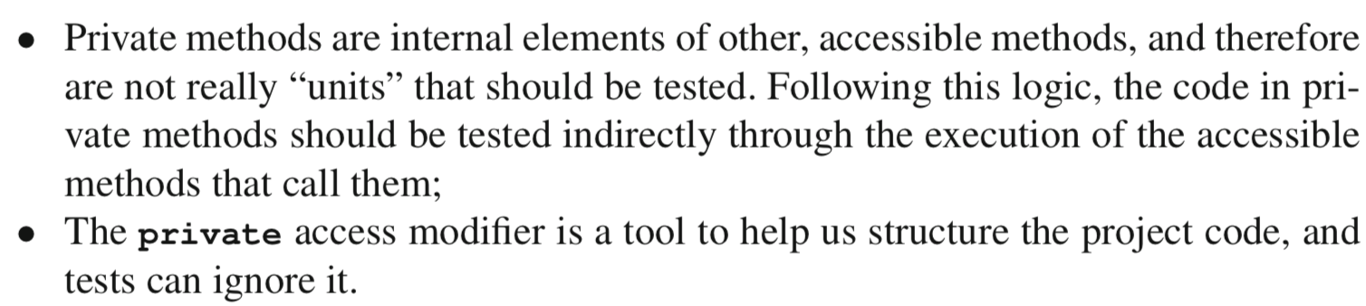

In cases where it is judged desirable to test a private method, we need to bypass the method’s access restriction. This can be done using metaprogramming. For sake of discussion, let us assume that class FoundationPile also has a method:



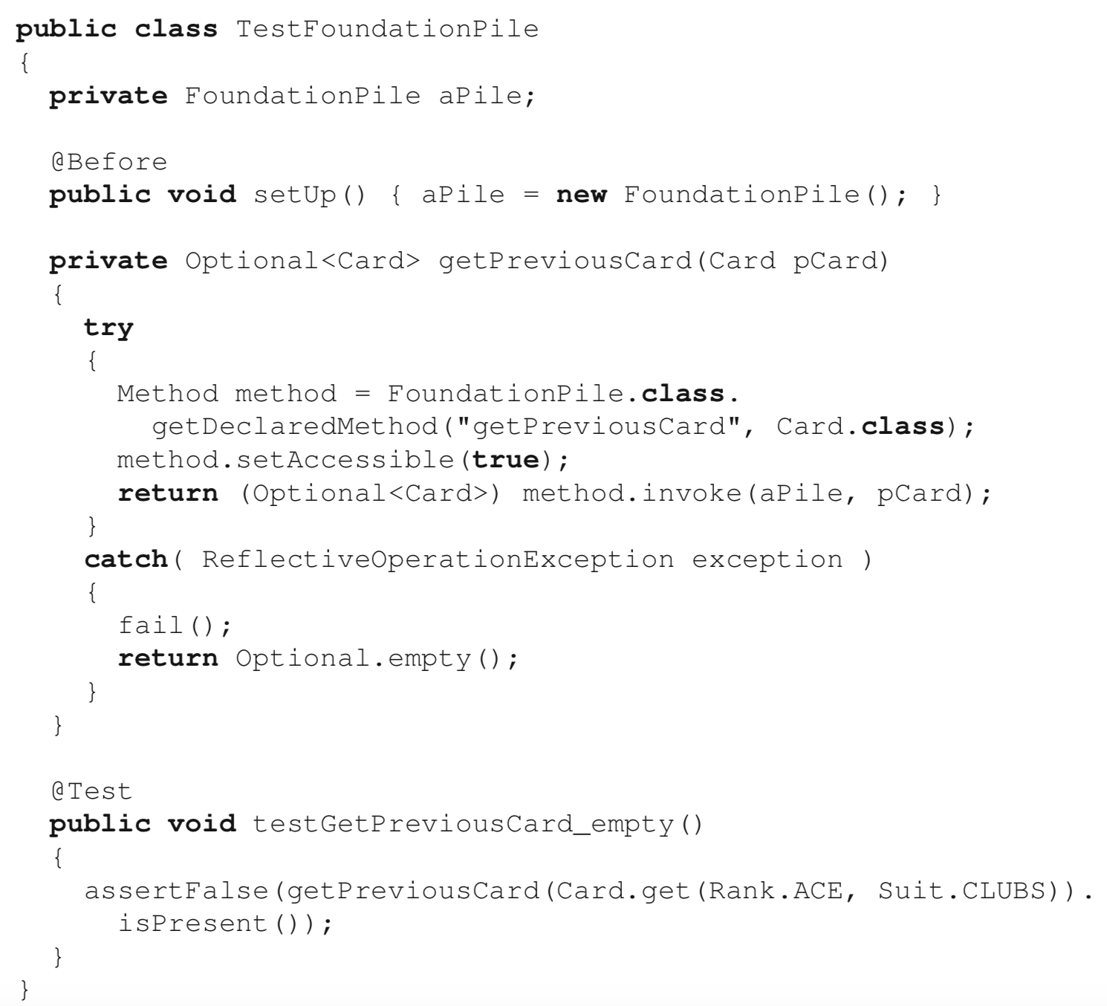

the call to getPreviousCard is NOT a call to the unit under tests. Instead, the call is to a *helper method* (of the same name) that uses metaprogramming to call the unit under test while bypassing the access restriction of the **private** keyword.

5.8 Testing with Stubs

The key to unit testing is to test small parts of the code *in isolation*. In some cases, however, factors can make it difficult to test a piece of code in isolation, for example, when the part we want to test:

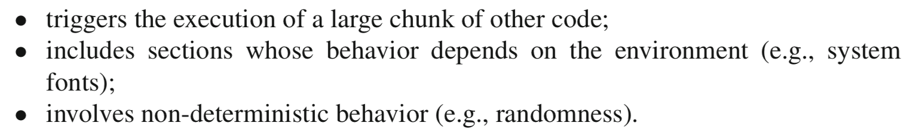

e.g. The GameModel class has a tryToAutoPlay() method that triggers the computation of the next move by dynamically delegating the task to a strategy

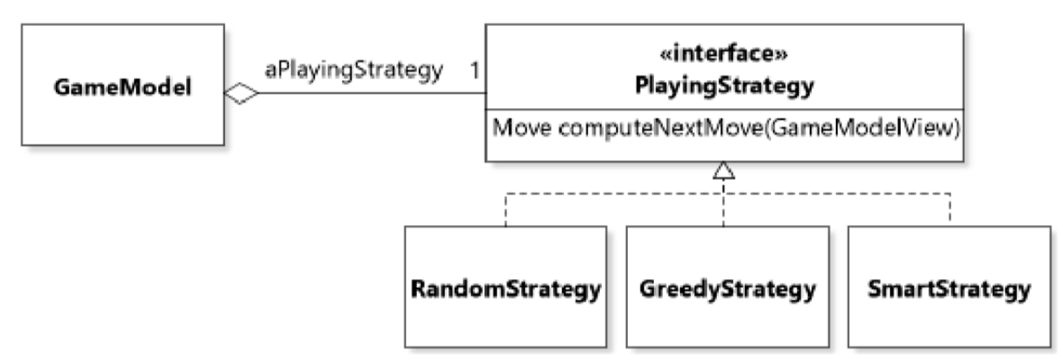

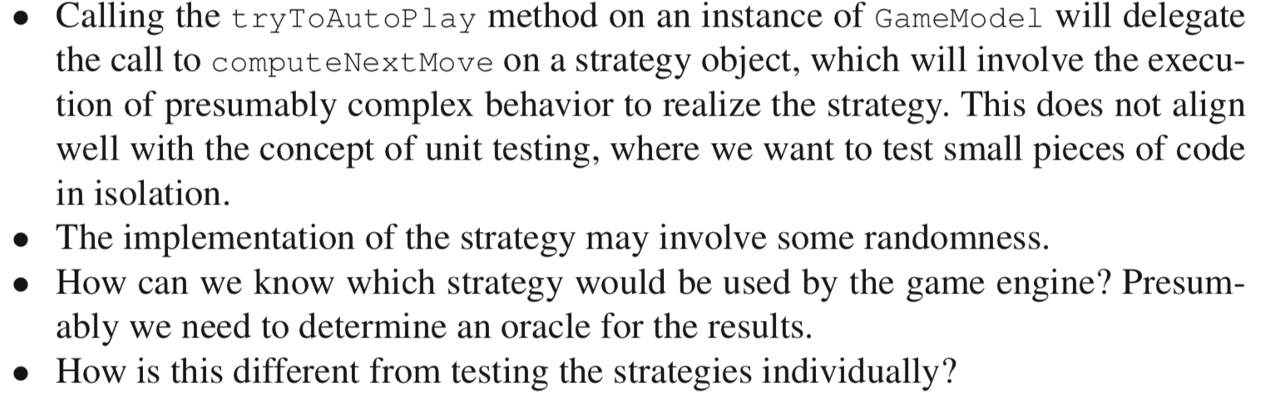

The way out of this conundrum is the realization that the responsibility of GameModel.tryToAutoPlay(...) is NOT to compute the next move, but rather to delegate this to a strategy. So, to write a unit test that tests that the UUT does what it is expected to do, we only need to verify that it properly relays the request to compute a move to a strategy. This can be achieved with the writing of a stub.

*A stub is a greatly simplified version of an object that mimics its behavior sufficiently to support the testing of a UUT that uses this object*. Using stubs is heavily dependent on types and polymorphism.