OPTIONS

1. Terminology

ZERO SUM GAME

|  |  |  |
| --- | --- | --- |
| Types | Buyer | Seller |
| Call option | Right to buy | Obligation to sell |
| Put option | Right to sell | Obligation to buy |

* (derive from) Underlying option ~ Stock
* Exercise/Strike Price ~E
* 100 shares per contract (organized, OTC)
* Expiration date
* Price of the option ~ Premium c/p 🡪 goes to sellers
* American(can be exercised anytime) vs European(only at maturity)

2.Option Strategies

Take a position in:

1. The option alone – *Naked Position*

2. The option and the underlying – *Non Combined*

3. Two or more options of the same type, known as a *spread*

4. A mixture of calls and puts, known as a *combination*

**A. Naked positions**

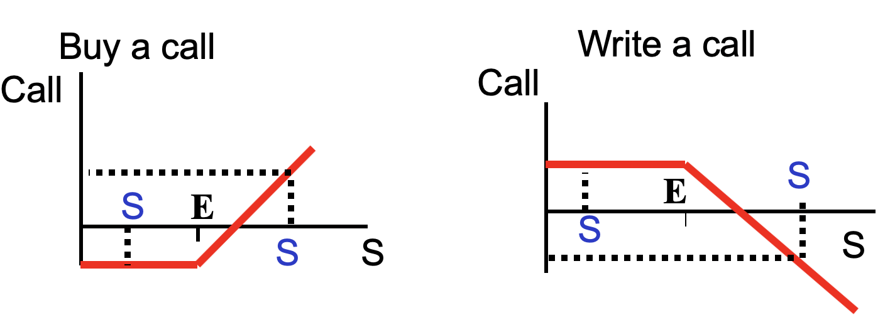

From call buyer’s view:

out of money (S<E)

at the money (S=E)

in the money (S>E)

**BEARISH**

-c-E+S

+c-S+E

**BULLISH**

don’t

exercise

**BULLISH**

**BEARISH**

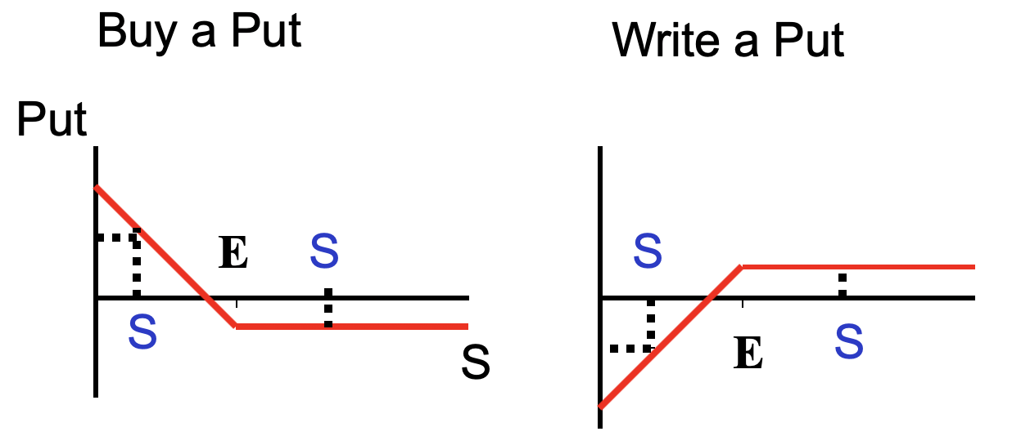

From put buyer’s view:

out of money (S>E)

at the money (S=E)

in the money (S<E)

-p-S+E

+p-E+S

Profit is limited(Price cannot be zero)

**B. Long S & P : Protective Put (**stock managers)

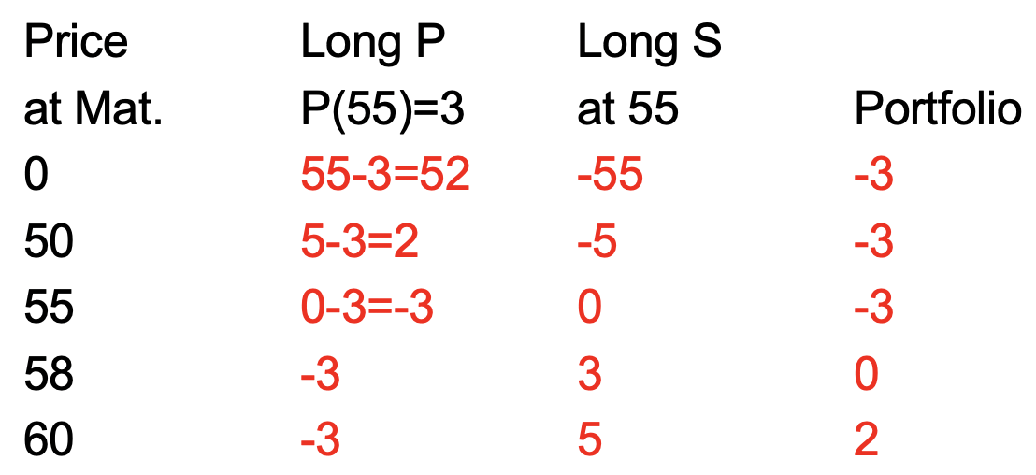

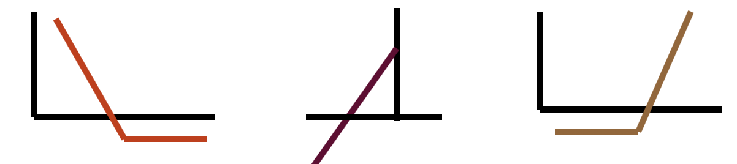

synthetic call

**Case Shortsell S and buy C**

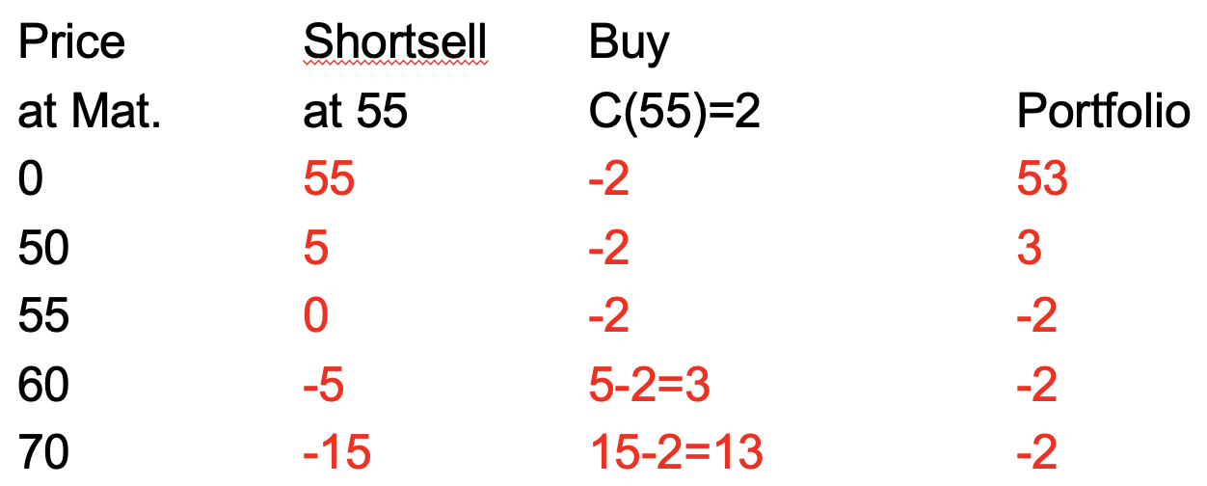

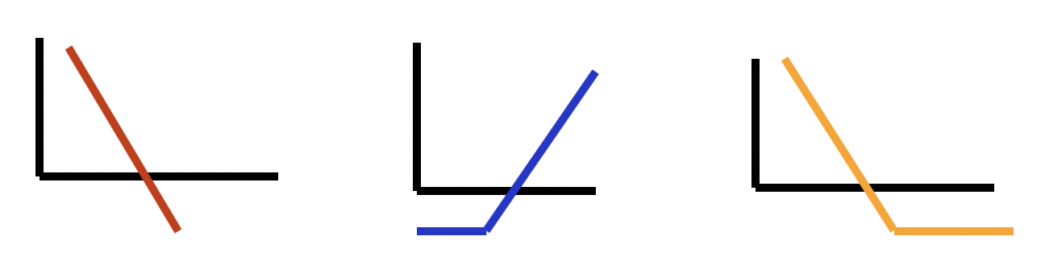

synthetic put

**C. Combination Strategy: Combine Put and Call on the same stock**

***Prediction: market is volatile***

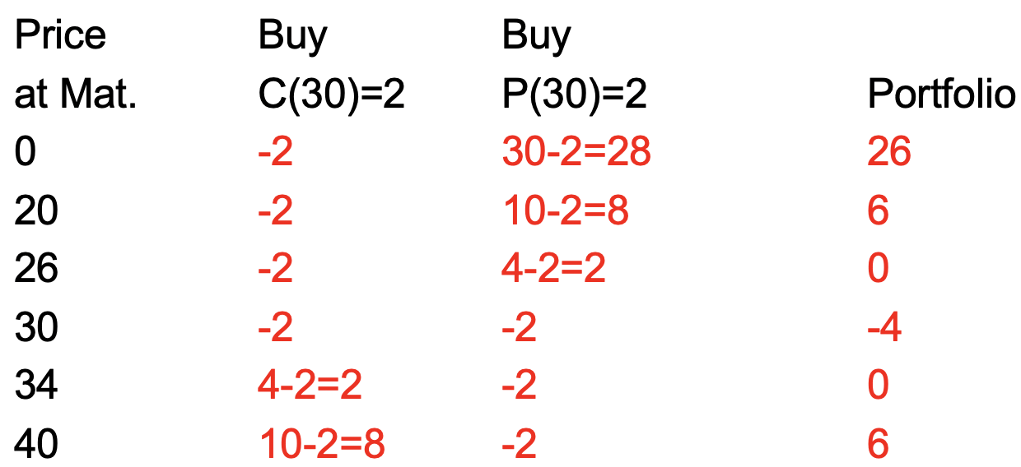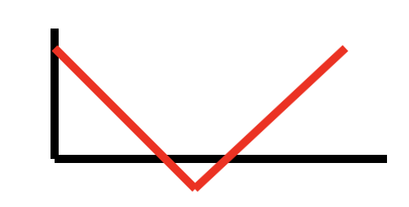

**D. Spread buy Call that is financed by another Call on the same SK (zero-cost strategy)**

***Bearish Spread: Profit if price decreases***

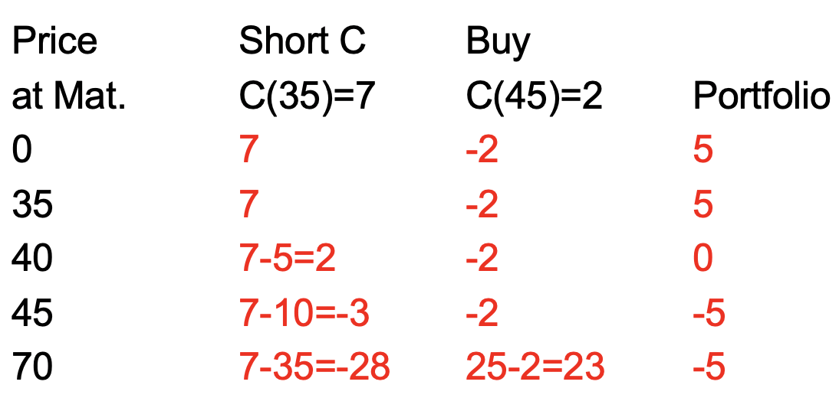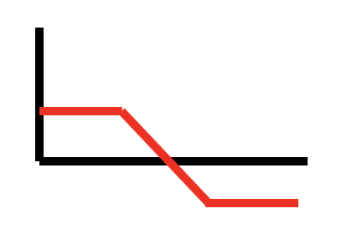

***Profit from small volatility***

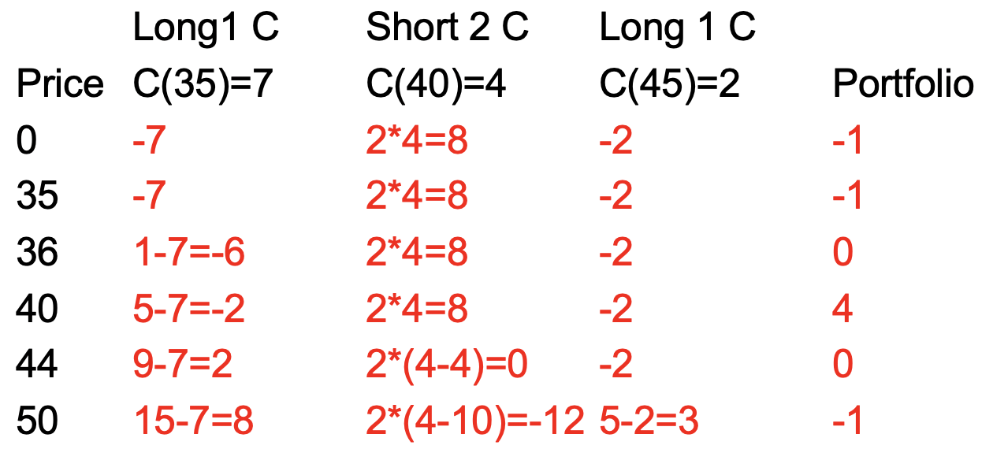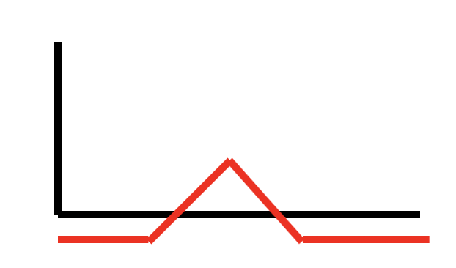

butterfly