The coefficient on inflation is not statistically significant at any of the conventional significance levels (1%, 5%, or 10%). The coefficient has a p-value of 34.4%. This suggests that inflation does not have statistically significant ability to predict future returns on the stock market.

Assets earn high returns (risk premiums) to compensate investors for the losses they incur during bad times (i.e., because they are exposed to underlying factor risks).

**Factors matter, not assets**:

Investing right requires looking through asset class labels to understand the factor content.

**Assets are bundles of factors**:

Equities and government bonds can be considered factors themselves; corporate bonds, hedge funds and private equity contain different amounts of equity risk, volatility risk, interest rate risk, and default risk.

**Different investors need different risk factors**:

Each investor has different preferences, or risk aversion coefficients, for each different source of factor risk.



CAPM The relevant measure of risk associated with investing in an asset is **how the asset covaries with the market portfolio** – the beta of the asset(not its volatility)

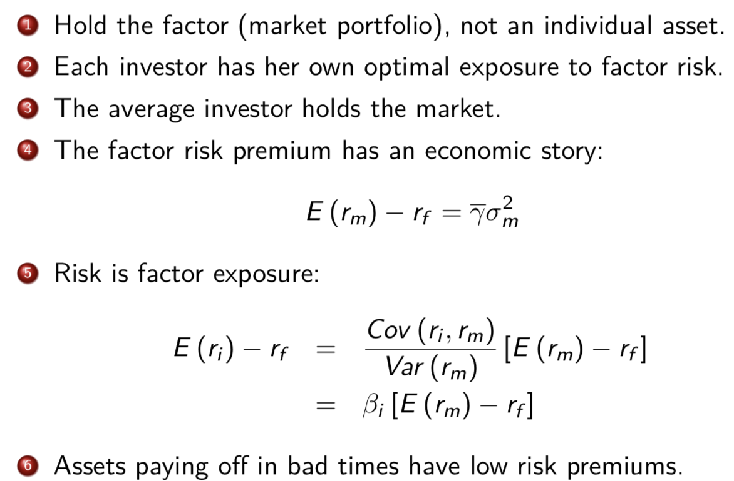

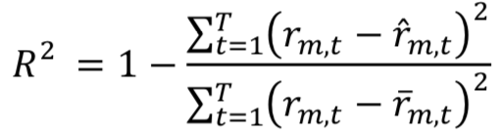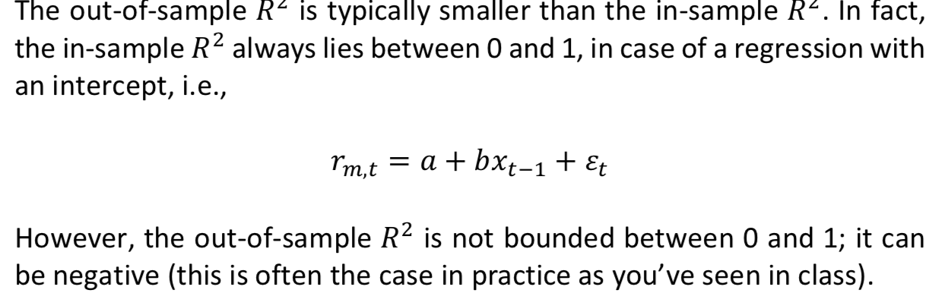

Now, in the case of in-sample regression, a single regression is estimated over the entire sample 1965:01-2010:12. The intercept and slope coefficients (a and b in the above equation) are estimated to minimize the sum of squared forecast errors over the entire evaluation period, i.e. 1965:01-2010:12. Therefore, the estimated intercept and slope coefficients minimize the sum of squared forecast errors over this period. Therefore, in the above equation for the 𝑅2, the numerator of the fraction on the right hand side (the sum of squared forecast errors from the above forecasting regression) cannot be larger than the denominator (the sum of squared forecast errors from the above forecasting regression with the slope coefficient b set equal to zero; therefore, the intercept is estimated as the mean of the left hand side variable, i.e. the market return, over 1965:01-2010:12). Therefore, the fraction is always smaller than 1 and the 𝑅2 cannot be negative.

In case of the out-of-sample regression however, the above argument does not hold any more. This is because, in each month starting with 1965:01, the forecasting regression is only estimated with data up to the previous month and the estimated intercept and slope coefficients are used to predict the returns in that month. Therefore, the intercept and slope coefficients are not estimated to minimize the sum of squared forecast errors over the entire evaluation period, i.e. 1965:01-2010:12. Therefore, it may well be the case that the sum of squared forecast errors over the entire evaluation period, i.e. 1965:01-2010:12 from the forecasting model above are larger than those obtained by setting b=0 in the above forecasting regression, and, consequently, the 𝑅2 is negative.

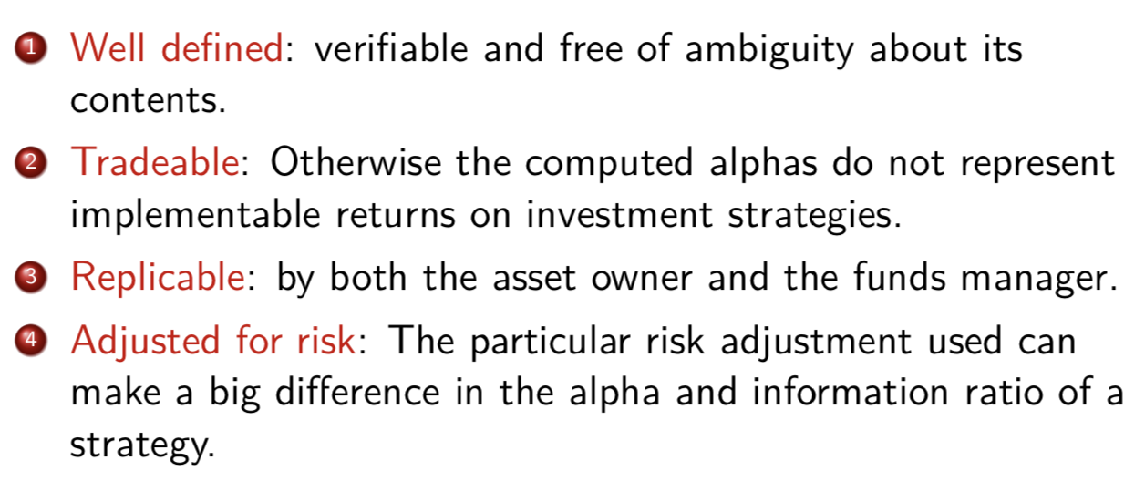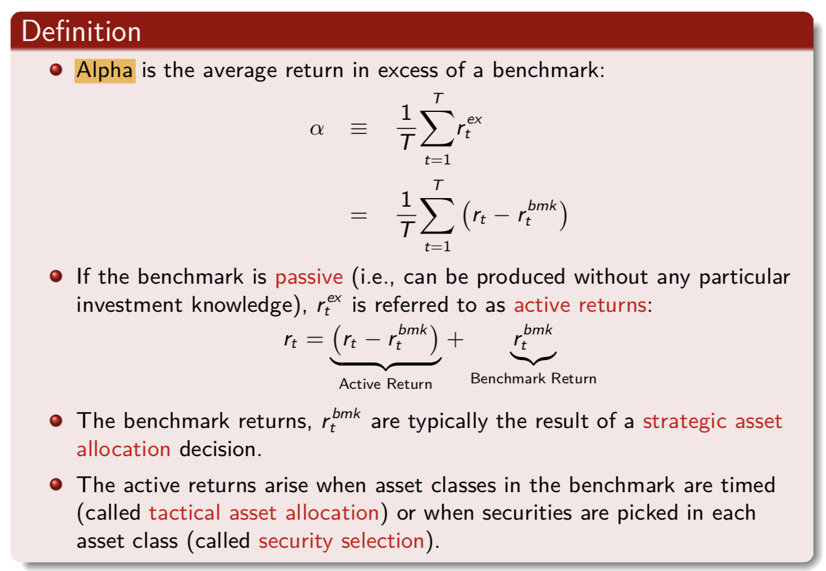

Critically depend on the benchmark

Alpha only measures average excess return compared to the (in this case, market) benchmark instead of considering risk beyond that represented by the benchmark. Managers can generate high alpha by taking more risk, meaning that alpha as the measure of performance does not account for other risk (beyond market) taken by fund managers.

Ideal benchmark

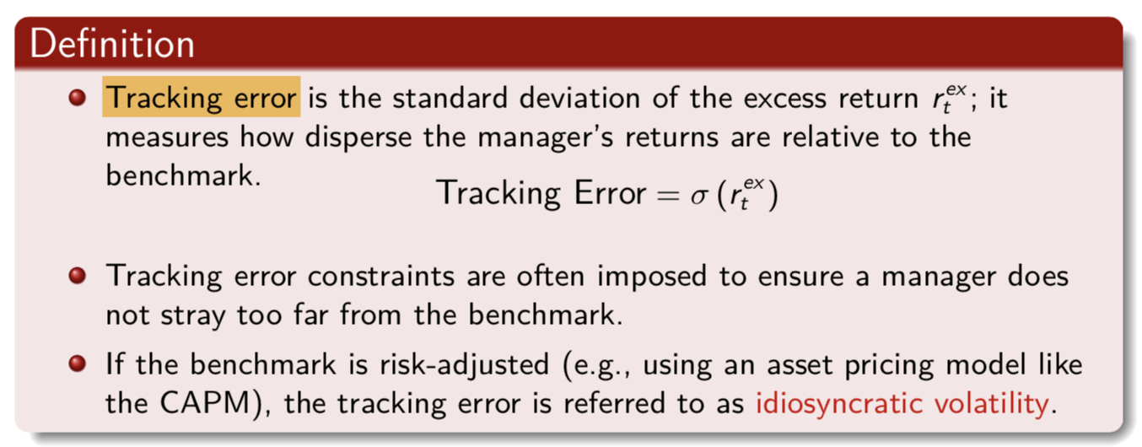

An advantage of the Information Ratio over alpha as a measure of performance is that it, unlike the alpha, adjusts for risk. The information ratio is a risk-adjusted measure of performance.(like Sharpe ratio)

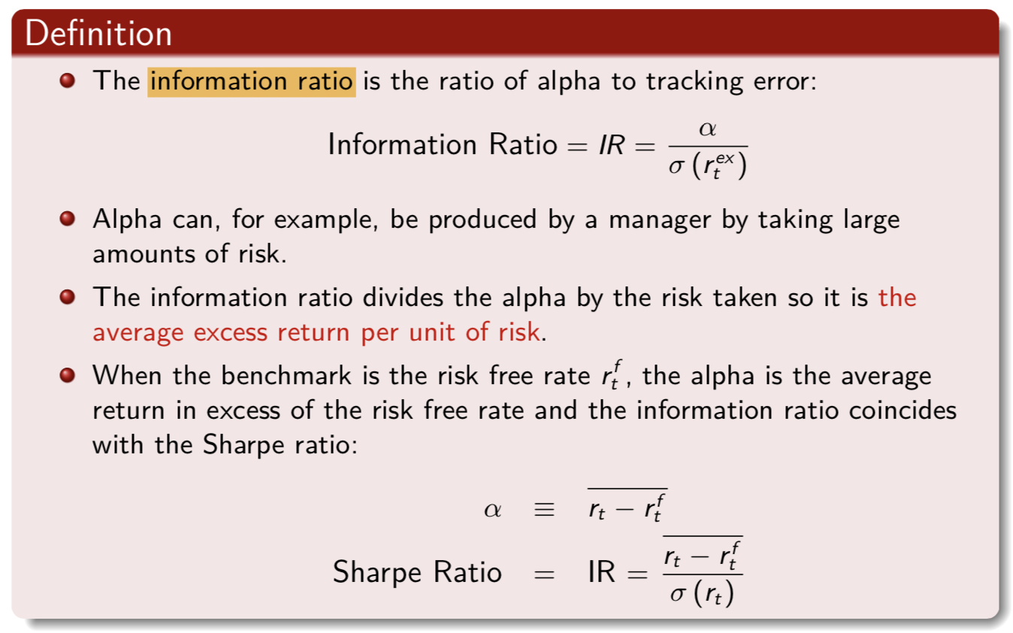

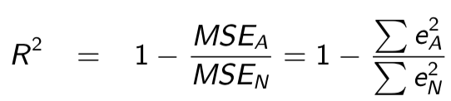

where eN and eA denote the vector of rolling OOS forecast errors from the **historical mean model** and the **OLS model,** respectively.

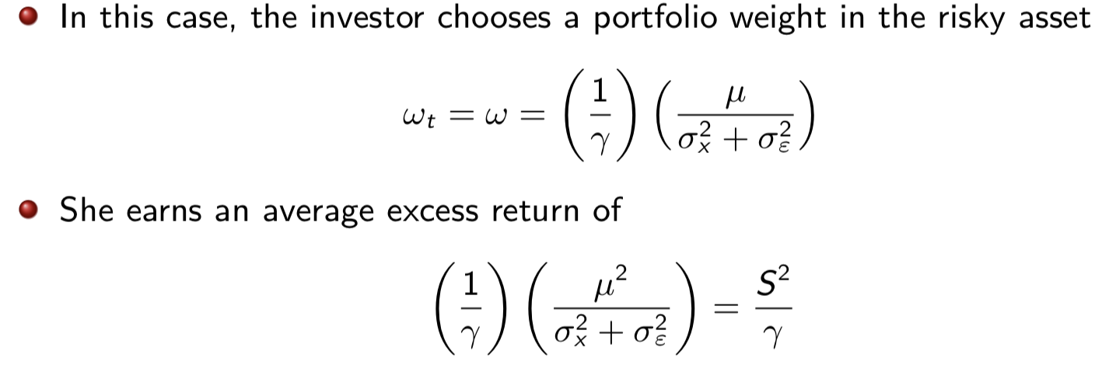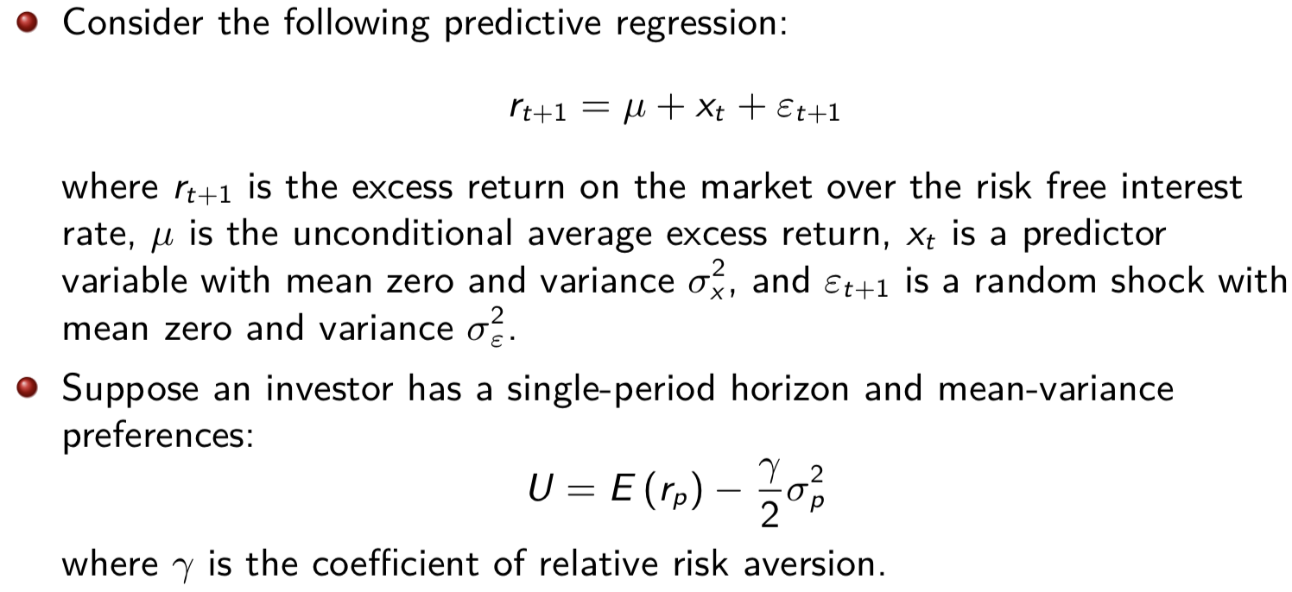

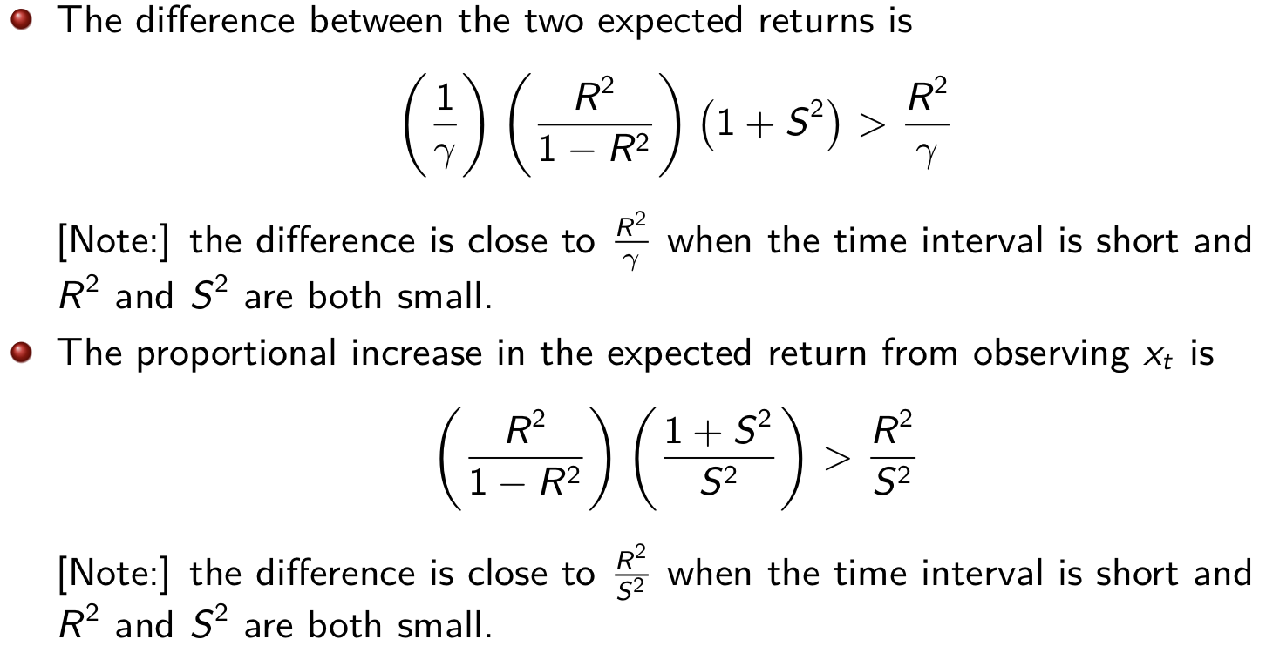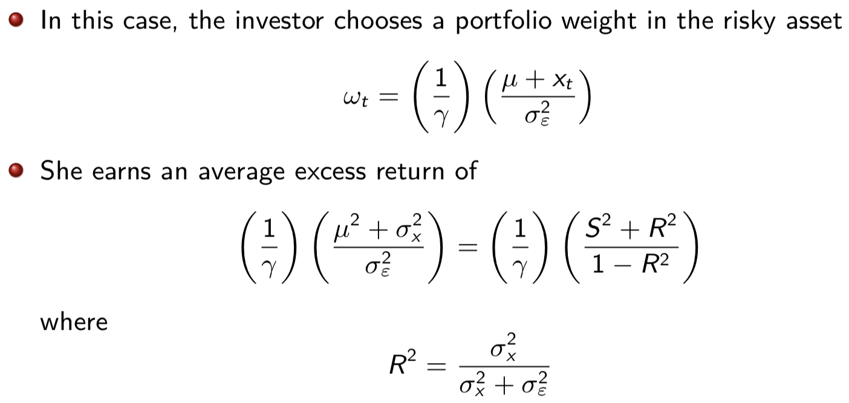

The magnitude of the in-sample 𝑅2 is very small at 0.16%. This implies that less than 1% (in fact, only 0.16%) of the variation in the next month’s market return is explained by the variation in the current month’s inflation level. However, the correct way to judge the magnitude of the 𝑅2 is to compare it with the squared Sharpe ratio of the market portfolio. Specifically, if the 𝑅2 is high relative to the squared Sharpe ratio, then an active investor can achieve substantial increase in returns (absolute and percentage) by using the predictor variable to predict returns compared to using the historical average market return as the best forecast of the next month’s market return.

The correct way to judge the magnitude of R2 is to compare it with S2. If R2 is large relative to S2, the investor can use the information in the predictive regression to obtain a large proportional increase in expected return.

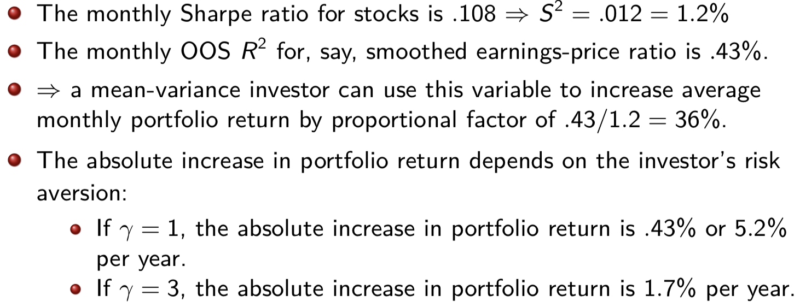

The investor who observes xt earns a higher portfolio return in part by taking on greater risk. ⇒ the increase in average return is not a pure welfare gain for a risk-averse investor.

The utility difference is positive so the investor prefers the active portfolio to the passive investment strategy. Since the utility is in units of expected returns, the utility difference measures the amount of transaction costs/management fees that the investor would be willing to pay to invest in the active.

The first multifactor model was the **arbitrage pricing theory (APT)** The factors cannot be arbitraged or diversified away ⇒ in equilibrium, investors must be compensated for bearing these multiple sources of factor risk. The APT is silent on the number and identity of the factors.

**Fama-French (FF) 3-Factor Model**

* Size effect: Stocks with lower market capitalization (small stocks) tend to have higher average returns than large stocks, after adjusting for their betas
* Value effect: Value stocks (stocks with high ratios of a fundamental e.g., book value, sales, earnings, dividends, to price) tend to have higher average returns than growth stocks (stocks with low ratios of fundamentals to price)



The portfolios are **reformed** in June of t + 1. [The more you rebalance, the more transaction costs 🡪 Benefits decreases.]

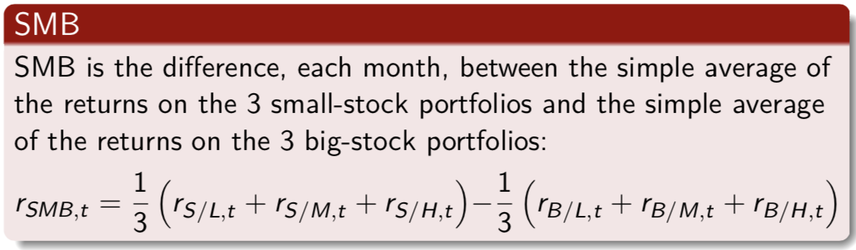

SMB is the difference between the returns on small and big-stock portfolios with about the same weighted-average book-to-market equity. ⇒it is largely free of the influence of BE/ME, focusing instead on the different return behaviors of small and big stocks.

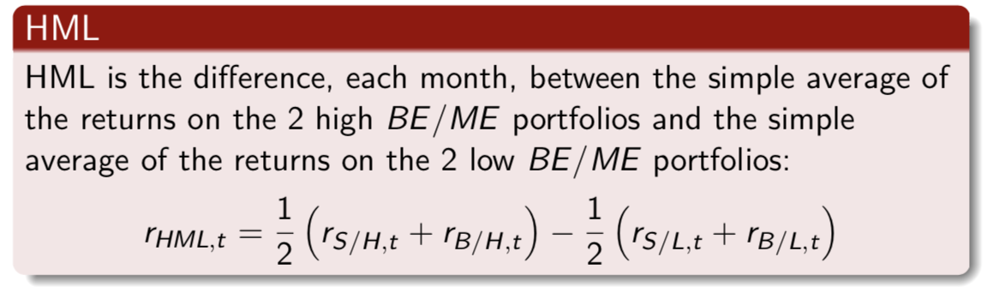

The two components of HML have about the same weighted-average size. ⇒it is largely free of the size factor in returns, focusing instead on the different return behaviors of high and low BE/ME firms.

Produce a wide range of average excess returns to be explained (.32% to 1.05% per month).

Confirm negative relation between size and average return.

Confirm stronger positive relation between average return and book-to-market equity.

The market factor leaves much of the variation in stock returns unexplained (particularly for small-stock and high-BE/ME portfolios). [R2]

In the absence of competition from the market factor, SMB and HML typically capture substantial time variation in stock returns. However, they leave common variation in stock returns that is picked up by the market (especially for large-size portfolios) [R2]

SMB captures shared variation in returns missed by the market and HML.

HML captures shared variation in returns missed by the market and SMB.

Addition of SMB and HML causes the market βs to collapse toward 1.

Addition of SMB and HML causes large increases in R2.

[Intercepts from Time-Series Regressions] If the premiums associated with any set of factors suffice to describe the cross-section of average returns, the intercepts in the time-series regressions of excess returns on the factor-mimicking portfolio returns should be indistinguishable from zero.

The 3 factors do a good job explaining the cross-section of stock returns.

**The size and book-to-market factors can explain the differences in average returns across stocks, but the market factor is needed to explain why stock returns are on average above the one-month bill rate.**