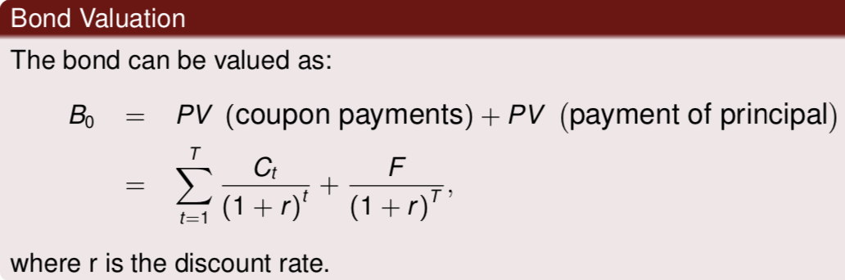

A bond can be viewed as a package of two investments:

* The first investment generates the regular coupon payments, $Ct , till (and including) maturity date T .
* The second produces the face value, $F, at maturity T.

zero coupon bonds: stripped bonds/strips

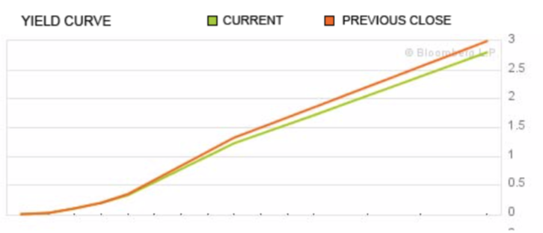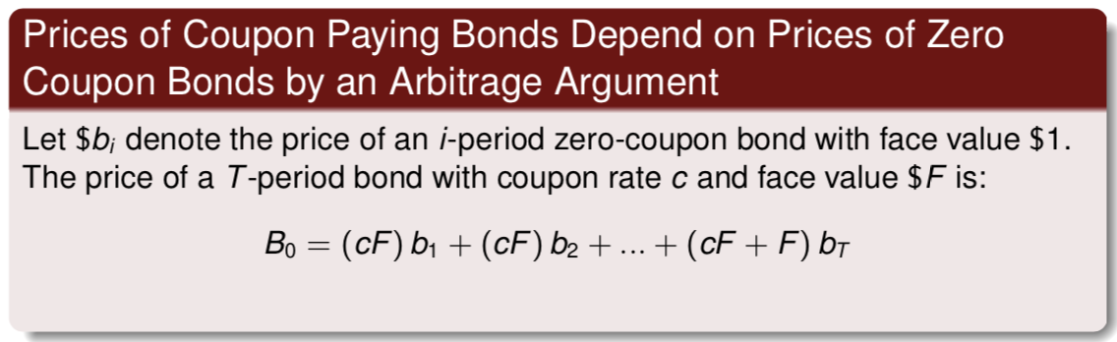

**Yield to maturity (y)**

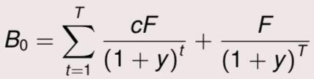It is the annual return(APR) earned by buying a bond and holding it to maturity.

It is the discount rate that sets the value of future payments equal to the price.

It is the rate that sets the NPV of investing in the bond equal to zero.

The **yield curve plots** the yield to maturity against the maturity of bonds

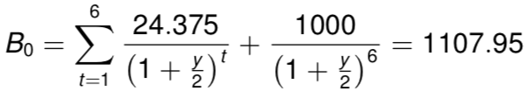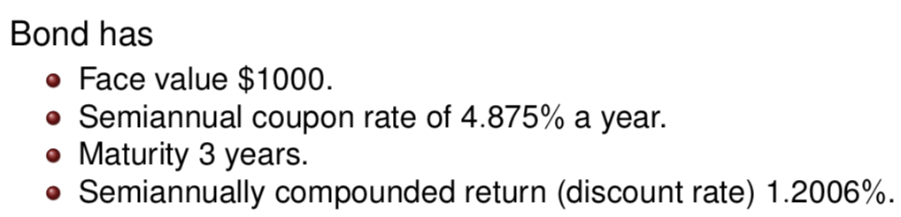

* Bond prices and interest rates must move in opposite directions.
* The yield to maturity (our measure of the interest rate on a bond) is defined as the discount rate that explains the bond price.

⇒ when bond prices fall, yields to maturity must rise. When yields to maturity rise, bond prices must fall.

When the yield is equal to the bond’s coupon rate, the bond sells for exactly its face value (**at par**). B0 = F

When the yield is higher than the coupon rate, the bond sells **at a discount** to face value. B0 < F

When the yield is lower than the coupon rate, the bond sells **at a premium**. B0 > F

**Bond return (Holding period return HPR)**

A bond’s yield to maturity is not the same as its holding period return. A bond’s holding period return (HPR) from period 0 to 1 is defined as:

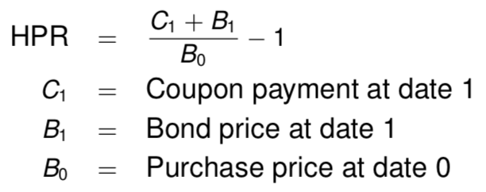

**Spot rate**

The series of spot rates r1, r2, ..., rt, ... traces out the **term structure of interest rates**

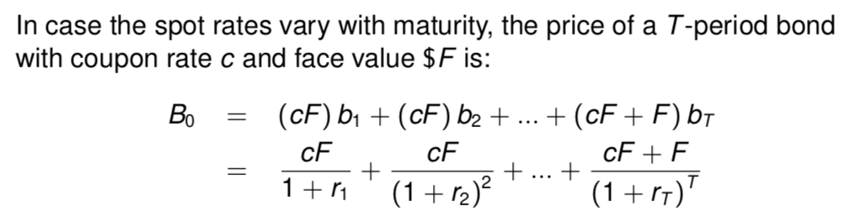

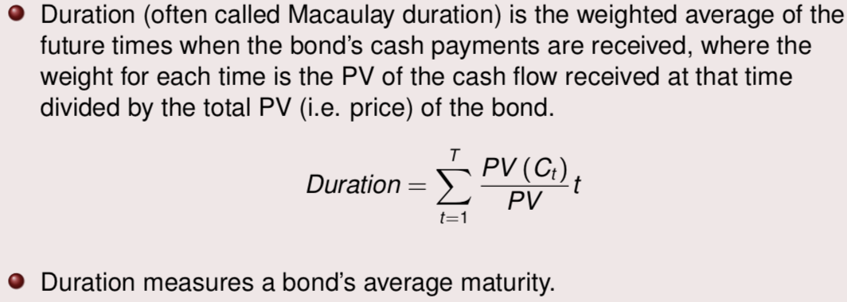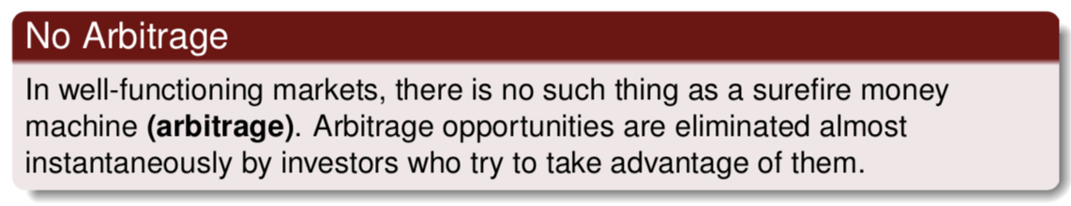

A dollar tomorrow cannot be worth less than a dollar the day after tomorrow.

i.e. a one-year zero-coupon bond cannot be worth less than a two-year zero-coupon bond

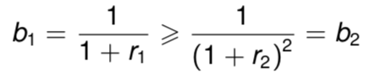

**Forward interest rate**

You want to arrange today for borrowing or lending in the future.

⇒ no cost today, and no risk in the cash flows

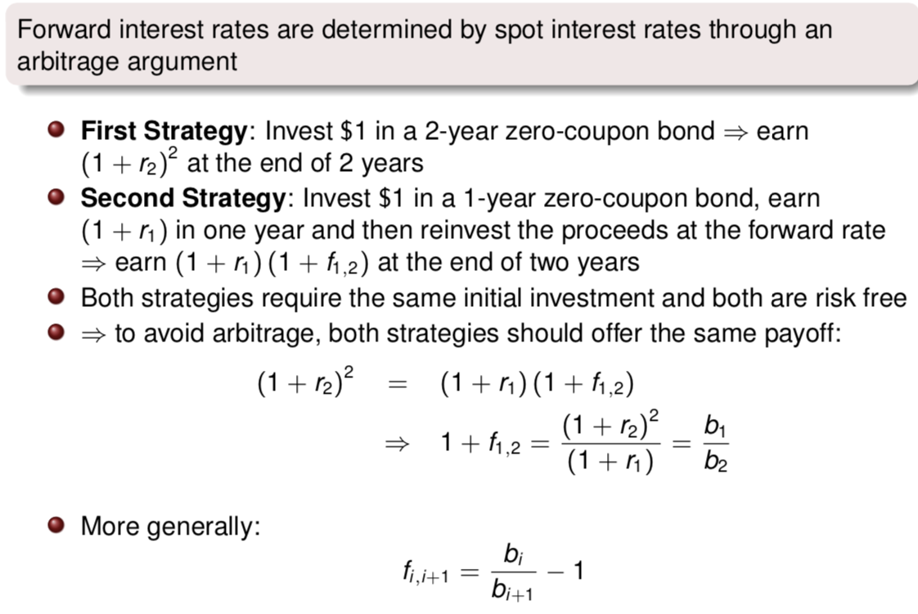

To rule out arbitrage, forward rates cannot be negative.

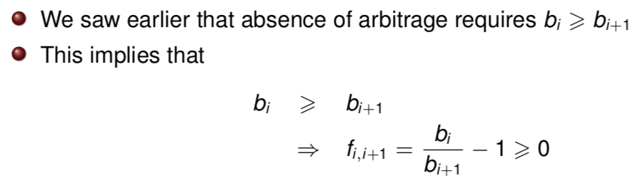

**Expectation Theory (explation of term structure)**

In equilibrium, investment in a series of short-maturity bonds must offer the same expected return as an investment in a single long-maturity bond:

(1 + r1,t ) (1 + Et r1,t +1 ) = (1 + r2,t )2

The only reason for an upward (downward) sloping term structure is that investors expect short-term interest rates to rise (fall)

The lower the duration, the less sensitive to fluctuation in interest rates.

An increase in the coupon lowers duration

An increase in the interest rate lowers duration

The longer the maturity, the greater the duration.

Zero-coupon bonds repay the principal at maturity, but make no coupon payments along the way.⇒ the duration of a zero-coupon bond is equal to its maturity.

Coupon-paying bonds deliver cash payments earlier than zero-coupon bonds with the same maturity and, therefore, have shorter duration (i.e., they are less sensitive to interest rate fluctuations and have higher prices than strips with the same maturity.)

**Immunization**

Immunization theory tries to eliminate sensitivity to shifts in the term structure by matching the duration of the assets to the duration of the liabilities.

If duration is truly a measure of sensitivity to interest rate shifts, a shift in the term structure will have the same impact on the present value of both assets and liabilities ⇒ will leave unchanged the ability of the program to meet any obligations.

Immunization is dynamic (Even if a position is immunized, there is the need to rebalance the asset portfolio in response to changes in interest rates; passage of time also affect duration).

Value in essence buys assets with high yields (or low prices) and sells assets with low yields (or high prices).In equities, the strategy is called **value-growth investing**.

In foreign exchange, the value strategy is called carry. This strategy goes long currencies with high interest rates and shorts currencies with low interest rates.

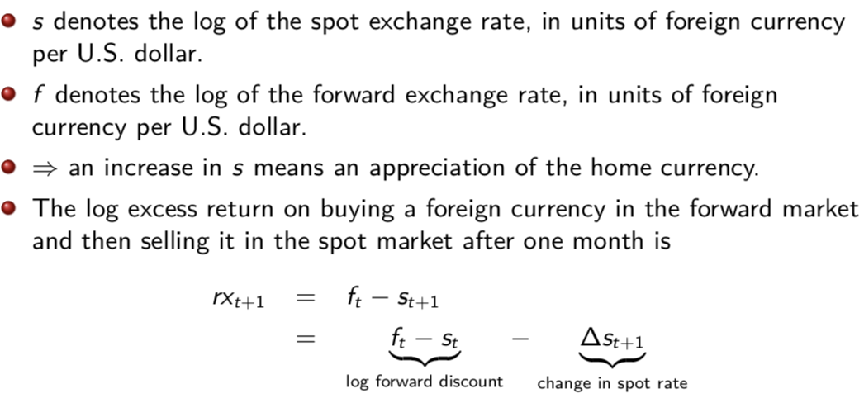Notation

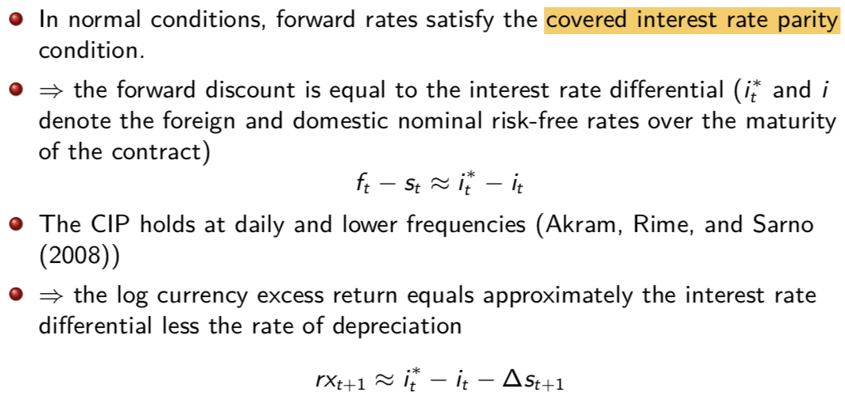CIP

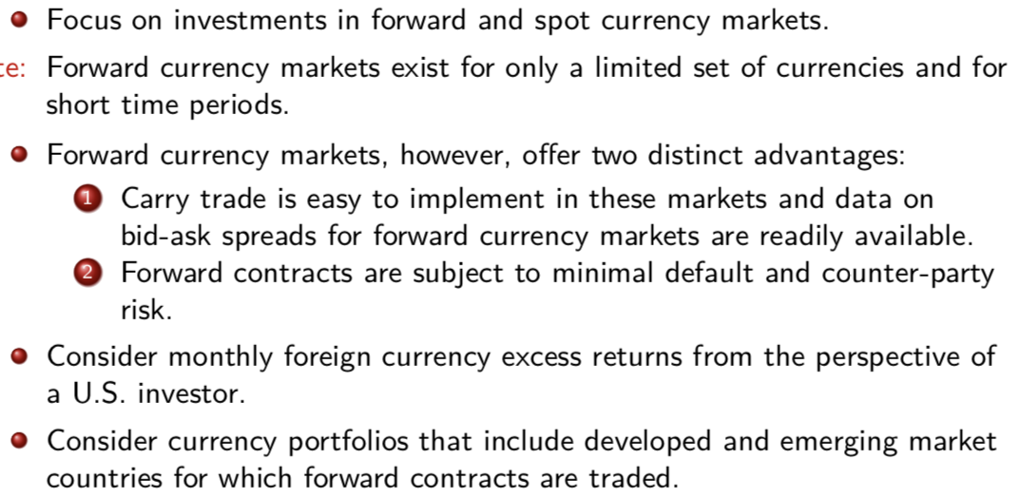

* A U.S. investor with access to forward currency markets can generate large returns with annualized Sharpe ratios that are comparable to those in the U.S. stock market.
* Similar results are obtained on a smaller sample of developed countries. [Not driven by emerging market]
* The model performs on nominal interest rate. But we can see that nominal interest rate relies on real interest rates. [not driven by inflation]
* The results contradict the standard UIP condition that the average rate of depreciation of currencies in portfolio j should equal the average forward discount on these currencies.
* Risk premium on investing in currencies with currently high interest rate(nor those with high interest rate on average) [active-higher SR]

**Risk factors**

Principle Component

1. explain most variation

2. have clear interpretation

* The first principal component explains 70% of the common variation in portfolio returns, and can be interpreted as a level factor, since all portfolios load equally on it.
* The second principal component, that is responsible for almost 12% of common variation, can be interpreted as a slope factor, since portfolio loadings increase monotonically across portfolios.

Average excess returns increase monotonically across portfolios ⇒ the second principal component is the only plausible candidate risk factor that might explain the cross-section of portfolio excess returns (since none of the other principal components exhibit monotonic variation in loadings).

The average currency excess return, RX: is the average portfolio return of a U.S. investor who buys all foreign currencies available in the forward market (the correlation of the first principal component with RX is .99).

Carry Trade Factor: HMLFX. The difference between the return on the last portfolio and the one on the first portfolio (the correlation of the second principal component with HMLFX is .94). This is the return in dollars on a zero-cost strategy that goes long in the highest interest rate currencies and short in the lowest interest rate currencies.

The relation between the bond price and interest rate is convex: a unit change in interest rate leads to a greater change in the bond price when interest rate is lower.

The bond price is the expected cash flow in on year discounted by the risk-adjusted rate.

The yield sets the present value of the promised payment equal to the price.

The expected return (P1-P0)/P0

**changes in YTM**

1. This is because the yield on the coupon bond is an amalgam of the yields on each of the three components of the cash flow from the bond.

2. This is because this bond’s coupon rate is lower than that of the 10% coupon bond. A greater fraction of its value is tied up in the final payment in the third year, and so it is not surprising that its yield is closer to that of a pure 3-year zero-coupon security.

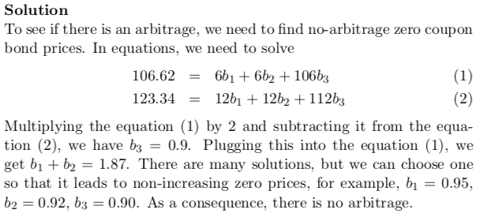

The duration is a measure of sensitivity of the bond price to the interest rate or yield. A percentage-change in bond prices is equal to the percentage-change interest rates multiplied by the duration.

We see the loadings on RX factor are similar across portfolios.This suggests that this factor does not capture the cross sectional differences in the average returns across the currency portfolios.

However, they are highly statistically significant, suggesting RX factor helps to explain the average level of the returns.

[This is intuitive since, as mentioned above, the RX factor is important to explain the overall level of the returns. If this factor is excluded from the regression, then the contribution of this factor gets attributed to ‘unexplained returns’ or ‘e’ in the above regression.]

We see, to the contrary, that loadings on HML factor differ dramatically across the portfolios – increasing monotonically as we move from portfolio 1 to portfolio 6.

This suggests that this factor helps explain the cross sectional variation in average returns across the 6 currency portfolios.

**risk price**

This is the compensation earned for unit exposure (beta) to HML risk.

**term-structure**

Since there is no uncertainty, the growth of $1 should be identical under each of the following two investment policies:

Buy and hold 4 yr zero =

Buy 3 yr zero;roll proceeds into 1 yr zero

(1+y4 )4=(1+y3 )3×(1+r4 )

This example illustrates how the shape of the term structure provides information about market expectations of future interest rates.

Suppose today’s date is 0. Then, define ri as the short rate that prevails at date i, for the period from date i-1 to i . Hence r1 is the rate today on a one period loan (bond), while r2, r3,... etc; refer to rates on future loans ( one period bonds to be issued in the future). We can also define spot rates yn as the yields to maturity on loans originating today and terminating at time n (zero-coupon bonds issued today and maturing at time n). The term structure of interest rates is given by the set of rates, y1, y2, y3, ...