Pred 0:

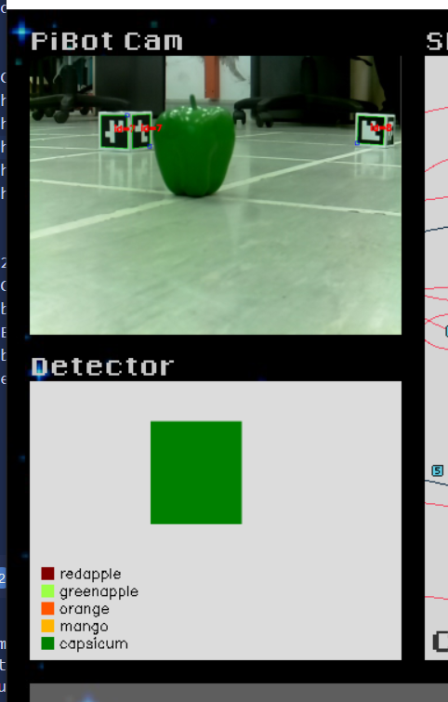

Pred 1:

Pred 2:

Pred 3:

Pred 4:

Pred 5:

Pred 6:

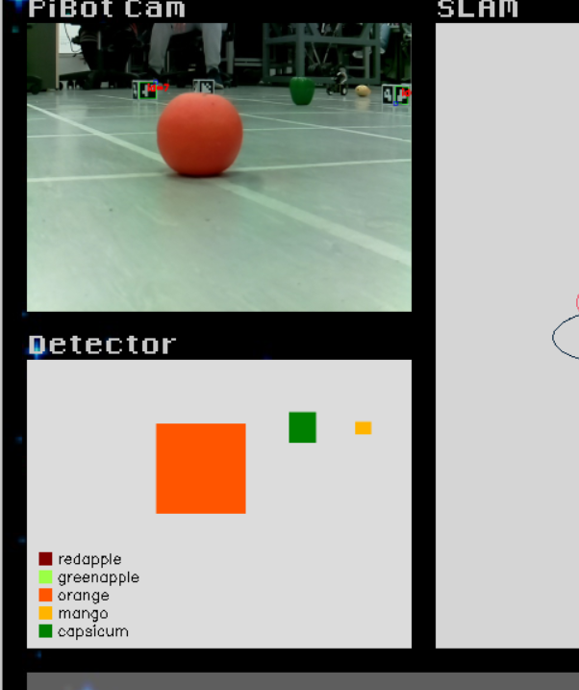

Pred 7:

Pred 8:

Pred 9:

Pred 10:

