**Paper #1:**

**A 3-D Numerical Simulation of non-Newtonian Blood Flow through Femoral Artery Bifurcation with a Moderate Arteriosclerosis: Investigating Newtonian/non-Newtonian flow and its Effects on Elastic Vessel Walls**

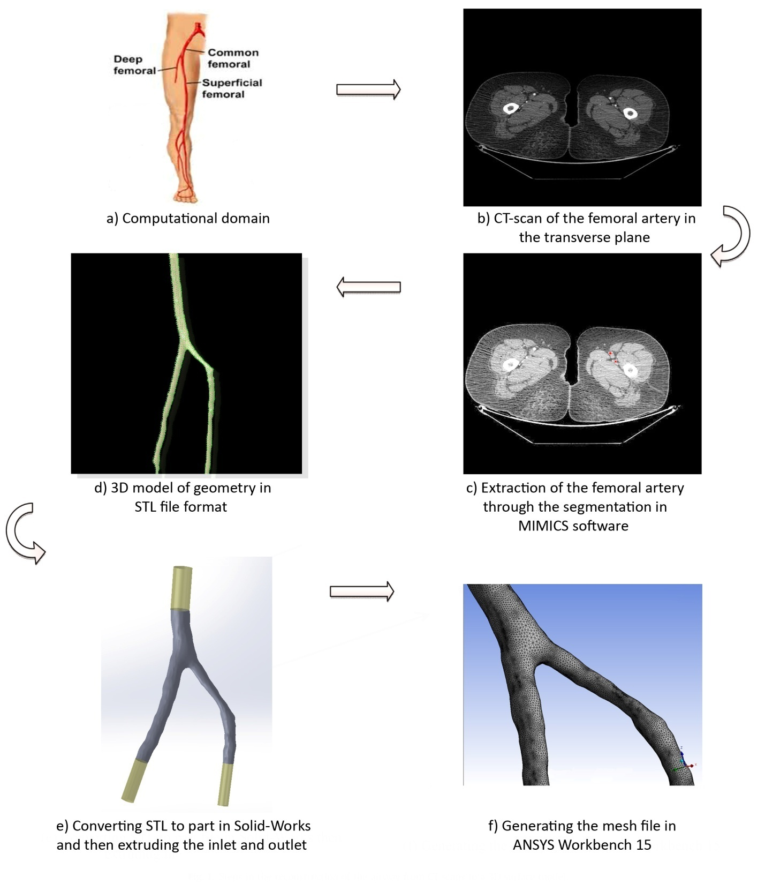

Figure 1**-** The steps taken for preparation of the real 3D model from CT-Scan images.

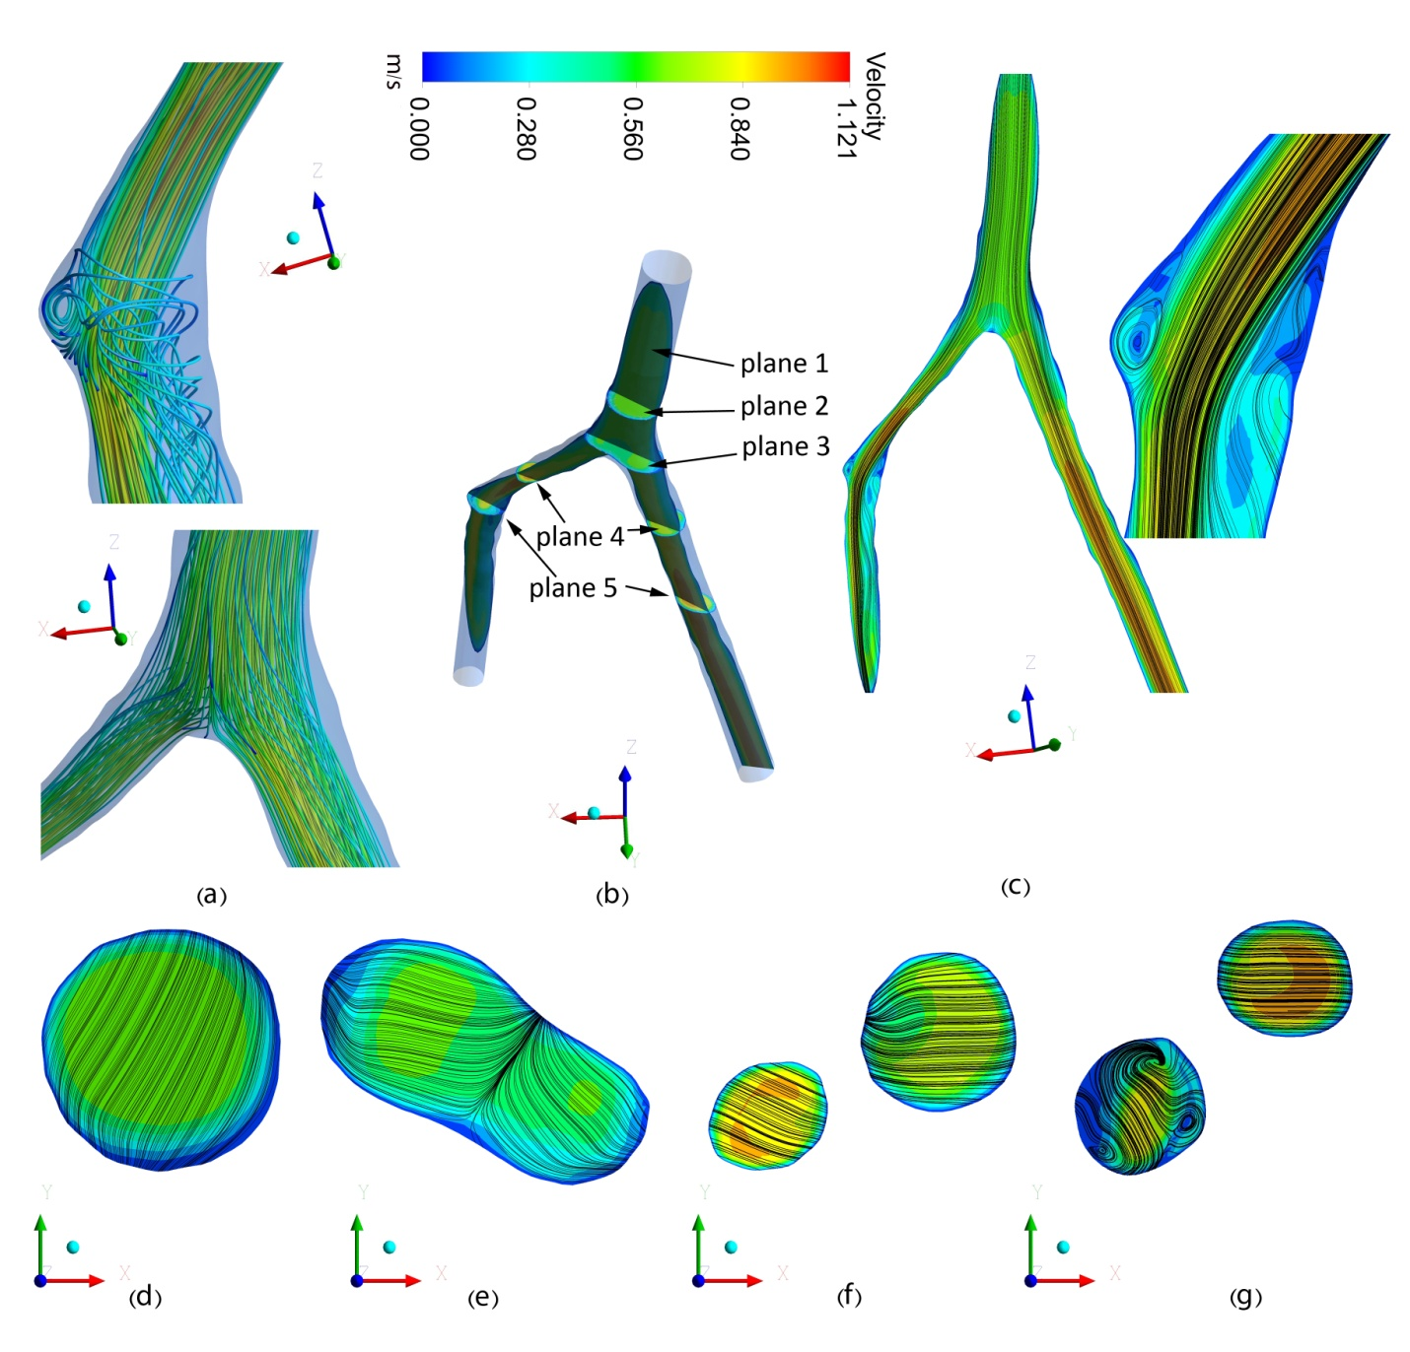

Figure 2- 2-D and 3-D contours and streamlines at the time of maximum flow. (a) 3-D streamlines, (b) surface locations, (c) contour and streamlines of plane 1 (c), plane 2 (d), plane 3 (e), plane 4 (f) and plane 5 (g).

# Paper 2#:

# Effect of employing a new biological nanofluid containing functionalized graphene nanoplatelets on thermal and hydraulic characteristics of a spiral heat exchanger

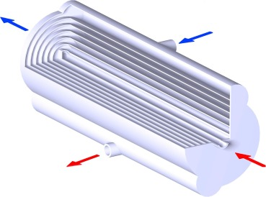

Fig. 1. Schematic of heat exchanger and its internal view as well as the inlet and outlet of both fluids.

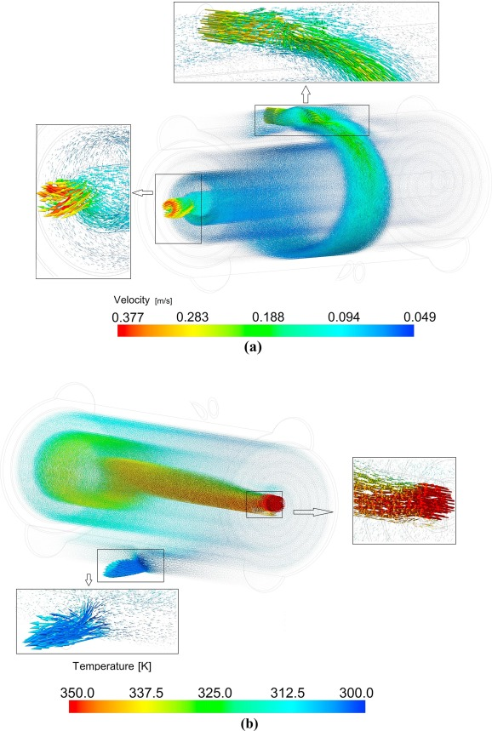

Fig. 2. The velocity vectors: (a) cold water, (b) hot fluid

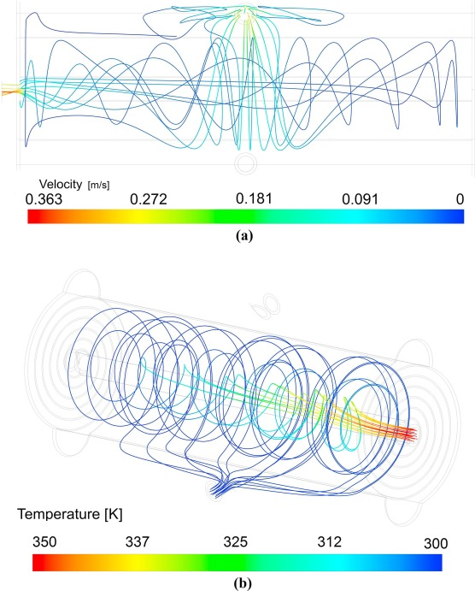

Fig. 3. Pathlines for *ϕ* = 0.1%: (a) cold water side at Re = 3000, (b) nanofluid side at Re = 500.

**Paper #3:**

**A Hybrid Finite-Element/Finite-Difference Scheme for Solving the 3-D Energy Equation in Transient Non-Isothermal Fluid Flow over a Staggered Tube Bank**

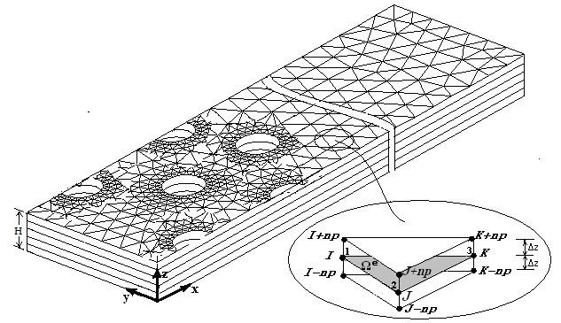

Fig. 1- The hybrid 3-D mesh used in the present study

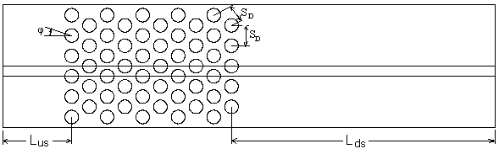

Fig. 2- Physical model of flow around a staggered tube bank

= 0.1, Re = 300 row 2 row 4





row 1 (a) row 3

= 0.5, Re = 300 row 2 row 4





row 1 (b) row 3

= 1, Re = 300 row 2 row 4





row 1 (c) row 3

Steady-state, Re = 300 row 2 row 4



row 1 (d) row 3

Steady-state, Re=100 row10



row 9 (e)

Fig.3- Isotherms in the staggered tube bank in mid-plane

**Paper #4:**

**Investigation of Micro and Nano-sized Particle Erosion in a 90º Pipe Bend Using a Two-Phase Discrete Phase Model**

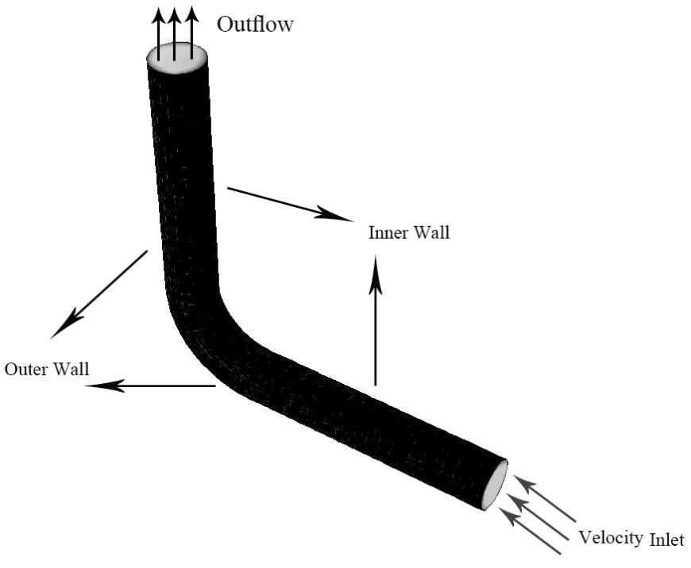

Fig. 1**-** Schematic description of the pipe flow configuration with the elbow being considered for analysis

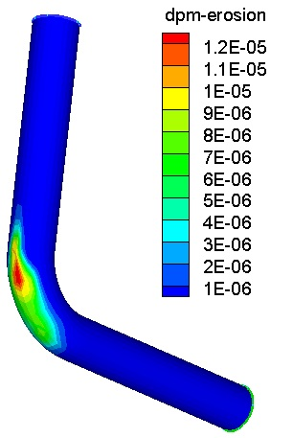

Fig. 2**-** Erosion contour on the wall of the bend

**Paper #5:**

**Application of nanofluid to improve the thermal performance of horizontal spiral coil utilized in solar ponds: geometric study**

|  |  |  |  |  |
| --- | --- | --- | --- | --- |
| C:\Papers\Renewable Energy - Dr. Safaei\FLU - Copy.jpg | | |  | |
| (a) | | | (b) | |
|  |  |  | |  |
| (c) | | | | |

Fig. 1- Geometry and studied sections

|  |  |  |
| --- | --- | --- |
| π | 2 π | 5 π |
|  |  |  |
|  |  |  |
|  |  |  |
|  |  |  |
|  |  |  |
|  | | |

Fig. 2- Variations of axial velocity for regions normal to the flow, φ=0.02%.

|  |  |  |  |  |
| --- | --- | --- | --- | --- |
| π | 2 π | 3 π | 4 π | 5 π |
|  |  |  |  |  |
|  |  |  |  |  |
|  |  |  |  |  |
|  |  |  |  |  |
|  |  |  |  |  |

Fig. 3- Velocity distribution vectors for regions normal to the flow in different twist angles of coil and different cross sections.